123 Anywhere St., Any City

hello@techguruplus.com

@techguruplus

+123-456-7890

EDUCATION

Borcelle University

2022 - 2024 | Bachelor in Computer Engineering

University

2020 - 2021 | Master in Computer Engineering

SKILLS

knowledge and hand-on experience with operating systems (maintenance, troubleshooting)
strong ops skills and support mindset

deep understanding of modern monitoring concepts experience with Databases

LANGUAGES

English native language

German speaking, reading,writing Chinese speaking, reading,

REFERENCES

Samira Hadid

Position | Company name hello@techguruplus.com +123-456-7890

HARPER RUSSO
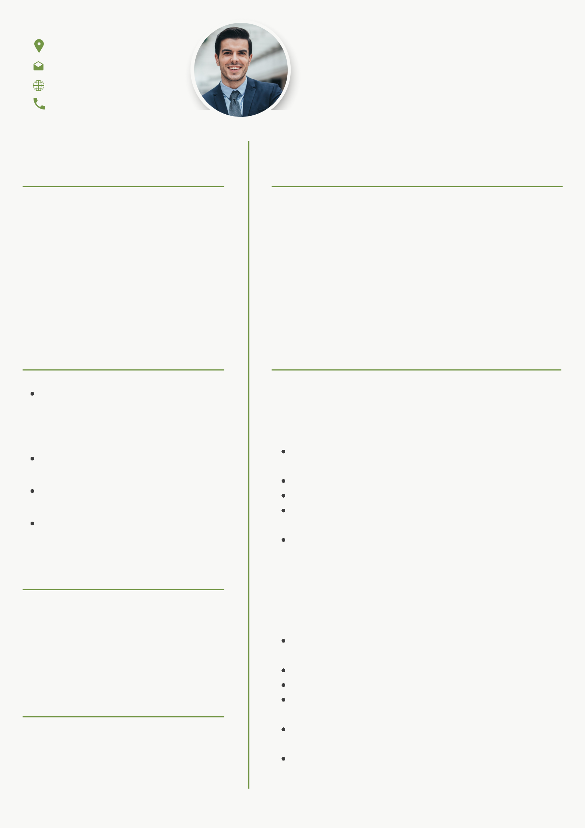

DEVOPS ENGINEER

PROFILE

- am a strong, skillful, and self-organized DevOps engineer with 5 years experience of developing infrastructure-related components platform, optimizing the existing environments. Have strong scripting knowledge. Good understanding of Infrastructure-as-a-Code concepts.

EXPERIENCES

2023 Ginyard International Co. Junior software developer

set-up, maintenance and ongoing development of continuous build/ integration infrastructure developing pipeline for computer vision applications optimize the existing environments/structure establish and strengthen the security notification and management tools

participate in technical discussions to aid system design, analysis, and troubleshooting

2024 Larana. Inc.

Senior Devops engineer

Deliver the project from design to testing, including new programs, enhancements, and modifications Monitor the performance and test the server Participate in estimation and planning sessions Work closely with the Product team to deliver quality features in high-quality code and best practices Contribute to development of technical project documentation and user documentation
Drive major architectural changes as we scale to improve our engineering velocity

