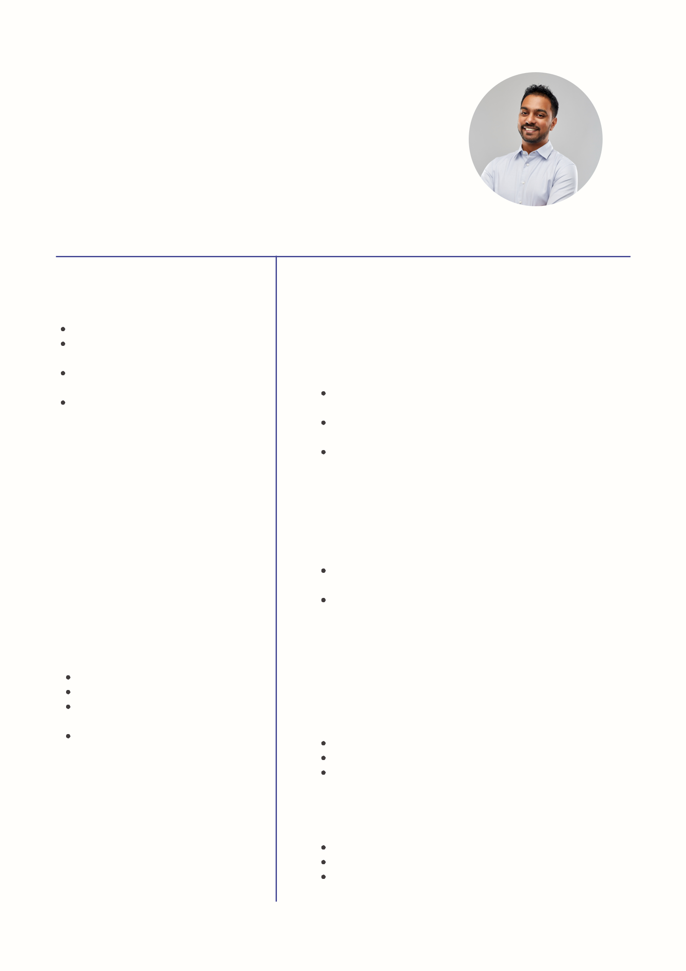
David Benjamin

Project Engineer

Results-driven project engineer with over five years of experience managing complex engineering projects from conception to completion.

SKILLS

Licensed Civil Engineer

Master's Degree in Project

Engineering

Accredited by the Standard

Compliance Agency

Well-versed in QA/QC

policies

REFERENCES

Philippe Stolvan

Manager, Present Builders

Email:

hello@techguruplus.com

Kyleigh Riteman

HR Lead, Top Tier Engineering

Phone: 123-456-7890

CONTACT

123-456-7890 hello@reallygreatsite.com 123 Anywhere St., Any City, ST 12345 www.techguruplus.com

WORK EXPERIENCE

Project Coordinator

Top Tier Engineering

2035-present

Ensures compliance with safety and performance standards

Develops and maintains schedules for complex engineering projects

Conducts risk analysis and mitigation for high-profile projects

Senior Engineer

Present Builders

2032-2035

Supervised 15 projects, leading to a 30% increase in project completion rate within a year Implemented process improvements that reduced project cycle time by 20%

EDUCATION

West State University

Master's in Project Engineering | June 2034

Capstone Project Excellence Award

2 Peer-Reviewed Research Papers Published Commencement Speaker, 2034

North City College

Degree in Civil Engineering | June 2030

Dean’s List - 2026-2028

Project Excellence Award, 2029

President, Student Government (2029-2030)

