 Lydia Mary

SOFTWARE ENGINEER

About Me

I have a background as Software Engineering experienced in maintaining and developing high performance data platform, integrating data from a variety of internal and external sources, in order to support data and analytics activities functions business.

Education

(2005-2009)

INGOUDE UNIVERSITY

Bachelor of Software Engineering

GPA : 3.6

Contact

+123-456-7890

hello@techguruplus.com

www.techguruplus.com

123 Anywhere Street., Any

City

Skills

Prior experience with AWS is

preferred.

Prior experience with Docker or other virtualization technologies. Prior experience with highly available database technologies. Excellent analytical skills and ability to ramp up quickly on new tools/technologies.

Experiences
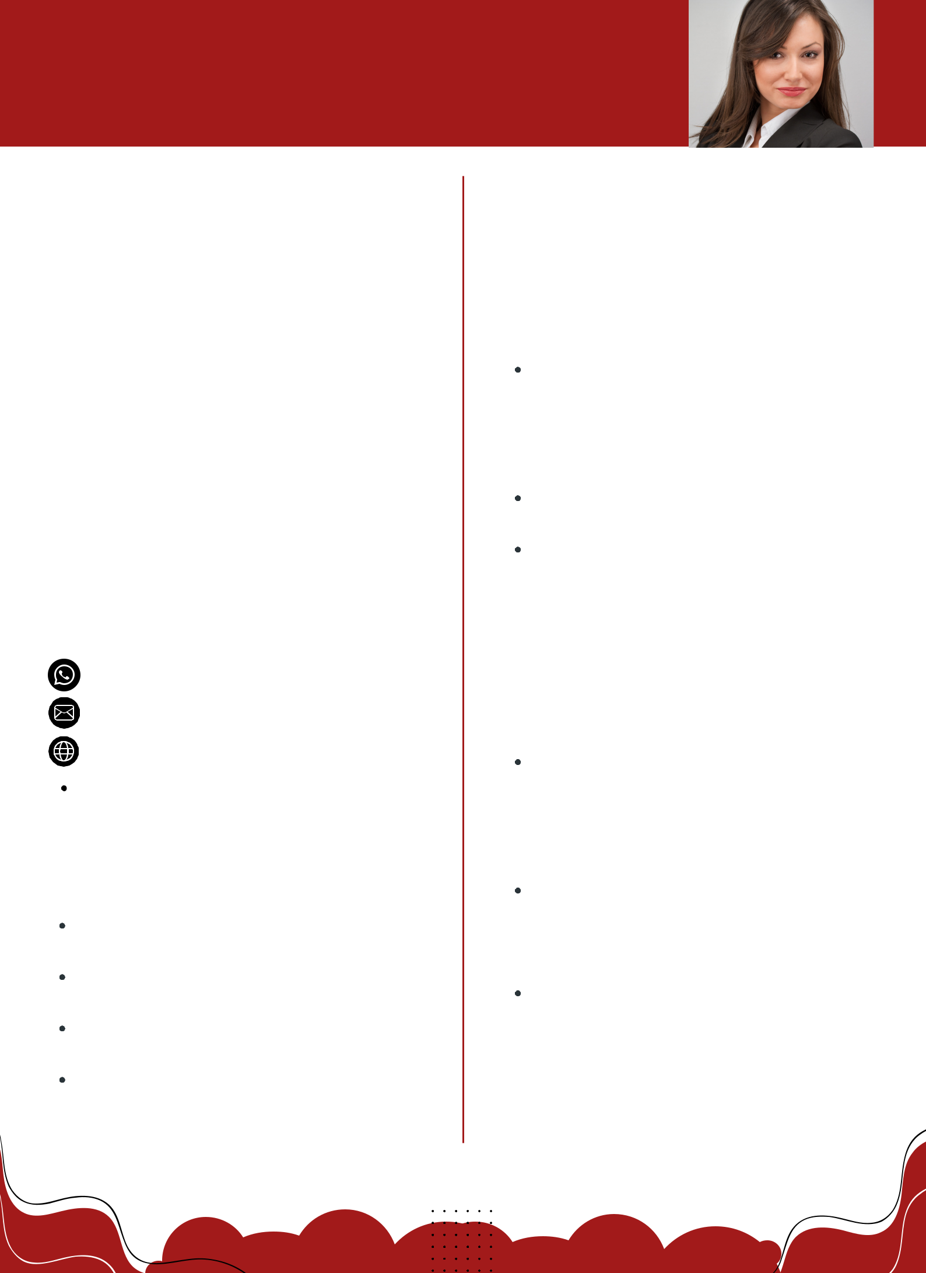

(2010-2013)

Ginyard International Co.

RESPONSIBLE FOR NETWORK AND SOFTWARE

Develop features that improve the team’s ability to deliver reliability, velocity, and efficiency to the customer when managing databases, both on-premise and in the cloud.

Contribute to code reviews along with design and architecture reviews. Collaborate with Technical lead on team initiative(s) to deliver on quarterly objectives

(2014-Now)

Wardiere Inc.

SOFTWARE ENGINEERING

Develop features that improve the team’s ability to deliver reliability, velocity, and efficiency to the customer when managing databases, both on-premise and in the cloud.

Use Infrastructure As Code tools and techniques to help product teams with migration templates from on-prem database technologies to AWS. During work-hours DFR rotation week (once every 6 weeks), provide customer service and support to our engineering teams on Slack. There is no Pagerduty rotation as part of DFR week.

