Note_10.17

Class

Package: rgbif 🡪 website

par(mfrow=c(1,2)) 🡪 1 row 2 colum

ex.

|  |  |
| --- | --- |
|  |  |

par(mfrow=c(2,2)) 🡪 2 row 2 colum

ex.

|  |  |
| --- | --- |
|  |  |
|  |  |

🡪每個框框可以放一個圖

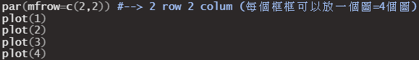

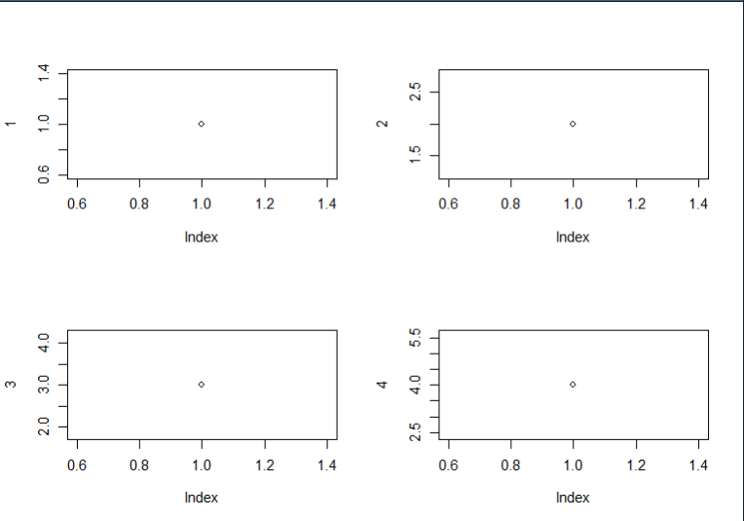

# GADM 🡪可以下載多data的網站

# zip::XXXXXX 🡪 :: 要下載package但是可以不用library