23CSE202 — DATABASE MANAGEMENT SYSTEMS
FootVerse — Database Design Document
S3 B.Tech CSE • Amrita School of Computing, Amritapuri Campus
Group 05
Team members: Govardhan, Lakshyardha, Priyatam, Sumadhur

3.1 Project description and scope
FootVerse is a football-themed web application that combines player and club information, merchandise browsing, account sign-in, a local demo order workflow, and optional AI-generated scout/tactical text. The application uses React and Vite for the client, Express for API routes, and SQLite through better-sqlite3 for persistent data.
Scope note: this is an academic demonstration. The checkout creates a database order but does not process real payments or store shipping addresses. AI-generated analysis is not independently verified. The match centre, editable favourites, 2FA, and saved payment methods are not fully implemented as production features.

3.2 Entity-relationship diagram
The diagram reflects the tables and foreign-key relationships declared in db/schema.sql. Dashed edges indicate optional references or relationships where a product may be associated with a club.
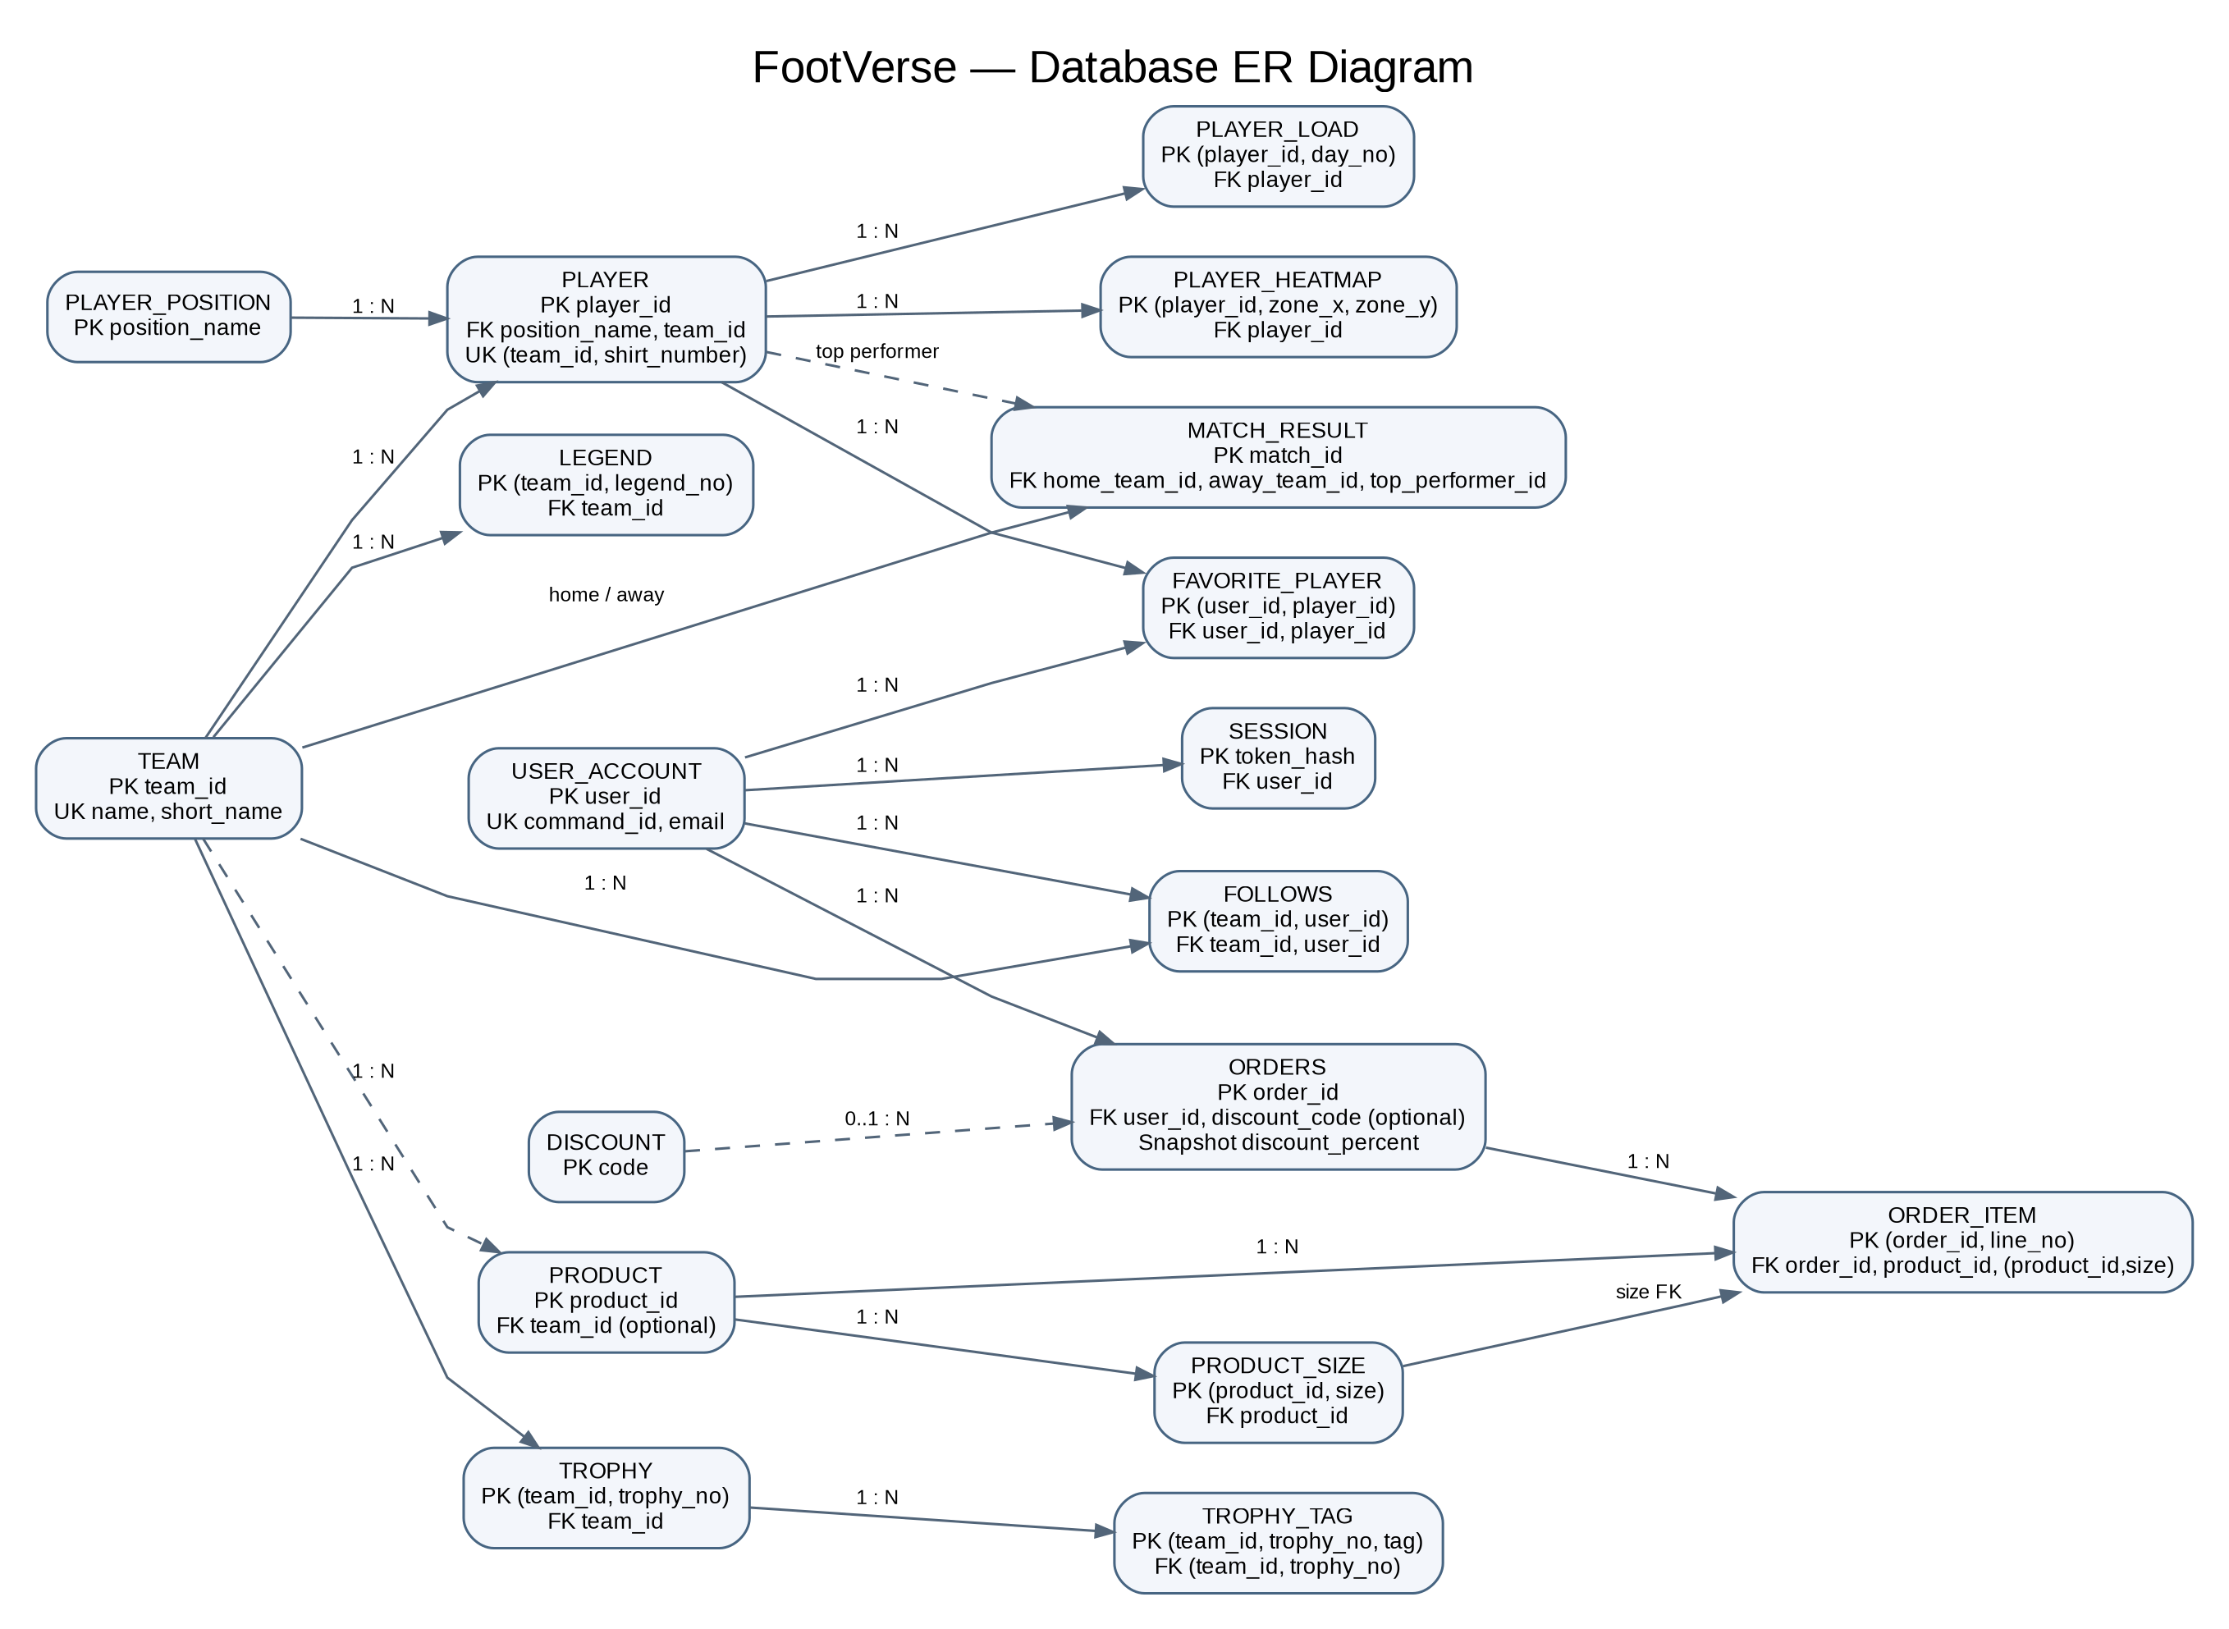

3.3 Relational schema
Notation: PK = primary key; FK = foreign key; UK = unique key. The authoritative executable definition is db/schema.sql.
- TEAM: team_id PK; name UK; short_name UK; league; rating; ucl_titles; season_win_rate; established_year; slogan; logo_url; banner_url.
- PLAYER_POSITION: position_name PK; category.
- PLAYER: player_id PK; name; shirt_number; position_name FK; nationality; market_value_eur_m; rating; goals; assists; pass_accuracy; sprint_speed; stamina; recovery_rate; fitness_level; bio; last_match; instagram_handle; twitter_handle; image_url; team_id FK; UK(team_id, shirt_number).
- PLAYER_LOAD: player_id FK; day_no; load_pct; PK(player_id, day_no).
- PLAYER_HEATMAP: player_id FK; zone_x; zone_y; intensity; PK(player_id, zone_x, zone_y).
- TROPHY: team_id FK; trophy_no; year; title; description; PK(team_id, trophy_no).
- TROPHY_TAG: team_id; trophy_no; tag; PK(team_id, trophy_no, tag); composite FK(team_id, trophy_no) to TROPHY.
- LEGEND: team_id FK; legend_no; name; title; PK(team_id, legend_no).
- MATCH_RESULT: match_id PK; match_date; league; home_team_id FK; away_team_id FK; home_score; away_score; status; minute; top_performer_id FK.
- USER_ACCOUNT: user_id PK; command_id UK; name; email UK; password_hash; membership; xp; avatar_url; joined_date.
- PRODUCT: product_id PK; name; category; price; original_price; tag; description; image_url; team_id optional FK; collection.
- PRODUCT_SIZE: product_id FK; size; size_order; PK(product_id, size).
- DISCOUNT: code PK; percent.
- ORDERS: order_id PK; order_date; status; shipping_fee; discount_code optional FK; discount_percent purchase-time snapshot; user_id FK.
- ORDER_ITEM: order_id FK; line_no; product_id FK; size; quantity; unit_price purchase-time snapshot; customization; PK(order_id, line_no); composite FK(product_id, size) to PRODUCT_SIZE.
- FOLLOWS: team_id FK; user_id FK; PK(team_id, user_id).
- FAVORITE_PLAYER: user_id FK; player_id FK; PK(user_id, player_id).
- SESSION: token_hash PK; user_id FK; created_at; expires_at.

3.4 Main relationships and integrity constraints
- Each player belongs to one team and one player-position category. A team can have many players; (team_id, shirt_number) is unique.
- Teams own trophies and legends. TROPHY and LEGEND use composite primary keys containing team_id because their numbering is scoped to the owning team.
- MATCH_RESULT references two teams (home and away) and optionally a top performer. A match cannot have the same team as both home and away.
- PRODUCT_SIZE stores available sizes in a separate relation. ORDER_ITEM references both the product and the valid product-size pair.
- USER_ACCOUNT has many ORDERS and SESSION rows. FOLLOWS and FAVORITE_PLAYER implement many-to-many associations.
- ORDER_ITEM.unit_price and ORDERS.discount_percent preserve purchase-time values so catalogue price or discount changes do not alter historical totals.
- Date fields validate ISO date shape and calendar validity. Foreign keys are enabled by the server connection.

3.5 Functional dependencies and normalization
Functional dependencies (FDs) describe how attributes determine other attributes; they are not foreign-key constraints. In USER_ACCOUNT, user_id → command_id, name, email, password_hash, membership, xp, avatar_url, joined_date. The schema declares user_id as the primary key and command_id and email as UNIQUE, so each is a candidate key (assuming the declared NOT NULL/UNIQUE semantics in the schema). For TROPHY, (team_id, trophy_no) → year, title, description; for LEGEND, (team_id, legend_no) → name, title. PLAYER.player_id determines that player's stored attributes; PLAYER.position_name references PLAYER_POSITION.position_name through a foreign key.
Normalization analysis of the implemented schema:
1NF: Repeating or multivalued collections are represented as rows in separate relations rather than arrays in a single cell: PLAYER_LOAD, PLAYER_HEATMAP, PRODUCT_SIZE, TROPHY_TAG, FOLLOWS, and FAVORITE_PLAYER. Social links are stored in separate attributes. Each field stores a single value.
2NF: For relations with composite keys, non-key attributes depend on the whole key: PLAYER_LOAD.load_pct depends on (player_id, day_no); PLAYER_HEATMAP.intensity depends on (player_id, zone_x, zone_y); TROPHY attributes depend on (team_id, trophy_no); LEGEND attributes depend on (team_id, legend_no); ORDER_ITEM line attributes depend on (order_id, line_no). Relations consisting only of key attributes have no non-key partial dependencies. These claims should be revisited if the business rules change.
3NF: Derived values such as team form/standing, ranks, and order totals are calculated by views instead of duplicated in base tables. PLAYER_POSITION stores category against position_name, avoiding repeating the category in every PLAYER row. ucl_titles and season_win_rate are imported sample statistics, explicitly retained as a documented exception rather than calculated from the sample match rows.
BCNF and candidate-key closure examples: In USER_ACCOUNT, {user_id}+ contains all USER_ACCOUNT attributes because user_id is the primary key. {email}+ and {command_id}+ also contain all USER_ACCOUNT attributes because email and command_id are declared UNIQUE candidate keys. For TROPHY, {(team_id, trophy_no)}+ = {team_id, trophy_no, year, title, description}; neither component alone identifies a trophy across all teams. These examples show the relevant determinants are superkeys for these relations; they are not a claim that every possible business rule outside the declared schema has been proven.
Candidate-key closure — USER_ACCOUNT: Start with {user_id}. Apply the primary-key dependency to obtain {user_id, command_id, name, email, password_hash, membership, xp, avatar_url, joined_date}; this is the full relation, so user_id is a candidate key. The UNIQUE constraints give the same full-closure result for email and command_id.
Candidate-key closure — TROPHY: Start with {team_id, trophy_no}. The composite primary key identifies the row and determines year, title, and description, so the closure contains every TROPHY attribute. TROPHY_TAG uses (team_id, trophy_no, tag) as its key because a trophy can have multiple tags.

3.6 Validation and setup
Run npm install, configure .env.local only if AI analysis is needed, and start the app with npm run dev. The SQLite database is created and seeded from db/schema.sql, db/views.sql, and db/seed.sql on first startup. npm run lint performs TypeScript checking; npm run build creates the client bundle and server bundle.
Do not include node_modules, local environment files, or a live development database and its WAL/SHM files in a submission ZIP. Keep the SQL schema, view, seed, query, and README files so the database can be rebuilt reproducibly.

