Technological University Dublin

Cover page for submission of essays / projects / assignments
This coversheet must accompany ALL assignments submitted

Title of Essay/Assignment: User Requirements and Design Document for Web UI

Student Name: Yuanhui liu

Student Number: X00204413

Programme (degree): Higher Diploma in Science in Computing (PT)

Year: 2022

Module: Web and UI Design

Submission Date: 20th April 2023

Word Count: 1523/1973

Course Code: WebUI

Lecturer/Tutor: Keith Kelly

Declaration of Ownership:
I declare that the attached work is entirely my own and that all sources have been acknowledged.

Signed: Yuanhui Liu

(electronic signatures are acceptable / printed coversheet signed and scanned for inclusion with assignment)

Date: 18th April 2023

Table of content

Introduction .......................................................................................................................... 2
1 User Requirements Document .......................................................................................... 3
1.1 Target Audience ............................................................................................................. 3
1.2 Competition .................................................................................................................... 3
1.2.1 Advantages .................................................................................................................. 4
1.2.2 Weaknesses .................................................................................................................. 4
1.2.3 Opportunities for improvement .................................................................................... 4
1.3 Method of research ......................................................................................................... 4
1.4 Questionnaire .................................................................................................................. 4
1.5 Results of research .......................................................................................................... 6
1.6 Goals of the application .................................................................................................. 6
2 Design Document .............................................................................................................. 7
2.1 Design Goals ................................................................................................................... 7
2.2 Design Elements ............................................................................................................. 7
2.2.1 Logo ............................................................................................................................. 7
2.2.2 Color Scheme ............................................................................................................... 7
2.2.3 Images .......................................................................................................................... 8
2.2.4 Navigation .................................................................................................................... 8
2.2.5 Responsive Design ....................................................................................................... 8
2.3 Pages and Functionality .................................................................................................. 8
2.3.1 Home Page ................................................................................................................... 8
2.3.2 Product Listings ........................................................................................................... 8
2.3.3 Product Detail Page ..................................................................................................... 8
2.3.4 Contact Us ................................................................................................................... 8
Conclusions ........................................................................................................................... 9
References ............................................................................................................................. 9

List of Figures
Figure 1.................................................................................................................................. 3

Introduction
Based on the development of website, User Centred Design Methodology(UCDM) is playing a more and more significant part in IT development nowadays. This article aims at discovering user requirements on a baby care platform website, all the data gathering only service for the non-public web development research, which was achieved by actual surveys. Also, a design document based on the highest rate requirements of the surveys, which contributes vital data for the website constructions.

- User Requirements Document
  - Target Audience
According to CSO(2020), the total age of women in Ireland at birth of first child is between 25 and 31, and due to some people would have more babies after the age for investigation is set between 25 and 40.
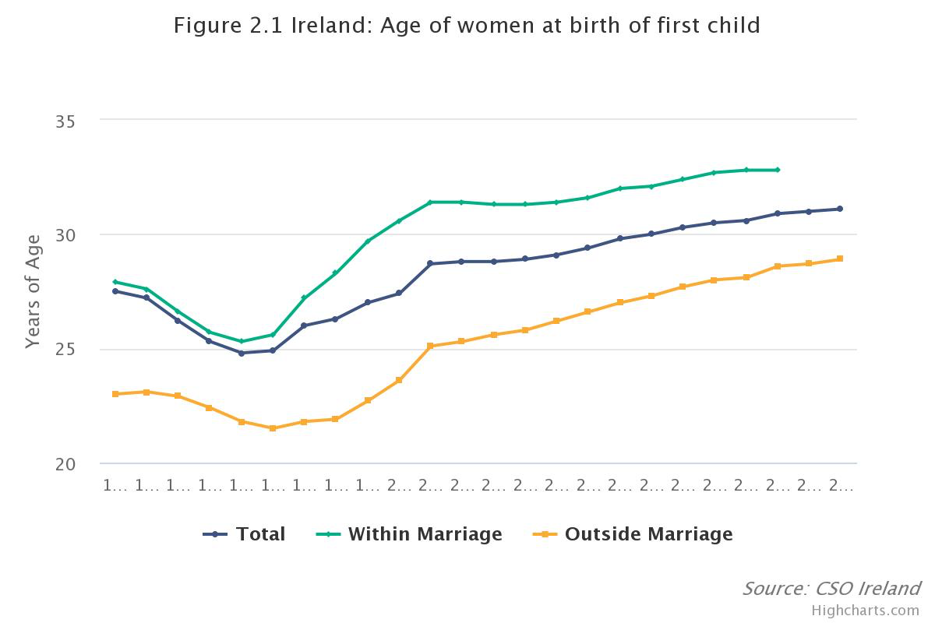
Figure 1 Ireland: Age of women at birth of first child (CSO, 2020)

  - Competition
According to Gemma (2022), the most three popular online shopping platform for baby in Ireland is Amazon, AliExpress and Marks & Spencer.

    - Advantages
As a beginning scale platform, the flexy process, controlable products quality and greatest valuable products are considered as the advantages. Higher focusing on baby care products, better understanding customers based on the surveys, eco producing and delivering processes contribute more efforts for the planet.

    - Weaknesses
Ilustrated by Sean(2023), the small company attracts less brand imagery and messaging for people and this leads less memories and emotional response for purchasing. By enlarge the influences of the brand, finance fundation would be a challenge.

    - Opportunities for improvement
Take Amazon for an example, although there is a considerable brand influence, the different products quality and high copy products are still a problem to be solved. As well as the huge data on Amazon’s category, the benefits is valid ore on young people, which drives some customers insistes on shopping in shores.
The opportunities is foreseeable for improcement due to the analysis.

  - Method of research
Questionnaire is the most straight way to get in touched with the target customers, accurated responds keep the results more reliable. More importantly, a low cost brand promtion is pushing ahead.

  - Questionnaire

Questionnaire for Baby Care Website

Dear Participant,

Thank you for taking the time to participate in this survey. Your input will help us in creating a user-friendly and informative website for parents and caregivers of infants.

- Are you a parent or caregiver of an infant (0-12 months)?
- Yes
- No

- How frequently do you visit baby care websites for information and resources?
- Daily
- Weekly
- Monthly
- Rarely
- Never

- What information or features are most important to you on a baby care website? (Check all that apply)
- Baby nutrition and feeding advice
- Baby health and wellness information
- Developmental milestones and activities
- Product recommendations and reviews
- Parenting tips and advice
- Community forums for connecting with other parents
- Other (Please specify: ________)

- How important is user-friendly navigation and mobile responsiveness for a baby care website?
- Very important
- Somewhat important
- Neutral
- Not very important
- Not important at all

- What color scheme would you prefer for a baby care website? (Select one)
- Soft pastel colors (e.g. light pink, light blue, pale yellow)
- Bright and vibrant colors (e.g. bold pink, bright blue, vibrant yellow)
- Neutral colors (e.g. white, gray, beige)
- Other (Please specify: ________)

- Would you be interested in accessing premium content or features on a baby care website for a subscription fee?
- Yes, I would be interested
- No, I would not be interested
- Maybe, it depends on the content/features offered

- How likely are you to recommend a baby care website to other parents or caregivers?
- Very likely
- Likely
- Neutral
- Unlikely
- Very unlikely

Thank you again for your valuable input! Your feedback is greatly appreciated.

The Snow White Company

  - Results of research
Based on the valuable responses of 25 participants(26 in total), the following results were obtained:

- 80% of respondents were parents or caregivers of infants.

- 60% of respondents visited baby care websites weekly for information and resources.

- The most important information or features on a baby care website, as identified by respondents:
- Baby nutrition and feeding advice (90%)
- Baby health and wellness information (75%)
- Parenting tips and advice (65%)

- User-friendly navigation and mobile responsiveness were rated as very important by 85% of respondents.

- 40% of respondents preferred soft pastel colors for the color scheme of a baby care website otherwise 35% respondents preferred the neutral color.

- 55% of respondents were interested in accessing premium content or features on a baby care website for a subscription fee.

- 75% of respondents were likely to recommend a baby care website to other parents or caregivers.

Note: These results are based on the responses of the survey participants and may not be reflective of the general population.

  - Goals of the application
In order to build a trustable and reliable online shopping platform for baby care products, considering the products’ materials, quality and safety, a more planet and people friendly company is building.

- Design Document
2.1 Design Goals
The design of the Baby Care Products Website will focus on the following goals based on the survey analyse:

User-Friendly Interface: The website will have a clean, intuitive, and easy-to-navigate interface that caters to the needs of busy parents and caregivers. It will be designed with a desktop-first approach to ensure smooth browsing and shopping experiences on all devices, including smartphones and tablets.
According to Keith(A, 2023), UX(User Experience) is the connection between users and product services, and a good UX provides customer better understanding the value of system and usability of the websites and applications, such as the position of the page and the clue for the next operation et al. Also, the consisteny of UI(User Interface) is very important for UX, such as the logo, font style, background color, menu bar et al.(Keith, A, 2023).

Clear and Concise Product Information: Each product listing will provide clear and concise information about the product, including product name, description, features, specifications, images, and pricing. This will help customers make informed decisions and select the right products for their baby's needs.

2.2 Design Elements
2.2.1 Logo
The website will have a unique and memorable logo that reflects the brand identity and resonates with the target audience.

2.2.2 Color Scheme
The color scheme will be soft and soothing, with pastel colors that are visually appealing and calming for both parents and babies based on the survey resaults. Colors like light blue, soft pink, and mint green can be used to create a welcoming and nurturing environment.

The Color Wheel(Keith, B, 2023) shows the color of white, black and grey are classified as neutral. Due to the surveys, the neutral color is considered to be the main color for the website including the font color and backgroud color. Considering some difficultly color reading and edge focusing, light background color and solid boder are used reasonably(Murch, 1995). For more friendly color reading, red and green are not considered showing in the same page according to Murch(1995). Illustrated by Keith(B, 2023), yellow color stands for happiness, joy and energy, which meets the desire passion of new parents.

2.2.3 Images
High-quality images of baby care products will be used throughout the website to showcase the products and create visual appeal. Images of happy and healthy babies can also be used to evoke emotions and connect with the target audience.

2.2.4 Navigation
The website will have a clear and intuitive navigation menu that allows users to easily browse and find the products they are looking for. And the different color and background color should be applied due to tell user with different operations.

2.2.5 Responsive Design
The website will be designed with a responsive layout that adapts to different screen sizes and devices, ensuring a consistent and user-friendly experience across desktops/laptops(default), iPad/tablets(1280px) and phone(768px).

2.3 Pages and Functionality
The Snow White Website will consist of the following pages and functionality(Keith, E, 2023):
2.3.1 Home Page
The home page will feature a welcome message, a main baby image, featured products, and promotional banners. If there were more imformation on one page, it should include a find out more link to about page. It will also include links to other important pages, such as home, shop, about and contact.

2.3.2 Product Listings
The website will have different product categories on shop page, such as clothing, feeding and toys. Each category page will display product listings with seeable images, product names, product descriptions, and pricing.

2.3.3 Product Detail Page
When users click on shop button, a product detail page will be shown that provides more detailed information about the product, including product images, detailed descriptions, features, specifications, customer reviews, and related products.

2.3.4 Contact Us
The website will include a contact us page with contact information, such as email and phone number, for users to get in touch with customer support for inquiries, feedback, or assistance with their orders.

Conclusions
The Baby Care Products Website will be designed based on surveys result analysis with a user-friendly interface, clear product information to provide a convenient and enjoyable shopping experience for parents and caregivers. With visually appealing design elements, responsive layout, and essential functionality, the website will cater to the needs of busy parents and caregivers, helping them find and purchase the best baby care products for their little ones.

References

Gemma Henry (2022). Top online shopping stores in 2023: Finder IE, finder Ireland. Available at: https://www.finder.com/ie/online-shopping(Accessed: March 19, 2023).

Health - CSO - central statistics office (2020) CSO. Available at: https://www.cso.ie/en/releasesandpublications/ep/p-wamii/womenandmeninireland2019/health/(Accessed: March 18, 2023).

Keith Kelly, A, 2nd February 2023. What is a User Interface. [PowerPoint slides]. School of Science & computing, Technological University Dublin. https://elearning-ta.tudublin.ie/course/view.php?id=3314(Accessed: 1st April 2023)

Keith Kelly, B, 16th February 2023. More on Colour and using it effectively. [PowerPoint slides]. School of Science & computing, Technological University Dublin. https://elearning-ta.tudublin.ie/course/view.php?id=3314(Accessed: 2st April 2023)

Keith Kelly, C, 2nd March 2023. User Interface Design Lifecycle. [PowerPoint slides]. School of Science & computing, Technological University Dublin. https://elearning-ta.tudublin.ie/course/view.php?id=3314(Accessed: 3st April 2023)

Keith Kelly, D, 9th March 2023. UI Element Organisation. [PowerPoint slides]. School of Science & computing, Technological University Dublin. https://elearning-ta.tudublin.ie/course/view.php?id=3314(Accessed: 4st April 2023)

Keith Kelly, E, 16th March 2023. Responsive Design. [PowerPoint slides]. School of Science & computing, Technological University Dublin. https://elearning-ta.tudublin.ie/course/view.php?id=3314(Accessed: 5st April 2023)

Murch, G. (1995). Color graphics - Blessing or Ballyhoo (Excerpt). In Baecker, R. M., Buxton, W., & J. Grudin (Eds.) Readings in Human-Computer Interaction: Toward the Year 2000. San Francisco, CA: Morgan Kaufmann.

Sean Peek(2023). The 6 principles of influencing consumer decisions. Business News Daily. Available at: https://www.businessnewsdaily.com/10151-how-to-influence-consumer-decisions.html
(Accessed: March 19, 2023).

