http://www.sebastiansulinski.co.uk/web_design_tutorials/tutorial/6/install_apache_php_and_mysql_on_windows_xp
- Install Apache, PHP and MySQL on Windows XP
- Installing Apache on Windows XP
This tutorial will show you how to install Apache 2.0.59, PHP 5.2.3 and MySQL 5.0.41 on machine running Windows XP.
To start with we will download all of the necessary applications which can be found at the following locations:
Apache: Apache download page
File to download: Win32 Binary (MSI Installer): apache_2.0.59-win32-x86-no_ssl.msi
PHP: PHP download page
File to download: PHP 5.2.3 zip package
MySQL: MySQL download page
File to download: Windows (x86) ZIP/Setup.EXE
Create a folder on your desktop and place all downloaded files inside of it.
Now go the the C:\ drive and create a folder with a name webserver.
This will be the folder where all of our apache, php and mysql files will be kept. Inside of this folder create another two: php and mysql.
Go to your desktop to the previously created folder and double click apache_2.0.59-win32-x86-no_ssl.msi. This will start installation of Apache web server. Follow the instructions:
- Install Apache, PHP and MySQL on Windows XP
- Installing PHP on Windows XP
Go to your desktop and in the folder you initially created find file called php-5.2.3-Win32.zip.
Extract the content of this file to C:\webserver\php. Pull out all of the files from the php-5.2.3-Win32 folder and place them directly in C:\webserver\php.
Now we need to add our C:\webserver\php folder to the path of the Environment Variables.
To do this right click My Computer icon on your desktop and choose Properties. Then choose Advanced tab and click Environment Variables button (Fig. 13).
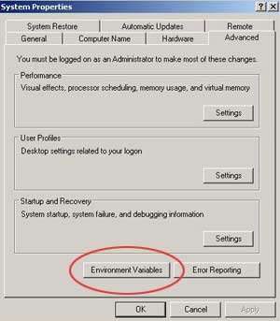
Fig. 13
Now select Path from the System variables list in the bottom part of the window and click Edit (Fig. 14).
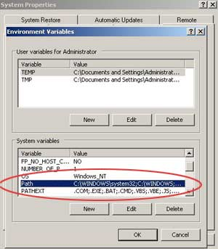
Fig. 14
In the new window click inside the Variable value: box and press End button on your keyboard to get to the end of the path.
Now type in or copy and paste the following ;C:\webserver\php (Fig. 15). Make sure you start it with semicolon and to use back slashes.
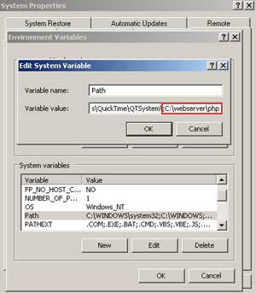
Fig. 15
Once you have done this click OK in all of the windows until you close the System Properties window. Now you need to restart the computer.
Next step will be to find out if our PHP is working. Go to Start > Run and type cmd. In the command prompt window type php -v. You should see something like Fig. 16.
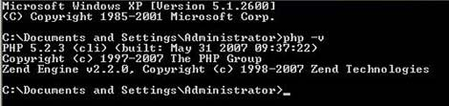
Fig. 16
We still have some tweaking to do before we finish our installation.
Go to C:\webserver\php and find file called php.ini-recommended. Rename that file to php.ini.
Open this file and make the following amendments:
- identify line with doc_root = and change it to:
doc_root = C:\webserver\Apache2\htdocs
- identify line with extension_dir = "./" and change it to:
extension_dir = C:\webserver\php\ext
Save and close the file.
Apache Configuration
Now we need to make sure that Apache knows where to search for php modules.
To do that first go to C:\webserver\Apache2\conf and open file httpd.conf in your text editor.
Because we will be running PHP as an Apache module which is faster and more secure option comparing to CGI binary, we will need to do the following changes to httpd.conf file:
- identify LoadModule section and add the following line at the top of this section:
LoadModule php5_module "C:/webserver/php/php5apache2.dll"
- identify AddType section and add the following line at the top of this section:
AddType application/x-httpd-php .php
- lastly place the following line somewhere within the content:
PHPIniDir "C:/webserver/php/" - ensure you have a closing slash at the end of the path.
Save and close file. Restart Apache by going to Start > All Programs > Apache HTTP Server 2.0.59 > Control Apache Server and click Restart.
Now go to C:\webserver\Apache2\htdocs folder and select all files by pressing Ctrl + A on your keyboard. Right click on any of the selected files and choose Properties. In Attributes section of the General tab tick Hidden checkbox and click Apply and OK to close the window. This way you will only see your own files in this folder which is the root of our web server and the place where you will be setting up all your projects.
Inside C:\webserver\Apache2\htdocs create a file and give it a name phpinfo.php. Open this file with your text editor and place the following line:
<?php phpinfo(); ?>. Save and close the file.
Open your browser and type the following line in the URL:
http://localhost/phpinfo.php.
You should see now a PHP information page (Fig. 17).
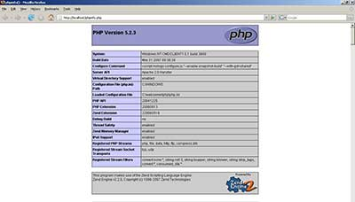
Fig. 17
Now that our Apache and PHP is installed let´s move on to the next section where we will be installing MySQL.
Go to your desktop and inside the folder you have initially created find file mysql-5.0.41.win32.zip. Extract the content of this file to the same folder on the desktop. Now go inside mysql-5.0.41-win32 folder and double click Setup.exe. Follow the steps:
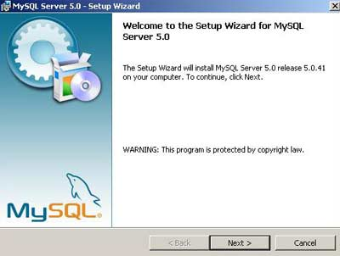
Fig. 18 - Click next.
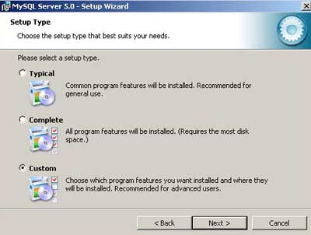
Fig. 19 - Select Custom and click next.
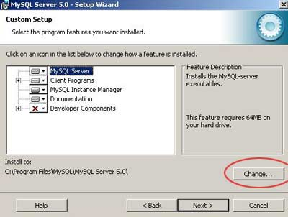
Fig. 20 - Click Change button to change the path of the installation.
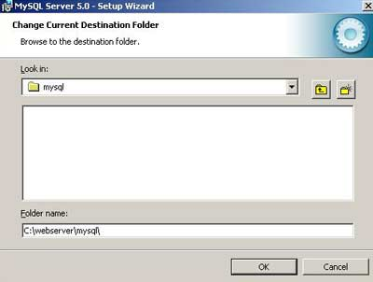
Fig. 21 - Navigate to C:\webserver\mysql and click OK, then click next.
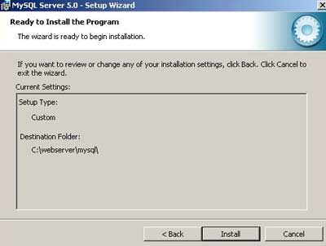
Fig. 22 - Click Install to start installation.
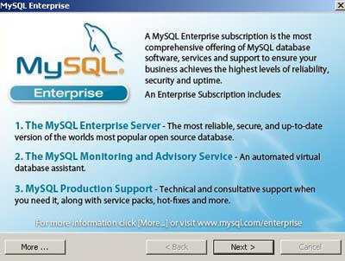
Fig. 23 - During installation a new window will pop up introducing MySQL Enterprise. Simply click next twice to continue with your installation.
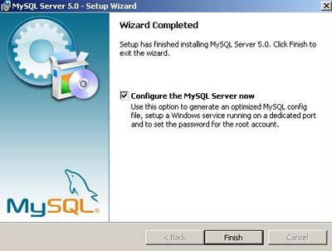
Fig. 24 - Your installation is finished. You are now ready to configure your MySQL Server. Click Finish to start configuration.
MySQL Configuration
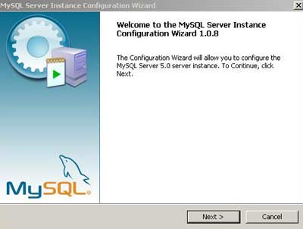
Fig. 25 - On the first screen click next.
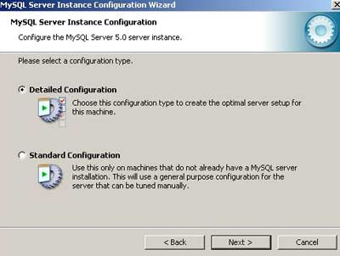
Fig. 26 - Select Detailed Configuration and click next.
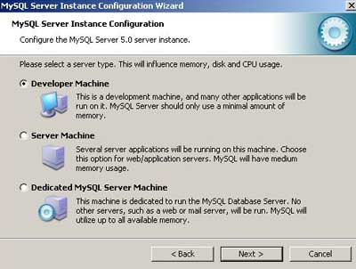
Fig. 27 - Select Developer Machine and click next.
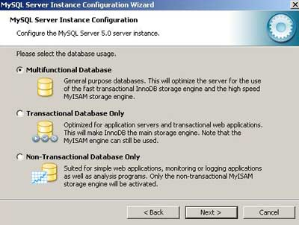
Fig. 28 - Select Multifunctional Database and click next.
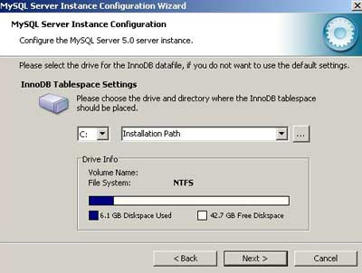
Fig. 29 - Leave everything as default and click next.
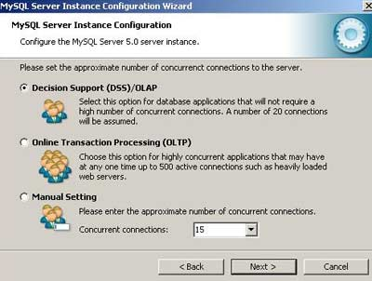
Fig. 30 - Select Decision Support (DSS)/OLAP and click next.
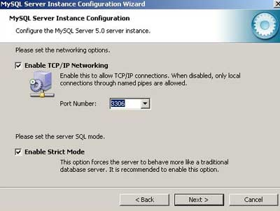
Fig. 31 - Leave two options checked and port number as 3306 and click next.
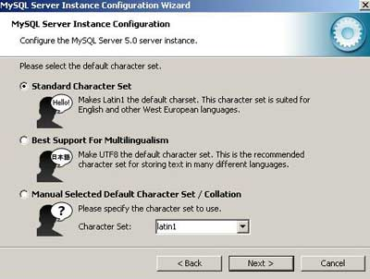
Fig. 32 - Select Standard character Set and click next.
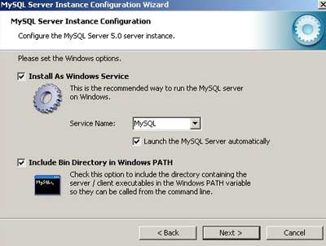
Fig. 33 - Select Include Bin Directory in Windows PATH and leave other options as default. Click next.
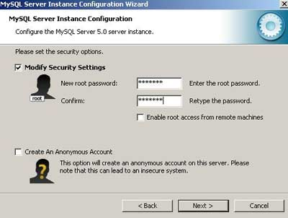
Fig. 34 - Tick Modify Security Settings and type in a password you want to use to access MySQL server, then click next.
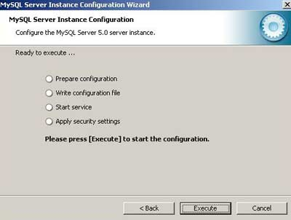
Fig. 35 - Click Execute to apply configuration settings.
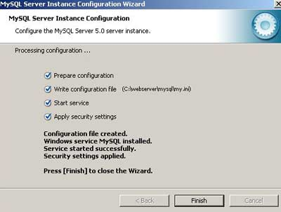
Fig. 36
Click Finish to exit configuration wizard.
The last thing you need to do is to open php.ini file located in C:\webserver\php and uncomment the line extension=php_mysql.dll by removing semicolon ; at the beginning. Save the file and close it. Restart the computer.
This way you have completed your installation and you are now ready to start developing your web applications using Apache, PHP and MySQL.
Good Luck!

