Working Title: “Before Dark”

Game Design Document

Published by: React Gaming

Things to decide on:

Kid’s name: Pablo

Kid’s age: 9

Summary

“Before Dark” is a 3D third-person action-based puzzle platformer game which follows an imaginative young kid through an afternoon at the local neighborhood park. Pablo, the hero of our game, has one simple goal: get back home before the sun goes down with all his groceries. The experience of “Before Dark” revolves around the horizon that exists between Pablo’s active imagination and the real world. Help Pablo find remarkable weapons, defeat his foes, recover the milk, and return safely home before the sun sets and the neighborhood streetlights come on. “Before Dark” will run on PC both browser-based through itch.io, and locally by downloading the game from our GitHub.

Group

* Mike Gee is the group’s leader. He manages the project’s progress and quality while supporting the programmers.
* Angel Martinez is the lead artist and designer of character art as well as SFX, music, and voice.
* Bram Metz is the lead artist and designer of game environment and art style direction.
* Jordan Mese is a programmer specializing in design of mechanics.
* Courtland Crouchet is a programmer specializing in website design.
* Leopold Frilot is a programmer focusing on documentation.

Characters

* Pablo is the main character of the game and the character you will be playing as. He is the righteous protector of mankind, sworn to protect his land from evil. Well, at least that’s what he would tell you. Pablo is a dutiful, resourceful, 9yo kid playing at the local park. With a stick in his hand and a snack in his pocket, he vows to complete his mother’s quest.
* The older brother is the driving force of the game. He presents Pablo with his main “quest” at the beginning of each playthrough and reminds Pablo that he needs to return before the streetlights turn on at regular intervals. The older brother also gives the level specific quest to find something located in one of the areas of interest in the park.
* The homeless man blocks passage to the next level. The homeless man likes to play along with Pablo’s imaginary world and tells him what he needs to continue to the boss of the level. He is represented physically sitting on a park bench and will move the bench once Pablo has the necessary requirements.

Setting

The game takes place in a neighborhood suburban park. The afternoon sun casts a soft orange glow over the large grassy area. The park is vast landscape with hills, trees, boulders, playground equipment, water fountains, winding sidewalks, and a few park benches which the homeless man likes to populate. Each “level” will be a different section of the park sectioned off by impassable terrain and the homeless man which guards the entrance to the next level. As Pablo traverses through the levels, he will come closer and closer to the main road which leads him back home. Meanwhile, time will pass, and light will dim, turning the pleasant afternoon shadows into something almost sinister.

Narrative

The story behind “Before Dark” is simple. Pablo, a 9yo boy, is playing in the park while his older brother watches over him. It’s getting late and the older brother reminds Pablo that they need to return home before it gets dark with all the groceries they had bought earlier in the day. Pablo turns this message into his own heroic quest. He grabs a stick and ventures forth through the park to find the groceries he had lost so that they may return home before the sun goes down and the streetlights turn on.

Core Game Loop

The player will appear at the start of the level and be told what to find by the older brother. The player will explore the area looking for the object, fighting “enemies” off along the way and finding “items” to help him on his journey. The player will then talk to the homeless man and be allowed into the boss room. After defeating the boss, the next level will start. After losing all health, the player will respawn at the beginning of the level, but time will continue. This will repeat until he has made it to the sidewalk or time has run out.

User Experience

The main experience we are trying to achieve is skill expression and exploration. Skill expression will be through dodging enemy attacks and punishing hard with the given window of opportunity. A sense of exploration will come about by hiding items well throughout the level and giving the player interesting platforming to try and be rewarded for.

Mechanics

The player will be able to…

* walk, sprint, and jump in a 3D plane.
* attack enemies.
* pick up items which alter the character’s stats and appearance and add them to an inventory system. <-- MAYBE NOT!
* pick up consumables for health gain and damage buffs.
* pick up the required items for completing the level.
* be stopped by “hazardous” terrain when lacking proper gear.
* Overcome certain terrains when certain items are equipped.
* watch a timer which shows the time of day in game.
* talk to the homeless man.

Dynamics

At the beginning, enemies will be weak and sporadic. There will be a sense of calm as you explore the forest area. The sounds of birds chirping, and other soothing ambient sounds will play periodically. The player will find items throughout the level which will buff him permanently and give him access to new areas previously impossible to reach. However, as time passes, the sun will sink lower and lower. The light color and amount will change accordingly.

Enemies/bosses’ stats will grow, maybe size too, and normal enemies will become more numerous. Naturally, with the sun lowering, shadows will grow longer, volume of ambient sounds of calm will be lowered, and volume of ambient sounds of stress(insects, frogs, etc.) will be heightened. Each progressive level should have different types of enemies with attacks that are more difficult to deal with.

Enemies

Normal Enemies

* Goblins
  + Level found: 1
  + Goblins are the first enemy the player will encounter in “Before Dark.” They are quick but weak both in health and strength.
  + They have one attack which has them run up to you, pull back their arm, and then stab forward.
  + They don’t scale very hard with sun height.
* Zombies
  + Level found: 1 and 2
  + Zombies are slow and stupid; however, they are quite healthy and hit very hard as the sun goes down
  + They have one attack which is a meaty swipe with their arms. The attack has a lot of windup but could kill Pablo outright if hit later in the day.
  + Scales really well in terms of power, not so much health wise.
* Ghosts
  + Level found: 2 and 3
  + Ghosts are more of a supportive enemy, they slowly float above the ground and try to stun Pablo with a scream. Once stunned, they will try to come in for a low damage swipe.
  + One main attack which is an AOE scream whose hitbox will be displayed some kind of way. This stuns Pablo for x number of seconds which scales with sun height. The secondary attack is a low damage swipe which the ghost will try to do after it successfully stuns Pablo.
  + Scales poorly except stun duration.
* Robots
  + Level found: 2
  + Robots walk rather quickly, but don’t do much of it as they prefer to camp and snipe Pablo with their arm cannon.
  + Robots have one attack which is their arm cannon blast. The range is not huge, but its wide cone make it tough to dodge.
  + Robots scale normally in all elements; they are essentially the base case.
* Spiders
  + Level found: 3
  + Spiders are very quick and have a larger detection radius than normal. They don’t hit very hard, but their attack has a very short cooldown.
  + Their only attack is a melee range bite which has a short windup, and even shorter cooldown.
  + Damage and Health scale poorly, but the amount of them scales well with sun height.
* Wolves
  + Level found: 3
  + The big baddies of the park, wolves are healthy, deal good damage, and are relatively quick. They are a bit more rare than the other enemies.
  + Their attacks include a charge, a bite, and seldomly a howl which debuffs Pablo in some way.
  + Damage, health, and cooldown scale particularly well.

Bosses

* Paco The Clown
  + The first boss of the game. Pablo hates clowns. He thinks they are stupid.
* Dr. Dentist
  + The second boss of the game. A horrifying entity that represents shots from the  doctor and visits to the dentist. Expect a lot of drills and needles.
* Shadow Boss
  + Final boss of the game. What’s more evil than darkness itself? Try not to encounter it too close to when the streetlights come on, as it scales strongly with sun height.

Level Design

* Level 1: Forest
  + Tress, hidden passages, and obstacles
  + Pit falls, quicksand like mud, and puddles that require
  + The hidden boots to cross the puddles and reach boss room, also eggs, and gloves
  + Exploration, quick reflexes, and puzzle solving
* Level 2: Playground
  + Playground equipment, hills, sidewalks, slides, and tunnels
  + Roaming enemies, not as many environmental hazards
  + Hidden sword and milk
  + Exploration, combat, questing, and rewards
* Level 3: Suburb
  + Building, alleyways, and possible house entry
  + Enemies, possibly moving vehicles
  + The remaining groceries
  + Game completion, and discovering who the final boss is

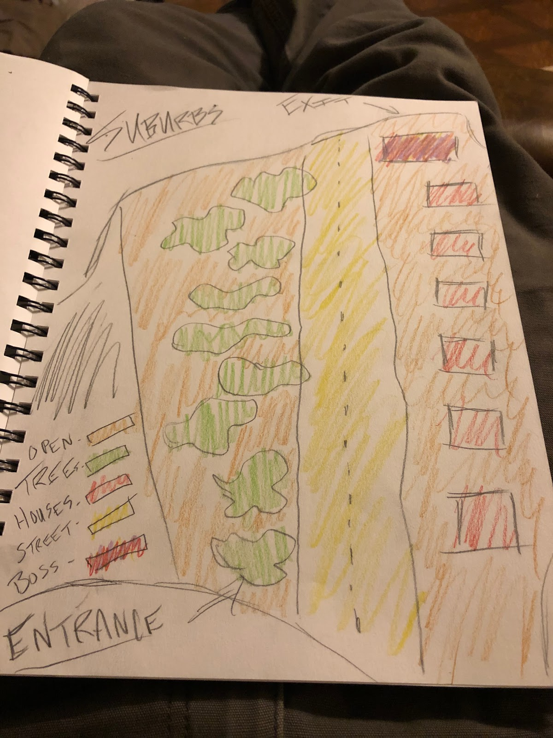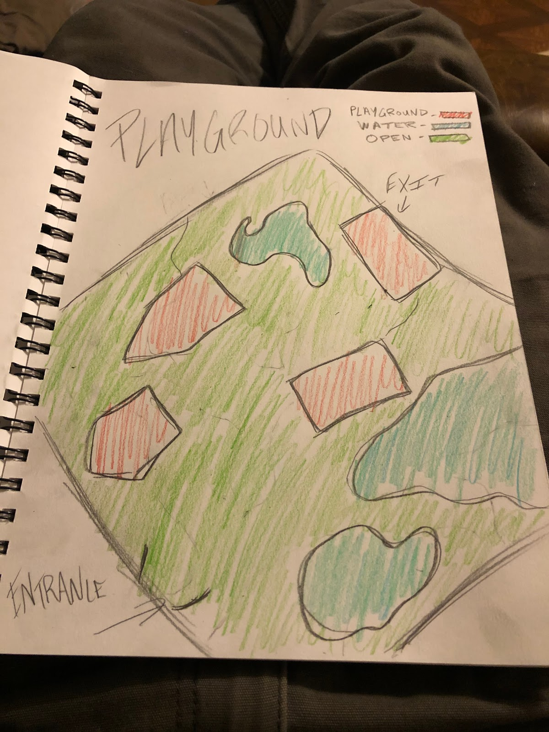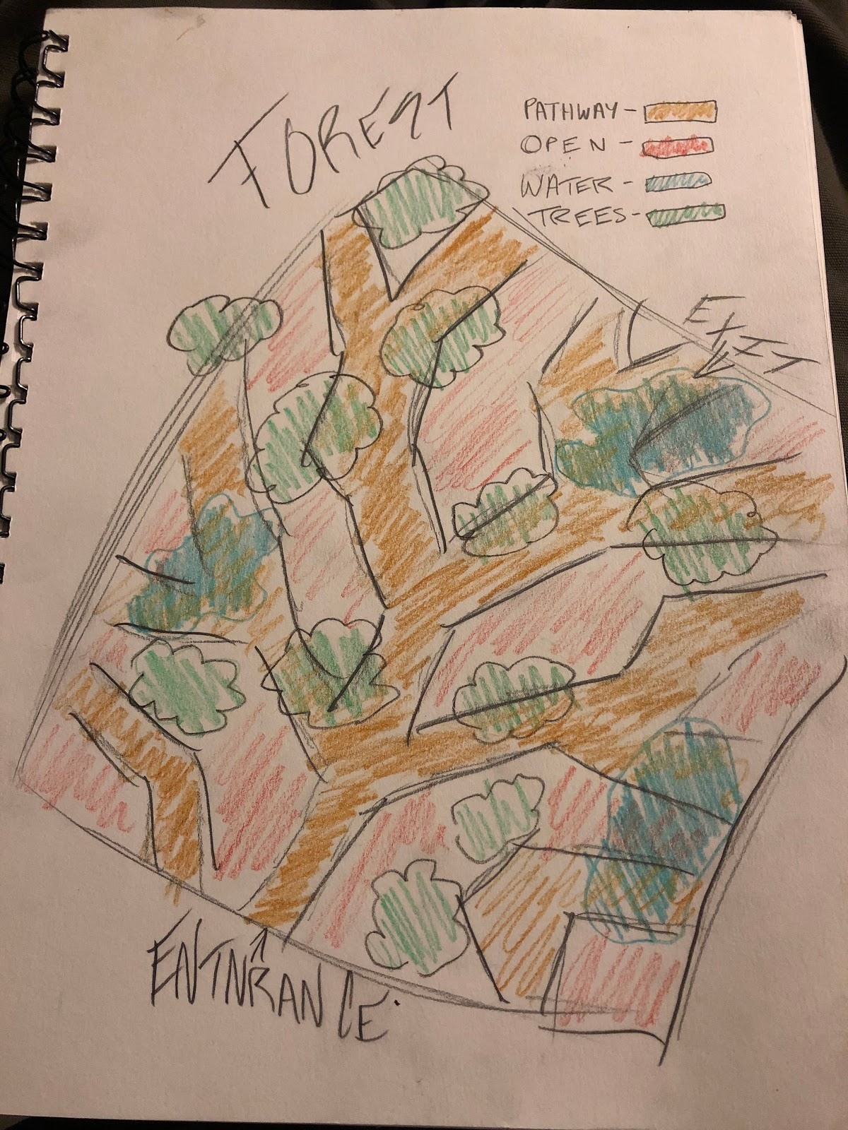

We decided to lean towards an open world format that will include loading screens between each level. A good example for this style would be kingdom hearts. At the beginning of the level, the player will be prompted to an objective they must complete before being able to access the end of the level. As an example, the player must collect rain boots to get across water, then being able to access an enemy fight to progress to the next level.

Art

We wanted to go with a simple, cell shaded style similar to Risk of Rain 2 and Breath of the Wild. One that is pleasing to look at while not being too complicated in nature. Although the design features use of lower polygon models, we are not looking towards the direction of the low-poly aesthetic where hard edges are clearly defined and noticeable. The simplistic style matches the imaginative nature of an innocent boy fighting imaginary monsters.

UI/Game Controls

/UI/HUD:

* There will be a “clock” on the top right and a health bar on the top left.
* Potentially a stamina bar beneath the heath bar
* Icon showing item currently equipped
* Inventory menu on pause screen. Select the icon of the item to equip.

Controls:

* Wasd movement. Potentially keyboard movement
* Space for jump
* Left click and right click for sword swing 1 and 2 at minimum
* // Interact button “E”?
* // Use item button “F”? middle mouse button?
* // Roll button shift?
* Pause button Esc

Audio

At the start, the music is quiet, relaxing, and pleasant as there is little threat to the main character. When the player progresses to the different levels, there will be subtle increases to the soundtrack’s intensity as the monsters grow more threatening and difficult. The final boss features an epic hardcore song that serves as a climax to the main character’s adventure before fading away with only ambient noises heard from the surrounding neighborhoodr. Sound effects are short and simple, capturing the expressiveness of the main character and allowing the player to feel immersed into the world.

Target Audience

This game aims to target an older crowd. “Before Dark” can be unsettling since it is an exploration game with a time constraint. This constraint is rather stressful since not only does it serve as a lose condition, but also it serves to strengthen the enemies. Players should be able to pick up on environmental clues, manage their time well, slay their enemies efficiently, and make it home with time to spare.

Target Device/Platform

PC at first, but open to console development as well in the future

Development Plan

The main development plan is to meet phase one of the project submission then move onto phase two which will focus on implementing the game. Phase one includes a company website, with our company name, team members, and a general idea of what the game is about. Presentation slides will be also be put together to give players a general idea of what to expect before the game is implemented. Concept art will be made, along with a story board including different characters, enemies, and environments of how the game will look, and feel to help with phase two. An OPPM sheet will be documented and dated to keep team members organized, and to meet goals in a timely fashion.  Furthermore, this design document containing the main components of the game mechanics, and inner workings will be used as a reference when implementation begins. In phase two, team members will work on separate aspects of the game while keeping one another updated on what’s being done. Artist will work on taking the previously made concept art and turning it into 3D models which the programmers can then import into the game. Music will also be implemented to give players a more immersive experience. Programmers will collaborate on making sure the game is bug free and enjoyable for all players. We plan on applying the agile process method, with group meetings every so often, and then working on implementing the ideas that were discussed during the meetings. GitHub will be used so all team members can work on the same project more efficiently without having to send files. Phase three will be adding the final touches to the game and getting the game ready for release. This will include doing several play throughs and making sure everything is working as it should.

Experimental Features to Try/Have Implemented

* Inventory system
* Many different attacks
* Many different enemies
* Enemy AI