**EXERCISE – VI**

**DATA FRAMES**

1. **Create the following data frame**

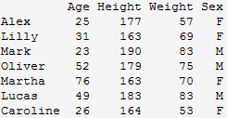

**a) What are the Names of Students?**

**b) Find the Mean Height of Students and Weight of Students.**

**c) Find the Standard Deviation of Height and Weight of Students.**

**d) Find the number of Male and Female Students.**

**Ans:**

**> x=data.frame(name=c("Alex","lilly","Mark","oliver","Martha","Lucas","Carolina"),Age=c(25,31,23,52,76,49,26),HEight=c(177,163,190,179,163,183,164),Weight=c(57,69,83,75,70,83,53),Sex=c("f","f","m","m","f","m","f"))**

**>x**

**name Age HEight Weight Sex**

**1 Alex 25 177 57 f**

**2 lilly 31 163 69 f**

**3 Mark 23 190 83 m**

**4 oliver 52 179 75 m**

**5 Martha 76 163 70 f**

**6 Lucas 49 183 83 m**

**7 Carolina 26 164 53 f**

**>x$name**

**[1] "Alex" "lilly" "Mark" "oliver" "Martha" "Lucas" "Carolina"**

**> mean(x$HEight)**

**[1] 174.1429**

**> mean(x$Weight)**

**[1] 70**

**>sd(x$HEight)**

**[1] 10.89998**

**>sd(x$Weight)**

**[1] 11.7047**

**>table(x$Sex)**

**f m**

**4 3**

**EXERCISE – VII**

**LISTS**

1. **If: p <- c(2,7,8), q <- c("A", "B", "C") and x <- list(p, q), then what is**

**the value of x[2]?**

**Ans:**

**> p<-c(2,7,8)**

**> q<-c("A","B","C")**

**> x<-list(p,q)**

**>x[2]**

**[[1]]**

**[1] "A" "B" "C"**

1. **If: w <- c(2, 7, 8) v <- c("A", "B", "C") x <- list(w, v), then which R sta**

**tement will replace "A" in x with "K".**

**Ans:**

**> w<-c(2,7,8)**

**> v<-c("A","B","C")**

**> x<-list(w,v)**

**>x[[2]][[1]]="K"**

**>x**

**[[1]]**

**[1] 2 7 8**

**[[2]]**

**[1] "K" "B" "C"**

1. **If a <- list ("x"=5, "y"=10, "z"=15), which R statement will give the**

**sum of all elements in a?**

**Ans: > a<-list("x"=5,"y"=10,"z"=15)**

**>sum(a$x,a$y,a$z)**

**[1] 30**

1. **Consider y <- list("a", "b", "c"), write an R statement that will**

**assign new names "one", "two" and "three" to the elements of y.**

**Ans:**

**> y<-list("a","b","c")**

**>y[[1]]="one"**

**>y[[2]]="two"**

**>y[[3]]="three"**

**>y**

**[[1]]**

**[1] "one"**

**[[2]]**

**[1] "two"**

**[[3]]**

**[1] "three"**

1. **If x <- list(y=1:10, t="Hello", f="TT", r=5:20), write an R statement**

**that will give the length of vector r of x.**

**Ans: > x <- list(y=1:10, t="Hello", f="TT", r=5:20)**

**>length(x[[4]])**

**[1] 16**

**>length(x$r)**

**[1] 16**

1. **Let string <- "Grand Opening", write an R statement to split thisstring into two**

**Ans:> string="grand opening"**

**> split=strsplit(string," ")**

**> split**

**[[1]]**

**[1] "Grand" "opening"**

**>li=list(split[[1]][1],split[[1]][2])**

**>li**

**[[1]]**

**[1] "Grand"**

**[[2]]**

**[1] "opening"**

1. **Let: y <- list ("a", "b", "c") and q <- list ("A", "B", "C", "a", "b", "c").**

**Write an R statement that will return all elements of q that are not in y**

**Ans:> y<- list ("a", "b", "c")**

**> q<- list ("A", "B", "C", "a", "b", "c")**

**>setdiff(q,y)**

**[[1]]**

**[1] "A"**

**[[2]]**

**[1] "B"**

**[[3]]**

**[1] "C"**

**EXERCISE- VII**

**CONDITIONAL CONTROL STRUCTURES**

1. **Program to check the leap year or not.**

**Ans:**

**year=as.integer(readline(prompt="Enter year"))**

**if(year%%4==0 || year%%400==0 && year%%100!=0){**

**print(paste(year,"is leap"))**

**}else{**

**print(paste(year,"is not leap"))**

**}**

**Output:Enter year2021**

**[1] "2021 is not leap"**

1. **Find the Factorial of a given Number.**

**Ans:x=as.integer(readline(prompt="Enter the limit."))**

**f=1**

**if(x==0){**

**print(paste("factorial of0 =1"))**

**}else{**

**for(i in 1:x){**

**f=f*i**

**}**

**print(paste("Factorial=",f))**

**}**

**Output: Enter the limit.5**

**[1] "Factorial= 120"**

1. **Check whether the given number is Even or Odd.**

**Ans:**

**num=as.integer(readline(prompt="Enter a no"))**

**if((num%%2==0)){**

**print(paste(num,"is even"))**

**}else{**

**print(paste(num,"is odd"))**

**}**

**Output:Enter a no5**

**[1] "5 is**

**EXERCISE- IX**

**ITERATIVE CONTROL STRUCTURES**

**FOR LOOP**

1. **Program to count the number of even numbers in a vector.**

**Ans: x=c(2,3,4,5,6)**

**for(i in 1:5)**

**if(x[i]%%2==0){**

**print(paste(x[i]))**

**}**

**Output:[1] "2"**

**[1] "4"**

**[1] "6**

1. **Program to Check Whether the given number is prime or not.**

**Ans:num=as.integer(readline(prompt="Enter the number"))**

**c=0**

**x=num**

**for(i in 1:num){**

**if(num%%i==0){**

**c=c+1**

**}**

**}**

**if(c==2){**

**print(paste("is prime"))**

**}else{**

**print(paste("is not prime"))**

**}**

**Output: Enter the number2**

**[1] "is prime"**

1. **Program to display multiplication table.**

**Ans:**

**num=as.integer(readline(prompt="Enter the num"))**

**for(i in 1:10){**

**print(paste(num,"x",i,"=",num*i))**

**}**

**Output: Enter the num2**

**[1] "2 x 1 = 2"**

**[1] "2 x 2 = 4"**

**[1] "2 x 3 = 6"**

**[1] "2 x 4 = 8"**

**[1] "2 x 5 = 10"**

**[1] "2 x 6 = 12"**

**[1] "2 x 7 = 14"**

**[1] "2 x 8 = 16"**

**[1] "2 x 9 = 18"**

**[1] "2 x 10 = 20"**

**EXERCISE- X**

**ITERATIVE CONTROL STRUCTURES**

**WHILE LOOP**

1. **Check whether the given number is Arm strong number or not.**

**Ans:** **num=as.integer(readline(prompt="enter number"))**

**r=0**

**rev=0**

**x=num**

**while(num>0){**

**r=num%%10**

**rev=rev+(r*r*r)**

**num=floor(num/10)**

**}**

**if(rev==x){**

**print(paste(x,"and",rev))**

**print(paste("the number is armstrong"))**

**}else{**

**print(paste("not armstrong"))**

**}**

**Output: enter number101**

**[1] "not armstrong"**

1. **Find sum of natural numbers without formula.**

**Ans:** **num=as.integer(readline(prompt="enter a number"))**

**i=1**

**s=0**

**while(i<=num){**

**s=s+1**

**i=i+1**

**}**

**print(paste("sum=",s))**

**Output:**

**enter a number5**

**[1] "sum= 5"**

1. **Program to print the Fibonacci Series**

**Ans: a1=0**

**a2=1**

**a3=0**

**i=1**

**num=as.integer(readline(prompt="enter the limit"))**

**print(paste("0"))**

**print(paste("1"))**

**while(i<=num-1){**

**a3=a2+a1**

**a1=a2**

**a2=a3**

**print(paste(a3," "))**

**i=i+1**

**}**

**Output:**

**enter the limit0**

**[1] "0"**

**[1] "1"**

**EXERCISE- XI**

**R BAR PLOT**

1. **Let us suppose, we have a vector of maximum temperatures (in degree**

**Celsius) for seven days as follows.**

**Max.temp: 22, 27, 26, 24, 23, 26, 28**

**make a vertical bar plot out of this data.**

**make a horizontal bar plot out of this data with some parameters**

**Ans:**

**temp=c(22,27,26,24,23,26,28)**

**barplot(temp,xlab="day",ylab="tempreture",main="temp per day")**

**Output:**

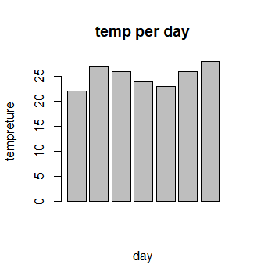

**temp=c(22,27,26,24,23,26,28)**

**barplot(temp,xlab="tempreture",ylab="day",main="temp perday",horiz=TRUE)**

**Output:**

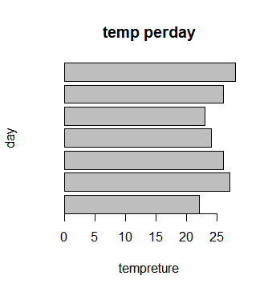

**2.Plotting Categorical Data**

**A vector of age of 10 college students given below**

**age <- c(17,18,18,17,18,19,18,16,18,18).create bar plot with some parameters**

**Ans: age<-c(17,18,18,17,18,19,18,16,18,18)**

**barplot(age,xlab="students",ylab="age",main="Ages of students")**

**Output:**

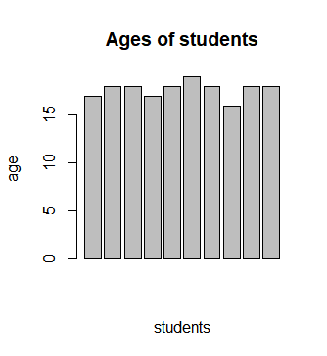

**EXERCISE- XII**

**R PIE CHART**

**3.Let us consider the below data represents the monthly expenditure breakdown of an individual.**

**>expenditure**

**Housing Food Cloths Entertainment Other**

**600 300 150 100 200**

**draw a simple pie chart out of this data**

**Draw Pie chart with additional parameters**

**Ans:**

**x=c(600,300,150,100,200)**

**labels<-c("Housing","food","cloth","Entertainment","other")**

**pie(x,labels,.ain="Expenditure")**

**Output:**

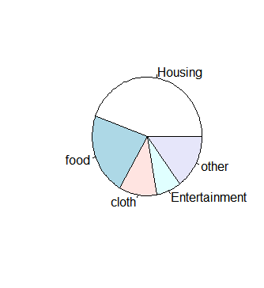

**x=c(600,300,150,100,200)**

**labels<-c("Housing","food","cloth","Entertainment","other")**

**pie(x,labels,.ain="Expenditure",col=rainbow(length(x)))**

**Output:**

