By: Cameron Fenton, Matthew Lepain, Timothy Patton, and James Kerr

Step One - Problem Definition:

The application that we plan to make will be called *Resource Database*, it will be an android application that will be used for teachers to sign out school resources such as but not limited to; Netbook carts, classrooms, library, musical instruments and computers. And for students to check the availability of the school library books and to see their scheduling for when their classes are booked for computer time. It will be an android application which will implement the Camera as a scanner using the zxing open source android library to read QR codes and Bar scanner which will read a String of characters which will be stored in the database and attached to its item. For example the music teacher at your school is signing out an instrument they sign in to the app they can point the camera at the barcode or QR code on a book and assign it to a student's name, with a Boolean value of signed out as true, then when the student wishes to return the instrument, the librarian or music will assign the value of signed out false to that instrument. A calendar function the target audiences, for the application, our intended end-users are librarians, music teachers, school department heads, general teachers, students. The calendar would be a visual displaying hours of each day including each period divided up into its own block which would colour red when a resource is booked and turn green when available. The administrator, librarian or music teacher will have the option to change when each period starts and ends to accommodate different schools schedules and shortened vacation or PA days.

Step Two - Problem Analysis:

Hardware Required: Android Phone running 4.0+ (API Level 14+), 16MB-32MB of free RAM. About 90.4% of android devices are in this range so it shouldn't be a concern. The app will run on android devices from 2.3 - 4.0 (API Levels 9 - 14) with a slightly more basic layout. User Training: We'll have a user manual and popup hints on the first run of the program, this will allow a quick and interactive experience which will help with the learning curve associated with first use. Recommend Age: The recommend age would be students (14-19) who have android phones. It would also be useful for teachers too. Time to learn: The time to learn the program should be pretty short because of the popups for user training and the ease of use of a QR code scanner. Costs: Free. User Cost: Free as the assignment requires it to be so.

Step Three – End User Requirements:

Interview Info:

Mr. Nasim - ICS4U Teacher, Clarington Central Secondary School, KPRDSB (April 7th, 2015)

-already have a school board wide library system would be difficult to replace (but it would save them money)

-to fix this make it more generalized, work for more resources than just books

-no one is going to want to attach or codes to thousands of books just to change systems

Mrs. Shaw - Music Teacher, Essex District High School (March 2nd, 2015)

-use for cataloguing instruments and signing them in and out

-would be really helpful

-make the job much easier and save time

Mr. McKinnon – Librarian, Essex District High School (March 2nd, 2015)

* General Advice and feedback on the concept

Mr. Werry - Librarian, Clarington Central Secondary School, KPRDSB (April 30th, 2015)

-already have a school board wide library system would be difficult to replace (but it would save them money)

-focus app to replace netbook cart and classroom sign out system, current one has an inefficient layout and costs too much

-If it uses a simpler layout it would be helpful

-current system has useless functions such as letting

-use a calendar based system with requests via email

-allows for admin to deny / revoke a specific teachers access to a resources

-allows for teachers to see which resources are already booked

-thinks QR codes is not good for signing resources back in because there is not always a staff member in the library to do so

-An email system for reminding teachers the morning of their use of a resource so they don’t forget, also that notifies them if their request for a booking has been cancelled, denied, or revoked by an admin

Our overall reception of the feedback is that QR codes and barcodes would take too long to use on books, and would not work for netbook carts or classrooms. Music teachers like the idea of using QR codes for keeping track of instruments. That the application needs to be free. Make it adaptable to a wide range of resources. A calendar for displaying when teachers have classrooms and netbook carts, etc. booked out so that teachers can plan around each other, and have a schedule on hand to keep track of when they are booked for each resources.

Step four – Software Project Plan

1. Statement of Work (SOW)

As a Group

-Main Class that connects everything (Encapsulation)

-Database, setting it up, this will be in use during the applications lifetime when in use by the end-user. And helping each other with its integration into Tim’s login page and James resource calendar which will need access to it for determining if a resource is or isn’t currently booked or signed out for a specific data and time

-Android class for Database Access

Cameron Fenton

- Android class to run scanner (QR (Quick response) code / Barcode Scanner) and retrieve stringed data

Algorithm Pseudocode: Create instance of android activity, display buttons for opening scanner, and display text instructions, on Click of the button create instance of QR/Barcode scanner, request android permission for camera use, camera is displayed, user points rear-facing camera at the QR or Barcode to be scanned, scanner class returns value contained in code in form of a string of characters, send to database class, close class and create new instance of previous class in app, terminate scanner class

- Website Development, managing the site. Completed, <https://datamanagementsolutionsapp.wordpress.com/>

-Our GitHub repository where we store our files, for use throughout entire project https://github.com/cameronfenton/resourcedatabase

James Kerr

-Android resource availability calendar and a way to send and read data from the database

- GUI and framework, ongoing throughout the project

Matthew Lepain

-App Icon Development

Algorithm:

* generate QR code image
* create multiple sketches
* take best sketches and turn them into a finished product in Photoshop
* have group member and potential users vote on their favourite design

-User Manual (README)

Algorithm:

* build version
* copyright information
* instruction to grab the documentation
* instruction to install, configure and run the program
* instructions to submit bugs, features requests, submit patches, join mailing list, get announcements, or join the user or dev community in other forms
* Other contact info (email address, website, company name, database address, etc.)
* legal notices (crypto stuff)

“<http://stackoverflow.com/questions/2304863/how-to-write-a-good-readme>”

* explain purpose of the app
* explain in detail the interface and functions of the app
* create a step by step instruction of basic use of the app

NOTE: Should contain everything you want the user to know before running the software

Tim Patton

-Android class including login Page, admin, teacher, or student

-Android class to search available resources

B. Resource List (Group):

-Internet Access, Database, Website, Android phones running at least Android 4.0+ (API Level 14+) for admin and all other end-users, printer access to print off QR and barcodes, an administrator of sorts, a music teacher, librarian, someone to administrate who is allowed to access which resources and when.

C. Work Breakdown (Group): The website is complete. The android app Icon is complete, any touches up or changes to it will only take one to two days, one for changes and the other for us to all come to an agreement on changes made. The Login page class with a system to separate between students and teachers will take five days to make, one for the interface, one for its algorithm, and three to integrate it into our database accessible class.

D. Project Schedule (Group): Our project schedule will be organized by Gantt Charts, see Gantt charts below. Our goal is to complete the interfaces early on so we can agree on a look and feel to the application and then as we progress on the project integrate in everyone’s individual java class files, such as the calendar, login algorithms, database accessible class, QR scanner, user manual pages, app icon, and user-friendly pop up messages. The app icon and scanner are currently ready to go in and as soon as we have built the framework which is our first step, we can start designing an interface and adding in the app icon and scanner. The login algorithms can be started on early however they will need to be adjusted to access the database once it is ready, which we are currently researching as a group on how to set up now. However they can be tested with separate variables for username and passwords specific to each type of end-user while the algorithms are being made. The search and calendar classes will have to be the last of the algorithms to be made as they depend on the database the most. Testing and bug fixing will be our 2nd last task, it is hard to estimate the amount of time it will take to complete testing, we plan on having some of our interviewees try the app out in a mock up situation. Reflection report will come last after or during our completion of testing.

E. Risk Plan (Group): Potential risks include us not being able to successfully set up a database and integrate it into our app. We will have to use our own server and pay for one ourselves with money out of our pockets or we will have to distribute the information back and forth through an email system or host the server ourselves.

Gantt chart:

|  |  |  |  |  |  |  |  |  |  |  |  |  |  |  |
| --- | --- | --- | --- | --- | --- | --- | --- | --- | --- | --- | --- | --- | --- | --- |
| **Project Title:** | Resource Database |  |  | |  | | --- | |  | |  |  |  |  |  |  |  |  |  |
| **Programmer's Name:** | Group |  |  |  |  |  |  |  |  |  |  |  |  |
| **Date:** | 24/04/2015 |  |  |  |  |  |  |  |  |  |  |  |  |
|  |  |  |  |  |  |  |  |  |  |  |  |  |  |
|  |  |  |  |  |  |  |  |  |  |  |  |  |  |
| **SubTask** | **Start Time** | **Length of Task** | **Progress %** |  |  |  |  |  |  |  |  |  |  |
| Scope Document | 1 | 0 | 100 |  |  |  |  |  |  |  |  |  |  |
| Feasibility Study | 0 | 0 | 0 |  |  |  |  |  |  |  |  |  |  |
| Introduction / Login Screen | 0 | 0 | 0 |  |  |  |  |  |  |  |  |  |  |
| Search Screen | 0 | 0 | 0 |  |  |  |  |  |  |  |  |  |  |
| QR/Bar Code Scanner | 2 | 0 | 100 |  |  |  |  |  |  |  |  |  |  |
| Database Reader | 0 | 0 | 0 |  |  |  |  |  |  |  |  |  |  |
| Android App Logo | 2 | 0 | 100 |  |  |  |  |  |  |  |  |  |  |
| User Guide | 0 | 0 | 0 |  |  |  |  |  |  |  |  |  |  |
| Application Encapsulation | 2nd last | 0 | 0 |  |  |  |  |  |  |  |  |  |  |
| Testing&Reflection Report | last | 0 | 0 |  |  |  |  |  |  |  |  |  |  |
|  |  |  |  |  |  |  |  |  |  |  |  |  |  |
|  |  |  |  |  |  |  |  |  |  |  |  |  |  |
|  |  |  |  |  |  |  |  |  |  |  |  |  |  |
|  |  |  |  |  |  |  |  |  |  |  |  |  |  |
|  |  |  |  |  |  |  |  |  |  |  |  |  |  |
|  |  |  |  |  |  |  |  |  |  |  |  |  |  |
|  |  |  |  |  |  |  |  |  |  |  |  |  |  |

Screenshots and application:

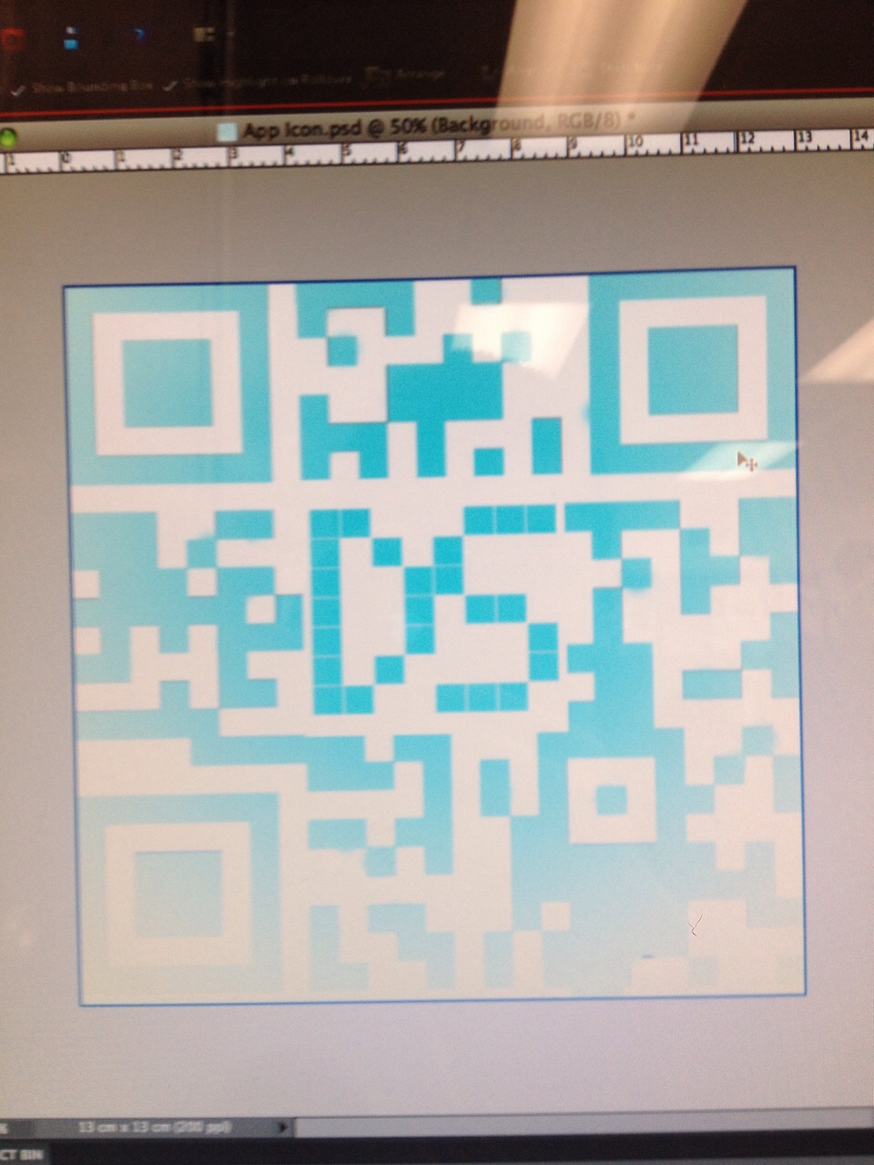 Logo by Matthew Lepain, Early app screenshots by Cameron Fenton

