**DATABASE MANAGEMENT SYSTEMS LAB**

NAME-LEPAKSHI JAGMOHAN

SAPID-500119039

RNO-R2142230040

BATCH-2

**Experiment 17**

**To understand the concepts of Trigger.**

**1. CREATE TRIGGER SALARY_VIOLATION BEFORE INSERT OR UPDATE OF SALARY, SUPERVISOR_SSN ON EMPLOYEE of experiment 3.**

**INPUT:**

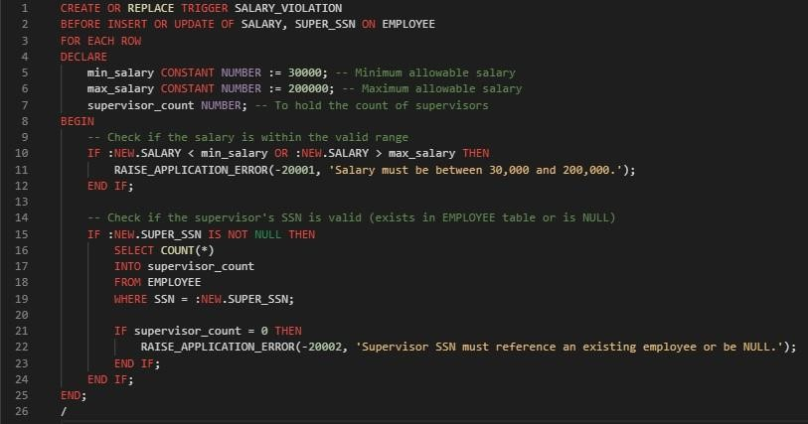

**Valid Insert:**

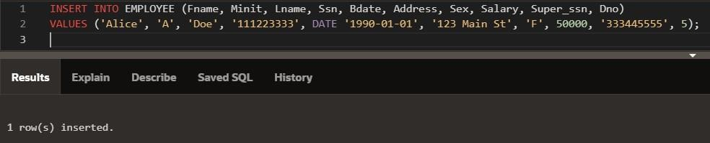

**Invalid Insert:**

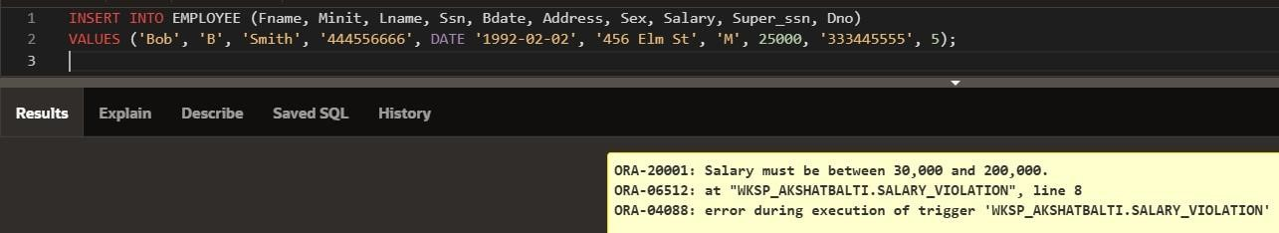

**Invalid Update:**

