AZURE - Created VM / Connected via RDP

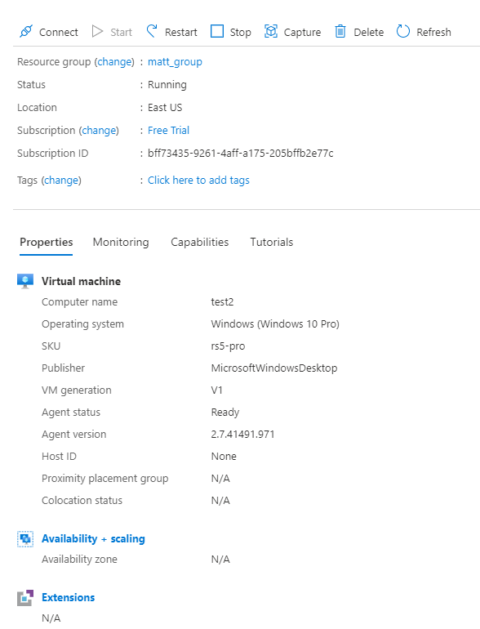

**POWERSHELL**

**Installing Azure repos to access Azure on local pc -**

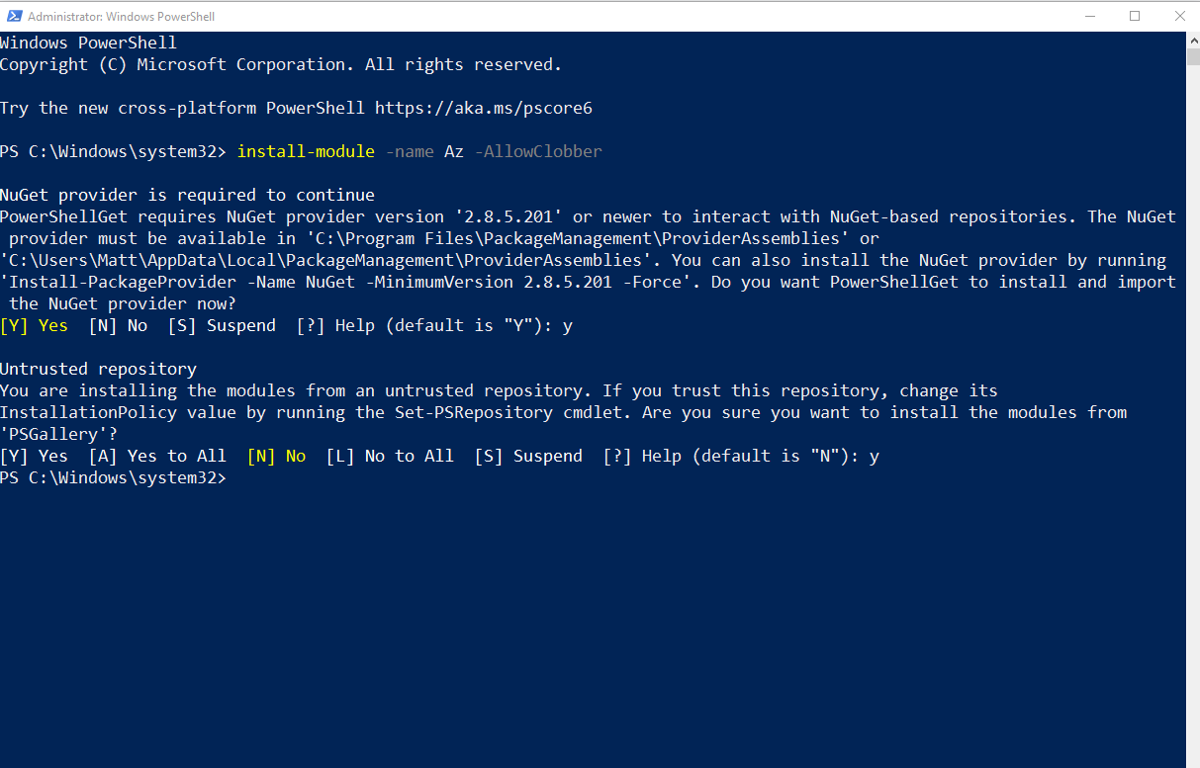

Problem solving -

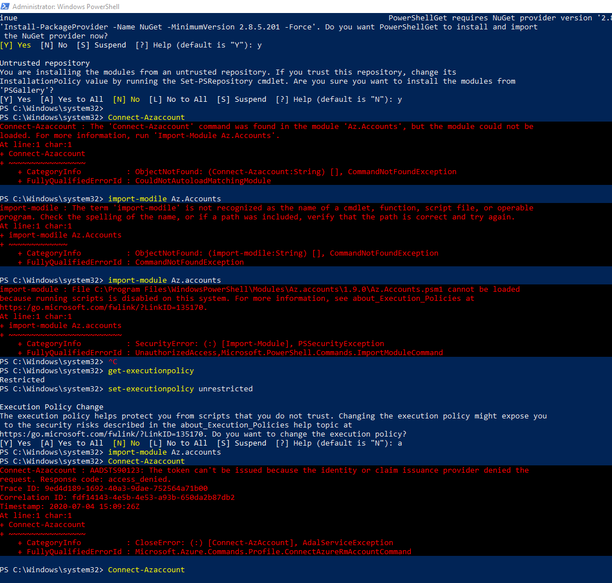

Logging into VM 1

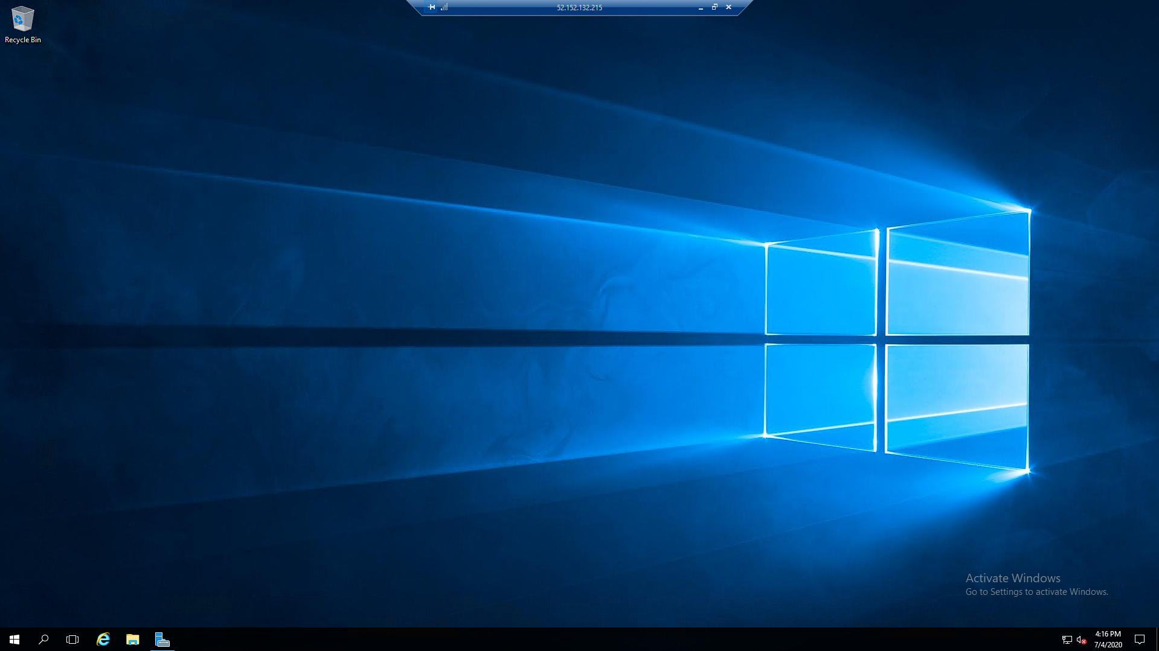

**INTUNE**

1. Successfully created device policies with notifications (password length, firewall) for Windows 10 devices. Created MDM Push Certificate with Apple. Created Android policies + tested user login on mobile.
2. User login from Android Device-

