DESIGN THE CONTROLLER AND MODELLING OF THREE-WHEELED OMNIDIRECTIONAL MOBILE ROBOT

Le Duc Phap Anh, Le Quang Canh, Tran Minh Hiep, Dang Quang Vinh

Department of Mechatronics, HCMC University of Technology and Education, HCMC, Viet Nam

Subject: Autonomous Vehicles and Mobile Robot, Lecturer: Dr. Ha le Nhu Ngoc Thanh

# Abstract

Omnidirectional mobile robots are holonomic vehicles that can perform translational and rotational motions independently and simultaneously. The paper provides a detailed mathematical analysis of the motion of a three-wheeled omnidirectional mobile robot, leading to the robot's kinematics. The paper also addresses the problem of trajectory tracking, in which the robot must track the desired trajectory while also tracking the desired orientation, let to the controller design. To demonstrate the efficacy of the proposed approach, a simulation platform was created using MATLAB, and then will being test this model in realistic - real omnidirectional mobile robots.

# I. Introduction

These days, mobile robots are becoming more and more popular because they can be used in a variety of settings, including on land, in the air, and underwater. Based on their mobility, wheeled mobile robots can be categorized as either holonomic or non-holonomic. Robots that resemble bicycles, tricycles, differential drives, and cars are examples of non-holonomic robots. A system having the same number of actuations and degrees of freedom is called a homonuclear robot. Mobile robots that are omnidirectional are holonomic, meaning they have the ability to move in both directions at the same time and independently. It is a desirable alternative in a variety of settings due to its ability to move in any direction, independent of the vehicle's orientation. For this reason, they are highly helpful in a variety of applications, including personal help, rehabilitation, industrial uses, service robots, hobbies, and competitions. Numerous omnidirectional wheel mechanisms have been proposed since Grabowiecki's invention of the omnidirectional wheel in 1919. In essence, free rolling mechanisms allow this class of wheel mechanisms to move passively in a direction perpendicular to the active direction, while active traction force is provided in the normal direction.[1]

This paper offers a thorough general analysis of the three-wheeled omnidirectional robot's motion, taking into account all feasible wheel speed values in both directions. The study focuses on the kinematics of robot, then design controller base on is kinematics and the trajectory problem. A simulation platform has been developed to compute the various parameters mentioned above, as well as to clearly visualize the TWOMR motion and the various forces.

# II. Mathematical Analysis of the Three-Wheeled Omnidirectional Robot Motion

1. ***Robot’s description***

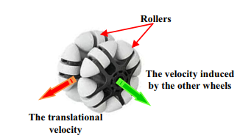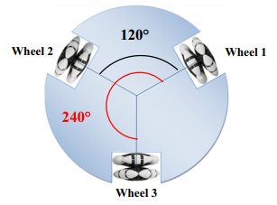The TWOMR is a holonomic, three-wheeled, omnidirectional mobile robot that can move independently and simultaneously in both translation and rotation. The robot is outfitted with three omni-wheels that are evenly spaced 120 degrees around its circumference (Figure 1). In order to ensure that the motor and the wheel share the same rotational axle, each omni-wheel is mounted directly to its motor shaft. The robot can execute movements that robots with conventional wheels are unable to accomplish by independently controlling the speed of each motor.

Figure 2: The omni-wheel

Figure 1: The robot configuration

An omni-wheel with multiple rollers installed to allow sideways movement perpendicular to the rolling direction is depicted in Figure 2. Three omni-wheels at the very least are necessary for an omnidirectional drive system.

1. ***The induced Velocity***

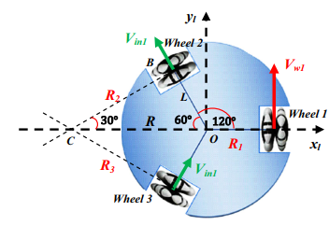Take a look at Figure 3's omni-drive system. Let us assume that wheel 1 (right) has the translational velocity , and that wheel 2 and wheel 3 (left) are not in use. In this scenario, assuming no slippage, the rollers on wheels 2 and 3 will cause them to acquire a velocity perpendicular to their normal rolling directions, which is the inner of wheel 3 and the outer of wheel 2. We refer to this speed as the induced velocity. As a result, the system will revolve around a single point, C, which is the point where two lines intersect that are perpendicular to the wheel's respective velocities, and .

Figure 3: Calculation of the induced velocity

The incluced velocity can be easilt caculated. From Figure 3, in triangle OBC we have:

Where L refers to the robot radius, and therefore,

Now, we can calculate the radius of rotation of the robot center using Pytagoras theorem as follows:

Also,

The robot rotates around point C in the scenario shown in Fig. 3, causing its wheels to spin at the same angular velocity:

Therefore,

Then, the induced velocity induced by applying the linear velocity to the wheel j is:

The two rest wheels freely acquire this induced velocity, which is inner on the preceding wheel and outer on the following wheel. and have the same sign, according to Eq. (7).

1. 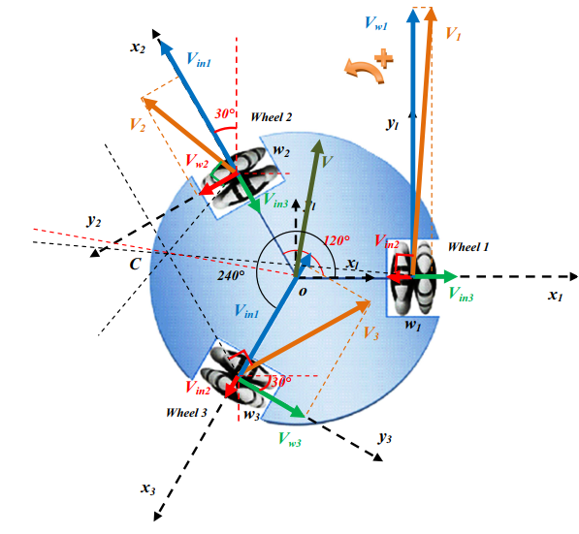***Analysis of the Three-Wheeled Omnidirectional Robot Motion***

Figure 4: Analysis of the different velocities on the three-wheeled omnidirectional robot

Consider the general case illustrated in Figure 4. The three wheels, receive three different velocities. Think of the rotation in the positive direction as rotating counter-clockwise. We establish a local frame connected to the robot's center of mass. The xlaxis and the wheel 1's rotational axis are parallel. Each wheel has a local frame attached to it: wheel 1 has wheel 2 has (), and wheel 3 has (). Every -axis is aligned with its corresponding wheel shaft. When applied to the wheels, the velocities Vwj are measured using their algebraic values; that is, a velocity is positive if it is going in a positive direction and negative if it is going in a negative direction. The following represents the velocity transformations between the robot's local frame and the frames of its wheels:

where the coordinates of the velocity in the frame of the wheel j are represented by and the coordinates of the velocity in the robot's local frame are represented by . The rotational matrices that convert the wheels' frames j to the local frame are denoted by the letters. They can be expressed as follows:

According to Figure 4, the induced velocities are located on the direction, and each applied wheel velocity, , is located on the direction of the wheel frame (). Let represent the aggregate velocity applied to each wheel. Then, its abscissa component is the total of the induced velocities, and its ordinate component is the wheel velocity applied to the wheel. Thus, each aggregate velocity has the following expression in its wheel frame ():

The aggregate translational velocity of each wheel within its wheel frame is described by equations (14), (15), and (16). We must convert these velocities to the local frame in the manner shown below to obtain them in the local (robot) frame:

By changing (17, 18 and 19) to (11–13) and (14–16), respectively, we get:

The resultant translational velocity of the robot can be computed as follows:

The total angular velocity of the robot is determined by utilizing the respective contributions from each wheel. When the robot rotates around point C in Fig. 3, its points all rotate with the same angular velocity caused by , as the first wheel turns and has the translational velocity , while the other two wheels are looked at. Equations (4) and (5) can be used to determine the first wheel's contribution to the robot's total angular velocity as follows:

And we can get contribution of the second and the third wheels as follows:

So:

From Eqs. (25) and (29), we get:

This equation is the forward kinematics of the Three-Wheeled Omnidirectional Mobile Robot, express in the local frame. This equation can be written in matrix form as:

And the amplitude of the translational velocity is:

And its direction by

Where atan2 is the four-quadrant inverse tangent (arctangent) which can be take its values in the interval , while atan takes its values in the interval .

Each wheel's algebraic aggregate translational velocity and direction are provided by:

# III. Controller design

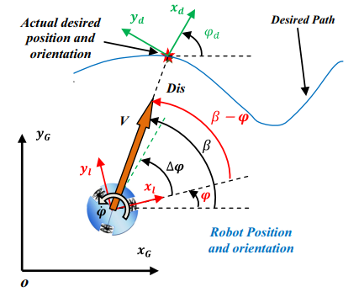The problem of trajectory tracking is depicted in Figure 5. The robot has to track the desired trajectory and the desired orientation simultaneously. Since the TWOMR can move simultaneously in translation and rotation, the adopted strategy consists in applying a translational velocity directed toward the target, in order to minimize the position error (the distance between the robot and the desired position) and an angular velocity to minimize the orientation error (the difference between the orientation of the robot and the desired orientation).

Figure 5: The trajectory tracking problem

Let the inputs of the controller are where:

Let

With this controller, we can controller the moving of the robot pursues the target we setup.

# IV. Simulation

## Matlab (point to point and trajectory)

In this section, we will use Matlab to simulate the movement of our robot. We utilize Simulink to generate each component of the robot model (Figure 6): the kinematics of the robot, the motor dynamics of the robot, and the controller for the robot's trajectory. We can certainly model the case when the robot moves from point A to point B.

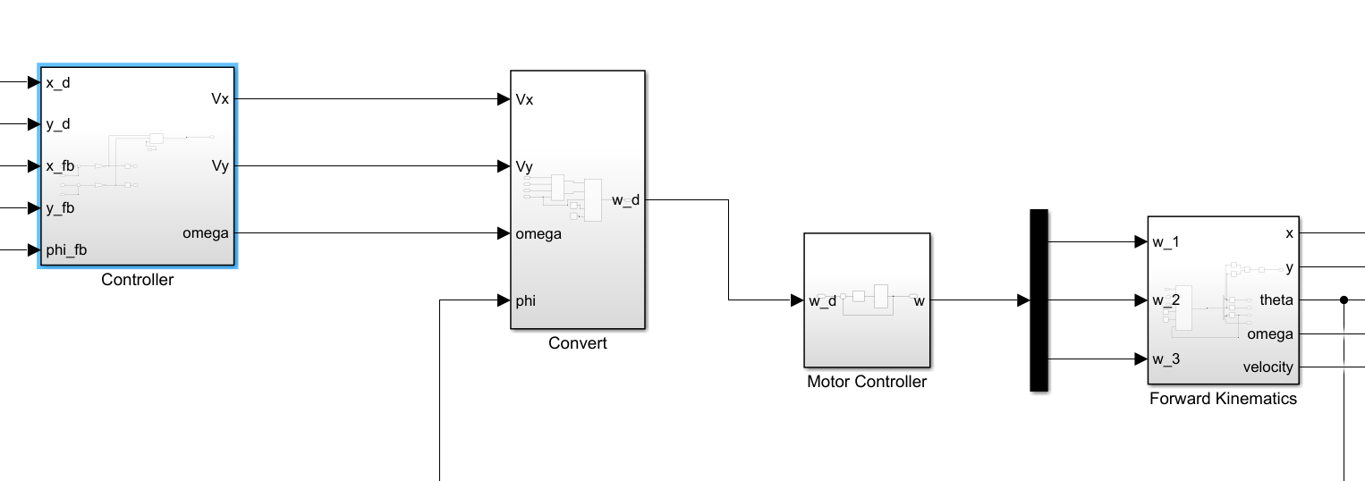

Figure 6:Simulink block for each component of robot model

Then we test the model and take the result. First, we give the input is a point and have result as Figure 7.

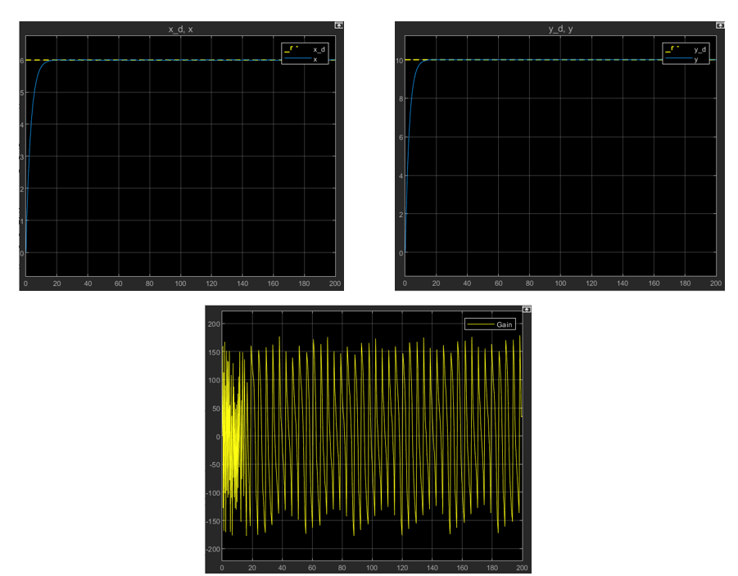

Figure 7: The graph displays the result of model when test point to point

We see that the robot is quickly moving to the point we setup.

Then, we test the trajectory of controller with some path and have the result as Figure 8 and Figure 9.

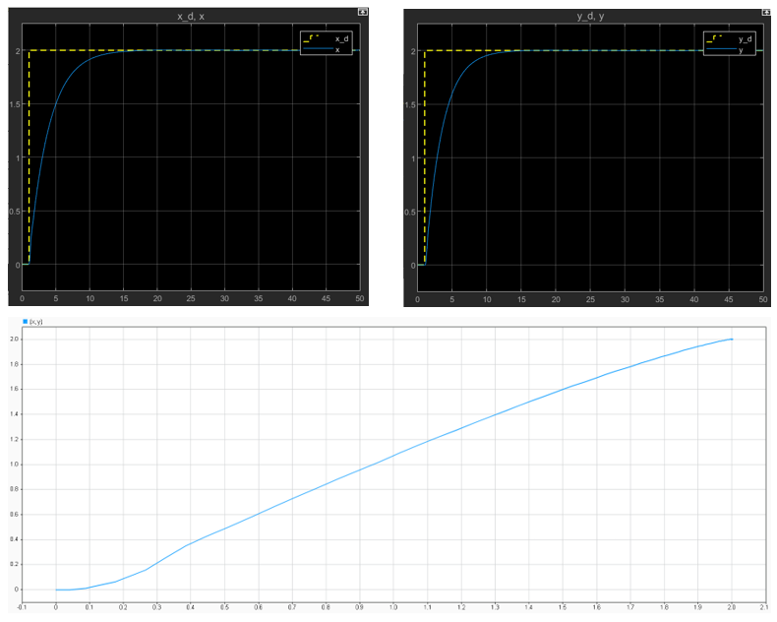

Figure 8:Graph display the trajectory with path is the line

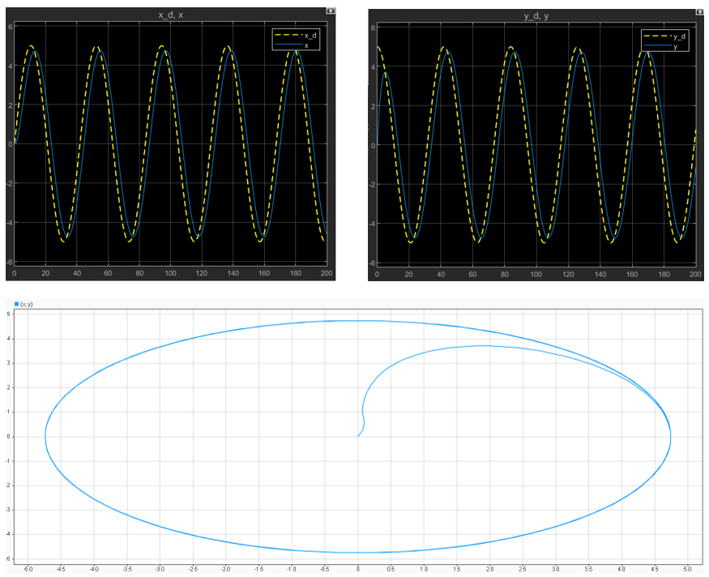

Figure 9: Graph display the trajectory with path is the circle

The results obtained totally ensure the controller's desired requirements (ignoring the inaccuracy when simulating).

## Realistic experiment

Now, we investigate the above-mentioned results in a real-world model. The goal of this experiment is to create a three-wheeled omnidirectional robot that can be controlled in terms of velocity and direction.

About the hardware’s robot, we need prepare:

* Robot frame (have structure of a three-wheeled omnidirectional robot)
* Microcontroller: Arduino Mega 2560
* Module Motor’s controller: L298N
* Power supply: 5V

We communicate and control the robot though out the computer connected with microcontroller.

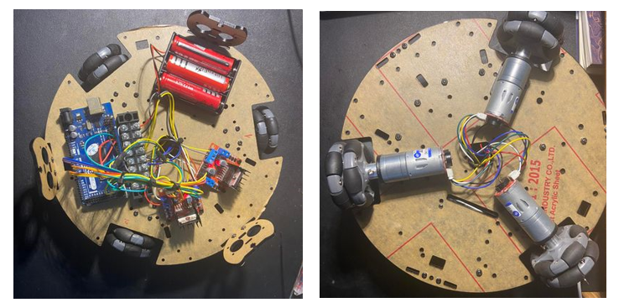

Figure 10:The three-wheeled omnidirectional robot

Then, for developing the code operation of the robot, we rely on the model we investigated earlier and the Matlab model.

In experiment, we have tested the result of encode in motor when we use the PID controller, we have the result as show below.

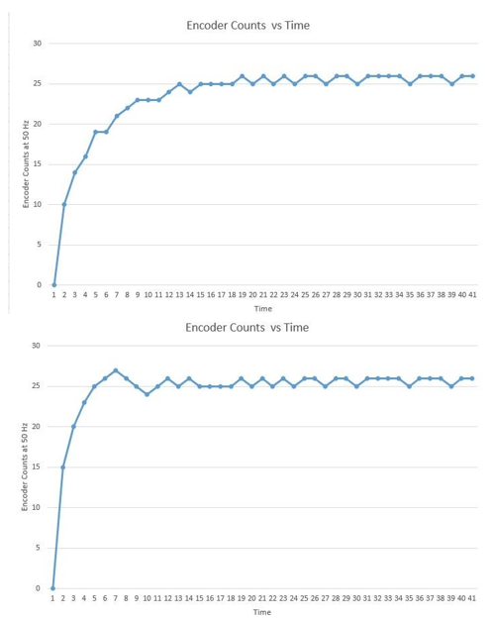

Figure 11: The encoder output in two separate PID controllers

We also test the controller with the velocity and control the direction of robot an have good result.

In short, we obtained positive results from the experimental model in managing the speed and navigation of the robot following the experiment.

# VI. Conclusions.

In short, we accomplished the investigation's goal: we now understand how a three-wheeled omnidirectional mobile robot moves, how to model this robot, and how to build a controller for the robot that guides it to the desired point or trajectory. As a result, it will be extremely valuable for future research on this area.

**References**

|  |  |
| --- | --- |
| [1] | Nacer Hacene, Boubekeur Mendil, " Motion Analysis and Control of Three-Wheeled Omnidirectional  Mobile Robot", 2 January 2019. |