STAT 260 R Assignment 2

Rodriguez Castro Raul V01030827

P(X = 2) -> dbinom(2, size=18, prob=0.171) P(X ≤ 3) -> pbinom(3, size=18, prob=0.171)

# Question 1

lambda = 4.5 * 7.5 #seconds * duration

## Section a P(X <= 35) i.e cdf

ppois(q = 35, lambda = lambda)

## [1] 0.6282507

## Section b

P(X = 33) i.e pmf (discrete) or pdf (continuous)

dpois(33, lambda)

## [1] 0.06869264

## Section c P(30 <= X <= 36) = P(X <= 36) - P(X <= 29)

ppois(36, lambda) - ppois(29, lambda)

## [1] 0.4536192

# Question 2

blades_total = 196  
 blades_prob = 0.11

## Section a

# P(X >= 20) = 1 - P(X <= 19)  
  
 at_least_20 = 1 - pbinom(19, size = blades_total, prob = blades_prob)  
  
 #P(X = 20)  
 equals_20 = dbinom(20, size = blades_total, prob = at_least_20)

## Section b

x = seq(0,50, by = 1)  
y = dbinom(x, size = blades_total, prob = 0.11)  
  
plot(x, y, type = 'h',  
 main = 'Title',  
 xlab = 'X title'  
 )  
grid()

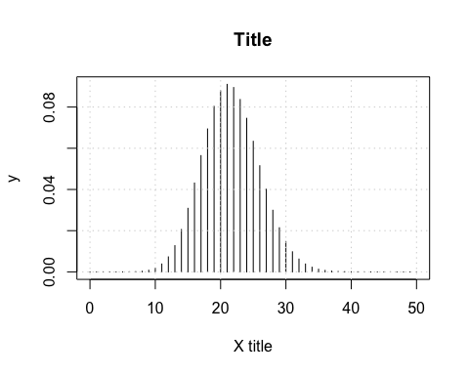 ## Section c

#(P X >= 20) = 1 - P(X >= 19)  
 1 - pbinom(19, size = blades_total, prob = blades_prob)

## [1] 0.6724187

## Section d

random_X = rbinom(x, size = blades_total, prob = at_least_20)  
 plot(x, random_X, type = 'h',  
 main = 'Probability They Get Replaced',  
 xlab = 'number of blades')

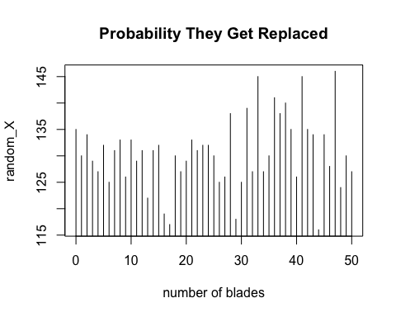

# Question 3

## Section a

P(23.7 <= X <= 30.4) = P(X <= 30.4) - P(X <= 23.6)

mean = 28.3  
 sd = 2.39  
 x = 23.6  
   
 pnorm(30.4, mean = mean, sd = sd) - pnorm(x, mean = mean, sd = sd)

## [1] 0.7855886

## Section b P(X >= 27.4) = 1- P(X <= 27.3)

1 - pnorm(27.3, mean = mean, sd = sd)

## [1] 0.6621763

## Section c P(25 <= X <= 31.6) = P(X <= 31.6) - P(X <= 24)

pnorm(31.6, mean = mean, sd = sd) - pnorm(24, mean = mean, sd = sd)

## [1] 0.8803261

## Section d

qnorm(0.35, mean = mean, sd = sd)

## [1] 27.37908

# Question 4

## Section a

set.seed(111)  
 simulation.data = rbinom(2800, size = 72, prob = 0.36)

## Section b

hist(simulation.data,   
 main = "Histogram of Simulation Data",  
 xlab = "Values of X",  
 ylab = "Frequency",  
 col = "skyblue",   
 breaks = 20)

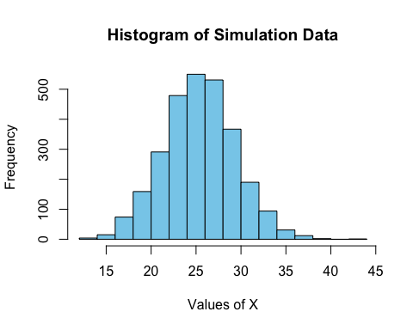 Right-skewed histogram

## Section c

mean(simulation.data)

## [1] 25.87071