# 



**E-Commerce project**

**NailArt**

| **Authors** | C2203L_Group 04 |
| --- | --- |
| LE HOANG MINH KHOI  MAI VAN TUAN ANH  NGUYEN HOANG VIET |
| **Date** | **07/10/2022** |
| **Instructor** | **LUC VAN TIEN** |

**Acknowledgement**

Our e-Project 1 needs assistance to be done and we, the authors, would like to give our acknowledgement to those who have supported and motivated us during the period of implementing this e-Project 1.

First and foremost, we would like to thank our instructor Mr. **LUC VAN TIEN** whose support and useful advices helping us to complete our e-Project 1 effectively. His encouragement and comments had dramatically enriched and improved our work.

Secondly, we would like to thank Aprotrain - Aptech Computer Education, teachers, and staffs for their support throughout our learning and completing this e-Project 1.

Thirdly, we would like to thank our families’ members including our parents, spouses and siblings for their support and care all the time, especially in the period of completing our work.

Lastly, our deep thanks to all our classmates during studying time in Aptech. Their kind help, care, and motivation help us conquer the higher targets in the future.

**1.** **Problem Definition**

1.1 ***Problem Abstraction***

Nail art is a creative way to paint, decorate, enhance, and embellish the nails. It is a

type of artwork that can be done on fingernails and toenails, usually

after manicures or pedicures. Manicures and pedicures are beauty treatments that

trim, shape, and polish the nails. Often, these procedures remove the cuticles and

soften the skin around the nails. Types of manicures can vary from polish on natural

nails to dipping powder and acrylic nails.

1.2  ***The Current System***

The nail-care industry has been growing like never before ever since the invention of

modern nail polish.

Nail art is also a way to create its own identity through fashion, using colours and

shapes as a disruption of childhood and entering to the female teen/adult world, also

leaving the influence of their parents to create their own selves.

Here we are aiming to design a website “NailArt” which will provide an easy way to

learn nail art with various designs and steps involved.

1.3 ***The Proposed System***

The Web site is to be created based on the following requirements.

1) The home page must describe the keywords or highlight the nail art designs with all navigation links defined.

2) The site should provide the brief information about nailart as from where it originated etc.

3) There should be a well designed menu with necessary sub menu options.

4) There should be various categories (forms and styles) like easy to design for kids, complex for elders.

5) There should also be categories of designs as Faces, geometric design, flowers etc. Minimum 5 categories are expected here.

6) Proper description of the design along with the image and steps

7) Along with the nailart designs there should be a section which will showcase the various products and accessories for art like nail polish etc

8) Also there should be a section giving information about nail care.

9) About Us

10) Contact us page: contact us details with location should be displayed using GeoLocation API (eg. GoogleMaps).

11) Feedback form

12) Gallery section should be added.

13) Color combination must be uniform throughout the project.

14) Navigation must be smooth.

1.3.1 ***Boundaries of the System***

The website provides information on 4 types of product included: cellphone, smartwatch, earphone, tablet,etc that support customers in finding and choosing the right product with their needs. In addition, customers can use all the information for reference.

1.3.2 ***Hardware and Software Requirements***

**Hardware:**

• A minimum computer system that will help you access all the tools in the

courses is a Pentium 166 or better

• 64 Megabytes of RAM or better

**Software:**

• Notepad/HTML editor

• Dreamweaver

• IE 5.0/ Netscape 6.0

**2.** **Customer Requirements Specification**

2.1 ***Users of the System***

The system can be used by customers and administrators.

- Customers are users who are allowed to visit the main website where they can view and interact with the information (such as product details, brands, color, prices and others). Customers can to place compare different types of products.

- Administrators are affiliates, also known as users who have access to administrative tools to provide their products and services, or simply make calls consultation appointment with the clients. Administrators should be divided into 2 groups for security reasons.

2.1.1 Customers

◉ Have the right to view and find products

◉ Have the right to give feedback

◉ Have the right to compare different types of products

2.1.2 Administrators

◉ Have the right to manage products (add, edit status)

◉ Have the right to manage product categories (add, edit status)

◉ Have the right to manage administrative account (add, change type, disable)

◉ Have the right to manage photo gallery (add, delete)

◉ Have the right to manage customer feedback (read)

2.2 ***System functions***

2.2.1 Homepage

+ Description: with customers who visit website for the first time, the homepage is divided into 3 sections:

- Navigation bar: Displays links to other information pages such as Courses, Products, Care, About and Contact pages.

- Main categories: pictures of Nail Art works, some nail care tips courses and their history.

- Footer of navbar links.

2.2.2 Products page

+ Description: For users who want to take a look at all kinds of products. There will be product illustrations and compare page.

+ Display: product name, product image, etc.

2.2.3 Function To View details of each product type

+ Description: For customers who want to access full information of the product, such as name, detailed description,…

+ Processing: Export from database using product #id with details: name, image, description, color in stock, storage in stock.

+ Display: Detailed information of each product.

2.2.4 Contact Us Function

+ Description: For those who want to give comments, reviews, or feedback on the problems.

2.2.5 About us Function

+ Description: about web page

2.2.6 Administrative functions

Login function:

+ Description: For administrators to access the Administration functions, access to all functions, products and order processing functions.

+ Input: Username and password.

+ Processing: Retrieve the database and check if the account exists or not, the password is correct or not, and the status of the account.

+ Display: Login interface including account and password.

2.2.9 Product view function:

+ Input: Enter product information such as: name, image, product description.

+ Processing: Add the information just entered to the database.

+ Save map:

2.2.10 Function to Recycle product:

+Enter: Admin can delete or recycle added products.

2.2.11 Function to add new brands:

+ Enter: The administrator can add new brands for new product line.

+ Processing: validate the input of the brands such as name, if valid add brand to database , if not: display an alert.

+ Privilege: only admin tier 1 can access this function

2.2.12 Function to add new category:

+ Enter: The administrator can add new category for new product line.

+ Processing: validate the input of the category such as name, description… if valid add the new product category to the database, if not: display an alert.

+ Privilege: only admin tier 1 can access this function

2.2.13 Function to add new storage

+ Enter: The administrator can add new storage for new product line.

+ Processing: validate the input of the storage such as name, if valid add the new storage to the database, if not: display an alert.

+ Privilege: only admin tier 1 can access this function

2.2.144 Function to Edit product and add image to Detail product

+Enter: Edit or add new product detail images

+Handling: Check the new image for correct product information, if valid, replace the old image, if not, keep it and display a warning.

**3.** **System Designs**

3.1 ***Entity Relationship Diagram***

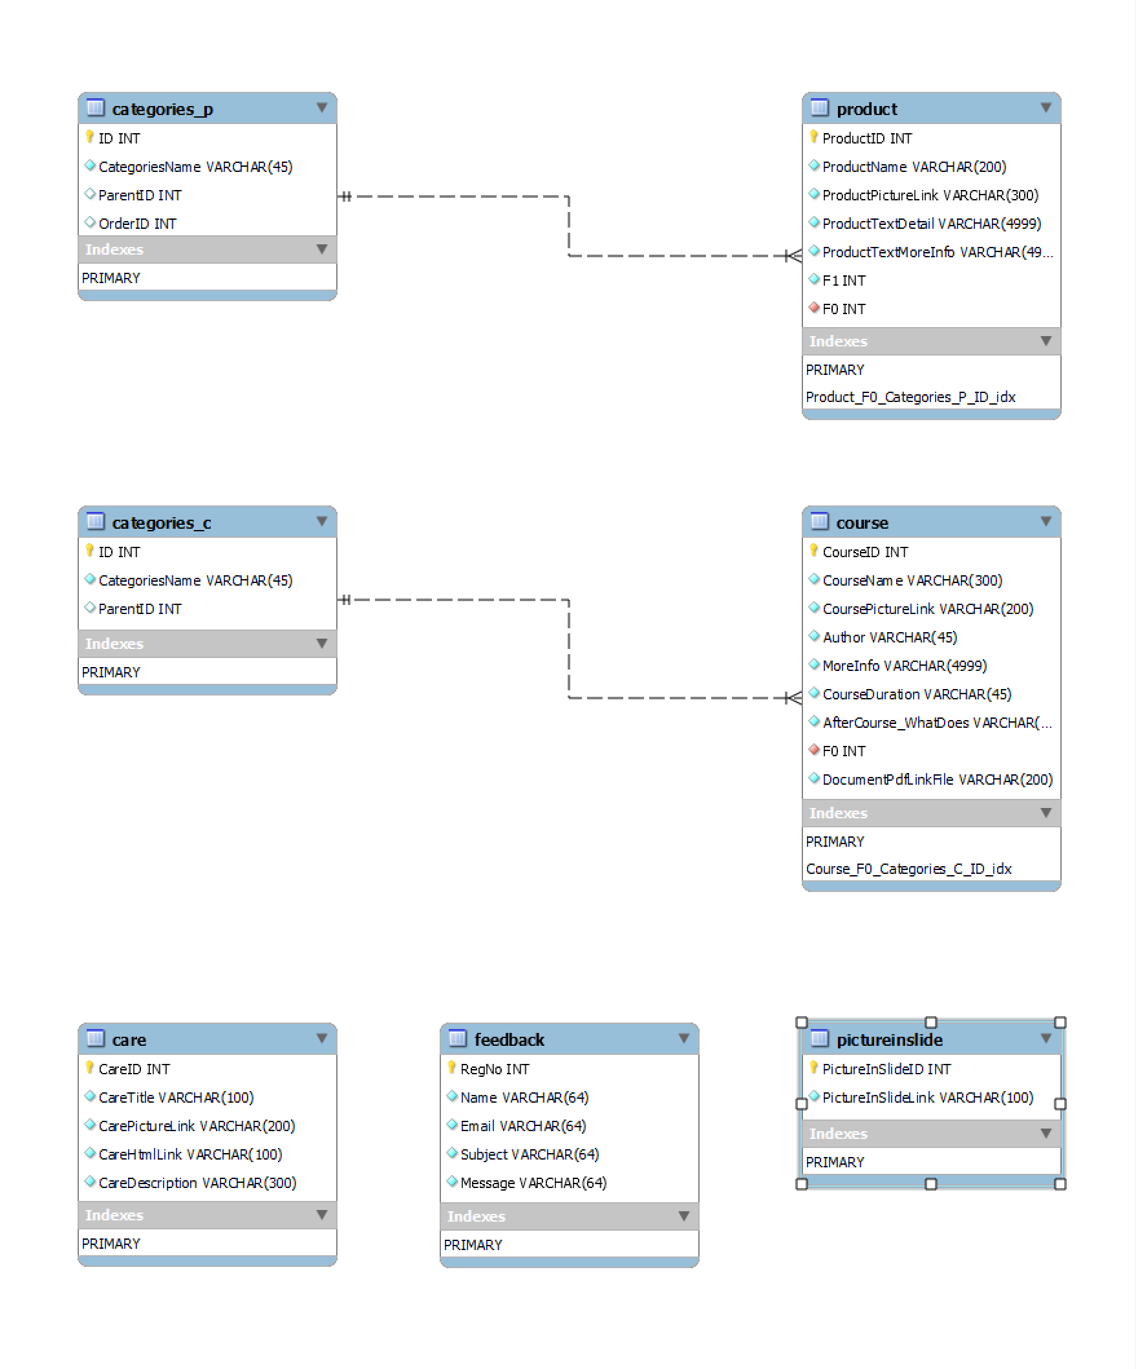

3.2 ***Database Design***

Tables detail description:

- Product table including :

+ ProductID int

+ ProductName varchar(200)

+ ProductPictureLink varchar (300)

+ ProductTextDetail varchar(4999)

+ ProductTextMoreInfo varchar(4999)

+ F1 int

+ F0 int

+ updated_at: datetime datatype

-- Categries_p table including:

+ ID int

+ CategriesName: varchar (45)

+ ParentID int

+ OrderID int

- Feedback table including:

+ Username varchar (64)

+ Email varchar (64)

+ Subject varchar (64)

+ Message varchar (64)

+ RegNo int

+ updated_at: datetime datatype

- Course table including:

+ CourseID int

+ CourseName varchar (300)

+ CoursePictureLink varchar (200)

+ Author varchar (45)

+ MoreInfo varchar (4999)

+ CourseDuretion varchar (45)

+ Aftercourse_Whatdoes varchar (4999)

+ F0 int

+DocumentPdfLinkFile varchar (200)

- Categories_c table including:

+ ID int

+ CategoriesName varchar (45)

+ ParentID int

- Pictureinslide table including:

+ PictureInSlideID int

+ PictureInSlideLink varchar (100)

- Care table including:

+ CareID int

+ CareTitle varchar (100)

+ CarePictureLink varchar (200)

+ CareHtmlLink varchar (100)

+ CareDescription varchar (300)

3.3 ***Sitemap***

***+ Users***

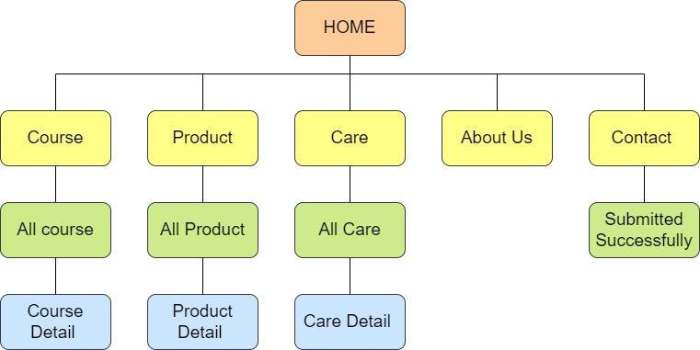

+***Admin***

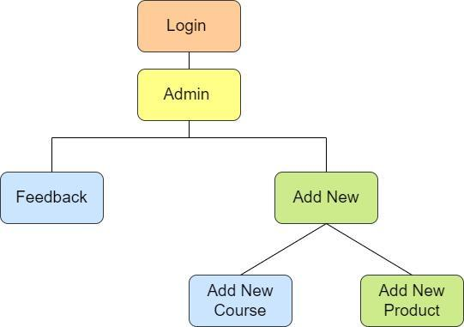

3.4 ***System functions design***

3.4.1 User Interface

* Home page

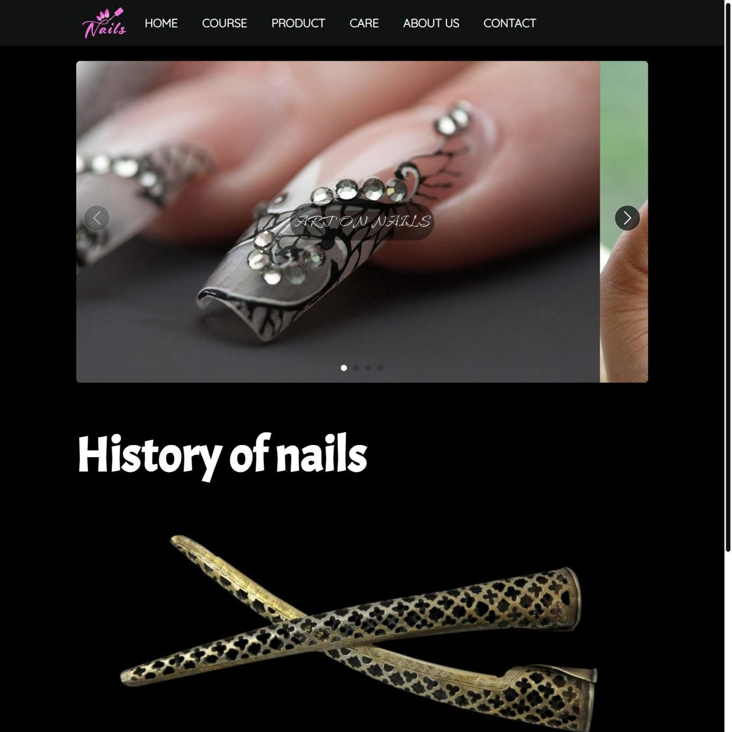

* Course



* Product

* Care

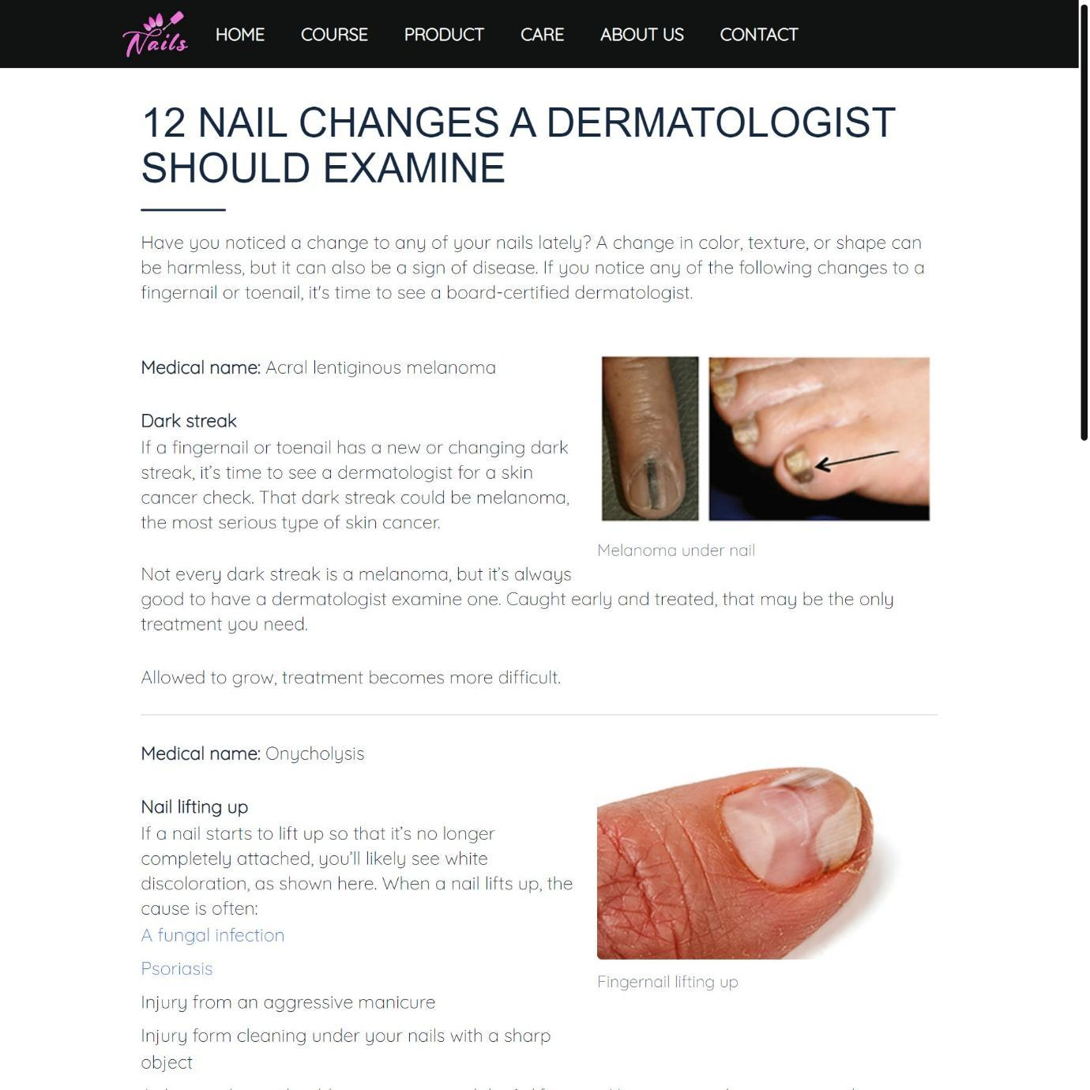

* Product Detail

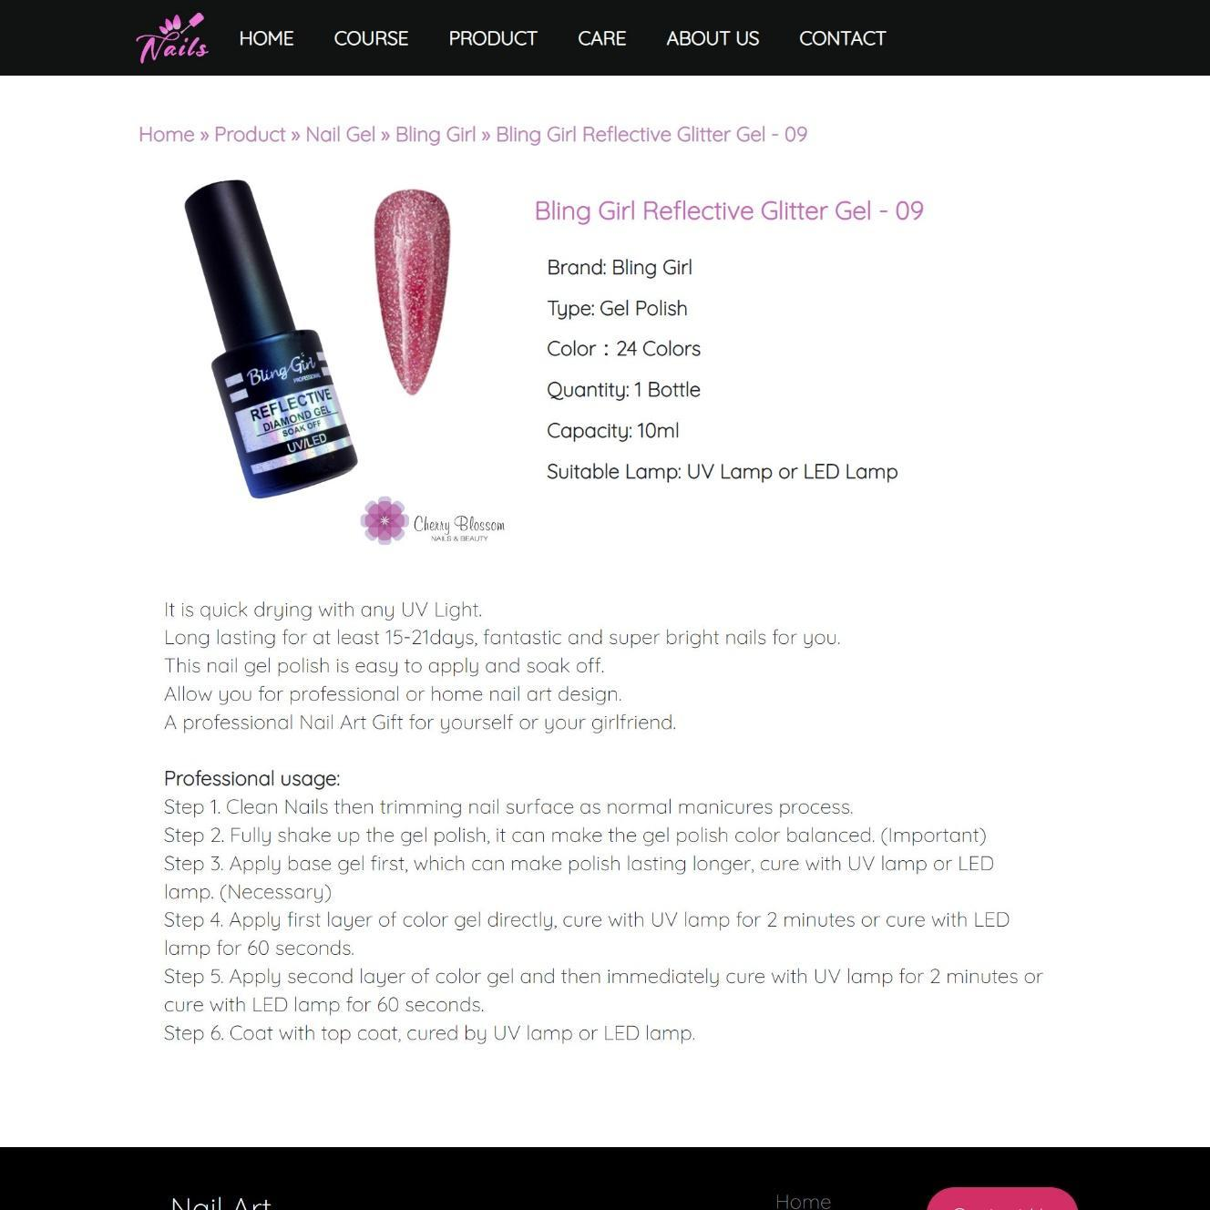

* Contact us

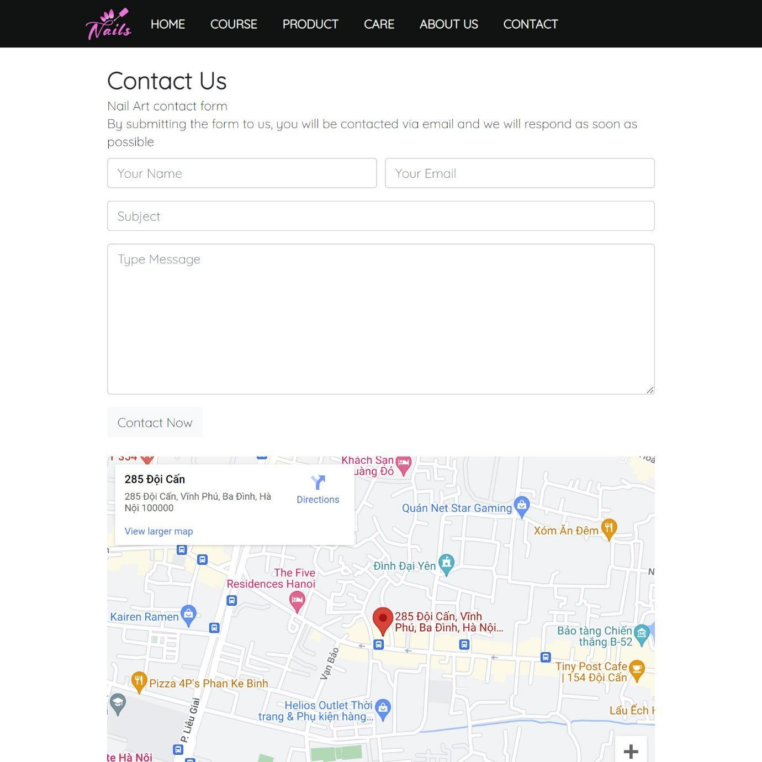

* About us

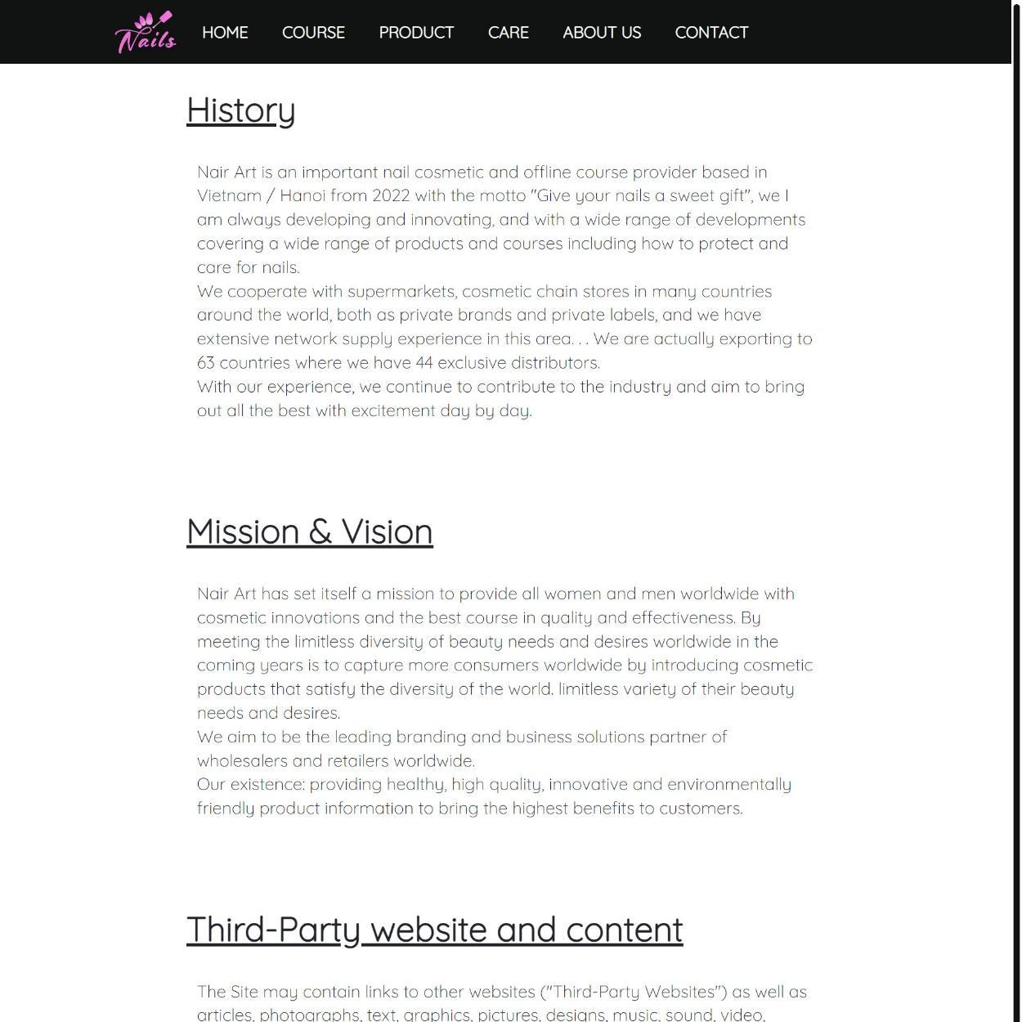

3.4.2 Admin Interface

* Login Page

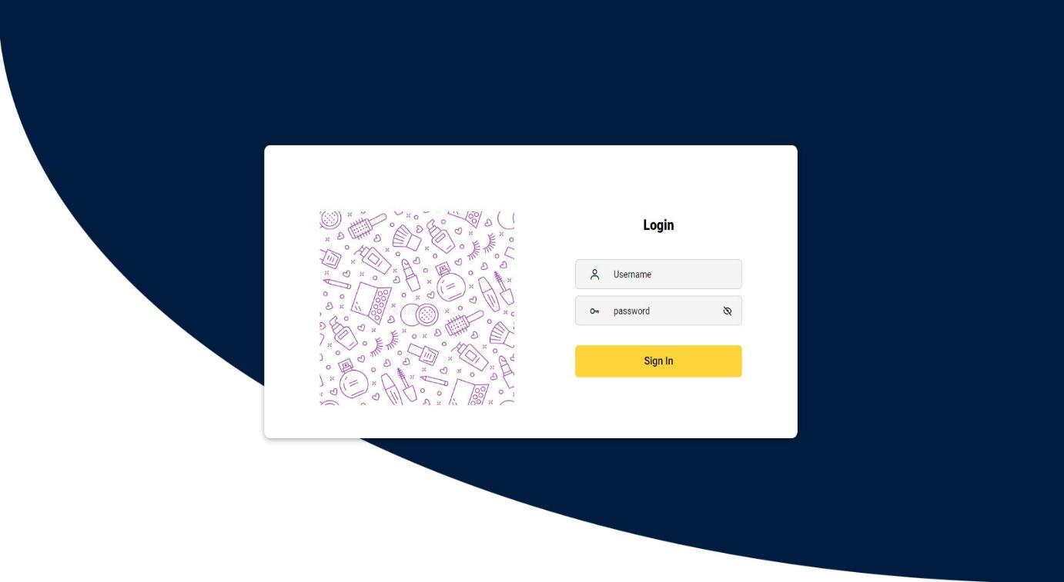

* Admin Information

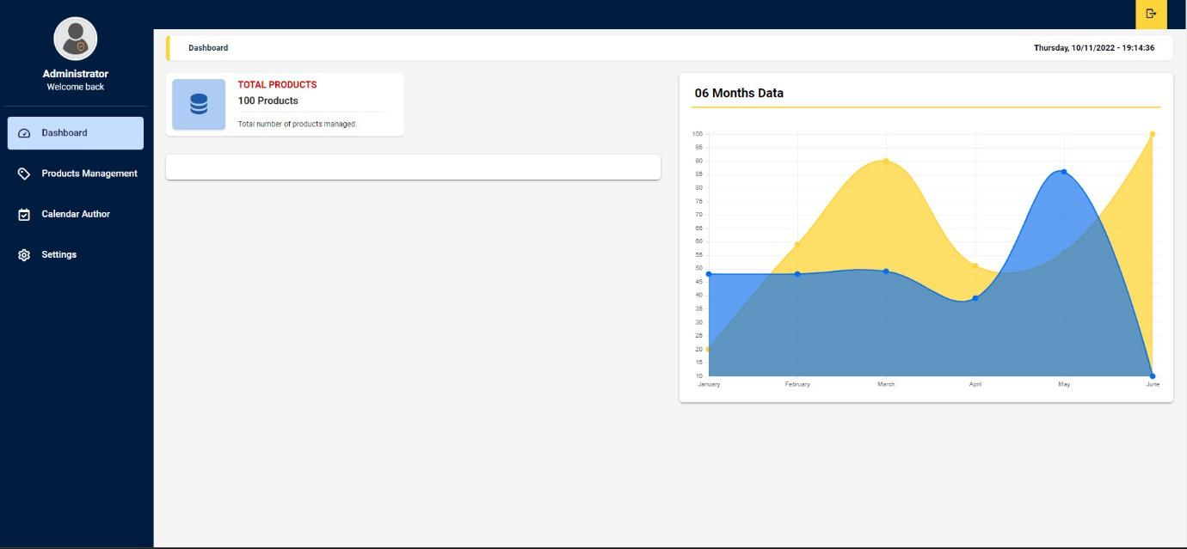

* Calendar Author

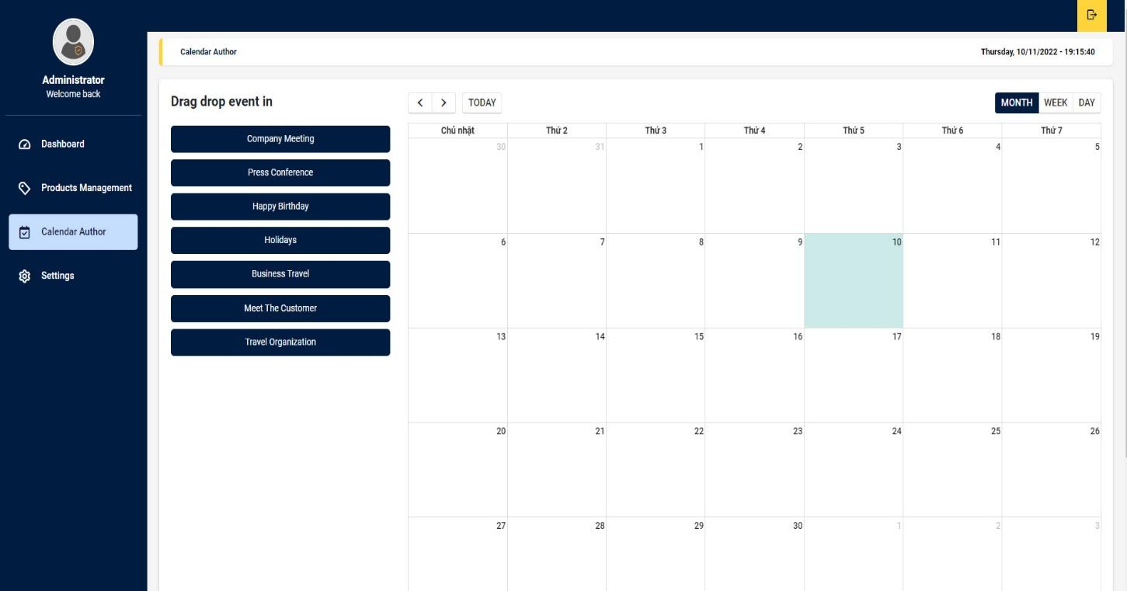

* Pages Management

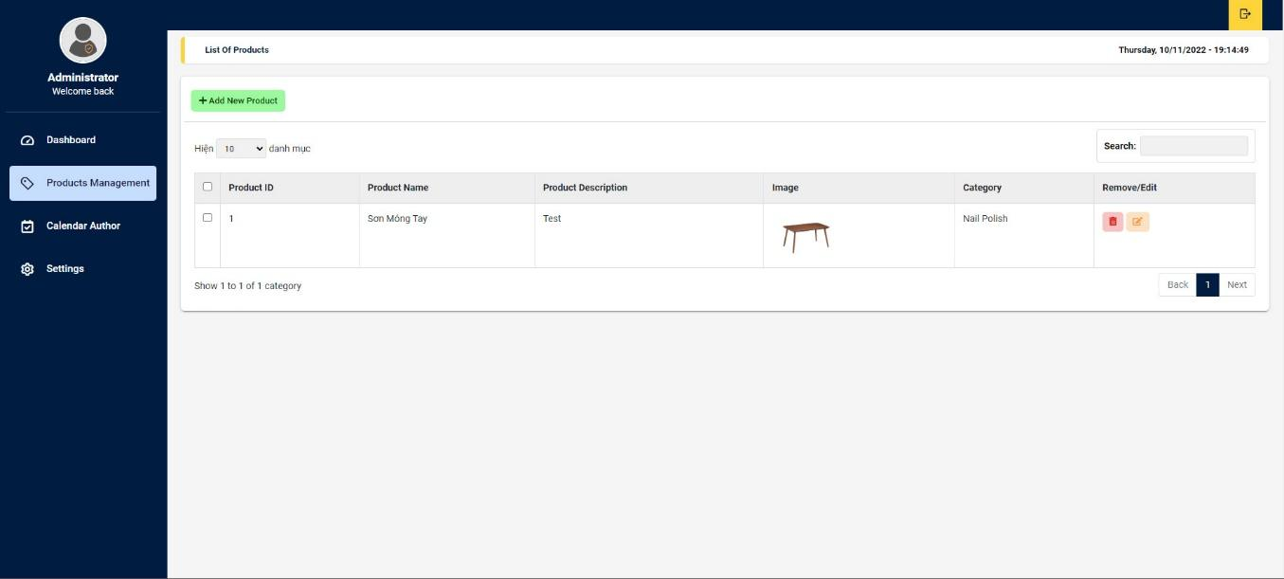

* Feedbacks

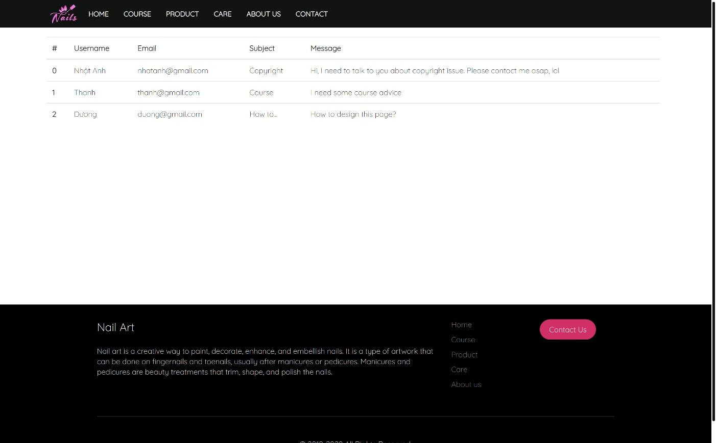

**4.** **Task sheet**

**C2203L - GROUP 4 - TASKSHEET**

| **Task** | **Start time** | **Finish time** | **Implemented by** | **Evaluation(%)** |
| --- | --- | --- | --- | --- |
| Feasibility study phase |  |  |  |  |
| Read, understand, analyze documents | 17/10/2022 | 20/10/2022 | Mai Văn Tuấn Anh  Nguyễn Hoàng Việt  Lê Hoàng Minh Khôi | 7% |
| Build a database | 20/10/2022 | 22/10/2022 | Mai Văn Tuấn Anh  Nguyễn Hoàng Việt | 50% |
| Contribute ideas to edit the database | 22/10/2022 | 23/10/2022 | Nguyễn Hoàng Việt | 17% |
| Contribute ideas to edit the database | 24/10/2022 | 25/10/2022 | Nguyễn Hoàng Việt | 20% |
| Browse and unify the database | 25/10/2022 | 25/10/2022 | Mai Văn Tuấn Anh | 10% |
| Requirement Analysis phase |  |  |  |  |
| User page analysis | 25/10/2022 | 26/11/2022 | Nguyễn Hoàng Việt | 50% |
| Analyze admin page | 27/10/2022 | 28/10/2022 | Nguyễn Hoàng Việt | 50% |
| Design phase |  |  |  |  |
| Design UI/UX interfaces for users | 29/10/2022 | 03/11/2022 | Mai Văn Tuấn Anh  Nguyễn Hoàng Việt | 80% |
| Design UI/UX interfaces for admin | 03/11/2022 | 04/11/2022 | Nguyễn Hoàng Việt  Lê Hoàng Minh Khôi | 10% |
| Development phase |  |  |  |  |
| Design registration, login, product display, order, compare, feedback functions in the user page | 04/11/2022 | 06/11/2022 | Mai Văn Tuấn Anh  Nguyễn Hoàng Việt | 75% |
| Design login, create an account, display, add, edit, delete products, product categories, display orders, feedback in the admin page | 06/11/2022 | 09//2022 | Mai Văn Tuấn Anh  Nguyễn Hoàng Việt | 60% |
| Testing phase |  |  |  |  |
| User page:  - Check login, register  - Check buttons, paths  - Check the compare and order function  - Check user feedback function | 09/11/2022 | 09/11/2022 | Mai Văn Tuấn Anh | 80% |
| Admin page:  - Check display, add, edit, delete products, product categories  - Check account creation for admin and user  - Check order display and user feedback | 09/11/2022 | 10/10/2022 | Lê Hoàng Minh Khôi  Nguyễn Hoàng Việt | 75% |
| Deployment phase |  |  |  |  |
| Submit source code and database | 11/11/2022 | 11/11/2022 | Mai Văn Tuấn Anh | 60% |