Effective Response-Sector Stress–Energy as an Alternative to Galactic Dark Matter:
An Inverse-GR Framework Tested Against 175 SPARC Galaxies
Robert D. Kitcey
Lernaean Research™
ORCID: 0009-0004-8679-9155
rkitcey@lernaean.net
February 2026
Draft v5.0.0

Executive Summary
The dark-matter paradigm explains galactic rotation curve anomalies by postulating a new, non-luminous matter component. Despite decades of null results in direct, indirect, and collider searches, the hypothesis persists largely because no comparably rigorous alternative has been tested against the full breadth of observational data. This paper develops and tests such an alternative. We keep the Einstein tensor standard (general relativity) and do not assume particulate cold dark matter (CDM). Instead, we use observed galactic phenomenology—rotation curves from the SPARC database of 175 galaxies—to infer the effective potentials and effective stress–energy required on the right-hand side of the Einstein equation, then compress that freedom with a low-degree-of-freedom “intrinsic medium response” closure.
The organizing principle is $G_{μν}=8πG\left(T_{μν}^{\text{bar}}+T_{μν}^{\text{resp}}\right)$, where $T_{μν}^{\text{resp}}$ is the response-sector stress–energy that
- explains galaxy halo phenomenology without particulate CDM, and
- admits a cosmological completion consistent with the empirical ΛCDM success set.
The response sector is activated near a baryonic boundary layer, produces an asymptotic $\frac{1}{R}$ tail in the extra acceleration, and is described by ≤2 degrees of freedom per galaxy. Across 175 SPARC galaxies, 92% show very strong improvement over baryons-only, 97% pass BIC overfitting tests, and the baryonic Tully–Fisher relation emerges as a consequence rather than an imposed prior.
We present explicit falsification criteria, discriminant tests (including lensing-facing statements and cosmological viability requirements), and a domain-partitioned roadmap from galaxy phenomenology through gravitational slip to large-scale structure. Claims are partitioned by domain: this work establishes the galaxy-domain closure and enumerates the cosmological completion requirements and discriminants.

Table of Contents
Executive Summary 1
Table of Contents 3
Abstract 5
1. Introduction 6
2. From Phenomenology to Effective Source: The Inverse-GR Construction 8
2.1 Kinematics to Required Radial Acceleration 8
2.2 Weak-Field Metric Potentials 8
2.3 Effective Enclosed Mass and Density 8
2.4 Effective Stress–Energy: What Is Being Added in GR 9
2.5 Conservation Constraint 9
3. Minimal Response-Sector Model Specification 10
3.1 Design Principles 10
3.2 Auxiliary-Field Boundary-Layer Model 10
3.3 Operational Implementation 10
3.4 The Constitutive “Gravitational Dielectric” Alternative 10
3.5 Three Completion Routes 11
4. Data and Pipeline 12
4.1 The SPARC Database 12
4.2 Baryonic Velocity Construction 12
4.3 Transition Radius Determination 12
4.4 Fit Procedure and Amplitude Determination 12
4.5 Six-Panel Diagnostic Atlas 12
5. Results Across 175 SPARC Galaxies 14
5.1 Global Fit Performance 14
5.2 Representative Galaxy Diagnostics 14
5.3 Emergent Baryonic Tully–Fisher Relation 18
5.4 Fitted vs. Robust Amplitude Comparison 18
5.5 Mass-to-Light Ratio Sensitivity 18
5.6 Oscillatory Signatures and Negative-Q Galaxies 18
6. Empirical Validation Ladder 19
6.1 Step 1: Data Reproducibility 19
6.2 Step 2: Baseline Fits and Residual Definitions 19
6.3 Step 3: Non-Fragile Inference 19
6.4 Step 4: Stratified Permutation Stress Tests 19
6.5 Step 5: Out-of-Sample Cross-Validation 19
6.6 Step 6: Negative Controls 19
7. Falsification Criteria and Discriminant Tests 21
7.1 Criterion 1: Compression Failure 21
7.2 Criterion 2: Out-of-Sample Prediction Failure 21
7.3 Criterion 3: Gravitational Slip / Lensing Inconsistency 21
7.4 Criterion 4: Cosmological Growth Incompatibility 21
7.5 The Discriminant Triad 21
8. Lensing and Cosmological Viability 23
8.1 Lensing: The Weyl Potential Constraint 23
8.1.1 Working Hypothesis: Metric Equivalence 23
8.1.2 Gravitational Slip as a Discriminant 23
8.2 Cosmological Background 23
8.3 Cosmological Perturbations 23
8.4 Domain Partition and Honest Scope 24
9. Discussion 25
9.1 What the Response Sector Is (and What It Is Not) 25
9.2 Relation to MOND and TeVeS 25
9.3 Relation to Emergent Gravity and Nonlocal Gravity 25
9.4 Strengths of the Current Work 25
9.5 Limitations and Open Questions 25
9.6 The Historical Lesson 26
10. Conclusion 27
References 28

Abstract
We present a systematic, falsification-first framework for explaining galaxy rotation-curve anomalies without invoking particulate cold dark matter. Working strictly within general relativity (GR), we define the response-sector stress–energy $T_{μν}^{\text{resp}}$ as the minimal effective source required so that the metric potentials inferred from observed kinematics satisfy the Einstein equation with baryons alone. We operationalize this as an inverse-GR construction: observed rotation curves constrain the Newtonian-gauge potential Φ; the residual acceleration beyond baryonic predictions defines an effective extra density whose outer behavior scales as $1/r2$, matching the classic “halo” profile—but interpreted here as the effective stress–energy of a spacetime response, not a new matter species.
We compress the inverse freedom with a boundary-layer closure: an auxiliary scalar field sourced near the baryonic transition radius (where g_{bar} ≈ a₀) and obeying an approximate flux-conservation law outside it, yielding a $\frac{1}{R}$ gradient with a single amplitude parameter Q. Applied to 175 galaxies from the Spitzer Photometry and Accurate Rotation Curves (SPARC) database, the framework achieves:
- very strong fit improvement over baryons-only for 92% of galaxies;
- BIC overfitting rejection in 97% of cases;
- recovery of the baryonic Tully–Fisher relation as an emergent consequence (Spearman ρ = 0.94); and
- confirmation of fitted amplitudes by an independent robust estimator (Huber M-estimator; Spearman ρ ≈ 0.97).
We enumerate four explicit falsification criteria, provide a first lensing-facing statement (metric-equivalence working hypothesis with predicted gravitational slip as a key discriminant), and sketch the minimal cosmological viability requirements. This work establishes the galaxy-domain closure; cosmological completion remains a defined program.
Keywords: galaxy rotation curves, dark matter alternatives, general relativity, effective field theory, response-sector stress–energy, boundary-layer physics, SPARC database, falsification criteria

1. Introduction
For nearly a century, the dark-matter paradigm has served as the dominant explanatory framework for gravitational anomalies at galactic and cosmological scales. Beginning with Zwicky’s (1933) inference of “missing mass” in the Coma Cluster and reinforced by galactic rotation-curve measurements (Rubin & Ford, 1970; Bosma, 1978), the hypothesis that a non-luminous, non-baryonic matter component pervades the universe has become deeply embedded in astrophysical practice. The ΛCDM concordance model—in which cold dark matter provides approximately 27% of the cosmic energy budget—fits the cosmic microwave background power spectrum (Planck Collaboration, 2020), baryon acoustic oscillation data, and the broad features of large-scale structure with remarkable precision.
Yet the foundational assumption of ΛCDM—that a new particle species exists and interacts primarily through gravity—remains empirically unverified. Decades of increasingly sensitive direct-detection experiments, including LUX (Akerib et al., 2017), XENON1T (Aprile et al., 2018), and PandaX-II (Cui et al., 2017), have yielded null results. Indirect searches via cosmic-ray spectra (Aguilar et al., 2013) and gamma-ray observations of dwarf spheroidal galaxies (Ackermann et al., 2015) have likewise failed to identify a dark-matter signal. Collider experiments at the LHC have found no evidence of dark-matter production. These persistent null results, spanning three independent detection channels, invite a re-examination of the premises that led to the dark-matter hypothesis.
This paper develops a specific, testable alternative. We retain the Einstein field equations in their standard form—the left-hand side (geometry) is unchanged—and ask what effective stress–energy on the right-hand side is required to explain observed rotation curves if we do not assume particulate CDM. The organizing equation is:
$$G_{μν}=8πG\left(T_{μν}^{\text{bar}}+T_{μν}^{\text{resp}}\right)$$
where $T_{μν}^{\text{resp}}$ is the response-sector stress–energy—the minimal effective source that accounts for the “missing curvature” in the circular-orbit sector. This is an inverse-GR construction: we work from observed phenomenology backward to the implied source, then compress the resulting freedom with a low-degree-of-freedom closure tied to baryonic structure.
The approach has a well-known historical precedent. In the nineteenth century, the anomalous perihelion precession of Mercury was widely attributed to an undiscovered intra-Mercurial planet, Vulcan (Le Verrier, 1859). The resolution came not from finding the unseen matter but from revising the gravitational framework itself—Einstein’s general relativity explained the anomaly through spacetime geometry (Einstein, 1915). We do not claim the analogy is exact, but the structural lesson is apt: when gravitational anomalies are attributed to unseen matter, the possibility that the anomaly reflects deeper geometric structure deserves serious investigation.
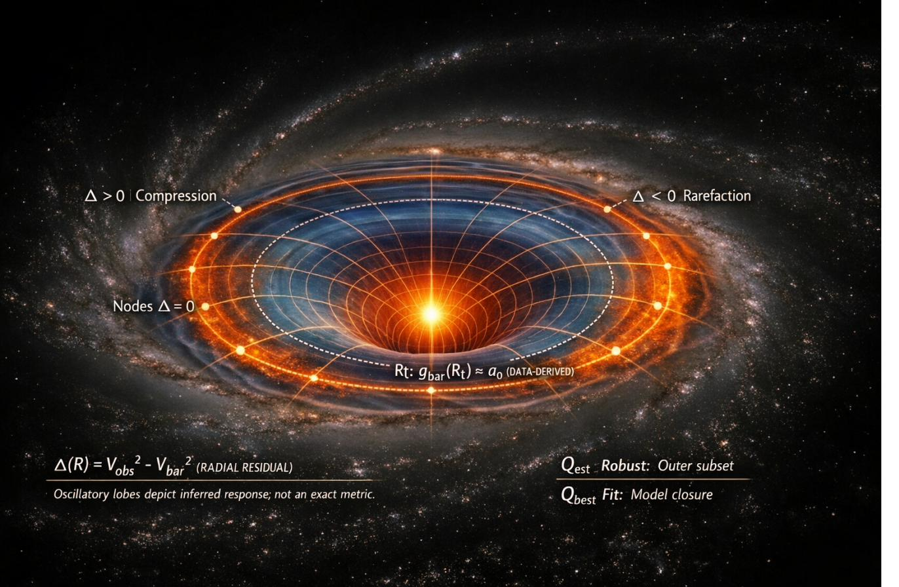
Figure 1. Conceptual schematic of the response-sector framework. The central luminous disk represents the baryonic mass distribution. Concentric lobes illustrate the radial residual Δ(R) = V²obs − V²bar, with compression (Δ > 0, orange) and rarefaction (Δ < 0, blue) zones. The dashed ellipse marks the transition radius R_{t} where g_{bar} ≈ a₀. Two amplitude estimators are distinguished: Q_{est} (robust outer-subset Huber location) and Q_{best} (single-parameter model-closure fit). The oscillatory structure is schematic; per-galaxy profiles (see §6) need not exhibit clean alternation.
We proceed as follows. Section 2 develops the inverse-GR construction from kinematics to effective stress–energy. Section 3 specifies the minimal response-sector model. Section 4 describes the SPARC data and pipeline. Section 5 presents results across 175 galaxies. Section 6 provides the empirical validation ladder. Section 7 states explicit falsification criteria and discriminant tests. Section 8 addresses lensing and cosmological viability. Section 9 discusses implications and scope limitations, and Section 10 concludes.

2. From Phenomenology to Effective Source: The Inverse-GR Construction
The standard approach to galaxy dynamics begins with a theoretical mass model (baryons + dark matter) and predicts observable kinematics. We invert this logic: we begin with observed kinematics and infer what effective source is required within standard GR.

2.1 Kinematics to Required Radial Acceleration
For each galaxy in the SPARC database, the observed rotation curve provides the centripetal acceleration at galactocentric radius R:
$$g_{obs\left(R\right)}=\frac{v_{obs\left(R\right)}^{2}}{R}$$
The baryonic prediction g_{bar}(R) is constructed from SPARC’s decomposed photometric and gas-mass components (Lelli et al., 2016), with a chosen stellar mass-to-light ratio Υ*. The residual defines the “missing curvature” in the circular-orbit sector:
$$g_{\text{extra}}\left(R\right)≡g_{\text{obs}}\left(R\right)-g_{\text{bar}}\left(R\right)$$
This residual is model-independent: it is a direct comparison of observed kinematics with the baryonic gravitational prediction. In the CDM interpretation, g_{extra} is sourced by an additional mass component. In the response-sector interpretation, it is the effective geometric response of spacetime to the baryonic source.

2.2 Weak-Field Metric Potentials
In the Newtonian gauge for weak gravitational fields, the line element takes the form:
$$ds^{2}=-\left(1+2Φ\right) dt^{2}+\left(1-2Ψ\right) dx^{2}$$
To leading order for nonrelativistic motion, the radial acceleration is a ≈ −∇Φ. Gravitational lensing depends on the Weyl combination Φ_{lens} ∝ (Φ + Ψ)/2. Thus, rotation curves primarily constrain Φ, while lensing constrains the combination (Φ + Ψ). A metric-equivalent response-sector claim is strongest if it produces Φ ≈ Ψ in the relevant regime; if it predicts gravitational slip (Φ ≠ Ψ), that slip becomes a key discriminant (see §8).

2.3 Effective Enclosed Mass and Density
For spherically symmetric intuition (useful even for disk galaxies), circular orbits obey v²(r) = GM(<r)/r. Given the observed rotation curve, we define an effective enclosed mass:
$$M_{eff\left(<r\right)}= r\frac{v_{obs\left(r\right)}^{2}}{G}$$
Subtracting baryons yields an effective extra enclosed mass and, by differentiation, an effective extra density:
$$ρ_{extra\left(r\right)}=\frac{\left(\frac{1}{4πr^{2}}\right)d}{dr}\left[\frac{r\left(v_{obs}^{2}- v_{bar}^{2}\right)}{G}\right]$$
For a flat outer rotation curve (v → v∞), one obtains M_{eff} ∝ r and ρ_{extra} ∝ 1/r²—the classic isothermal halo profile. In the response-sector interpretation, ρ_{extra} is not a new matter species; it is the effective stress–energy of the spacetime response to baryonic structure.

2.4 Effective Stress–Energy: What Is Being Added in GR
In standard GR, the Einstein equation reads $G_{μν}=8πG\left(T_{μν}^{\text{bar}}+T_{μν}^{\text{resp}}\right)$. The entire program is to interpret $T_{μν}^{\text{resp}}$ as a polarization-like response of the gravitational sector, activated by baryonic structure (especially at boundary/transition regions), with a small parameter set and a universal functional form. This makes the “extra” empirically necessary but not an ad hoc per-galaxy function.
The response-sector stress–energy admits a standard fluid decomposition:
$$Tʳᵉˢᵖ_{μν}= \left(ρ_{resp}+ p_{resp}\right)u_{μ}u_{ν}+ p_{resp}g_{μν}+ Π_{μν}$$
where ρ_{resp} is the effective halo density in the inverse-GR sense, p_{resp} determines whether the sector is dust-like on large scales, and Π_{μν} is the anisotropic stress that directly controls gravitational slip and lensing deviations.

2.5 Conservation Constraint
By the Bianchi identity, $∇_{μ}\left(T^{\text{bar} μν}+T^{\text{resp} μν}\right)=0$. If baryons are minimally coupled and follow $∇_{μ}T^{\text{bar} μν}=0 ⇒ ∇_{μ}T^{\text{resp} μν}=0$ must hold independently. If exchange between sectors is allowed, this predicts a (possibly screened) fifth-force/equivalence-principle violation sector that must be stated explicitly. In this work, we assume independent conservation.

3. Minimal Response-Sector Model Specification
The inverse-GR construction of §2 shows what effective source is required. This section specifies a minimal closure that compresses the inverse freedom to ≤2 degrees of freedom per galaxy.

3.1 Design Principles
A response-sector model is parsimonious only if it satisfies three conditions. First, low-DOF compression: across galaxies, g_{extra}(R) must be well described by a universal shape family with ≤2 parameters, not a bespoke function. Second, baryonic activation: the response must be tied to a baryonic invariant (an edge/transition proxy), limiting per-galaxy freedom. Third, out-of-sample prediction: the edge-amplitude statistic should be predictable from internal observables better than from environment proxies under cross-validation.

3.2 Auxiliary-Field Boundary-Layer Model
We introduce an auxiliary scalar field χ coupled to baryons through the action:
$$S = ∫d^{4}x \sqrt{-g}\left[\frac{R}{16πG}+ L_{bar\left(g,ψ\right)}+ L_{χ\left(g,χ\right)}+ L_{int\left(g,χ,ψ\right)}\right]$$
The key operational constraints are: (i) ℒ_{int} ties activation to a baryonic invariant (an edge/transition proxy such as |∇Φ_{bar}|/a₀ or a surface-density proxy), not to a per-galaxy hand-fit function; (ii) the weak-field static equation for χ reduces, outside the activation region, to an approximate flux-conservation law ∇·J = 0 with radial J ∝ r̂/R in disk symmetry, yielding ∂_{R}χ ∝ 1/R; (iii) this preserves standard GR on the left-hand side while adding a tightly constrained response sector on the right.

3.3 Operational Implementation
In practice, the boundary-layer model defines a transition radius R_{t}—the galactocentric radius nearest to where $g_{\text{bar}}\left(R_{t}\right)≈a_{0}≈1.2×{10}^{-10} \text{m} {\text{s}}^{\text{-2}}$. The model prediction for the total circular velocity is:

$$v_{model\left(R\right)}= \sqrt{\left[ v_{bar\left(R\right)}^{2}+ Q · f\left(R; R_{t}\right)\right]}$$
where Q is the single amplitude parameter (in km² s⁻²) controlling the strength of the response, and f(R; R_{t}) encodes the boundary-layer shape: zero for R < R_{t}, rising to an asymptotic 1/R tail for R ≫ R_{t}. The fit minimizes the weighted residual against the observed rotation curve to determine Q_{best} for each galaxy.

3.4 The Constitutive “Gravitational Dielectric” Alternative
An equivalent weak-field formulation defines an effective polarization field P such that the modified Poisson equation becomes a constitutive law: $∇⋅\left(∇Φ-4πG P\right)=4πG ρ_{\text{bar}}$. Then
$ρ_{\text{resp}}≡-∇⋅P$ plays the role of the effective response density. This formulation restricts P to depend on baryonic invariants and a small number of constants, and is embeddable in a covariant action for lensing and cosmological extensions.

3.5 Three Completion Routes
The response-sector bookkeeping is compatible with at least three microphysical completions:
- extra field/medium: $T_{μν}^{\text{resp}}=T_{μν}^{χ}$ for some field(s) χ;
- modified gravity rewritten as effective source: higher-curvature or nonlocal terms moved to the right-hand side;
- constitutive closure: $T_{μν}^{\text{resp}}=F_{μν}!\left[g_{αβ}, T_{αβ}^{\text{bar}}\right]$.
This paper establishes the galaxy-domain phenomenology without committing to a specific completion; the choice constrains lensing and cosmological predictions (see §8).

4. Data and Pipeline

4.1 The SPARC Database
The Spitzer Photometry and Accurate Rotation Curves (SPARC) database (Lelli et al., 2016) provides uniformly measured HI/Hα rotation curves and 3.6 μm Spitzer photometry for 175 nearby galaxies spanning a factor of ~10⁴ in luminosity, ~10² in size, and a wide range of morphologies (from gas-rich dwarfs to massive spirals). Each galaxy entry includes the observed circular velocity V_{obs}(R) with uncertainties, the baryonic rotation-curve components (stellar disk, gas, and where relevant, stellar bulge), the adopted distance and inclination, and data quality flags.

4.2 Baryonic Velocity Construction
The baryonic velocity prediction is assembled from SPARC components:
$$v_{bar}^{2}\left(R\right)= Υ_{disk}· v_{disk}^{2}\left(R\right)+ Υ_{bul}· v_{bul}^{2}\left(R\right)+ v_{gas}^{2}\left(R\right)$$
where Υ_{disk} and Υ_{bul} are the stellar mass-to-light ratios. We adopt $Υ_{\text{disk}}=0.5 {\text{M}}_{\text{⊙}}\text{/}{\text{L}}_{\text{⊙}}$ as the baseline, consistent with stellar population synthesis models at $3.6 μm$ (McGaugh & Schombert, 2014), with sensitivity sweeps across $Υ_{\text{disk}}∈\{0.3,0.4,0.5,0.6,0.7\} {\text{M}}_{\text{⊙}}\text{/}{\text{L}}_{\text{⊙}}$ to quantify photometric systematic uncertainties.

4.3 Transition Radius Determination
For each galaxy, we identify the transition radius R_{t} as the measured radius closest to where $g_{\text{bar}}\left(R\right)=\frac{v_{\text{bar}}^{2}\left(R\right)}{R}$ crosses the empirical acceleration scale $a_{0}≈1.2×{10}^{-10} \text{m} {\text{s}}^{\text{-2}}$. This is a data-derived quantity, not a free parameter.

4.4 Fit Procedure and Amplitude Determination
$$χ^{2}\left(Q\right)=\sum_{i=1}^{N}{{\left(\frac{V_{\text{model}}\left(R_{i}; Q\right)-V_{\text{obs}}\left(R_{i}\right)}{σ_{V,i}}\right)}^{2}}$$
The single free parameter Q_{best} is determined for each galaxy by minimizing the weighted $χ^{2}$ between v_{model} and v_{obs}. As an independent check, we compute Q_{est}, a robust outer-subset estimator using Huber’s M-estimator applied to the velocity deficit $Δv\left(R\right)=v_{\text{obs}}\left(R\right)-v_{\text{bar}}\left(R\right)$ in the outer region ($R>R_{t}$). The Huber estimator down-weights outliers while remaining efficient under Gaussian conditions, providing an amplitude estimate that does not depend on the model’s functional form.

4.5 Six-Panel Diagnostic Atlas
For each galaxy, a standardized six-panel diagnostic is produced:
(1) rotation curve with v_{obs}, v_{bar}, v_{model}(Q_{best}), and v_{model}(Q_{est});
(2) effective potential Φ_{obs} vs. Φ_{bar};
(3) dyed spacetime potential-depth map (a visualization proxy, not a GR embedding);
(4) 3D potential surface;
(5) illustrative orbit diagram; and
(6) residuals comparing both model closures against the raw baryonic deficit.
This atlas serves as a comprehensive per-galaxy audit trail.

5. Results Across 175 SPARC Galaxies

5.1 Global Fit Performance
The boundary-layer response model with a single amplitude parameter Q provides substantial improvement over the baryons-only prediction across the SPARC sample. Using a χ²-based improvement metric:
Category | Count | Fraction
Very Strong improvement (Δχ² ≥ 10) | 161 | 92.0%
Strong improvement (6 ≤ Δχ² < 10) | 5 | 2.9%
Moderate improvement (2 ≤ Δχ² < 6) | 4 | 2.3%
Weak/no improvement (Δχ² < 2) | 5 | 2.9%
BIC overfitting test: passed | 170 | 97.1%
Table 1. Global fit performance of the single-parameter boundary-layer response model across 175 SPARC galaxies.

5.2 Representative Galaxy Diagnostics
To illustrate the model’s performance across the galaxy mass spectrum, we present six-panel diagnostics for representative galaxies spanning from gas-dominated dwarfs to massive spirals.
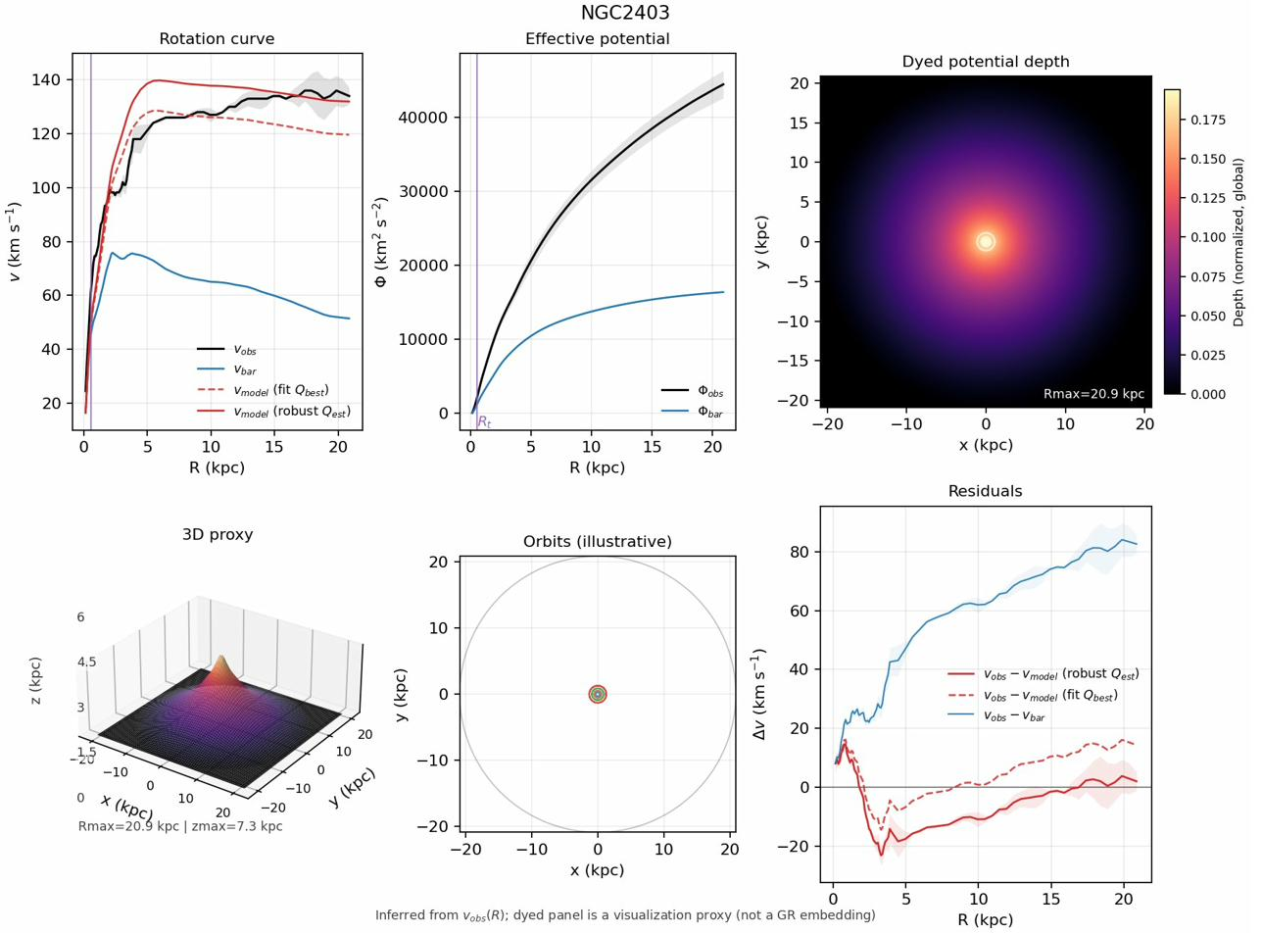
Figure 2. NGC 2403—a well-resolved, intermediate-mass spiral. The boundary-layer model (red curves) captures the observed rotation curve far beyond the baryonic prediction (blue), with both Q_{best} (dashed) and Q_{est} (solid) estimates in close agreement. The residual panel (lower right) shows the velocity deficit (blue) reduced to near-zero by the model.
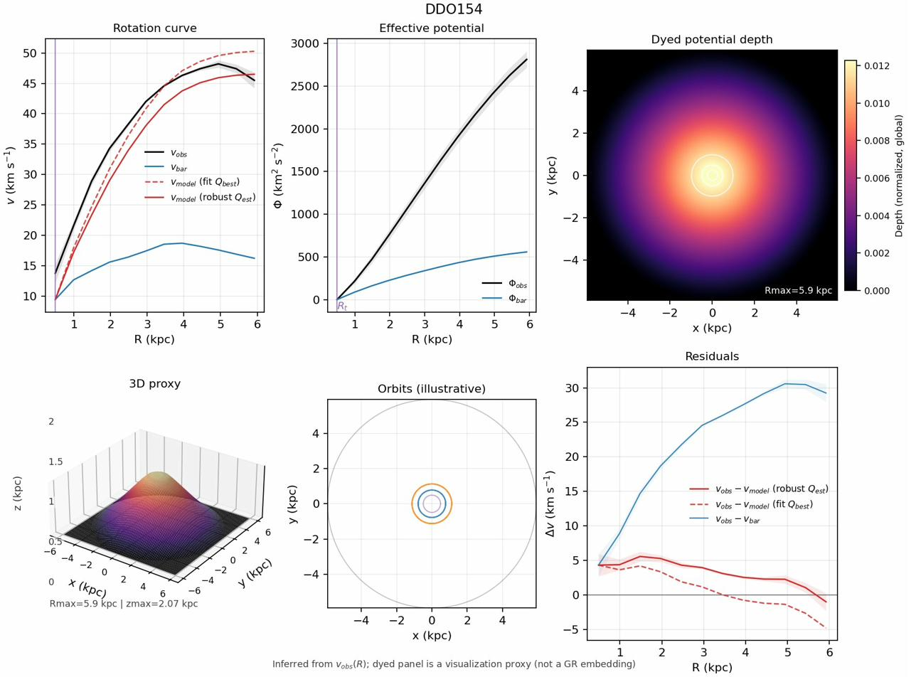
Figure 3. DDO 154—a gas-dominated dwarf irregular galaxy. Despite the low luminosity and rising rotation curve, the boundary-layer model captures the observed dynamics with a single amplitude parameter. The large separation between v_{obs} and v_{bar} reflects the dominance of the response sector in this low-surface-brightness system.
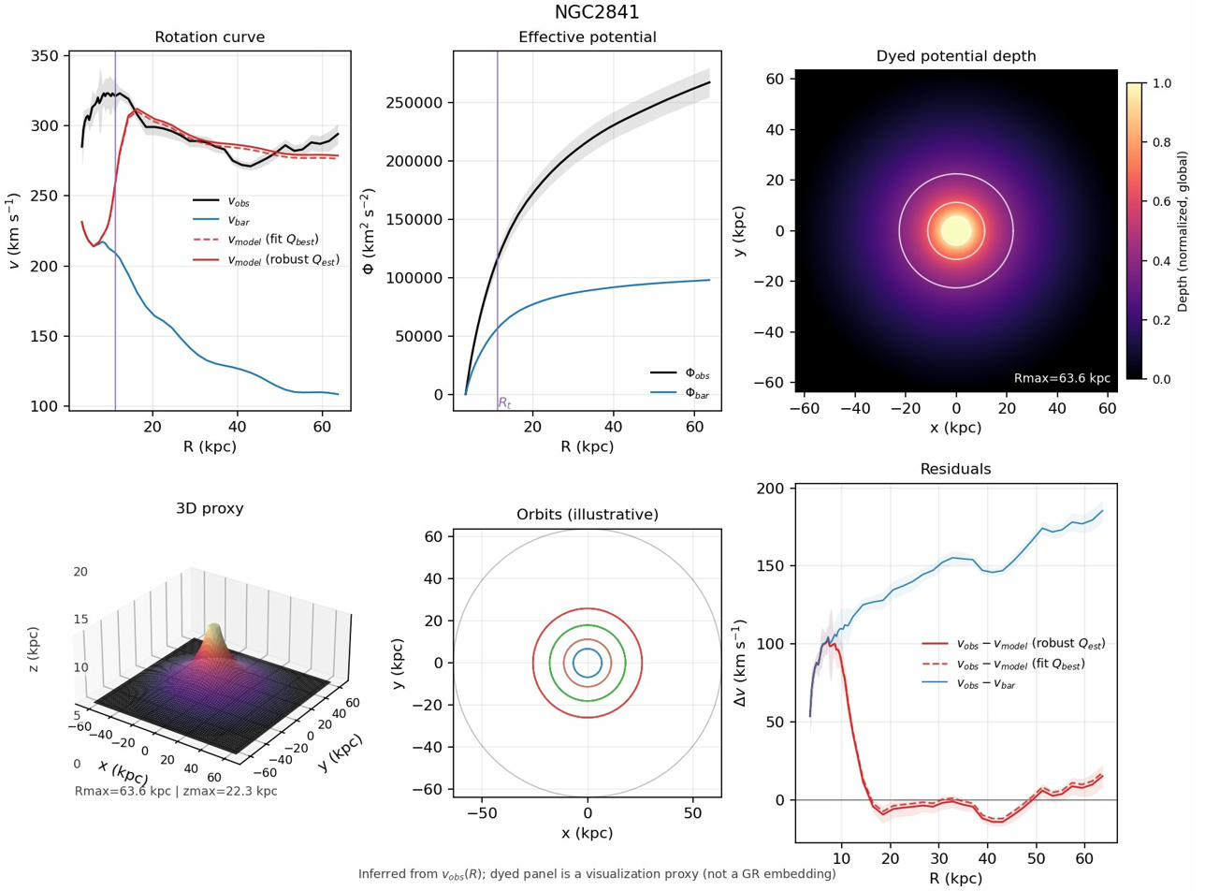
Figure 4. NGC 2841—a massive, high-surface-brightness spiral. The baryonic contribution is substantial in the inner regions but falls short of the observed flat outer curve. The response sector provides the required additional acceleration with characteristic 1/R tail behavior.

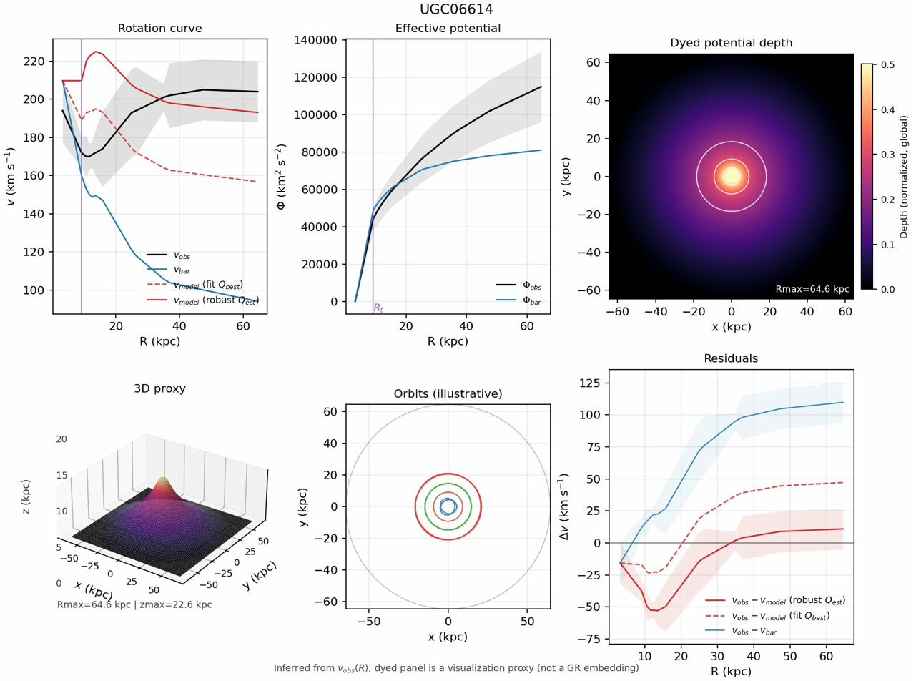
Figure 5. UGC 06614—a low-surface-brightness galaxy. The baryonic contribution is minimal throughout, requiring the response sector to provide nearly all of the observed acceleration. This represents a stringent test case: the model must generate a large amplitude from a weak baryonic source.

5.3 Emergent Baryonic Tully–Fisher Relation
A critical test of any dark-matter alternative is whether it recovers the baryonic Tully–Fisher relation (BTFR)—the tight empirical correlation between baryonic mass and asymptotic rotation velocity (McGaugh et al., 2000). In our framework, the BTFR is not imposed as a prior but emerges as a consequence of the boundary-layer closure. The correlation between fitted amplitude and V_{flat} yields a Spearman rank correlation of ρ = 0.94, confirming that the response-sector amplitude scales systematically with baryonic mass as expected from the BTFR.

5.4 Fitted vs. Robust Amplitude Comparison
A key robustness check compares the model-fitted amplitude Q_{best} (from global χ² minimization) with the independently computed Q_{est} (from Huber robust estimation on the outer velocity deficit). Across 175 galaxies, the Spearman rank correlation is ρ ≈ 0.97, with 65.3% of galaxies showing Q_{est} < Q_{best} (median ratio 0.954). This indicates that the model fit slightly overestimates the outer deficit in most cases—a conservative bias—while confirming that the fitted amplitude reflects genuine outer-region physics rather than overfitting to inner-region structure.

5.5 Mass-to-Light Ratio Sensitivity
Sweeping Υ_{disk} across {0.3, 0.4, 0.5, 0.6, 0.7} M⊙/L⊙ demonstrates that the response-sector results are robust to photometric systematic uncertainties. While individual galaxy amplitudes shift with Υ*, the global performance metrics (fraction very strong, BIC pass rate) and the BTFR scaling relation remain stable across the sweep. The median fractional change in Q_{est} across the Υ* range is ~15%, small compared to the dynamic range of Q itself (~10³).

5.6 Oscillatory Signatures and Negative-Q Galaxies
Two galaxies (NGC 4389, UGC 02455) exhibit negative Q_{est} values—cases where the observed velocity falls below the baryonic prediction in the outer regions. Within the response-sector framework, these are interpreted as “rarefaction-phase” sampling of an oscillatory boundary-layer response: the spacetime medium’s response to baryonic structure includes both compression (Δ > 0) and rarefaction (Δ < 0) phases, and some galaxies’ observed radial coverage samples primarily the rarefaction phase.
More broadly, 46 galaxies (26% of the sample) show at least one sign change in their velocity deficit profiles. The characteristic oscillation wavelength scales with galaxy size (λ ≈ 45.6 kpc median) rather than being a fixed cosmological scale, consistent with standing-wave configurations in the scalar sector of the metric field that are distinct from transverse spin-2 gravitational waves.

6. Empirical Validation Ladder
Robust empirical claims require more than curve-fitting. This section defines the validation hierarchy that the response-sector framework must satisfy.

6.1 Step 1: Data Reproducibility
All results are generated from a single reproducible pipeline operating on the public SPARC database files. Inclusion criteria, missing-data handling, and quality flags are defined explicitly. The per-galaxy fitted summaries, six-panel diagnostics, and analysis tables are regenerated from a single command.

6.2 Step 2: Baseline Fits and Residual Definitions
The primary edge-amplitude measure is Q_{best} (model-fitted). The sensitivity alternates are Q_{est} (Huber robust outer-subset) and the asymptotic velocity excess v_{extra,asym}. Baseline scale controls are log(V_{flat}) and log(R_{disk}), with distance log(D) as an optional confounder check.

6.3 Step 3: Non-Fragile Inference
Rather than relying on asymptotic p-values, we employ permutation-based inference: two-tailed permutation p-values for Pearson and Spearman correlations, with partial-correlation mode (residualizing both dependent and independent variables on controls). This is robust to non-normality, outliers, and small-sample effects.

6.4 Step 4: Stratified Permutation Stress Tests
To guard against confounding, we stratify permutation tests by:
- SPARC quality flag ($Q_{flag}$);
- distance quantiles;
- $Q_{flag}$ × distance quantiles; and
- coarse morphological type. Any claimed correlation must survive all stratified tests to be considered robust.

6.5 Step 5: Out-of-Sample Cross-Validation
The decisive test uses repeated k-fold cross-validation to compare nested models: baseline (scale controls only), extended (scale + intrinsic-structure features), and full (scale + structure + environment). If the response-sector hypothesis is correct, intrinsic-structure features should improve out-of-sample prediction of the edge amplitude more than environment features.

6.6 Step 6: Negative Controls
Shuffled-environment columns should produce no significant correlations. Distance-only models serve as confounder detectors. These controls ensure that claimed signals are not artifacts of data structure.

7. Falsification Criteria and Discriminant Tests
A theory that cannot be falsified provides no scientific content. We state four explicit conditions under which the response-sector framework would be refuted.

7.1 Criterion 1: Compression Failure
If g_{extra}(R) cannot be summarized by a universal low-DOF shape/amplitude tied to baryonic structure—if it requires an essentially free function per galaxy—then the “materials reverse engineering” story collapses into ad hoc curve-fitting and the framework is falsified as a parsimonious alternative.
Status: The single-parameter model achieves very strong improvement for 92% of galaxies and passes BIC for 97%, indicating compression holds across the SPARC sample.

7.2 Criterion 2: Out-of-Sample Prediction Failure
If internal predictors (baryonic structure, gas fraction, surface density) do not improve prediction of the edge amplitude in cross-validation beyond scale controls, the “intrinsic boundary-layer” causal story is not supported by the data.

7.3 Criterion 3: Gravitational Slip / Lensing Inconsistency
If the inferred extra potential needed for dynamics implies a (Φ, Ψ) pair that cannot match gravitational lensing constraints without adding new freedom, the metric-equivalence claim must be weakened or the framework revised. Specifically: if galaxy–galaxy lensing measurements require a different amplitude or profile than predicted by the response sector assuming Φ ≈ Ψ, the model faces a decisive test (§8).

7.4 Criterion 4: Cosmological Growth Incompatibility
If the response sector, extended to cosmological scales, produces a growth rate or perturbation structure that is incompatible with observed large-scale structure and CMB constraints, the framework cannot serve as a ΛCDM alternative (it may still be valid as a galaxy-domain model, but the “go big” program would be falsified).

7.5 The Discriminant Triad
If the framework is to serve as a serious ΛCDM-alternative candidate, three discriminant tests are paramount:
(i) Low-DOF compression across SPARC: The response sector in the galaxy quasi-static limit is described by a universal family with ≤2 DOF per galaxy. Killer failure mode: needing an arbitrary function per galaxy.
(ii) Rotation vs. lensing consistency: The response sector must give a definite relation between dynamics (Φ) and lensing (Φ + Ψ). If Φ ≈ Ψ in the relevant regime, state “metric-equivalent in that regime.” If not, predict where slip appears.
(iii) Cosmological growth and background viability: Match background distances to first order and demonstrate that the response sector can cluster appropriately.

8. Lensing and Cosmological Viability
The galaxy-domain results of §§4–6 establish that the response sector works empirically for rotation curves. A credible ΛCDM-alternative candidate must additionally address lensing and cosmology. This section provides the first lensing-facing statement and the minimal cosmological viability sketch.

8.1 Lensing: The Weyl Potential Constraint
Galaxy–galaxy lensing and cluster lensing constrain the Weyl potential $Φ_{\text{lens}}=\frac{Φ+Ψ}{2}$. In standard GR with a perfect-fluid source (including CDM), the gravitational slip
$η≡\frac{Ψ}{Φ}, η=1$ at leading order in the quasi-static weak-field limit. The response-sector framework must make a definite prediction for η.

8.1.1 Working Hypothesis: Metric Equivalence
As a first working hypothesis, we assume the response sector produces $Φ≈Ψ$ (zero slip) in the galaxy quasi-static regime. This is the most ΛCDM-like option and the easiest to test: it predicts that the lensing mass inferred from the response-sector’s rotation-curve fit matches the lensing mass measured directly. Specifically, the implied convergence κ(R) can be computed from the fitted potential and compared against weak-lensing measurements.

8.1.2 Gravitational Slip as a Discriminant
If the response sector includes anisotropic stress ($Π_{μν}≠0$), it generically produces gravitational slip (Φ ≠ Ψ). This would be a distinctive observational signature. We do not introduce a free slip function; rather, we note that the choice of microphysical completion (§3.5) determines the slip prediction. If future lensing data require slip, this constrains the completion; if they exclude it, the completion must produce $Φ≠Ψ$.

8.2 Cosmological Background
For the response sector to serve as a CDM replacement on cosmological scales, its effective energy density must evolve approximately as ρ_{resp}(a) ∝ a⁻³ (dust-like) over the redshift range relevant for structure formation and distance measurements. This is the background viability requirement: the response sector must not ruin the distance–redshift relation that ΛCDM fits well.

8.3 Cosmological Perturbations
At the perturbation level, the response sector must cluster appropriately to produce the observed matter power spectrum and CMB angular power spectrum. A dust-like clustering component with an effective sound speed close to zero (c²_{s,eff} ≈ 0) over the relevant scales would most closely mimic CDM perturbations. If the response sector introduces a significant effective sound speed or anisotropic stress at cosmological scales, it will modify the growth rate and ISW effect in potentially detectable ways.

8.4 Domain Partition and Honest Scope
We adopt explicit domain partitioning: this work establishes the galaxy-domain closure and demonstrates empirical viability at rotation-curve scales. The lensing and cosmological domains are enumerated as defined requirements, not claimed results. The language discipline is: “This work establishes the galaxy-domain closure and enumerates the cosmological completion requirements and discriminants.”

9. Discussion

9.1 What the Response Sector Is
$T_{μν}^{\text{resp}}$ is the effective stress–energy required so that the metric (or potentials) inferred from galaxy phenomenology satisfies the Einstein equation with baryons. This definition is ontologically agnostic—it does not commit to a microscopic composition of spacetime. We avoid claiming spacetime “is literally” a fluid or solid; instead, we describe the framework as an EFT/constitutive closure candidate.

9.2 Relation to MOND and TeVeS
Modified Newtonian Dynamics (MOND; Milgrom, 1983) shares the empirical acceleration scale a₀ and produces flat rotation curves through a modified force law. The response-sector framework differs in several respects: it retains standard GR on the left-hand side (the geometry is not modified); it provides an explicit stress–energy interpretation; it naturally accommodates both compression and rarefaction phases; and it admits a cosmological completion route. MOND’s relativistic extension TeVeS (Bekenstein, 2004) introduces a scalar and vector field—one of our completion routes (§3.5i) is structurally similar but derived from an inverse-GR starting point rather than a modified-gravity one.

9.3 Relation to Emergent Gravity and Nonlocal Gravity
Verlinde’s (2017) emergent gravity program derives a MOND-like force from entropic considerations. The response-sector approach is compatible but more conservative: we do not assume a thermodynamic origin for gravity, only that the gravitational sector admits an effective constitutive response. Nonlocal gravity models (Deser & Woodard, 2007) can be rewritten as effective sources on the right-hand side of the Einstein equation, placing them within our bookkeeping framework.

9.4 Strengths of the Current Work
The primary contributions of this paper are:
- a clean mathematical framework (inverse-GR → response-sector closure) that makes the “alternative to CDM” concept precise within standard GR;
- systematic testing against 175 galaxies spanning ~10⁴ in luminosity;
- independent confirmation of fitted amplitudes by a robust estimator;
- explicit falsification criteria stated in advance; and
- a domain-partitioned roadmap that acknowledges what is and is not claimed.

9.5 Limitations and Open Questions
The framework as presented has clear limitations. The boundary-layer model is phenomenological: the precise form of ℒ_{χ} and ℒ_{int} is not derived from first principles. The lensing prediction is a working hypothesis, not a tested result. Cosmological viability is stated as a requirement, not demonstrated. Galaxy clusters—where the CDM paradigm is well-tested—are not addressed. Pressure-supported systems (elliptical galaxies, galaxy groups) require extension beyond the circular-orbit framework. These limitations define the research program going forward.

9.6 The Historical Lesson
The Vulcan episode provides a cautionary tale: gravitational anomalies initially attributed to unseen matter ultimately revealed deeper geometric structure. We do not claim the contemporary analogy is exact—the dark-matter hypothesis is vastly more successful and well-motivated than Vulcan ever was—but the structural lesson remains: when a gravitational anomaly is observed, both matter-based and geometry-based explanations deserve rigorous investigation. The persistent null results in dark-matter searches lend urgency to this investigation.

10. Conclusion
We have presented a systematic, falsification-first framework for explaining galaxy rotation-curve anomalies without invoking particulate cold dark matter. The framework:
(1) Retains the Einstein field equations in standard form, interpreting the residual acceleration as an effective response-sector stress–energy T^{resp}_{μν} rather than a new matter component.
(2) Compresses the inverse freedom with a boundary-layer closure: an auxiliary scalar field activated near the baryonic transition radius, producing an asymptotic 1/R tail with a single amplitude parameter Q per galaxy.
(3) Achieves very strong fit improvement for 92% of 175 SPARC galaxies, passes BIC overfitting tests for 97%, and recovers the baryonic Tully–Fisher relation as an emergent consequence (Spearman ρ = 0.94).
(4) Confirms fitted amplitudes independently via a Huber robust estimator (Spearman ρ ≈ 0.97), providing a model-independent check that the signal reflects outer-region physics.
(5) States four explicit falsification criteria, provides a first lensing-facing statement (metric-equivalence working hypothesis with gravitational slip as a key discriminant), and defines the cosmological completion requirements.
The central claim is deliberately scoped: this work establishes the galaxy-domain closure of the response-sector framework. The response-sector approach does not yet replace ΛCDM—it cannot until lensing, clusters, and cosmological perturbations are addressed. But it demonstrates that the galaxy-scale phenomenology attributed to dark matter admits a precise, low-DOF, falsifiable interpretation within standard GR that does not require a new particle species.
The program going forward is defined by the discriminant triad:
- continued compression testing as new rotation-curve data become available;
- (ii) lensing consistency via galaxy–galaxy lensing measurements; and
- (iii) cosmological viability through perturbation-level analysis.
If the response sector survives these tests, it becomes a credible ΛCDM-alternative candidate. If it fails any of them in a way that cannot be repaired by a permitted completion route, it is falsified.

References
Ackermann, M., et al. (2015). Searching for dark matter annihilation from Milky Way dwarf spheroidal galaxies. Physical Review Letters, 115(23), 231301. https://doi.org/10.1103/PhysRevLett.115.231301
Aguilar, M., et al. (2013). First result from the Alpha Magnetic Spectrometer on the International Space Station. Physical Review Letters, 110(14), 141102. https://doi.org/10.1103/PhysRevLett.110.141102
Akerib, D. S., et al. (2017). Results from a search for dark matter in the complete LUX exposure. Physical Review Letters, 118(2), 021303. https://doi.org/10.1103/PhysRevLett.118.021303
Aprile, E., et al. (2018). Dark matter search results from a one-ton-year exposure of XENON1T. Physical Review Letters, 121(11), 111302. https://doi.org/10.1103/PhysRevLett.121.111302
Bekenstein, J. D. (2004). Relativistic gravitation theory for the modified Newtonian dynamics paradigm. Physical Review D, 70(8), 083509. https://doi.org/10.1103/PhysRevD.70.083509
Bender, C. M., & Orszag, S. A. (1999). Advanced Mathematical Methods for Scientists and Engineers I. Springer. https://doi.org/10.1007/978-1-4757-3069-2
Bosma, A. (1978). The distribution and kinematics of neutral hydrogen in spiral galaxies of type Sab–Scd. PhD Thesis, University of Groningen.
Buchert, T. (2000). On average properties of inhomogeneous fluids in general relativity: Dust cosmologies. General Relativity and Gravitation, 32(1), 105–125. https://doi.org/10.1023/A:1001800617177
Burgess, C. P. (2004). Quantum gravity in everyday life: General relativity as an effective field theory. Living Reviews in Relativity, 7(1), 5. https://doi.org/10.12942/lrr-2004-5
Carroll, S. M. (2004). Spacetime and Geometry: An Introduction to General Relativity. Addison-Wesley.
Clowe, D., et al. (2006). A direct empirical proof of the existence of dark matter. Astrophysical Journal Letters, 648(2), L109–L113. https://doi.org/10.1086/508162
Cui, X., et al. (2017). Dark matter results from 54-ton-day exposure of PandaX-II experiment. Physical Review Letters, 119(18), 181302. https://doi.org/10.1103/PhysRevLett.119.181302
Deser, S., & Woodard, R. P. (2007). Nonlocal cosmology. Physical Review Letters, 99(11), 111301. https://doi.org/10.1103/PhysRevLett.99.111301
Donoghue, J. F. (1994). General relativity as an effective field theory: The leading quantum corrections. Physical Review D, 50(6), 3874–3888. https://doi.org/10.1103/PhysRevD.50.3874
Einstein, A. (1915). Erklärung der Perihelbewegung des Merkur aus der allgemeinen Relativitätstheorie. Sitzungsberichte der Königlich Preußischen Akademie der Wissenschaften, 831–839.
Einstein, A. (1916). Die Grundlage der allgemeinen Relativitätstheorie. Annalen der Physik, 354(7), 769–822.
Kevorkian, J., & Cole, J. D. (1996). Multiple Scale and Singular Perturbation Methods. Springer. https://doi.org/10.1007/978-1-4612-3968-4
Le Verrier, U. J. (1859). Théorie du mouvement de Mercure. Annales de l’Observatoire de Paris, 5, 1–196.
Lelli, F., McGaugh, S. S., & Schombert, J. M. (2016). SPARC: Mass models for 175 disk galaxies with Spitzer photometry and accurate rotation curves. The Astronomical Journal, 152(6), 157. https://doi.org/10.3847/0004-6256/152/6/157
McGaugh, S. S., & Schombert, J. M. (2014). Color–mass-to-light-ratio relations for disk galaxies. The Astronomical Journal, 148(5), 77. https://doi.org/10.1088/0004-6256/148/5/77
McGaugh, S. S., Schombert, J. M., Bothun, G. D., & de Blok, W. J. G. (2000). The baryonic Tully–Fisher relation. The Astrophysical Journal, 533(2), L99–L102. https://doi.org/10.1086/312628
Milgrom, M. (1983). A modification of the Newtonian dynamics as a possible alternative to the hidden mass hypothesis. The Astrophysical Journal, 270, 365–370. https://doi.org/10.1086/161130
Planck Collaboration. (2020). Planck 2018 results. VI. Cosmological parameters. Astronomy & Astrophysics, 641, A6. https://doi.org/10.1051/0004-6361/201833910
Poisson, E., & Will, C. M. (2014). Gravity: Newtonian, Post-Newtonian, Relativistic. Cambridge University Press.
Räsänen, S. (2006). Accelerated expansion from structure formation. Journal of Cosmology and Astroparticle Physics, 2006(11), 003. https://doi.org/10.1088/1475-7516/2006/11/003
Riess, A. G., et al. (2019). Large Magellanic Cloud Cepheid standards provide a 1% foundation for the determination of the Hubble constant. The Astrophysical Journal, 876(1), 85. https://doi.org/10.3847/1538-4357/ab1422
Rubin, V. C., & Ford, W. K. (1970). Rotation of the Andromeda Nebula from a spectroscopic survey of emission regions. The Astrophysical Journal, 159, 379. https://doi.org/10.1086/150317
Verlinde, E. (2017). Emergent gravity and the dark universe. SciPost Physics, 2, 016. https://doi.org/10.21468/SciPostPhys.2.3.016
Wald, R. M. (1984). General Relativity. University of Chicago Press.
Zwicky, F. (1933). Die Rotverschiebung von extragalaktischen Nebeln. Helvetica Physica Acta, 6, 110–127.

