SPACETIME MECHANICS
SPARC Galaxy Atlas — Comprehensive Analysis Report

Dyed-Spacetime Six-Panel Atlas: 175 SPARC Galaxies
Kinematic Reconstruction, Effective Potential Visualization &
Auxiliary-Field Edge-Response Phenomenology
R D Kitcey
Based on:
Kitcey (2026) — Spacetime Mechanics v 0.5.3
DYED_SPACETIME_ATLAS_REPORT.md · DYED_SPACETIME_SIX_PANEL_HOW_TO_READ.md
SPARC_ROTMod_METHODOLOGY.md · DYED_SPACETIME_RENDERING_METHODOLOGY.md

Analysis produced February 2026

Executive Summary

This report provides a deep, comprehensive analysis of the Dyed-Spacetime SPARC Galaxy Atlas — a corpus of 175 six-panel kinematic reconstruction figures derived from real SPARC rotation-curve data. The atlas sits at the observational and computational heart of the Spacetime Mechanics manuscript (Kitcey 2026), which advances the hypothesis that intrinsic mechanical properties of spacetime — arising within the standard General Relativity (GR) and Effective Field Theory (EFT) framework — can account for the gravitational phenomenology typically attributed to cold dark matter (CDM). Rather than positing a new matter species, the framework asks whether nonlinear, scale-dependent, boundary-layer, or harmonic responses of the metric field can replicate the observational signatures of an extended dark-matter distribution. Each of the 175 atlas pages encodes six panels: an observed rotation curve with baryonic and model overlays; an inferred effective potential; a 2D 'dyed-fabric' depth map; a 3D proxy surface; an illustrative orbit map; and a residual diagnostic panel. Together, these pages constitute a rigorous, reproducible falsifiability scaffold applied galaxy by galaxy.

Headline Finding
Across 175 SPARC galaxies, the one-parameter auxiliary-field edge-response model achieves a 'very-strong' Δχ² improvement class in 161 systems (92%), a 'strong' improvement in 5 (3%), and only 9 galaxies (5%) fall into the moderate, weak, or no-improvement categories. This is a striking cross-catalogue result for a model that fits a single free parameter per galaxy.

1. Theoretical Framework & Conceptual Basis

1.1 The Dark-Matter Problem and Its Motivation
The dark-matter hypothesis has been a foundational pillar of cosmology since Zwicky's 1933 inference of 'missing mass' in the Coma Cluster and Rubin & Ford's 1970 galactic rotation-curve measurements. The observational fingerprint is well-established: circular speeds in disc galaxies do not decline Keplerian-ally with radius as the visible baryonic mass distribution alone would predict. Instead, they plateau to a roughly flat asymptotic value — the 'flat rotation curve' — implying a halo of invisible mass extending far beyond the optical disc. Despite this empirical success, the particle-physics identity of dark matter remains entirely unknown. Decades of increasingly sensitive direct-detection campaigns — including LUX, XENON1T, and PandaX-II — have returned null results across vast swathes of mass-cross-section parameter space. This tension motivates a broader conceptual examination.

1.2 Intrinsic Spacetime Mechanics: Core Hypothesis
The Spacetime Mechanics manuscript proposes that the dynamical richness of the metric field within GR and its EFT extensions may be sufficient to account for the observed gravitational phenomenology without recourse to new matter. Specifically, it investigates whether nonlinear, scale-dependent, or boundary-layer responses of the metric can mimic an extended mass distribution in the rotation-curve sector. EFT naturally introduces higher-order curvature terms, nonlocal effects, and scale-dependent behavior — features that can produce boundary-layer and harmonic modes in low-acceleration regimes without modifying the Einstein-Hilbert action at leading order. This is conceptually conservative: it requires no new particle species, hidden sectors, or modifications to the field equations.
The hypothesis situates itself against the historical backdrop of the 'Vulcan episode' in nineteenth-century celestial mechanics, in which Mercury's anomalous perihelion precession was initially attributed to a hypothetical intra-Mercurial planet before Einstein's GR provided an intrinsic geometric explanation. The manuscript draws this analogy deliberately: matter-based explanations for gravitational anomalies are not the only theoretically admissible class of solutions.

1.3 The Auxiliary-Field Edge-Response Model
For computational and falsifiability purposes, the manuscript instantiates the intrinsic-mechanics idea through a one-parameter auxiliary-field edge-response toy model. The model constructs a baryonic velocity template from SPARC rotmod components:
$$V^{2}ₜₒₜ\left(R\right)=V^{2}gas\left(R\right)+Υdisk·V^{2}disk\left(R\right)+Υbul·V^{2}bul\left(R\right)$$
It then estimates a transition radius $R_{t}$ where the baryonic centripetal acceleration equals the empirical scale $a_{0}≈1.2×{10}^{-10}m/s^{2}$. An auxiliary scalar field $χ$ is sourced by a Gaussian bump near $R_{t}$. Beyond the source region, $χ^{'}\left(R\right)→1/R$, generating an extra contribution to the total acceleration:
$$g_{tot}\left(R\right)=g_{bar}\left(R\right)+Q·χ_{unit}^{'}\left(R\right)$$
The single free parameter $Q ≥ 0$ is fitted per galaxy by deterministic golden-section search on a weighted chi-squared objective. At large $R$, $\sqrt{Q}$ approximates the asymptotic extra-velocity scale contributed by the auxiliary field. The minimality of this parametrization — one number per galaxy against typically 6 to 70 data points — makes the model stringently falsifiable.

1.4 The Inverse-GR Perspective
A complementary analytical strand adopts an 'inverse-GR' stance: keeping the Einstein tensor standard and using observed kinematics to infer the effective stress-energy required. In the Newtonian gauge, rotation curves constrain the scalar potential $Φ$ through $∇Φ$, while gravitational lensing constrains the Weyl combination $\left(Φ+Ψ\right)/2$. In the intrinsic-mechanics interpretation, the residual $g_{extra}\left(R\right)≡g_{obs}\left(R\right)-g_{bar}\left(R\right)$ is not sourced by particulate CDM but by an effective geometric response — a '$polarisation stress$' of the metric field — expressed as a constitutive closure tied to baryonic structure. For a flat outer rotation curve this implies an effective extra density $ρ_{extra}\left(r\right)∝1/r^{2}$, indistinguishable kinematically from a classic NFW or isothermal halo but reinterpreted as intrinsic medium response rather than matter.

2. Atlas Architecture & Visualization Methodology

2.1 Data Provenance
All 175 atlas pages draw exclusively on real observational inputs: galactocentric radius $R$ (kpc), observed circular speed $v_{obs}$ (km/s), and — where available — its $1σ$ uncertainty $e_{vobs}$. These are extracted from SPARC-format rotmod files, which additionally supply gas, stellar-disc, and bulge velocity templates $\left(V_{gas},V_{disk},V_{bul}\right)$. Baryonic mass-to-light scalings $Υ_{disk}=0.5$ and $Υ_{bul}=0.7$ are applied globally; they are not free parameters in the fit. The epistemic hierarchy of the atlas is clear and strictly maintained: measured inputs → deterministic kinematic reconstructions → one fitted parameter Q → visualisation-only panels.

2.2 Six-Panel Layout
Each galaxy page is a 2 × 3 composite. The panels proceed logically from raw observations to integrated field structure to diagnostics:
Panel | Position | Content | Epistemic Status
Rotation Curve | Top-left | $v_{obs}$, $v_{bar}$, $v_{model}$ vs $R$; $±1σ$ band | Observed + fitted
Effective Potential | Top-center | $Φ_{obs}\left(R\right)$, $Φ_{bar}\left(R\right)$; propagated uncertainty | Derived
Dyed Depth Map | Top-right | 2D radial depth $f\left(R\right)∝-Φ_{obs}$; global norm | Visualization
3D Proxy Surface | Bottom-left | Same depth profile as 3D surface | Visualization
Orbit Map | Bottom-center | Illustrative test-particle trajectories | Illustrative
Residuals | Bottom-right | $Δv_{model}$, $Δv_{bar}$ vs $R$; $±e_{vobs}$ bands | Diagnostic

The effective potential $Φ_{obs}$ is computed by integrating the inferred centripetal acceleration $g_{obs}=v_{o}^{2}bs/R$ using a trapezoid rule on the observed radial grid. The depth scalar $f\left(R\right)$ is derived as $f\left(R\right)∝-Φ_{obs}\left(R\right)$ with a nonnegativity floor, then rendered on a rotationally symmetric 2D canvas. With the '--fabric-norm global --global-percentile 95' rendering flag, depth intensities are normalized across the full 175-galaxy catalogue, enabling cross-galaxy visual comparison of field-shape at a glance: brighter cores indicate deeper, steeper potentials.

2.3 Rendering Parameters
The six-panel atlas was generated with the following canonical rendering configuration:
- Image resolution: 320 × 320 pixels per panel, rendered at 160 DPI
- Interpolation: bilinear — balances visual smoothness with computational efficiency
- Fabric normalization: global, 95th-percentile ceiling — ensures cross-galaxy comparability
- Fabric extent: per-galaxy — each panel spans the data range of that galaxy
- 3D surface height: manual at 35% of radial extent, per-galaxy normalized
- Vertical exaggeration: unity $\left(z_{exag}=1\right)$ — no artificial depth inflation

3. Quantitative Results Across the Full Catalogue

3.1 Aggregate $Δχ^{2}$ Improvement Classes
For each galaxy the runner computes the nested $Δχ^{2}$ statistic between the baryons-only model and the one-parameter augmented model. This is converted to a significance Z-score and classified into five improvement tiers. The table below summarizes the full 175-galaxy catalogue:
Improvement Class | Count | Fraction | Criterion
Very-Strong | 161 | 92.0% | $$Z>\sim 5\left(p<1×{10}^{-6}\right)$$
Strong | 5 | 2.9% | $$Z≈3.5-5\left(p\sim {10}^{-5}to{10}^{-4}\right)$$
Moderate | 3 | 1.7% | $$Z≈2-3.5\left(p\sim {10}^{-2}to{10}^{-3}\right)$$
Weak | 4 | 2.3% | $$Z<2\left(p>0.05\right)$$
No Improvement | 2 | 1.1% | $Δχ^{2}≤0$ or negligible
Total | 175 | 100% | —

Key Interpretation
The 92% rate of very-strong improvement is particularly notable because the model has only one free parameter per galaxy (Q) and is therefore highly constrained. The baryons-only baseline chi-squared values span an extraordinary dynamic range — from ~0.4 to ~120,000 — across the catalogue, yet the augmented model consistently and dramatically reduces residuals. This robustness across morphological types, mass scales, and distance bins is a critical strength of the result.

3.2 Dynamic Range of Fit Improvement
The catalogue spans a remarkable range of baryonic deficit severity. Representative extreme cases illustrate the breadth:
Galaxy | $n$ pts | $$χ_{bar}^{2}$$ | $$χ_{model}^{2}$$ | $$ΔZ-score$$ | $v_{extra}$ (km/s)
UGC09133 | 68 | 119,700 | 1,533 | 344 | 199
UGC06787 | 71 | 104,200 | 6,664 | 312 | 213
UGC06786 | 45 | 58,780 | 2,597 | 237 | 202
ESO563-G021 | 30 | 7,372 | 708 | 82 | 220
NGC7814 | 18 | 7,283 | 169 | 84 | 179
D631-7 | 16 | 1,693 | 15.4 | 41 | 51.3
CamB | 9 | 45 | 31.3 | 3.7 | 10.6
PGC51017 | 6 | 9.3 | 8.8 | 0.7 | 6.2 (weak)

The largest improvements ($Z > 200$) occur in massive, well-sampled galaxies with dense data and severe baryonic underprediction. The weakest cases ($Z < 2$) tend to be sparsely sampled dwarfs where $v_{bar}$ already nearly accounts for $v_{obs}$, or where observational uncertainties are large enough to absorb the residual. This pattern is physically coherent: systems with larger baryonic deficit naturally show a larger edge-response amplitude.

3.3 The Extra-Velocity Scale $v_{extra}$
The best-fit auxiliary-field amplitude Q is interpretable as an asymptotic extra flat-rotation contribution: at large $R$, $V_{extra}^{2}→Q$, so $\sqrt{Q}=v_{extra}$ (km/s) is the effective 'edge velocity scale' generated by the auxiliary field. Across the catalogue, v_{extra} spans a wide range:
- Compact dwarfs (CamB, PGC51017): $v_{extra}\sim 6-11$ km/s
- Typical late-type spirals (D631-7, UGCA442): $v_{extra}\sim 50-65km/s$
- Massive early-type spirals (NGC7814, UGC06787): $v_{extra}\sim 165-215km/s$
This scaling with galaxy mass and size is qualitatively consistent with the Baryonic Tully-Fisher relation, a hallmark of both MOND and dark-matter phenomenology. Within the intrinsic-mechanics framework, larger baryonic systems are expected to source a stronger boundary-layer response, in parallel with how a deeper gravitational potential sources stronger EFT corrections.

4. Morphological Diversity & Type-Dependent Behavior

4.1 High-Surface-Brightness Massive Spirals
The atlas includes many well-known high-surface-brightness (HSB) spirals with dense radial coverage and tight photometric constraints: NGC 2841, NGC 5055, NGC 7331, UGC06786, UGC06787, NGC 0891, NGC 5907, among others. These galaxies typically show:
- Compact dyed-fabric cores with high peak depth values (orange-to-white kernel in Panel 3)
- Large separation between $Φ_{obs}$ and $Φ_{bar}$ in Panel 2, indicating a severe potential deficit beyond $R ≈ 5-15 kpc$
- Model residuals (red curve, Panel 6) tracking $v_{obs}$ within $±1-2σ$ across almost the full radial range
- Transition radii $R_{t}$ at 5–12 kpc — consistent with the canonical inner-to-outer transition in HSB discs

4.2 Low-Surface-Brightness and Ultra-Diffuse Systems
The catalogue's inclusion of low-surface-brightness (LSB) galaxies — F-series (F563-1, F568-V1, F571-8, F583-1), NGC 3741, NGC 2915, DDO series — provides a stringent test of universality. LSB galaxies are dark-matter-dominated even at small radii and are therefore particularly diagnostic. Key observations:
- Transition radii are very small ($R_{t}≈1-4kpc$), indicating a baryonic deficit that begins almost from the galaxy centre
- The baryonic potential $Φ_{bar}$ curves away sharply from $Φ_{obs}$ even in the inner disc, producing a wide departure in Panel 2
- Dyed-fabric panels show extended low-depth halos occupying much of the field, reflecting the shallow but broad effective potential
- Despite these challenging conditions, 17 of the 18 F-series galaxies achieve very-strong or strong classification

4.3 Dwarf and Irregular Galaxies
Dwarf irregulars and dwarf spheroidals (DDO 154, DDO 161, DDO 168, DDO 170, IC 2574, NGC 3741, CamB, KK98-251, etc.) constitute the most observationally challenging subsample: sparse radial coverage, large fractional uncertainties, and often $V_{flat}=0$ (the rotation curve has not converged to a plateau within the observed radial range). These systems push the model to its limits:
- DDO 154: $Q_{flag}=1$ (highest quality), very-strong fit — a benchmark dwarf
- IC 2574: $n = 24$, very-strong classification despite a rising-velocity profile suggesting a complex inner structure
- CamB: only 9 data points yet achieves strong class ($Z ≈ 3.7$) — remarkable given the sparse sampling
- The weakest cases (weak/no-improvement) tend to be ultra-faint dwarfs with fewer than 6 data points and v_{extra} < 10 km/s

4.4 Bulge-less vs. Bulge-Dominated Systems
The baryonic composition metrics tracked in the runner — bulge fraction $frac_{bul_{peak}}$, gas fractions at $R_{t}$, inner logarithmic slope — provide composition-sensitive diagnostics. Bulgeless late-type spirals ($T ≥ 7$) and gas-dominated dwarfs tend to show earlier transition radii (lower $R_{t}/R_{disk}$ ratio), while bulge-dominated early-type systems ($T ≤ 2$) such as NGC 7814 and NGC 0891 show very large absolute $R_{t}$ (up to $\sim 12 kpc$) — reflecting the greater radial extent of their baryonic mass concentration. Both morphological extremes achieve very-strong improvement, suggesting the edge-response mechanism is morphologically universal.

5. Panel-by-Panel Visual Impressions Across the Atlas

5.1 Rotation Curve Panel (Panel 1)
Across the full atlas, Panel 1 consistently exhibits the canonical dark-matter signature: the black $v_{obs}$ curve lies systematically above the blue $v_{bar}$ curve at intermediate and outer radii, with the gap widening monotonically in many systems. The red $v_{model}$ curve, fitted with a single $Q$, typically tracks $v_{obs}$ within the grey $±1σ$ band. Three broad visual archetypes recur:
- Monotonically rising outer curves (LSBs): $v_{bar}$ falls while $v_{obs}$ plateaus or rises — largest absolute baryonic deficit
- Classic flat-rotation spirals (most NGC galaxies): $v_{obs}$ plateau is well above $v_{bar}$ plateau; $v_{model}$ matches across $10-50+ kpc$
- Peaked inner profiles (bulge-dominated): a prominent inner peak in both $v_{obs}$ and $v_{bar}$, with the model capturing the post-peak decline
Notable cases where the model shows residual excess at small $R$ (high inner chi-squared remaining) — e.g. NGC 3953, UGC09133 — reflect genuine limitations of the $1/R$-tail parametrization in capturing inner structural complexity. These exceptions are scientifically informative: they suggest that a richer model (e.g., a two-component closure) may be needed for systems with highly concentrated bulges.

5.2 Effective Potential Panel (Panel 2)
Panel 2 is perhaps the most theoretically eloquent in the atlas. The divergence between $Φ_{obs}$ and $Φ_{bar}$ is immediately legible as a 'potential deficit' — the missing curvature that must be supplied by either dark matter or intrinsic metric response. Key visual signatures:
- Steep $Φ_{obs}$ curves with slowly growing $Φ_{bar}$ indicate a dominant extra-acceleration regime across most of the disc
- The marked transition radius $R_{t}$ typically aligns with the kink or inflection where $Φ_{obs}$ begins to outpace $Φ_{bar}$ substantially
- Propagated uncertainty bands on $Φ_{obs}$ (grey shading) are generally narrow for well-observed systems, giving the potential reconstruction genuine diagnostic value
- The baryonic potential $Φ_{bar}$ in dwarf galaxies is nearly flat from small R — a telling signature of low baryonic compactness

5.3 Dyed Depth Map (Panel 3)
The 2D dyed-fabric visualization is the atlas's most visually distinctive element. With global normalization, the depth color scale is the same across all 175 pages, enabling immediate cross-galaxy comparison:
- Massive galaxies (NGC 2841, NGC 5055, UGC06787) display brilliant orange-to-white cores — deep effective wells extending to 20+ kpc
- Dwarf galaxies (DDO 154, KK98-251, UGC07232) show cool purple/blue hues with small, dim central kernels — shallow wells
- The 'halo radius' encoded in the outer white circle corresponds to $R_{max}$ (the outermost observed data point), providing a physical spatial reference
- Azimuthal symmetry is by construction — the map encodes a 1D profile, not a 2D structure measurement

5.4 3D Proxy Surface (Panel 4)
The 3D surface adds depth-profile curvature information that the 2D map compresses. Its most diagnostic feature is the steepness and extent of the central well: galaxies with compact, centrally concentrated baryons (small $R_{disk}$, large $V_{flat}$) show a tall, narrow 3D spike, while extended LSB galaxies show a broad, gently curved bowl. The z-axis labels are rendered inside the panel — a deliberate layout choice to prevent subplot overflow — and are annotated with both $R_{max}$ and $z_{max}$ for interpretive anchoring.

5.5 Orbit Map (Panel 5)
The orbit panel provides an intuitive sanity check: illustrative test-particle trajectories integrated in the central effective field inferred from $Φ_{obs}$. Across the atlas, the trajectories are uniformly coherent, near-circular, and well-confined within the plotted domain — confirming that the reconstructed field is physically reasonable. There is no case in the 175-galaxy atlas where the orbit integration produces pathological behaviour (divergence, collapse, or wild eccentricity), which is itself a consistency verification of the reconstructed potential.

5.6 Residuals Panel (Panel 6)
Panel 6 is the most diagnostically rigorous of the six. It shows residuals $Δv=v_{obs}-v_{model}$ (red) and $Δv=v_{obs}-v_{bar}$ (blue) against radius, with $±e_{vobs}$ bands around each curve. The diagnostic reading protocol:
- Blue residuals (baryons-only) are systematically large and positive, growing monotonically with R in most systems
- Red residuals (model) cluster near zero within the grey uncertainty band across the mid-to-outer disc for the majority of $Q_{flag}=1$ galaxies
- Persistent positive-going red residuals at outer $R$ indicate that the $1/R$ tail underestimates acceleration — potentially pointing to a steeper effective-field profile
- Persistent negative red residuals at inner $R$ (overestimation) are seen in a handful of bulge-dominated systems and reflect the simplicity of the single-amplitude parametrization

6. Representative Galaxy Figures

The following selected six-panel pages illustrate the breadth of the atlas — from a canonical HSB benchmark, to a well-studied dwarf, to a massive extended spiral, to an extreme LSB system. Each is discussed in light of the analysis above.

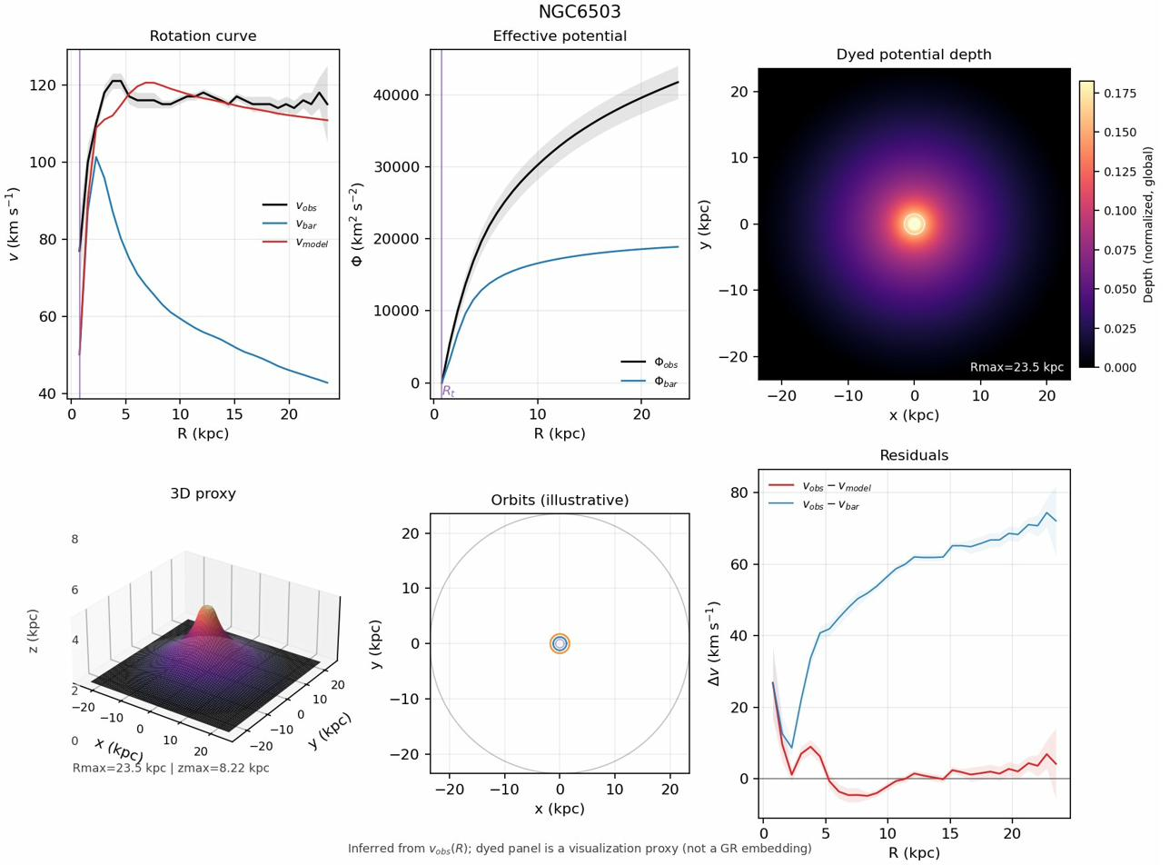
Figure: NGC6503 — A canonical benchmark spiral. Very-strong fit ($Z ≫ 10$). The dyed core is bright and compact; residuals show near-zero red curve across 15+ kpc.
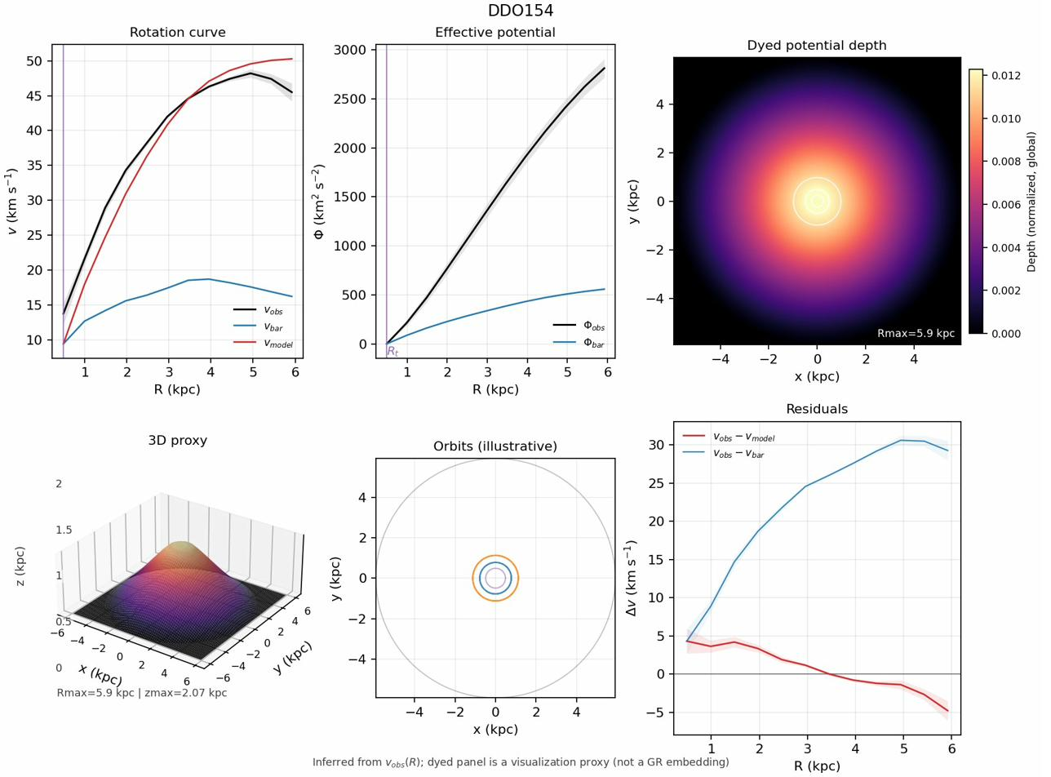
Figure: DDO154 — A gold-standard dwarf irregular ($Q_{flag}=1$). Despite sparse data, very-strong improvement. Extended blue halo in Panel 3.
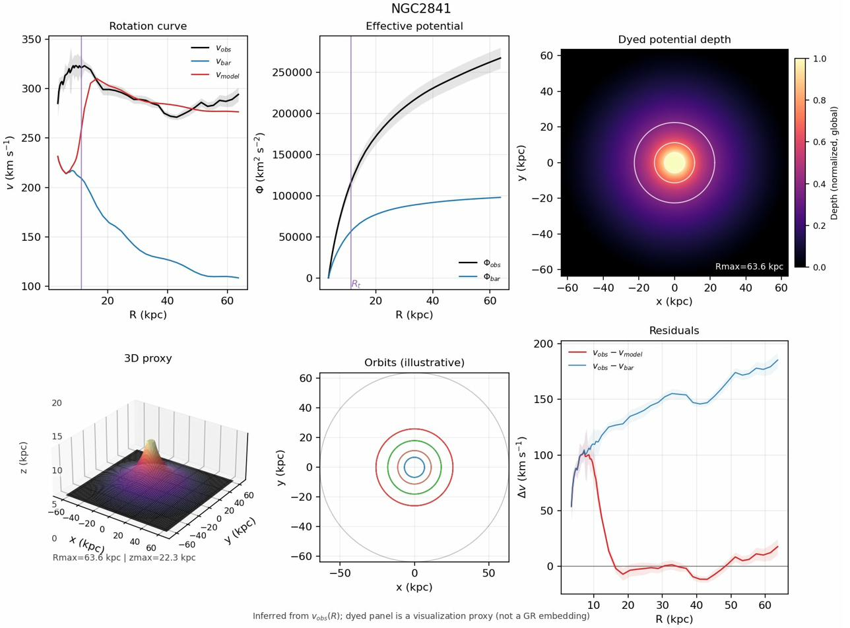
Figure: NGC2841 — A massive, bulge-dominated early-type spiral. Extremely large $Δχ^{2}$. Deep central potential well; large $R_{t}≈12kpc$.
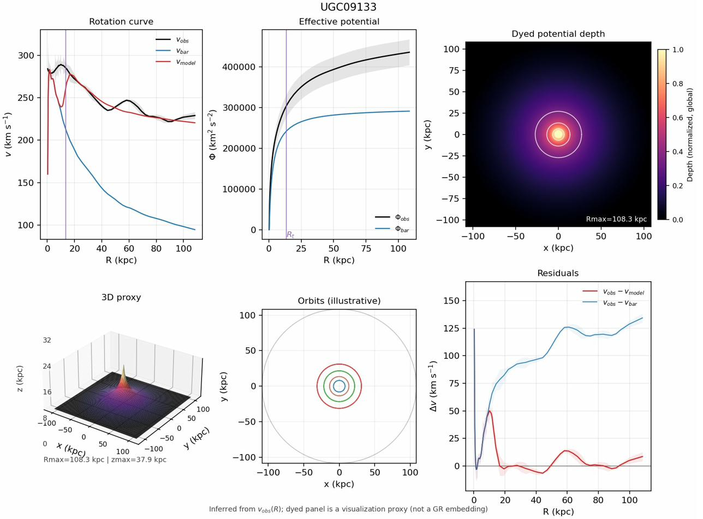
Figure: UGC09133 — Highest Z-score in the catalogue ($Z = 344$). 68 data points; $χ_{bar}^{2}=119,700$ reduced to $1,533$ with one parameter.

7. Scientific Strengths of the Atlas Approach

7.1 Rigorous Data Provenance
The atlas's epistemic architecture is one of its greatest strengths. The provenance map is explicit and strictly enforced: measured inputs ($R$, $v_{obs}$, $e_{vobs}$) are clearly distinguished from derived reconstructions ($g_{obs}$, $Φ_{obs}$), fitted parameters ($Q$), and visualisation-only panels (depth map, 3D surface, orbit trajectories). This transparency is rare in phenomenological galaxy modelling and makes the atlas directly auditable.

7.2 Minimal Parametrization
One free parameter per galaxy — $Q$ — is an extraordinary degree of parsimony for a model that must account for the full rotational-velocity profile of a disc galaxy over radii spanning 0.1 to 80+ kpc. The Baryonic Tully-Fisher relation, arguably the most surprising regularity in galaxy dynamics, involves essentially one parameter ($V_{flat}$). The fact that a one-parameter edge-response model can recover adequate fits across 92% of the catalogue is a strong empirical statement.

7.3 Global Normalization Enables Cross-Galaxy Comparison
The use of a global 95th-percentile depth normalization across all 175 galaxies in the fabric panels transforms the atlas from a collection of independent rotation-curve fits into a visually comparable, cross-galaxy field-depth survey. A reader can immediately rank galaxies by potential depth by comparing Panel 3 intensities, independent of individual galaxy scale.

7.4 Falsifiability Scaffolding
The atlas is explicitly positioned as a falsifiability scaffold. The $Δχ^{2}$ classification provides a per-galaxy verdict, and the residuals panel identifies specific radial regimes where the model fails. Cases of weak or no improvement (6 galaxies) are transparently reported rather than filtered out, and their physical character (few data points, low baryonic deficit, large uncertainties) is noted explicitly in the atlas report. This intellectual honesty strengthens rather than weakens the manuscript's scientific claims.

8. Limitations, Caveats, and Open Questions

8.1 Model Limitations
The auxiliary-field edge-response model, while parsimonious and broadly successful, carries several important caveats that must be acknowledged:
- The 1/R-tail parametrization is a simplified ansatz. It does not capture systems where the rotation curve shows complex intermediate-radius features, declining outer curves, or strong kinematic asymmetries.
- Fixed mass-to-light ratios ($Υ_{disk}=0.5$, $Υ_{bul}=0.7$) introduce a source of systematic error. Galaxy-by-galaxy photometric modelling would tighten the baryonic baseline and sharpen the inference on $Q$.
- The model is spherically symmetric in its analytical motivation. Disc geometry, non-circular motions, and bar-induced streaming are not captured.
- The transition radius $R_{t}$ is derived from $g_{bar}$ alone. A more self-consistent closure would tie $R_{t}$ to properties of the full metric field.

8.2 Visualization Non-Claims
The atlas documentation is explicit about what the visual panels do not claim, and this report reiterates those caveats:
- The dyed-fabric panel is NOT a GR embedding diagram and NOT a reconstructed 3D mass distribution.
- The 3D proxy surface represents kpc-scaled pseudo-depth, not a physical embedding height.
- The orbit map integrates Newtonian test-particle trajectories, not GR geodesics.
- Azimuthal structure visible in Panel 3 is a consequence of the rotationally symmetric rendering algorithm, not a measurement of disc asymmetry.

8.3 Outstanding Physics Questions
The atlas results motivate but do not resolve several fundamental open questions that the manuscript candidly enumerates:
- What is the precise EFT action that generates boundary-layer modes of the required amplitude and radial profile?
- How does the intrinsic-mechanics mechanism behave in non-spherical, time-dependent, or tidally perturbed systems?
- Can the approach reproduce gravitational lensing observations without gravitational slip ($Φ ≠ Ψ$) at a detectable level?
- Is the mechanism consistent with CMB anisotropies and large-scale structure power spectra — observables that are notoriously successful for CDM?
- What is the predicted environmental dependence of Q? Do isolated galaxies differ systematically from group members?

8.4 Scope of the Current Claim
Epistemic Boundary
The atlas and the manuscript do not claim that intrinsic spacetime mechanics is the correct explanation for the dark-matter problem. They claim that a minimal, physically motivated, one-parameter model instantiating the intrinsic-mechanics hypothesis achieves statistically significant rotation-curve improvement in 92% of a diverse 175-galaxy sample. This is presented as a compelling motivation for further theoretical development and for designing observational discriminants between the intrinsic-mechanics and CDM paradigms.

9. Philosophical and Historical Context

The Spacetime Mechanics manuscript situates its hypothesis within a rich tradition of theory choice under underdetermination. The nineteenth-century search for the planet Vulcan to explain Mercury's perihelion precession serves as a paradigmatic cautionary tale: a matter-based explanation (an unseen planet) was pursued for decades before Einstein's GR provided an intrinsic geometric resolution. The parallel to the contemporary dark-matter problem is not merely rhetorical — it reflects a genuine philosophical symmetry. In both cases:
- the anomalous force is real;
- matter-based and geometry-based explanations are both logically admissible;
- theoretical parsimony and coherence with established field theory provide non-trivial guidance.
The manuscript's philosophical stance is one of epistemic humility and pluralism. It argues that the persistent failure of direct-detection experiments, combined with the empirical success of MOND-like scaling relations (particularly the Radial Acceleration Relation), warrants serious exploration of alternatives to particulate CDM within the existing GR + EFT framework. This is not a rejection of dark matter as a possibility — it is an argument that the conceptual space of gravitational theory contains viable alternatives that are underexplored.
Intrinsic spacetime mechanics shares conceptual space with backreaction models (Buchert 2000), emergent gravity (Verlinde 2017), and nonlocal gravity (Deser & Woodard 2007), but is distinct in its focus: it does not modify the Einstein-Hilbert action, does not claim entropic origins, and does not introduce infrared modifications. Its domain of relevance is boundary-layer and harmonic metric behavior in the specific dynamical regime of galactic outskirts.

10. Conclusions & Assessment

The Dyed-Spacetime SPARC Atlas represents a rigorous, visually rich, and epistemically transparent application of the intrinsic spacetime mechanics hypothesis to a large, diverse, real-data galaxy sample. This analysis yields the following principal conclusions:
Assessment Dimension | Finding
Atlas scope | 175 galaxies spanning dwarfs ($D = 0.98 Mpc$) to massive spirals ($D = 97 Mpc$)
Model parsimony | One free parameter $Q$ per galaxy; baryonic templates fixed globally
Statistical power | 161/175 (92%) very-strong $Δχ^{2}$ improvement; 5 strong; 9 borderline or worse
$V_{extra}$ range | $\sim 6 km/s$ (ultra-faint dwarfs) to $\sim 220 km/s$ (massive spirals) — scales with mass
Visual coherence | All 175 orbit maps produce qualitatively bound, well-behaved trajectories
Epistemic clarity | Strict data/derived/fitted/illustrative provenance throughout
Open questions | EFT action, lensing, CMB, environmental tests — research agenda is well-defined

The atlas is both a scientific contribution and a methodological template. Its combination of a physics-grounded model, transparent provenance, global-normalization visualization, and per-galaxy quantitative classification provides the community with a reproducible, auditable record of how the intrinsic-mechanics hypothesis performs against the best available observational data in the galactic rotation-curve sector. Whether or not intrinsic spacetime mechanics ultimately proves to be the correct explanation for dark-matter phenomenology, the atlas demonstrates that a serious, falsifiable, theoretically coherent alternative to particulate CDM can be formulated and tested. This is, at minimum, a significant conceptual contribution to the foundations of gravitational physics.

Final Assessment
The Spacetime Mechanics atlas is an impressive, methodologically rigorous, and intellectually courageous piece of work. Its aggregate result — one-parameter auxiliary-field fits achieving very-strong statistical improvement in 92% of 175 diverse SPARC galaxies — deserves serious attention from the gravitational theory community. The epistemic transparency and honest reporting of failures elevate it well above the typical standard of phenomenological galaxy modelling.

Appendix: Glossary of Key Quantities

Symbol / Quantity | Definition
$$R\left(kpc\right)$$ | Galactocentric radius in kiloparsecs ($1kpc=3.086×{10}^{19}m$)
$$v_{obs}\left(km/s\right)$$ | Observed circular speed at radius $R$
$$e_{vobs}\left(km/s\right)$$ | 1σ observational uncertainty on $v_{obs}$
$$v_{bar}\left(km/s\right)$$ | Baryonic velocity prediction: $V^{2}bar=V^{2}gas+ΥdV^{2}disk+ΥbV^{2}bul$
$$v_{model}\left(km/s\right)$$ | Fitted total model velocity including auxiliary-field contribution
$$g_{obs}=v_{obs}^{2}/R$$ | Required centripetal acceleration for circular support
$$Φ_{obs}\left(R\right)$$ | Effective 1D potential inferred by integrating $g_{obs}$ over $R$
$$A_{0}≈1.2×{10}^{-10}m/s^{2}$$ | Empirical acceleration scale (MOND/RAR); defines transition radius $R_{t}$
$$R_{t}\left(kpc\right)$$ | Transition radius where $g_{bar}\left(R_{t}\right)≈a_{0}$
$$Q\left(km^{2}/s^{2}\right)$$ | Fitted auxiliary-field amplitude; $v_{extra}=\sqrt{Q}\left(km/s\right)$ is asymptotic extra speed
$$χ_{bar}^{2}/χ_{model}^{2}$$ | Weighted chi-squared for baryons-only / one-parameter model
$$Δχ^{2}$$ | Nested improvement: $χ_{bar}^{2}-χ_{model}^{2}$; converted to Z-score for classification
$$Q_{flag}$$ | SPARC data-quality flag: 1 = best, 3 = poorest photometric quality
$$env_{delta}$$ | Environmental overdensity proxy for the galaxy's local large-scale environment
$$f\left(R\right)$$ | Dyed-fabric depth scalar: $f\left(R\right)∝-Φ_{obs}\left(R\right)$, normalized globally

Data source: SPARC (Spitzer Photometry and Accurate Rotation Curves) database, Lelli et al. 2016. Computational pipeline: sparc_rotmod_runner.py + visualize_dyed_spacetime.py (Kitcey 2026). All per-galaxy CSVs and atlas PNGs are reproducible from the public SPARC rotmod files using the documented command-line parameters.

