AUTOMATION & DEVELOPMENT OF CALIBRATION & MAINTENANCE COMPUTERIZED MANAGEMENT INFORMATION SYSTEM (CMCMIS)
Summer Internship Report

Submitted By
Deep Rajubhai Sorathiya
23BCE332



DEPARTMENT OF COMPUTER SCIENCE AND ENGINEERING
SCHOOL OF TECHNOLOGY
INSTITUTE OF TECHNOLOGY
NIRMA UNIVERSITY
AHMEDABAD–382481

In association with
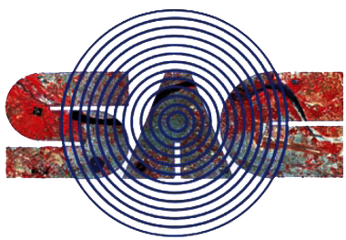
Space Applications Centre (ISRO), Ahmedabad

July 2026

Certificate
This is to certify that the summer internship entitled “Automation & Development of Calibration & Maintenance Computerized Management Information System (CMCMIS)” submitted by Deep Rajubhai Sorathiya (23BCE332), towards the partial fulfilment of the requirements for the award of the degree of B.Tech. in Computer Science and Engineering from Nirma University, Ahmedabad, is the record of work carried out by him under my supervision and guidance. In my opinion, the submitted work has reached the level required for being accepted for examination. The results embodied in this internship, to the best of my knowledge, have not been submitted to any other university or institution for the award of any degree or diploma.

Shri. Shreeyansh Kumar Golhani
SCI/ENGR – SF, TIMCD/EFMG/ESSA
Space Applications Centre (ISRO), Ahmedabad
(Internship Guide, Industry)

Dr. Ankit Thakkar
Professor, and In-charge Head,
CSE Department, Institute of Technology,
Nirma University, Ahmedabad.

Company Certificate
[The official completion / bona fide certificate issued by Space Applications Centre (ISRO), Ahmedabad on completion of the internship is to be attached on this page.]

Acknowledgement
The internship opportunity I had with the Test Instruments Maintenance and Calibration Division (TIMCD) in the Electronics Support Service Area (ESSA), Space Applications Centre (SAC), ISRO was a great chance for learning and professional development. I consider myself fortunate to have been provided with this opportunity and to have met so many talented professionals who guided me at every stage of this project.
With this in mind, I would like to express my deepest gratitude to my mentor at SAC-ISRO, Shri Shreeyansh Kumar Golhani (SCI/ENGR-SF), who — despite his demanding responsibilities — consistently took time to guide me, provided access to the division’s operations, and extended every courtesy during the training period.
I am also grateful to Shri Arun Bindal (Group Director, SCI/ENGR-G, ESSA-EFMG) and Shri B. A. Patel (Head, SCI/ENGR-SG, ESSA-EFMG-TIMCD) for giving me the opportunity to work with SAC-ISRO. I am equally grateful to Shri Rahul Agarwal (SCI/ENGR-SD), Shri Modhwadiya Vijaykumar Arabham (Technical Officer-D), Shri Chaudhary Nayan Ravibhai (Technical Officer-C), Shri Sudheer Kumar (Technical Officer-C), Shri Ravindra Kalya Vasave (Technician-D) and Shri Chavda Brijesh Ambalal (Technician-G), for their precious and thoughtful guidance, which was invaluable both theoretically and practically throughout the engagement.
Furthermore, I would like to thank Shri Mayank Singh Rana (SCI/ENGR-SD) and Shri Akhilesh Sharma (Head, SCI/ENGR-SG, SRSA-SQAG-GSQAD) for their exceptional support through the whole life cycle of the software development.
I would also like to thank Dr. Ankit Thakkar, In-charge Head of the Department of Computer Science and Engineering, Institute of Technology, Nirma University, and all faculty members for their continuous support and encouragement.
I perceive this opportunity as a major milestone in my career. I will continue to build on the skills and knowledge acquired here, and I look forward to future collaboration.

Deep Rajubhai Sorathiya (23BCE332)

Abstract
The Test Instruments Maintenance and Calibration Division (TIMCD) at the Space Applications Centre (SAC), ISRO, is responsible for the calibration, maintenance and documentation of test and measurement equipment used across the centre. Historically, this activity was supported only by a legacy, digitalised system that captured core master data but lacked role-based access, workflow enforcement, and automated NABL-compliant certificate generation, leading to transcription errors, approval delays and limited managerial oversight.
This report presents the Automation & Development of the Calibration & Maintenance Computerized Management Information System (CMCMIS), a full-stack, role-aware web application developed to digitise the complete lifecycle from Job Request to signed calibration certificate, while preserving the existing legacy master data. The system was built using a React 18 / Vite frontend and a Node.js / Express backend on a MySQL database, and implements a five-role access-control model (Super Admin, Lab In-Charge, Lab Engineer, Normal User and View-Only), automated PDF generation of NABL and Non-NABL certificates, Job Closing Forms and Job Request Forms, role-scoped KPI dashboards, six canned operational reports, a formal Master Data Correction workflow, and a full field-level audit trail.
The engagement, carried out over a twelve-week period, proceeded through structured phases of requirement elicitation, UI/UX design, core infrastructure and authentication development, workflow implementation, document-generation pipeline development, supporting-module development, analytics and audit implementation, and final integration testing. The resulting system constitutes a durable operational asset for the TIMCD calibration laboratory, improving workflow velocity, certificate quality and NABL compliance, operational visibility, and data integrity and auditability.

List of Figures
Figure 1: Login page — SSO and password login options
Figure 2: Login page — alternate authentication view
Figure 3: Role-scoped dashboard — Lab In-Charge KPI view
Figure 4: Equipment Register — list view
Figure 5: Equipment Register — registration form
Figure 6: Job Request — list and status view
Figure 7: Job Request — creation form
Figure 8: Job Card — detail view (Calibration tab)
Figure 9: Job Card — checklist tab (applied tasks)
Figure 10: Job Card — checklist tab (pass/fail tracking)
Figure 11: Calibration-Due report
Figure 12: Generated NABL-accredited calibration certificate (PDF preview)
Figure 13: Admin Console — User Management
Figure 14: Audit Trail browser — filtered log entries
Figure 15: Audit Trail browser — field-level change detail
Figure 16: Schedule / Lab Calendar view
Figure 17: Sample calibration certificate (redeveloped system) — page 1
Figure 18: Sample calibration certificate (redeveloped system) — page 2
Figure 19: Sample Job Request Form (PDF export)
Figure 20: Sample Job Closing Form (PDF export)

List of Tables
Table 1: CMCMIS Technology Stack Summary
Table 2: CMCMIS Data Dictionary — Principal Entity Groups

Contents
(Right-click on the table below and choose “Update Field” → “Update entire table” in Microsoft Word to populate page numbers after any further edits.)

Chapter 1: Introduction

1.1 About the Company

1.1.1 Introduction of the Company
The Space Applications Centre (SAC) is a major centre of the Indian Space Research Organisation (ISRO), located in Ahmedabad, engaged in the design, development and operational support of satellite-based applications for communication, navigation, earth observation and meteorology. Within SAC, the Electronics Support Service Area (ESSA) provides centre-wide electronics infrastructure and support services, and the Test Instruments Maintenance and Calibration Division (TIMCD) under ESSA is specifically responsible for ensuring that every piece of test and measurement equipment used across the centre is accurately calibrated, properly maintained, and correctly documented.
The internship was carried out within TIMCD, under the Electronics Support Service Area, and involved close engagement with the Test & Measurement Equipment (T&ME) and Facility & Plant Equipment (F&PE) laboratory sections, whose day-to-day calibration, maintenance and repair workflows formed the basis of the project.

1.1.2 Quality Policy
TIMCD operates under NABL (National Accreditation Board for Testing and Calibration Laboratories) accreditation requirements, which mandate strict traceability, accuracy and integrity of calibration records and certificates. Every calibration certificate issued by the division must conform to approved, audited formats, and every step of the calibration and maintenance workflow must be traceable to an accountable individual. Maintaining this quality standard was one of the central drivers behind the CMCMIS project.

1.1.3 Communication
Project communication was structured and hierarchical, consistent with the organisation’s reporting lines. Guidance and sign-off flowed through the internship mentor, Shri Shreeyansh Kumar Golhani (SCI/ENGR-SF), with periodic review and approval from the Head of TIMCD, Shri B. A. Patel, and the Group Director of ESSA-EFMG, Shri Arun Bindal. Requirement clarifications, design reviews and demonstrations were conducted through in-person sessions and walkthroughs with the lab in-charge and engineering staff of the T&ME and F&PE sections, ensuring that the system being built matched the operational reality of the laboratory floor.

1.1.4 Resources
The engagement made use of a modern full-stack development environment: a React 18 / Vite front end, a Node.js 18 / Express 4 back end, and a MySQL database seeded from the division’s pre-existing “cmms_*” legacy schema. Supporting resources included the official NABL and Non-NABL certificate formats, existing paper Job Request Forms (JRF) and Job Closing Forms (JCF), a LaTeX toolchain used to author canonical certificate templates, and the ISRO / SAC / NABL logo assets required for correct institutional branding of generated documents.

1.2 The System

1.2.1 Definition of System
The Calibration & Maintenance Computerized Management Information System (CMCMIS) is a single, connected, role-aware web application that digitises the complete lifecycle of test and measurement equipment calibration, maintenance and repair activity — from the raising of a Job Request, through engineer execution and Lab In-Charge approval, to the generation of a signed calibration certificate — while preserving and extending the division’s existing legacy master data rather than replacing it.

1.2.2 Purpose and Objectives
The system was designed with the following objectives:
- Digitise the end-to-end calibration/maintenance/repair workflow — from a user raising a Job Request through engineer execution, Lab In-Charge approval, and final certificate generation — within a single web application.
- Preserve the existing legacy master data (“cmms_*” MySQL tables for equipment, employees, departments and vendors) by extending them in place rather than replacing them, protecting historical records throughout the transition.
- Implement a robust, five-role access-control model — Super Admin, Lab In-Charge, Lab Engineer, Normal User and View-Only — with each role seeing only the screens, actions and data rows appropriate to their function.
- Automate the generation of official calibration documents — NABL-accredited certificates, Non-NABL certificates, Job Closing Forms and Job Request Forms — as correctly formatted, instantly downloadable PDF files.
- Provide real-time visibility through role-scoped KPI dashboards, six canned operational reports (each available on screen and as a PDF), and ad-hoc analytics, replacing the manual collation of data from disparate sources.
- Deliver a maintainable, modular codebase following a clean three-tier architecture (React front end / Express back end / MySQL), with an idempotent database migration bundle that safely evolves the schema from its legacy state.
- Ensure data integrity and auditability through a formal Master Data Correction workflow for amending verified records, and a full, field-level audit trail of every state-changing action across the system.

1.2.3 About Present System
The pre-existing system was a digitalised legacy application built around a set of “cmms_*” MySQL tables holding core master data for equipment, employees, departments and vendors. While this infrastructure captured basic records, it was not role-aware and did not enforce any workflow: job requests, engineer assignment and approvals had no structured status tracking. Calibration certificates were generated manually, which was vulnerable to transcription and formatting errors — a significant risk given NABL’s strict documentation requirements. There was no audit trail of who changed what and when, no centralised tracking of equipment calibration-due dates, and no mechanism for management oversight or capacity planning.

1.2.4 Proposed System
Rather than patching individual pain points in isolation, the engagement was scoped as a full-stack redevelopment: a single, connected, role-aware web application built on React, Express and MySQL that digitises the complete lifecycle from Job Request to signed calibration certificate. The proposed system preserves and extends the existing legacy master data, introduces the five-role access-control model, automates certificate generation, and adds role-scoped dashboards, canned reports, a Master Data Correction workflow and a full audit trail — addressing every gap identified in the present system.

1.3 Project Profile

1.3.1 Project Title
Automation & Development of Calibration & Maintenance Computerized Management Information System (CMCMIS).

1.3.2 Scope of Project
The scope of the project covered the full software delivery lifecycle for CMCMIS: requirement elicitation from stakeholders in the T&ME and F&PE lab sections; information architecture and UI/UX design; implementation of authentication, the Job Request and Job Card workflows, checklists, spares and document management, certificate PDF generation, equipment registration, scheduling and notifications, reporting and analytics, and the audit trail; a Master Data Correction workflow and Admin console; and end-to-end integration testing across 23 backend modules and more than 20 frontend screens, together with formal documentation (Software Requirements Specification, functional/structural/security test reports, and project presentation) — all delivered within a twelve-week internship period.

1.3.3 Project Team
The project was carried out by the intern under the guidance and support of the following personnel at SAC-ISRO:
- Shri Shreeyansh Kumar Golhani, SCI/ENGR-SF, TIMCD/EFMG/ESSA — Internship Guide.
- Shri Arun Bindal, Group Director, SCI/ENGR-G, ESSA-EFMG.
- Shri B. A. Patel, Head, SCI/ENGR-SG, ESSA-EFMG-TIMCD.
- Shri Rahul Agarwal (SCI/ENGR-SD), Shri Modhwadiya Vijaykumar Arabham (Technical Officer-D), Shri Chaudhary Nayan Ravibhai (Technical Officer-C), Shri Sudheer Kumar (Technical Officer-C), Shri Ravindra Kalya Vasave (Technician-D) and Shri Chavda Brijesh Ambalal (Technician-G).
- Shri Mayank Singh Rana (SCI/ENGR-SD) and Shri Akhilesh Sharma (Head, SCI/ENGR-SG, SRSA-SQAG-GSQAD).
- Deep Rajubhai Sorathiya (23BCE332), B.Tech. Computer Science & Engineering, Institute of Technology, Nirma University — Intern / Developer.

1.3.4 Hardware/Software Environment in Company
The following technologies were used in the development of CMCMIS at the company:
Technology | Role & Rationale
React 18 + Vite 5 | Frontend SPA framework and build tool. React’s component model enabled clean role-based conditional rendering; Vite provided sub-second hot-reload during development and optimised production bundles.
Tailwind CSS v3 | Utility-first CSS framework. A shared design-token configuration (tailwind.config.js) enforced visual consistency across all screens without a separate design-system library.
React Router v6 | Client-side routing, including the ProtectedRoute guard that enforces role/permission checks before rendering any screen.
TanStack Query v5 | Server-state caching and synchronisation, replacing manual useEffect/loading-state patterns and enabling automatic cache invalidation on workflow mutations.
Axios | HTTP client with request/response interceptors for transparent token refresh and consistent error handling across all API calls.
React Hook Form + Zod | Client-side form state management and schema validation, mirroring the identical Zod schemas used server-side for consistent validation rules.
Recharts | Chart library for dashboard KPI visualisations and report summary charts.
Node.js 18 + Express 4 | Backend HTTP server. Express’s minimal, middleware-first architecture enabled the strict, documented 13-step pipeline that every request passes through.
mysql2 | MySQL driver with connection pooling and parameterised query support, used throughout the repository layer for safe, injection-resistant SQL.
jsonwebtoken + bcryptjs | JWT signing/verification for access and refresh tokens; bcrypt for password hashing with a configurable work factor.
Zod (server-side) | Request payload validation with .strict() schemas rejecting unknown fields, applied per-route via a validate() middleware factory.
helmet + cors + express-rate-limit | Security middleware stack: hardened HTTP headers, restrictive CORS origin allow-listing, and per-endpoint rate limiting on authentication routes.
pino / pino-http | Structured, per-request logging with built-in secret redaction, emitting JSON logs suitable for log-shipping in production.
PDFKit | Programmatic PDF generation for calibration certificates, Job Closing Forms, and all six canned report types. Chosen for precise, code-driven layout control matching the LaTeX master templates.
multer | Multipart/form-data handling for job-card document uploads, with file-type and size validation enforced before business logic runs.
MySQL (Phase-3 migration bundle) | Relational database. A 28-migration, checksum-tracked, idempotent bundle evolves the schema from the legacy “cmms_*” state to the full CMCMIS schema across 40+ new tables.
Table 1: CMCMIS Technology Stack Summary

Chapter 2: System Analysis

2.1 Feasibility Study

2.1.1 Operational Feasibility
The system was assessed as operationally feasible because it mirrors the existing paper-based workflow (Job Request → Job Card → Certificate) that laboratory staff already follow, simply digitising and enforcing it through a role-aware application. The five-role model (Super Admin, Lab In-Charge, Lab Engineer, Normal User, View-Only) was designed to map directly onto existing organisational responsibilities, minimising the change-management burden on end users.

2.1.2 Technical Feasibility
The chosen technology stack — React/Vite on the front end, Node.js/Express on the back end, and MySQL for persistence — is mature, well-documented, and directly compatible with the existing legacy “cmms_*” MySQL schema, which meant no data migration to a different database engine was required. Prior experience with JavaScript-based full-stack development within the team, combined with the availability of well-established libraries for authentication (jsonwebtoken, bcryptjs), validation (Zod) and PDF generation (PDFKit), confirmed the technical feasibility of the proposed design.

2.1.3 Financial and Economic Feasibility
All core technologies used — React, Express, MySQL, and the associated npm ecosystem — are open-source and free of licensing cost, keeping the direct cost of the project limited to development effort. The economic case for the system rests on the elimination of recurring costs associated with the legacy manual process: rework caused by transcription errors in NABL-critical certificates, delays in approval and assignment, and the staff time previously spent manually collating status reports.

2.1.4 Handling Infeasible Projects
The single area of genuine technical risk — evolving a live, data-bearing legacy schema without discarding historical records — was not treated as a reason to abandon or reduce the scope of the project. Instead, it was explicitly addressed through a dedicated migration strategy (idempotent, checksum-gated SQL migrations, described in Chapter 3), which converted a potentially infeasible “big-bang” rewrite into a safe, incremental evolution of the existing database.

2.2 Requirement Analysis

2.2.1 Fact-Finding Techniques

2.2.1.1 Interview
Detailed requirement elicitation sessions were held with the lab in-charge and the mentor team. These sessions surfaced a documented set of pain points — no audit trail, no role separation, manual certificate generation vulnerable to formatting errors, and no centralised equipment calibration-due tracking — which were formalised into the functional scope, the five-role model, and the initial Software Requirements Specification (SRS) outline.

2.2.1.2 Questionnaire
In place of a formal written questionnaire, structured discussion points were used during walkthrough sessions with engineers and the lab in-charge to confirm assumptions about workflow steps, approval authority, and the information required on each certificate type.

2.2.1.3 Record Review
The pre-existing legacy “cmms_*” MySQL schema was studied in detail, along with the official NABL and Non-NABL certificate formats currently in use at SAC, and the existing paper Job Request Forms and Job Closing Forms. This review established exactly which master data had to be preserved and which document layouts had to be reproduced pixel-for-pixel in the new system.

2.2.1.4 Observation
The engagement began with a structured onboarding period during which the intern shadowed engineers in the T&ME and F&PE lab sections as they filled paper Job Request Forms and Job Closing Forms, directly observing the existing calibration and maintenance workflow end to end.

2.3 Context Diagram
CMCMIS sits at the centre of interactions between five categories of external user and the underlying legacy master-data store. The principal external entities and their interactions with the system are summarised below (a graphical context diagram, drawn to the same convention, should be inserted here in the final submission):
- Normal User — raises Job Requests and tracks their status.
- Lab Engineer — receives assigned Job Cards, records calibration/maintenance/repair data, completes checklists, and consumes spares.
- Lab In-Charge — approves/rejects Job Requests, verifies and closes completed Job Cards, and views lane-scoped dashboards and reports.
- Super Admin — manages users, roles, master data corrections, and system-wide configuration.
- View-Only User — has read access to dashboards and reports without the ability to raise or act on jobs.
- Legacy Master Data Store (“cmms_*” tables) — supplies and receives equipment, employee, department and vendor records.

2.4 Data Flow Diagrams

2.4.1 First Level DFD
At the first level, CMCMIS decomposes into four major processes: (1) Job Request Management — raise, submit, approve/reject, convert or cancel a request; (2) Job Card Execution — assignment, in-progress work, completion and verification/closure; (3) Certificate & Report Generation — producing NABL/Non-NABL certificates, Job Closing Forms, Job Request Forms and the six canned reports as PDFs; and (4) Master Data & Administration — equipment registration, user/role management, and the Master Data Correction workflow. Data flows between these processes and the legacy and new MySQL data stores, with notifications emitted on relevant transitions in each process.

2.4.2 Second Level DFD
The Job Card Execution process (from the first-level DFD) decomposes further into type-specific sub-processes: Calibration (recording reference equipment used, adjustment rows, and calibration observations), Maintenance (recording maintenance detail records), Repair (recording equipment used during repair activity), Checklist (applying task-library templates and recording pass/fail results), Spares Consumption (deducting used spare parts against the Procurement module’s inventory), and Document Attachment (uploading supporting files via multer with type/size validation). Each sub-process writes to its own child table linked to the parent Job Card record, and each state-changing action is mirrored into the audit_log / audit_log_changes table pair.

Chapter 3: System Design

3.1 System Flow
Development proceeded through eight structured phases over the twelve-week internship, each building on the deliverables of the previous phase.

Phase I: Requirements Understanding & Domain Study (Weeks 1–2)
Structured onboarding to the T&ME and F&PE lab sections; shadowing engineers filling paper Job Request Forms and Job Closing Forms; study of the legacy “cmms_*” MySQL schema and the official NABL/Non-NABL certificate formats; requirement elicitation producing the documented pain points, the five-role model, and the initial SRS outline.

Phase II: UI/UX Design (Weeks 3–4)
A full site map across all five roles; low-fidelity wireframes for the six core screens (Login, Dashboard, Equipment Register, Job Requests, Job Cards, Admin console); a Tailwind CSS design-token configuration signed off with the mentor; and high-fidelity mockups with a shared component library plan (DataTable, StatusPill, ProtectedRoute, KPI Cards).

Phase III: Core Infrastructure & Authentication (Weeks 5–6)
Scaffolding of the React 18 + Vite frontend and Express 4 + Node.js backend; design of new database tables atop the preserved legacy schema; and the idempotent, checksum-tracked migration runner. Authentication was implemented with bcrypt password hashing, JWT access/refresh token issuance with distinct secrets, SHA-256 hashed refresh-token persistence, refresh-token rotation with replay/theft detection, and a fixed 13-step Express middleware pipeline (helmet → CORS → compression → JSON body parsing → cookie-parser → request logging → rate limiting → authenticate → authorize → row-level scope → schema validation → controller → error handler).

Phase IV: Job Request & Job Card Workflows (Weeks 7–8)
The Job Request module delivered a formal lifecycle (raise → submit → approve/reject → convert → cancel) governed by an explicit state machine, with full status history, lane-based row scoping, bulk-verify-all, and JRF PDF export. The Job Card module implemented the execution lifecycle (assigned → in progress → completed → verified/closed → reopen) with Calibration and Repair sub-workflows recording reference equipment, adjustment rows, calibration observations, and equipment used during repair.

Phase V: Checklists, Spares, Documents & Certificate PDF Generation (Week 9)
A Task Library and Checklist Master module allowed checklist templates to be defined and applied at assignment time, with pass/fail marking by the engineer. Spare-parts consumption was tracked against job cards, linked to the Procurement module’s inventory. The certificate generation pipeline was implemented in two layers: LaTeX master templates authored as the canonical visual reference, faithfully reproduced as PDFKit modules for at-runtime generation using the ISRO, SAC and NABL logo assets.

Phase VI: Equipment Registration, Scheduling & Notifications (Week 10)
The Registration module covered Equipment Registration and Spare Parts inventory management. The Schedule module provided a lab activity calendar with a status state machine and full RFC 5545 ICS export. The Notifications module implemented an emitter/recipient-resolution architecture notifying the correct recipients on relevant workflow events, with an in-app notification centre providing unread badge counts and mark-as-read.

Phase VII: Reports, Analytics, Dashboard & Audit Trail (Week 11)
Six canned operational reports were implemented — Calibration-Due, Pending Jobs, Equipment Utilization, Engineer Summary, Job-Card Summary, and Job-Request Summary — each available as a filterable, lane-scoped JSON dataset and as a branded PDF export. A dynamic analytics metric-registration pattern exposed new metrics automatically via JSON and CSV endpoints. Role-scoped KPI dashboards were wired to Recharts visualisations. The system-wide audit trail was implemented using an audit_log / audit_log_changes table pair capturing actor, timestamp, action type, entity reference, and field-level before/after diffs, with an export_audit table recording every export of the audit log itself.

Phase VIII: Master Data Corrections, Admin Console, Integration Testing & Documentation (Week 12)
The Master Data Correction workflow allowed non-admin users to formally request amendments to verified master records, routed to Super Admin for approval/rejection, with the original record protected until the change is explicitly approved. The remaining Admin console screens (Users lifecycle, Equipment Verification queue, Job Request Terms management, Projects/Tasks/Checklists CRUD) and the cross-entity Inquiry quick-search module were completed, followed by end-to-end integration testing, defect resolution, and finalisation of the SRS, test reports and project presentation.

3.2 Entity-Relationship Diagram
A full entity-relationship diagram was maintained internally as part of the migration design; it is not reproduced graphically in this report and should be inserted here in the final submission. Conceptually, the schema is organised around the following entity clusters, all related back to the preserved legacy equipment/employee/department/vendor master tables:
- RBAC: roles, permissions, role_permissions, users, user_roles, user_role_history, user_lane_scopes, refresh_tokens, login_audit.
- Job Request & Job Card child entities: jc_calibration_equipment_used, jc_calibration_adjustments, jc_maintenance_details, jc_repair_equipment_used, jc_spares_used, jc_documents, jc_task_checklist, and related tables.
- Procurement: purchase_orders, purchase_order_items, spare_parts.
- Scheduling: schedules, schedule_status_history.
- Notifications, Master Data Correction, and Audit: audit_log, audit_log_changes, export_audit.

3.3 Data Dictionary
The table below summarises the principal new entity groups introduced by the 28-file migration bundle on top of the legacy “cmms_*” schema.
Entity Group | Purpose
roles / permissions / role_permissions / users / user_roles | Defines the five-role RBAC model and maps users to roles and permissions.
user_lane_scopes / refresh_tokens / login_audit | Row-level lane scoping for users, secure refresh-token persistence, and login history.
Job Request tables + status history | Captures the raise → submit → approve/reject → convert → cancel lifecycle and its audit trail.
Job Card + jc_calibration_*, jc_maintenance_details, jc_repair_equipment_used, jc_spares_used, jc_documents, jc_task_checklist | Captures the type-specific execution detail for each Job Card (calibration, maintenance, repair, spares, documents, checklist).
purchase_orders / purchase_order_items / spare_parts | Procurement and spare-parts inventory used to service Job Cards.
schedules / schedule_status_history | Lab activity calendar with a status state machine and ICS export.
notifications tables | Emitter/recipient-resolution records driving the in-app notification centre.
master data correction tables | Formal request/approval workflow for amending verified master records.
audit_log / audit_log_changes / export_audit | System-wide, field-level audit trail and non-repudiation log of audit exports.
_legacy_* prefixed tables (migration 099) | Unused legacy tables isolated (not dropped) to preserve historical data while preventing accidental access.
Table 2: CMCMIS Data Dictionary — Principal Entity Groups

3.4 Database Migration Strategy
The most structurally challenging aspect of the project was evolving a pre-existing, data-bearing legacy MySQL schema — representing years of equipment, employee and vendor master data — into the new CMCMIS schema without disrupting or discarding any of that data. A greenfield schema design was not an option, since the legacy tables contained validated historical records the new system had to read, display and extend.
The solution was a 28-file, sequentially numbered SQL migration bundle with a Node.js runner implementing three layers of safety: (1) Idempotency — every migration uses CREATE TABLE IF NOT EXISTS, INSERT IGNORE on seeded rows, and an information_schema-driven safe_alter_column() stored procedure that checks whether a column already exists before attempting an ALTER TABLE; (2) Checksum gating — the runner computes a SHA-256 hash of each migration file and stores it in a schema_migrations bookkeeping table, silently skipping a file already applied at its current hash and rejecting one whose hash has changed, preventing silent schema drift; and (3) Scope isolation — unused legacy tables were isolated under a “_legacy_” prefix rather than dropped, preserving their data while preventing accidental access by the new application code.

Chapter 4: Result and Discussion

4.1 Results

Workflow Velocity
A job request that previously had no status tracking or engineer assignment is now raised, approved, assigned, executed, tracked and closed entirely within the system. The approval notification reaches the Lab In-Charge immediately, and the PDF certificate is available for download the moment the job is verified and closed. What previously required multiple handovers over one or more days can now complete in a single working session.

Certificate Quality and NABL Compliance
Calibration certificates are generated programmatically from validated job-card data, eliminating the possibility of manual transcription and formatting errors that represented a compliance risk under NABL accreditation. The NABL and Non-NABL certificate formats are locked to their approved layouts in the PDFKit templates, matching the canonical LaTeX masters exactly, so every generated certificate is structurally compliant by construction.

Visibility and Oversight
Role-scoped dashboards give each user the specific KPIs relevant to their function — pending approvals for the Lab In-Charge, calibration-due alerts for equipment owners, and workload distribution and job assignment for management. Six canned reports are available on demand with date-range and lane filters, replacing the periodic manual collation of status across paper records.

Data Integrity and Auditability
The formal Master Data Correction workflow ensures verified equipment records cannot be silently amended; every proposed change is reviewed and explicitly approved by an admin before taking effect. The full field-level audit trail (audit_log / audit_log_changes) provides a complete, immutable record of every state-changing action across the system — a capability entirely absent from the prior manual process.

4.2 Discussion

Full-Stack Architecture in a Legacy Environment
Working within the constraint of a pre-existing, data-bearing legacy system — rather than designing greenfield — was the most instructive architectural experience of the project. It required learning to compose a new schema safely on top of an existing one, to write migration tooling that is correct by construction (idempotent, checksum-gated), and to make design decisions at the data layer that protect historical records while enabling entirely new capabilities.

Security as a First-Class Concern
Implementing the authentication layer from first principles — bcrypt hashing, JWT rotation, SHA-256 hashed refresh-token persistence, replay detection, and live permission revocation via a token_version claim — provided a deep, practical understanding of the security engineering that underpins any serious web application.

State Machine Modelling for Workflow Correctness
Modelling multi-step workflows (Job Request, Job Card, Schedule, Admin User lifecycle) as explicit state machines, rather than scattering transition conditionals across controllers, meant illegal transitions are rejected at the model level, impossible states cannot be represented, and the entire transition space is auditable in a single file.

Design Before Code
The two-week UI/UX design phase — information architecture, wireframes, high-fidelity mockups, design-token configuration — before any application code was written, produced a measurable improvement in development velocity during implementation, eliminating ambiguity at the component level.

Chapter 5: User Manual

5.1 Menu Screens along with Description
Login Screen showing SSO and password login options, the entry point for all five user roles:
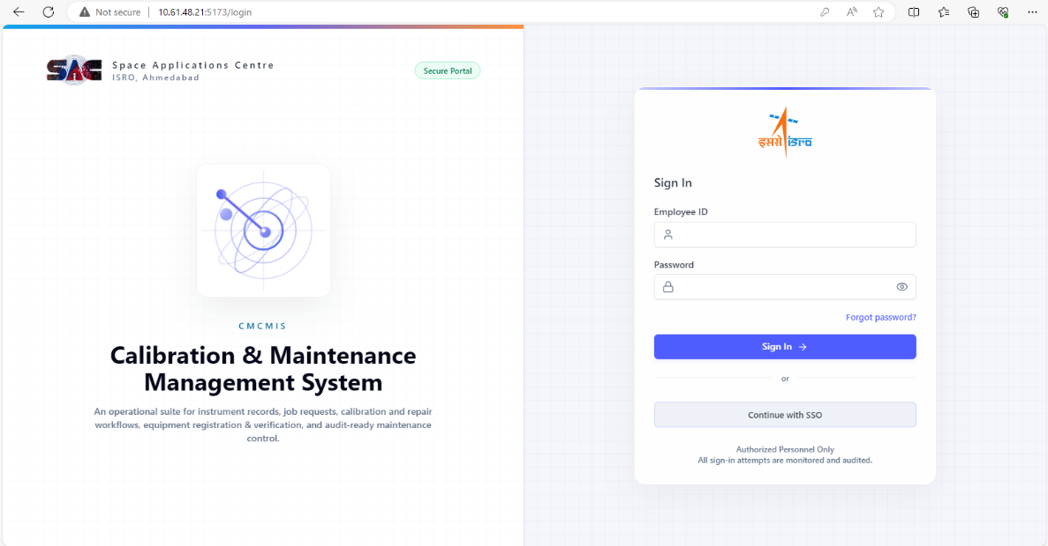
Figure 1: Login page — SSO and password login options
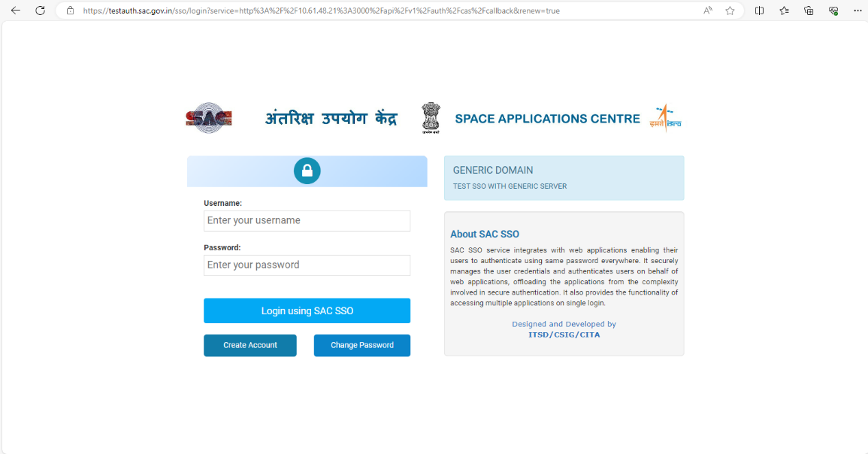
Figure 2: Login page — alternate authentication view
Role-Scoped Dashboard showing KPI cards tailored to the logged-in user’s role, here the Lab In-Charge view showing pending approvals, in-progress jobs, and calibration-due alerts:
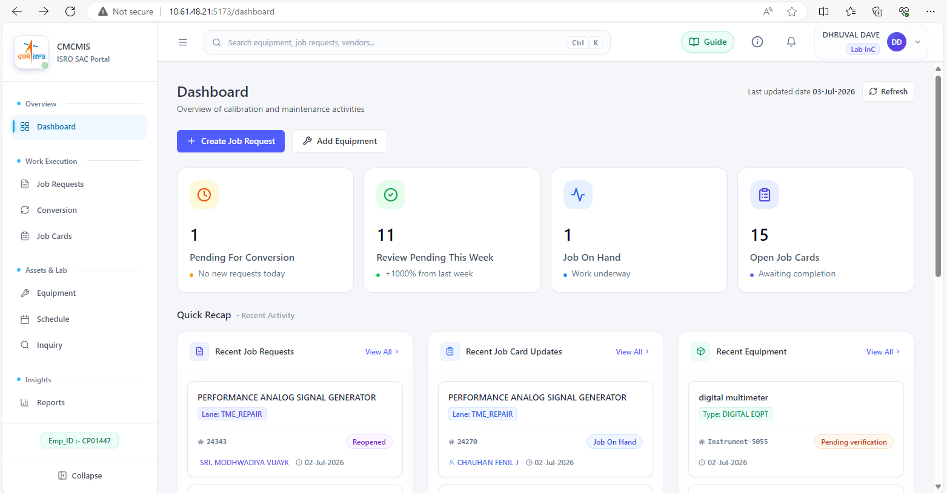
Figure 3: Role-scoped dashboard — Lab In-Charge KPI view

5.2 Forms along with Description
Equipment Register list view, providing a paginated, searchable and filterable listing of all registered equipment with calibration-due status indicators:
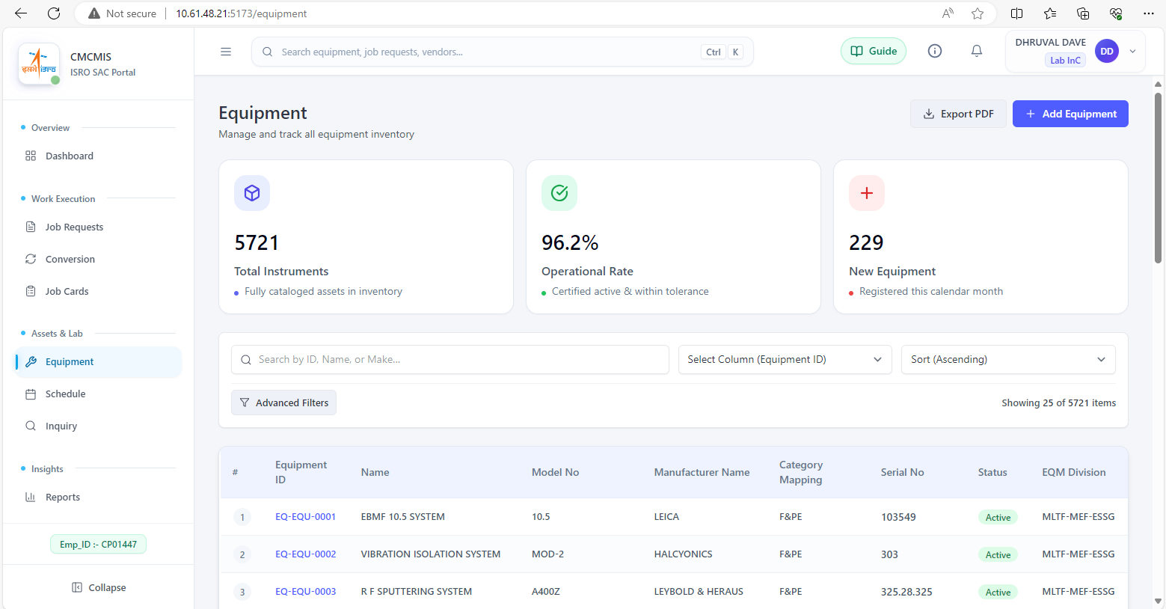
Figure 4: Equipment Register — list view
Equipment Registration form, used to add new equipment with type/make/division/project lookups:
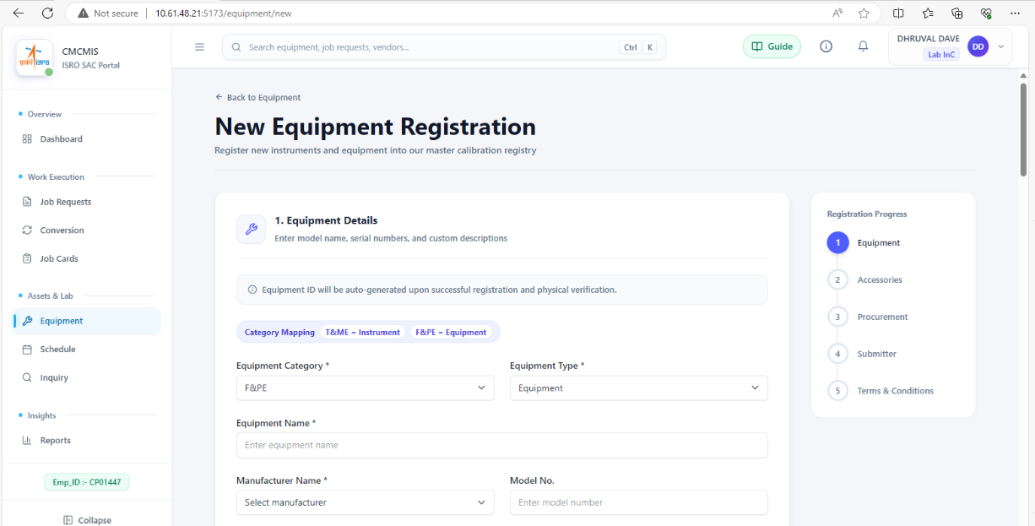
Figure 5: Equipment Register — registration form
Job Request list, showing multi-role status badges and role-appropriate action buttons:
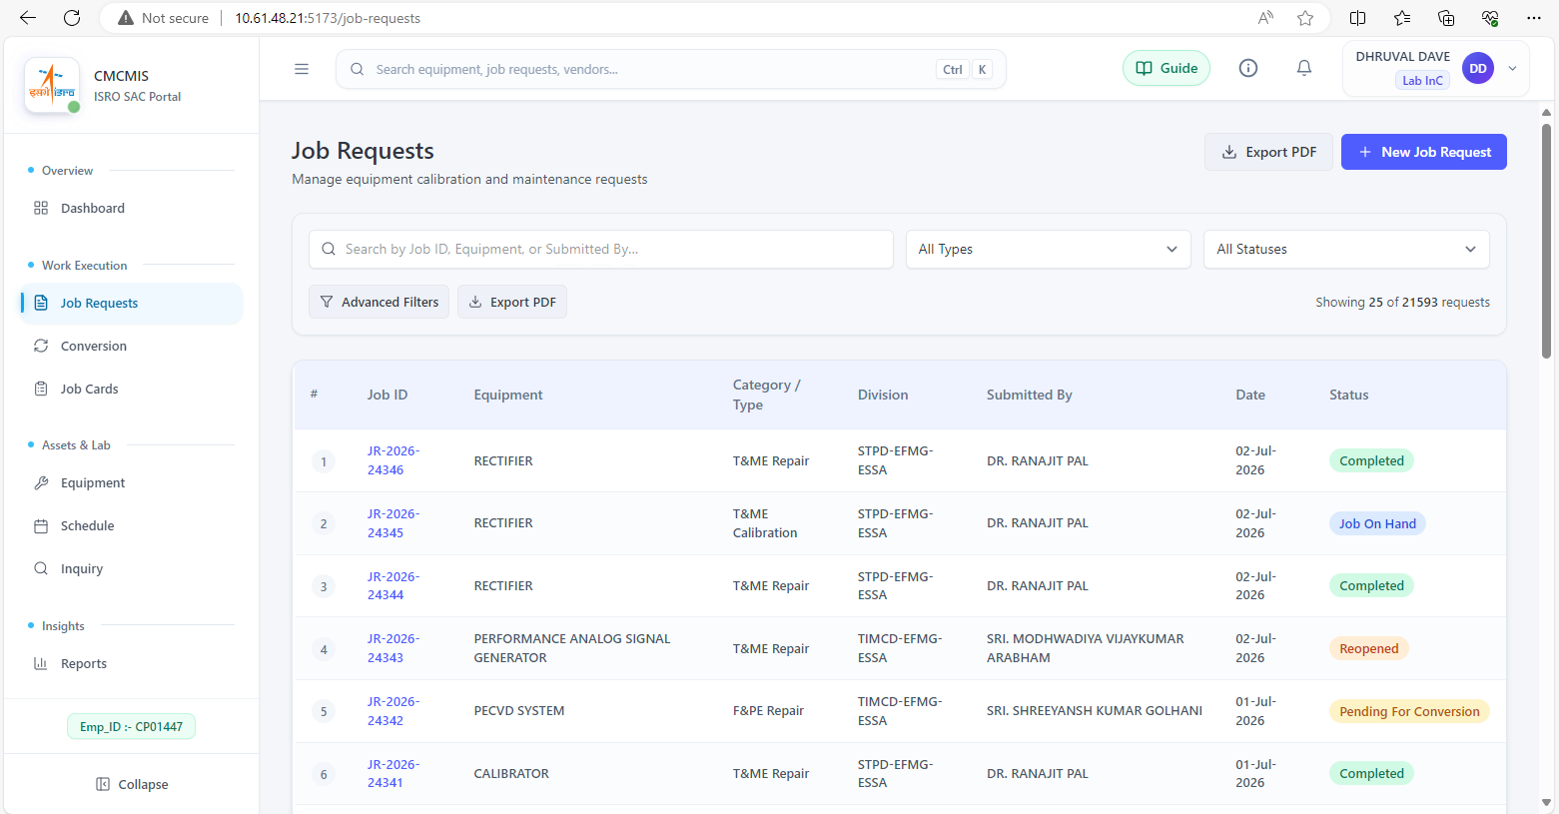
Figure 6: Job Request — list and status view
Job Request creation form, with equipment type-ahead, work-type selector and accessories field:
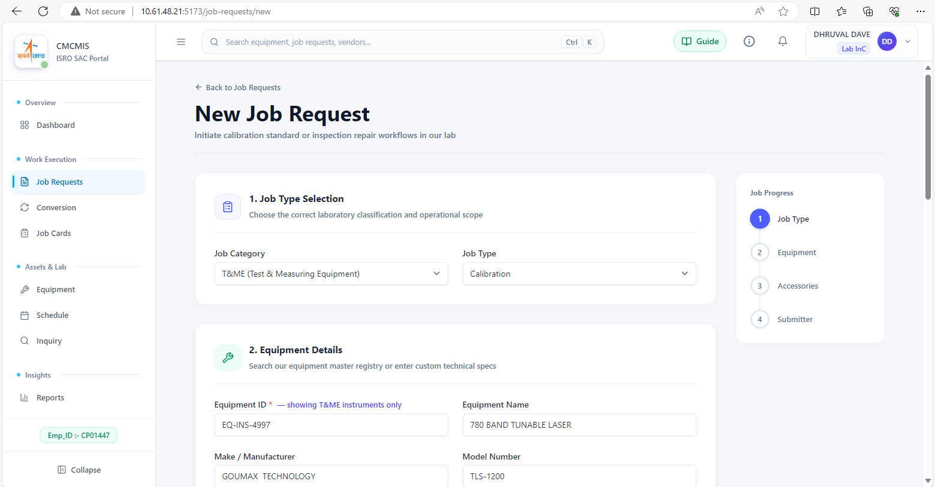
Figure 7: Job Request — creation form
Job Card detail view (Calibration tab), showing the calibration sub-workflow with equipment-used and adjustment rows:
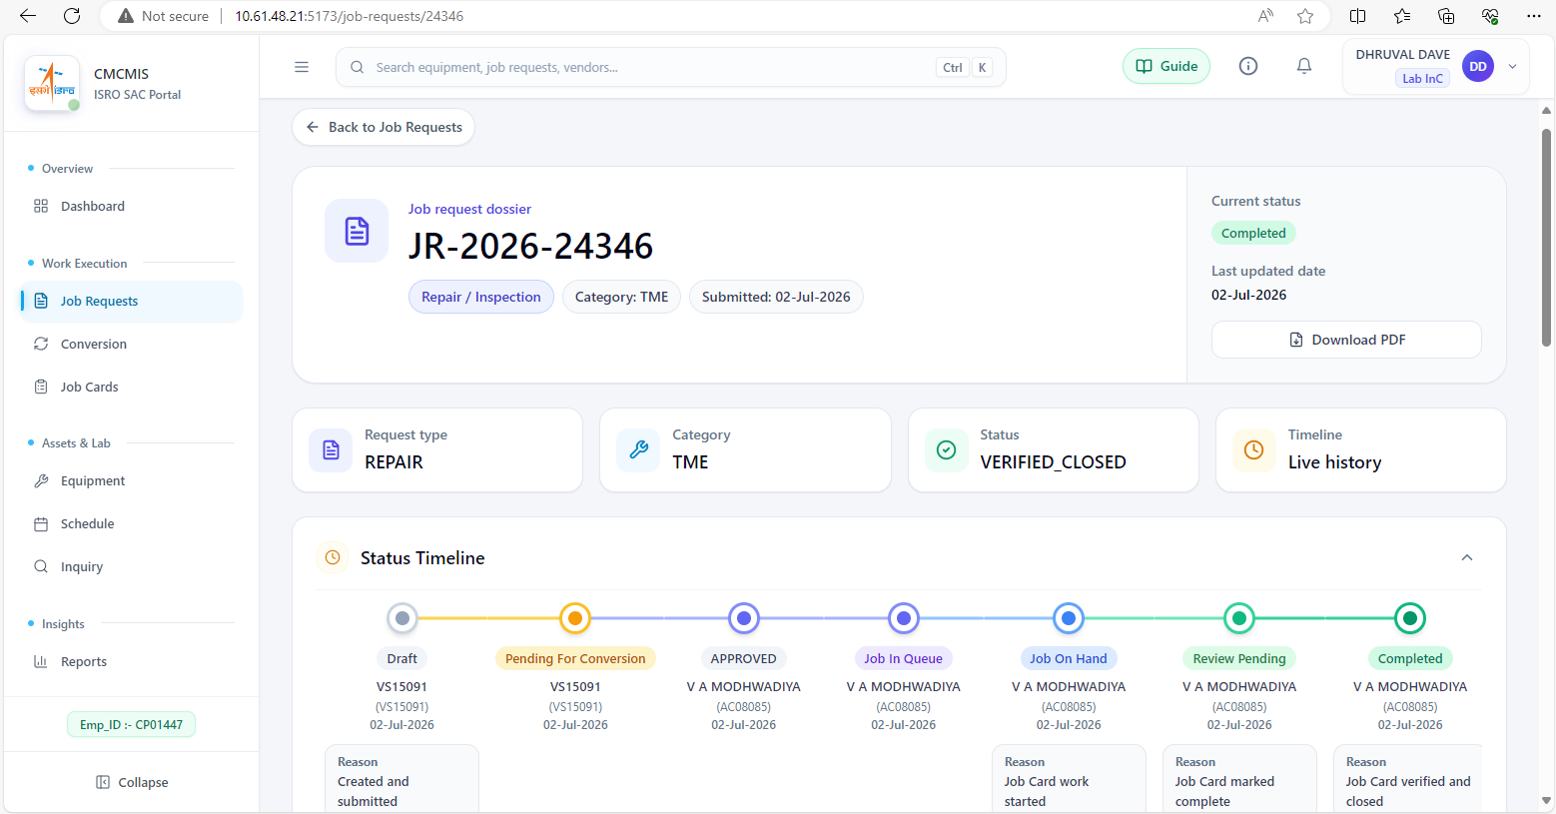
Figure 8: Job Card — detail view (Calibration tab)
Job Card checklist tab, showing applied tasks and pass/fail completion tracking:
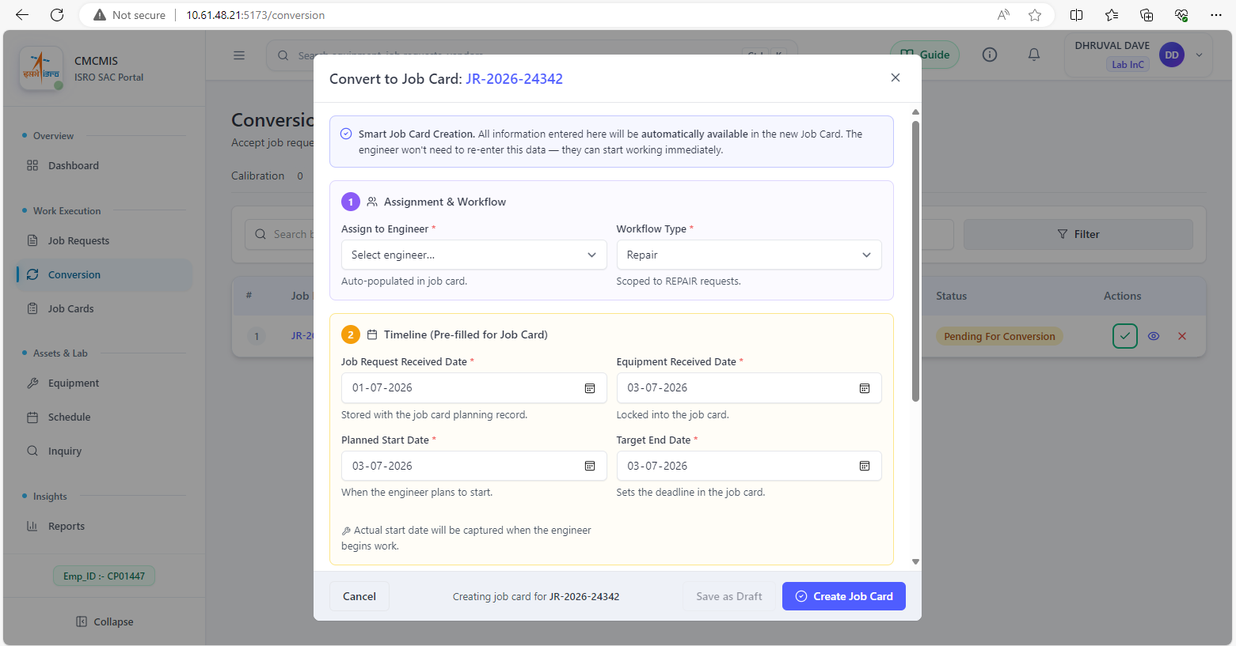
Figure 9: Job Card — checklist tab (applied tasks)
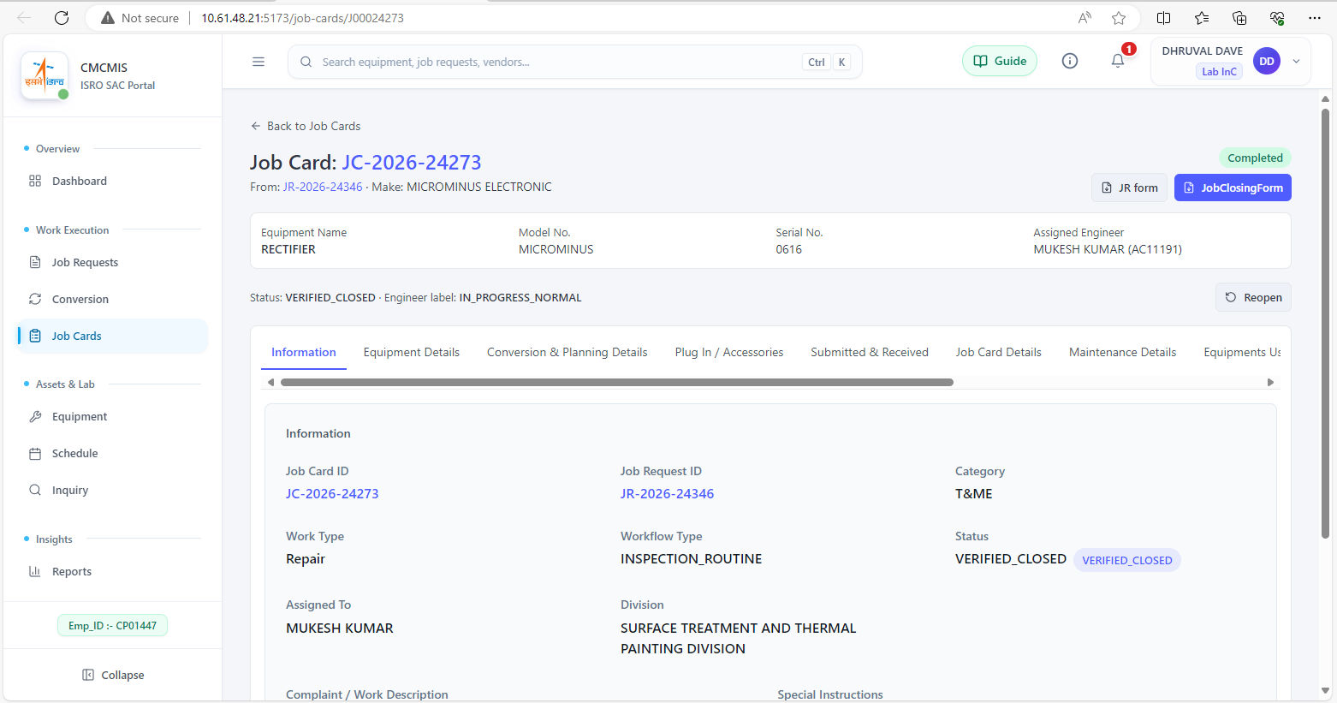
Figure 10: Job Card — checklist tab (pass/fail tracking)

5.3 Reports
Calibration-Due report, showing date filter, summary tiles, and table view of equipment approaching or past their calibration due date:
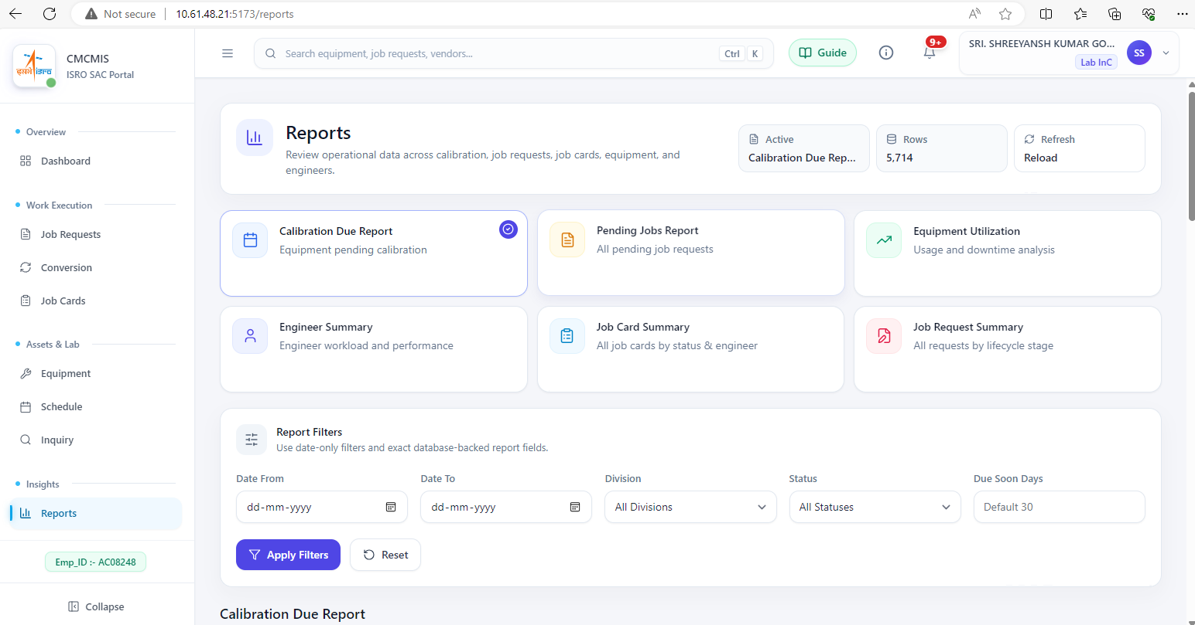
Figure 11: Calibration-Due report
Generated NABL-accredited calibration certificate PDF preview, produced directly from validated job-card data:
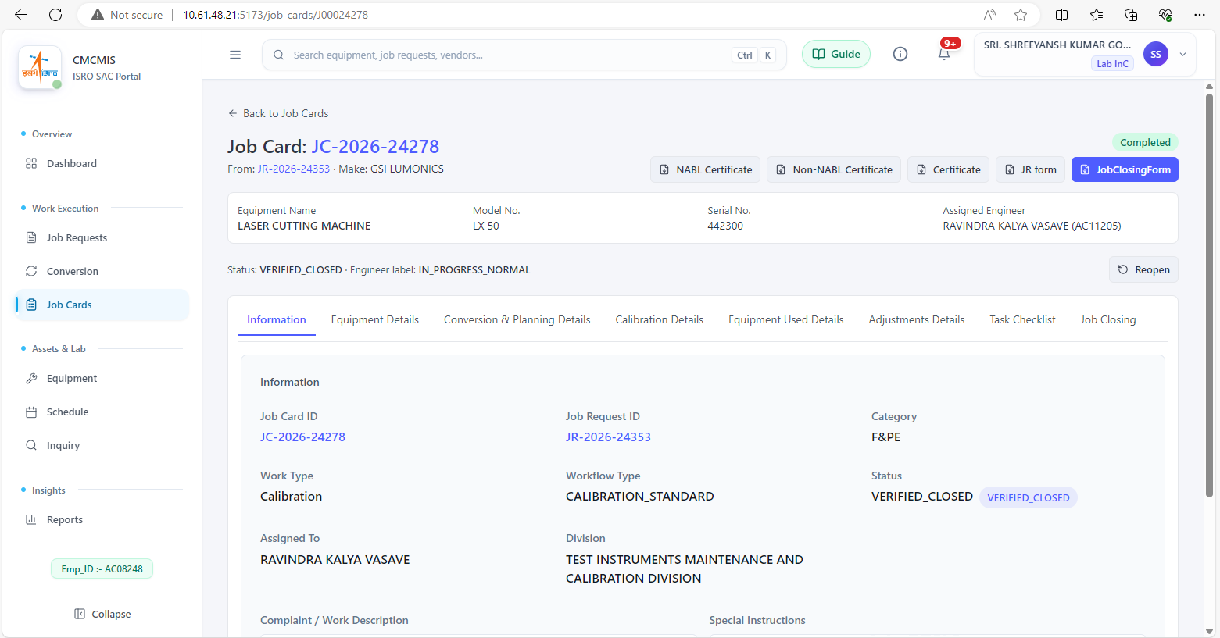
Figure 12: Generated NABL-accredited calibration certificate (PDF preview)
Admin console — User account administration, showing role assignment and activation controls:
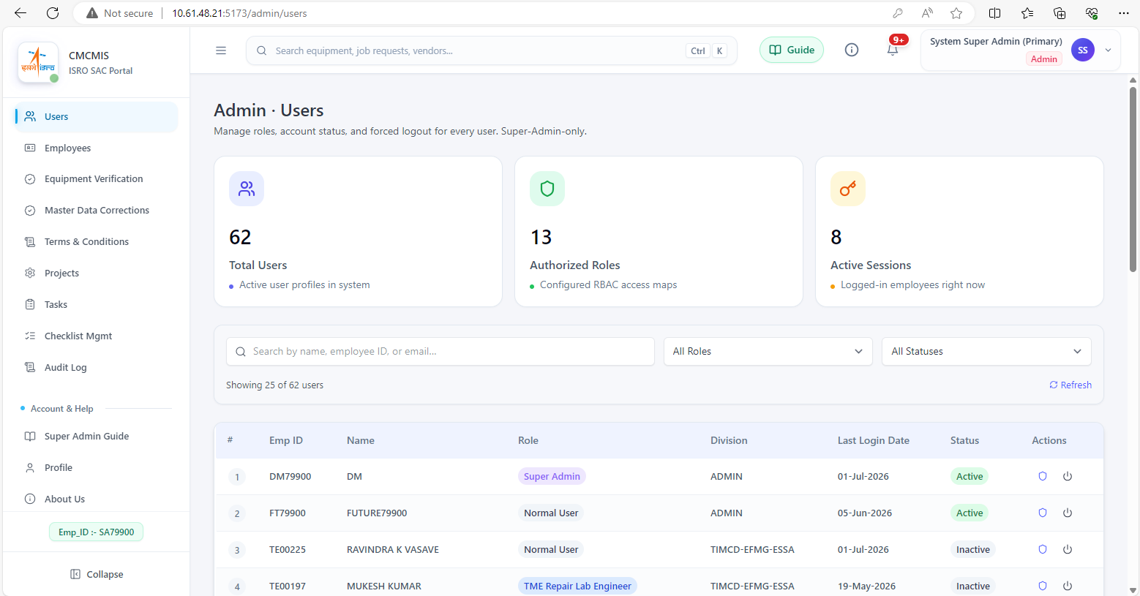
Figure 13: Admin Console — User Management
Audit Trail browser, showing filtered log entries with field-level change detail:
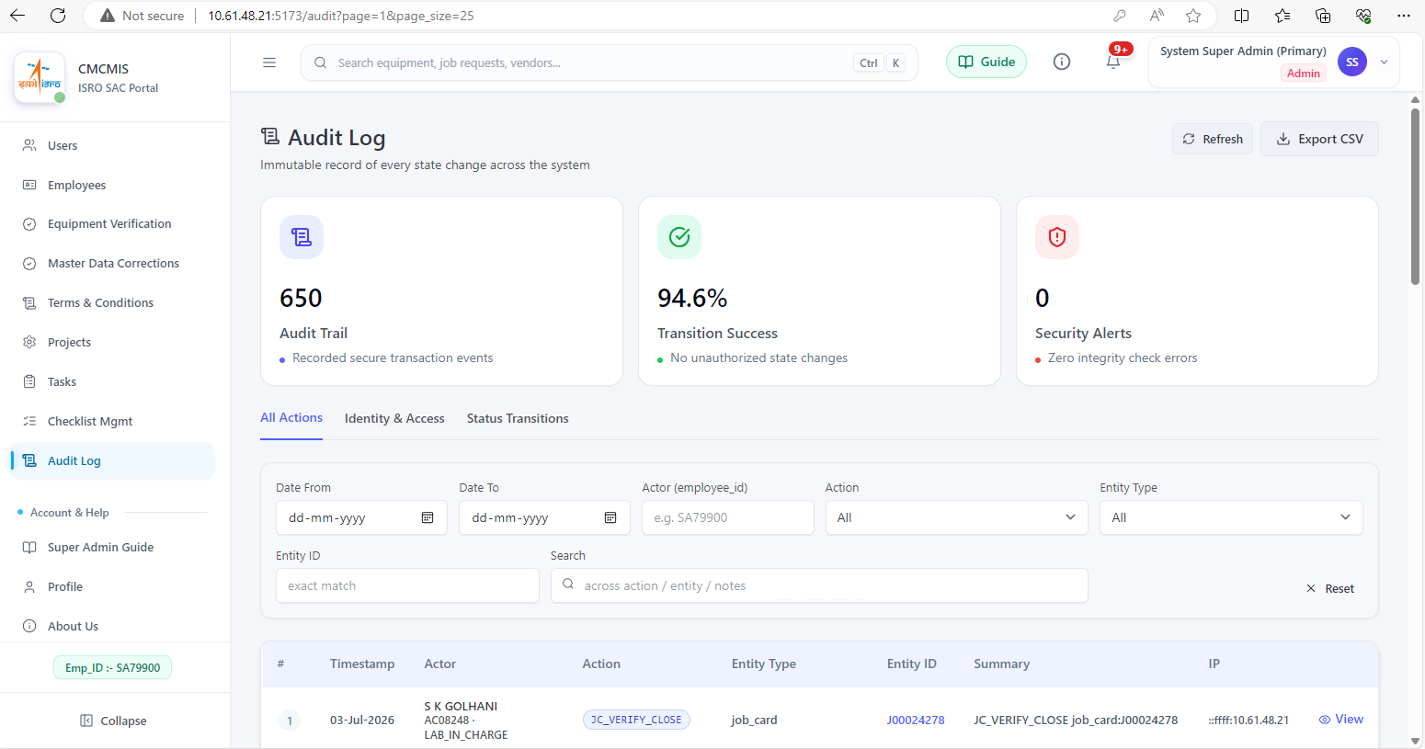
Figure 14: Audit Trail browser — filtered log entries
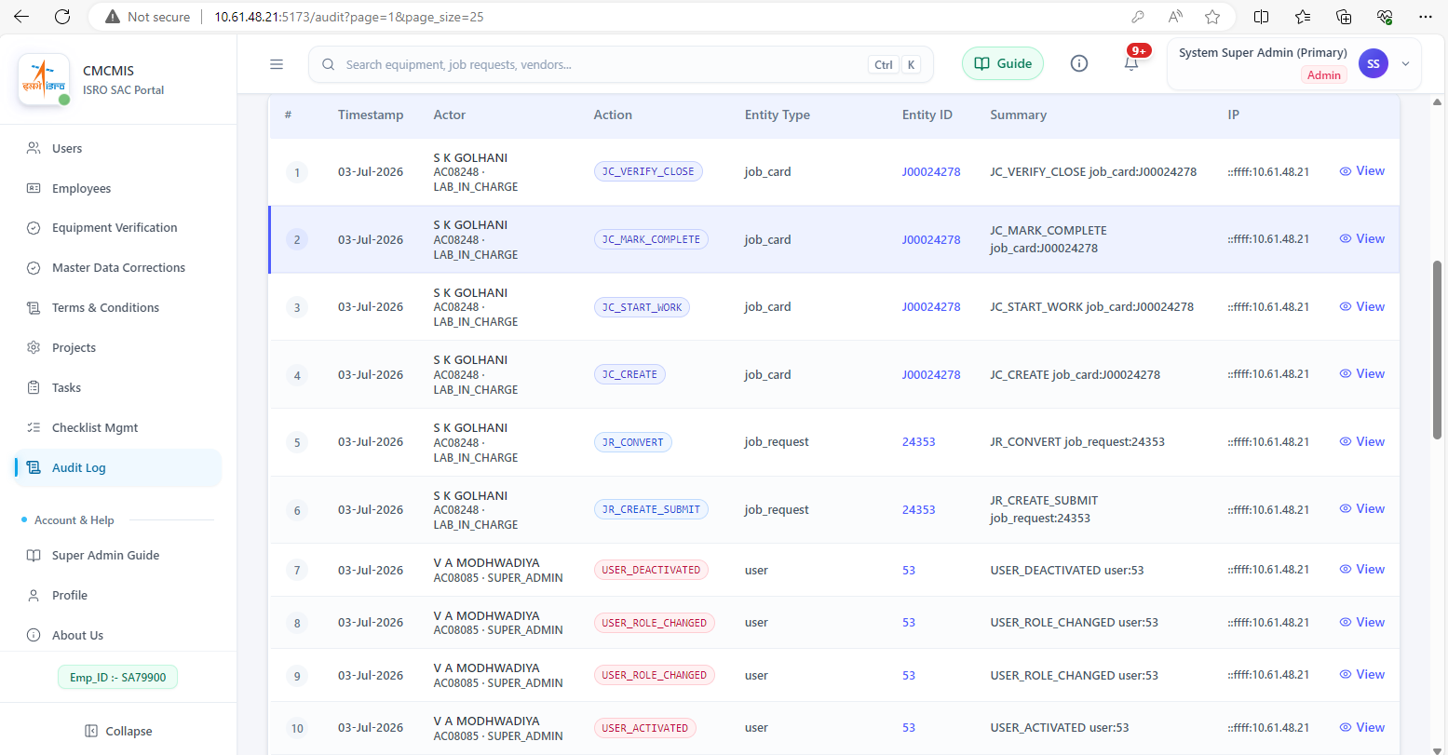
Figure 15: Audit Trail browser — field-level change detail
Lab activity calendar (Schedule module), with an ICS export option for calendar synchronisation:
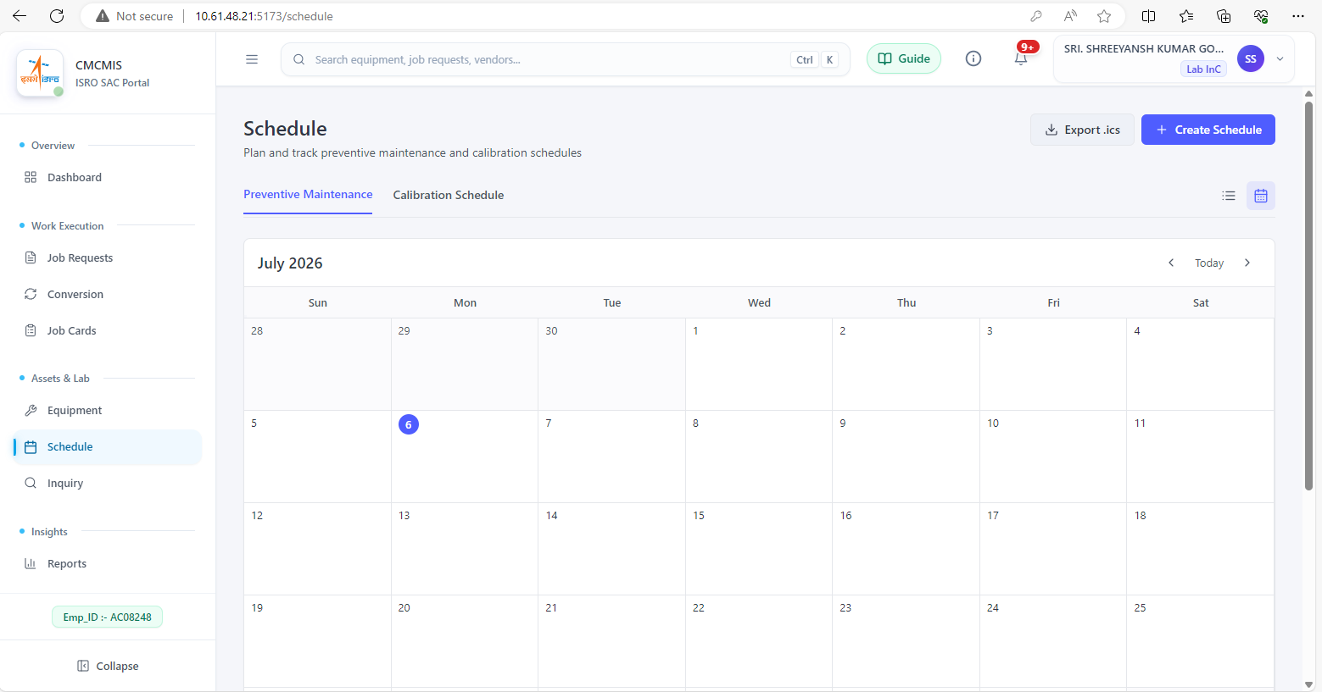
Figure 16: Schedule / Lab Calendar view

Chapter 6: Testing and Quality Assurance
(Note: the department template lists this chapter as “Result and Discussion” a second time; it has been renamed here to Testing and Quality Assurance, in line with the template’s note that chapter titles may be changed according to the work carried out.)
The final development week of the engagement was dedicated to end-to-end integration testing across all 23 backend modules and every frontend route of the application. Testing was carried out at three levels, each concluding in a formal, reviewed report:
- Functional testing — verifying that each workflow (Job Request, Job Card, checklist, spares, certificate generation, reporting) behaves correctly across all five roles and all defined state transitions.
- Codebase structure testing — reviewing module boundaries, the three-tier architecture (React frontend / Express backend / MySQL), and adherence to the documented 13-step middleware pipeline.
- Security testing — verifying password hashing, JWT issuance and rotation, refresh-token replay/theft detection, rate limiting on authentication routes, and role/permission enforcement at every protected route.
Defects identified during this phase were logged, triaged and resolved before the engagement concluded. The testing phase fed directly into the finalisation of the Software Requirements Specification (SRS) and the accompanying Functional, Codebase Structure and Security test reports, together with the final project presentation delivered to the mentor team.

Chapter 7: Conclusion and Future Work

7.1 Conclusion
This internship at SAC-ISRO was an intellectually demanding and professionally formative experience. The CMCMIS redevelopment project required navigating the real-world complexity of a legacy system with live data, a multi-stakeholder approval process, domain-specific compliance requirements (NABL), and a twelve-week delivery timeline — all characteristic of genuine production software work, rather than the more controlled conditions of academic projects.
The delivered system — a React/Vite frontend, a 23-module Node.js/Express backend, a 28-migration MySQL schema bundle, and a complete set of PDF certificate and report templates — constitutes a durable operational asset for the TIMCD calibration laboratory at SAC. It digitises and streamlines the complete lifecycle from job request to signed certificate, provides real-time visibility through dashboards and reports, enforces role-based access and data integrity, and generates every category of official calibration document correctly and consistently.
The skills acquired — full-stack architecture, security engineering, database migration design, state machine modelling, PDF generation, and formal technical documentation — and the experience of delivering a production-quality system within an ISRO operating environment will be foundational to my professional career. I am grateful to the TIMCD team at SAC for the guidance, trust and resources that made this outcome possible.

7.2 Future Scope
CMCMIS is envisioned to evolve into a comprehensive digital platform supporting end-to-end maintenance management. The future development scope includes:

1. Extensive Reporting Module
- Customizable, role-based dashboards for management, maintenance and operations teams.
- Automated generation of periodic reports (daily/weekly/monthly/annual) covering equipment downtime, maintenance costs, spare-parts consumption and manpower utilization.
- Trend analysis and predictive reports (MTBF, MTTR, failure patterns) to support data-driven decision-making.
- Export options in PDF/Excel formats with graphical representations (charts, heat maps, KPI trackers).

2. Document Upload and Storage
- Centralized repository for uploading and storing maintenance records, inspection reports, work orders, and compliance certificates.
- Version control to track document revisions and maintain audit trails.
- Search and retrieval functionality using tags, equipment ID, or date filters.
- Role-based access control to ensure data security and confidentiality.

3. Equipment Manuals and Technical Documentation
- Digital library for storing OEM manuals, technical drawings, wiring diagrams and SOPs.
- Quick-access linkage of manuals to respective equipment records for on-the-spot reference during maintenance/troubleshooting.
- Support for multiple file formats (PDF, CAD, images, videos) for comprehensive technical guidance.

Appendix A: Tools Used
The complete list of development tools, frameworks and libraries used to build CMCMIS is presented in Table 1 (Section 1.3.4, CMCMIS Technology Stack Summary). In addition to those, the following supporting tools were used during development:
- LaTeX — used to author the canonical master templates for calibration certificates, Job Closing Forms and Job Request Forms, later faithfully reproduced as PDFKit modules.
- Git — version control for the frontend and backend codebases.
- Postman — manual API testing of Express backend routes during development.
- MySQL Workbench — inspection and validation of the legacy and evolved database schema.

Appendix B: Additional Material — Sample Deliverables
Sample calibration certificates produced by the redeveloped system, matching the approved NABL/Non-NABL layouts:

Figure 17: Sample calibration certificate (redeveloped system) — page 1

Figure 18: Sample calibration certificate (redeveloped system) — page 2
Sample Job Request Form and Job Closing Form, generated as downloadable PDFs:

Figure 19: Sample Job Request Form (PDF export)
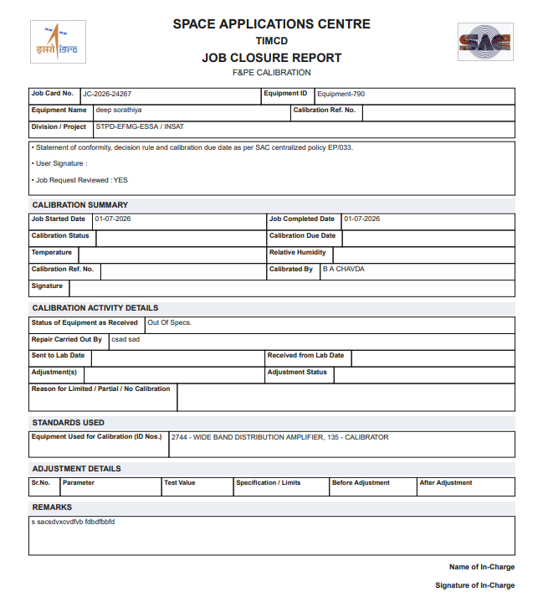
Figure 20: Sample Job Closing Form (PDF export)

References
This internship report is based primarily on first-hand engagement, design documentation, and the Software Requirements Specification produced during the internship at Space Applications Centre (ISRO), Ahmedabad, rather than on published external literature. The following standards and technical references informed specific aspects of the work:
- NABL 112 — Specific Criteria for Accreditation of Calibration Laboratories, National Accreditation Board for Testing and Calibration Laboratories.
- ISO/IEC 17025:2017 — General requirements for the competence of testing and calibration laboratories.
- RFC 5545 — Internet Calendaring and Scheduling Core Object Specification (iCalendar), used as the basis for the Schedule module’s ICS export.
- Official framework documentation for React, Express.js, MySQL, and the supporting libraries listed in Table 1, consulted throughout development.
Website URLs for the technical documentation referenced above have been intentionally omitted from this section and may be added as a separate appendix if required by the department.

