Sprint 2 Software Requirements Specification
Member interface requirements and Lead integration boundaries
IRON CHEF v3 | Vo Trung Tin | Reviewed 11 October 2026
This specification covers Vo Trung Tin's Sprint 1–2 deliverables. The graph and scan screens have run in a real browser. The graph capture contains 25 seeded ingredients and four substitution relationships; it does not show a completed Lead graph. The photo screen shows controls, not an accepted detector. Requirements below therefore separate implemented interfaces from acceptance gates.
Document control | Value
Edition | English revision 1.2, 11 October 2026
Audience | Member and Lead developers, reviewers, testers, and thesis supervisors
Scope | User, Creator, and reviewer UI; graph, scan, substitution, allergens, feedback, evaluation, and thesis evidence
Outside Member acceptance | Canonical datasets, model training and scoring, reviewed clinical policy, production deployment, and human research

Source baseline and interpretation
Source | Evidence used
Sprint 2 report supplied by the user | Work assignment: Vo Trung Tin owns UI requirements, use cases, data flows, and Member scaffold acceptance. The sprint runs 23 September–10 October 2026.
Member backlog, branch codex/member-sprint12-deliverables | Epic 1–12 implementation states and open gates G1–G10; engineering checkpoint dated 6 October 2026.
Lead backlog v109, origin/master 8bb8167 | As of 9 October 2026, Stage 3 is artifact-verified through exact step 327/561. Segment 6 was launched toward step 374. Final model quality and scoring remain unverified.
Browser captures dated 6 October 2026 | Actual frontend views of /explore/graph and /scan, with the graph backed by local seed data.
Frontend and monolith code | Routes, request boundaries, error states, fields, and adapter behavior reviewed for this edition.
Evidence rule: a browser image proves that a screen appeared during that run; code shows an implemented path; a backlog records the team's checkpoint. None alone proves production deployment, model quality, clinical safety, or a research result.

1 Product context and actors
ChefKix combines recipe creation and cooking journeys with ingredient intelligence. The Lead owns scientific evidence, canonical data, models, policies, and evaluation protocols. The Member owns user-facing surfaces and adapters. A visible UI control must not be treated as proof that its external model or evidence source is accepted.
Actor | Goal and access boundary
Guest | May view public welcome, graph, and scan screens. Account-dependent actions may stop at sign-in or integration-pending states.
User | May save allergen preferences, inspect recipes, scan ingredients, select substitutions, cook, and submit feedback under an authenticated profile.
Creator | May draft, edit, and publish recipes while preserving ingredient quantities and recipe context.
Reviewer or admin | May inspect protected evaluation and thesis evidence views with provenance and claim limits.
Lead or AI provider | Supplies accepted model artifacts, manifests, graph data, and reviewed policy. UI code cannot independently certify these inputs.

2 Observed browser interface
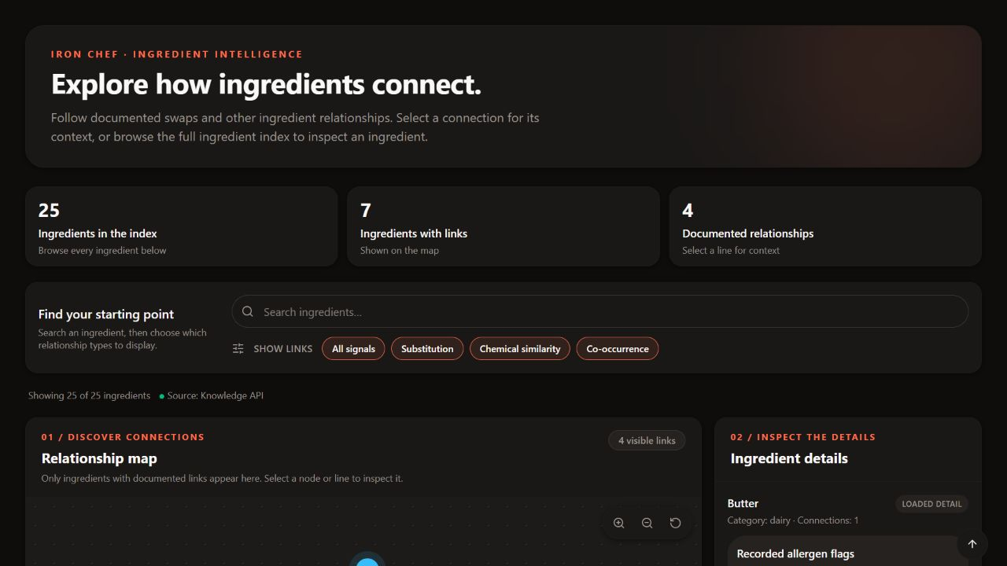
Figure 1. Graph search, relationship filters, coverage summary, and detail panel in the browser on 6 October 2026.
The running graph reported 25 ingredients, seven with links, and four documented substitution relationships. It loaded through the configured Knowledge API, but this was a local seed collection. Chemical-similarity and co-occurrence filters are visible controls; their presence does not establish those data types in the seed response.
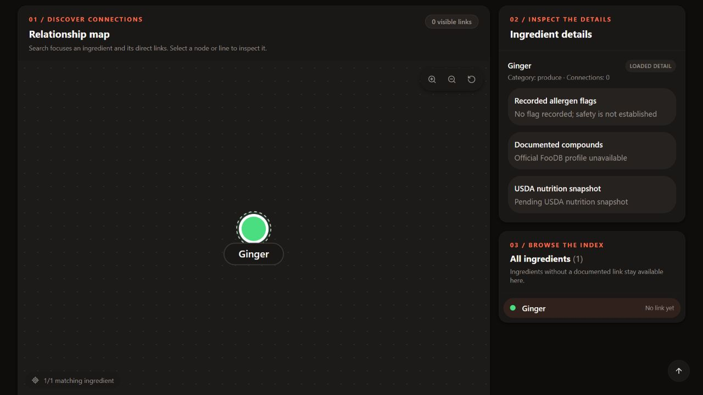
Figure 2. Searching Ginger centers an isolated node; compound and nutrition evidence is unavailable.
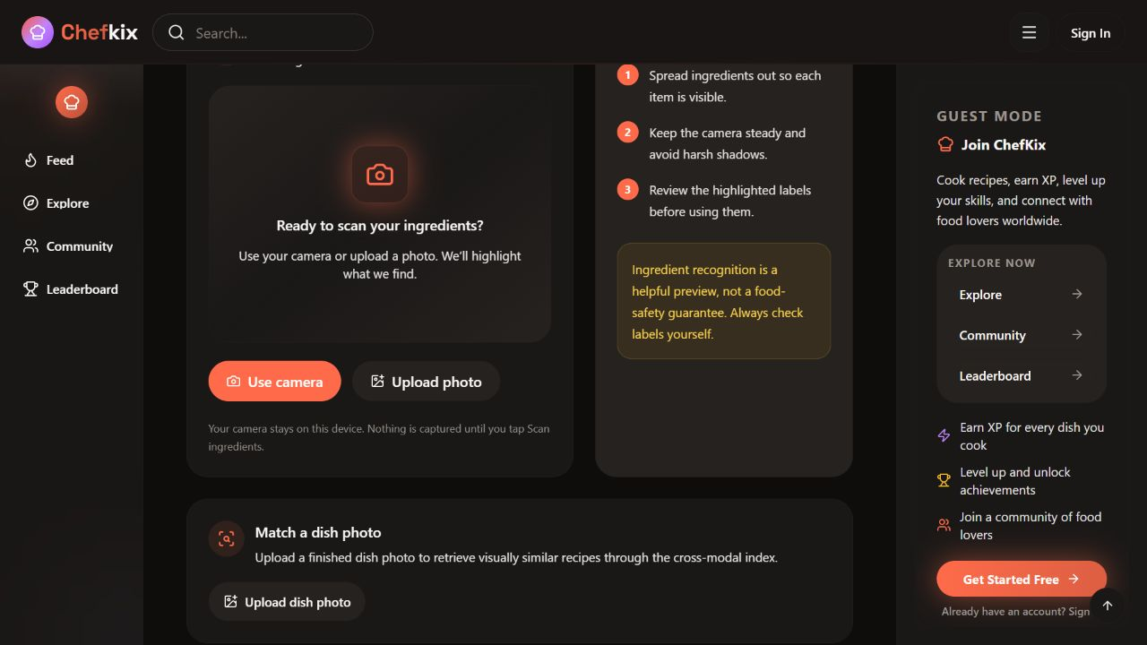
Figure 3. Public scan screen with camera, image upload, and dish-photo controls. No live detector inference is evidenced.

3 Functional requirements

UI-01 Recipe authoring
The Creator can draft, edit, and publish recipes. Ingredient identities and quantities remain available as context for substitutions.
Current state: Existing workflow; verify the saved context across services.

UI-02 Scan and input review
The User can capture or upload an image and see distinct permission, loading, error, unavailable, and demo states. Detections must be reviewable and editable before downstream use; manual input must remain possible.
Current state: Camera, upload, and overlay exist. Per-detection editing and real detector/device acceptance remain open.

UI-03 Contextual substitutions
Send ingredient, reason, recipe context, dietary tags, saved allergen flags, and session identity. Show candidate, quantity ratio, confidence, source, and unavailable values separately.
Current state: Adapters and UI exist; verify live source and receipt chain.

UI-04 Allergen profile
Support the configured EU 14 and FDA 9 groups plus custom terms; persist normalized flags and forward saved values on later requests.
Current state: Settings and persistence exist; authenticated end-to-end verification remains open.

UI-05 Three-valued safety
Safe requires reviewed policy support. Missing, invalid, conflicting, or unknown evidence yields Check. A policy conflict yields Blocked and disables the primary action.
Current state: Resolver and regression tests exist; production policy acceptance is pending.

UI-06 Compound explanation
Show source, grounding, units, and unavailable measurements. Compound presence or overlap must not imply cooking suitability, sensory equivalence, nutrition equivalence, or allergen safety.
Current state: UI surface exists; official index and real-payload capture are pending.

UI-07 Knowledge graph
Search and center results, drag and pan or zoom, inspect nodes and edges, load bounded neighborhoods, and show actual coverage.
Current state: UI and bounded seed API work; official graph import remains open.

UI-08 Evaluation dashboard
Protect the reviewer route, distinguish complete, pending, and rejected results, hide pending numbers, and preserve provenance and claim limits in exports.
Current state: Dashboard and schema validation exist; verified Lead manifests and scores are pending.

UI-09 Feedback
Record accept, reject, skip, and post-cooking outcomes against a session and real candidate receipt; show failure and retry states.
Current state: Controls and ingestion paths exist; cross-service recovery and representative outcomes remain open.

UI-10 Community
Preserve recipe interactions and gamification while keeping engagement events separate from research labels.
Current state: Existing product workflow; verify separation when reporting results.

UI-11 Thesis evidence
Map all 14 Lead chapters to artifact IDs, source routes, and honest readiness states. A planned capture is not a completed reviewed artifact.
Current state: Workspace mapping exists; source-backed captures remain open.

4 Non-functional requirements
ID | Acceptance condition
NQ-01 Safety | No name heuristic, missing allergen flag, model confidence, or compound overlap may upgrade a result to Safe. Missing or invalid policy yields Check; conflicts yield Blocked.
NQ-02 Evidence | Displayed metrics and explanations retain source, status, protocol, and limitations. A displayed hash is metadata until its artifact has been independently checked.
NQ-03 Degraded operation | Missing AI or data services produce explicit pending or error states. Ordinary production requests never silently switch to demo data.
NQ-04 Privacy and access | Profile data, uploads, and protected evaluation use application authentication boundaries. Private images and profile values are not published as open evidence.
NQ-05 Accessibility | Provide labels, keyboard operation, visible focus, and text cues in addition to color. Large-graph, mobile, and assistive-technology evidence remains required.
NQ-06 Bounded work | Graph depth 0–2 and limit 1–500; image cap 10 MiB; model requests support cancellation and a 30-second upstream timeout. Verify on deployment.

5 External interfaces and data contracts
Interface | Current contract
Graph | GET /knowledge/graph using q or root, depth, and limit. Response includes bounded nodes, edges, and coverage. Seed edges are substitution only; confidence may be null.
Profile | PUT /auth/settings/cooking and PUT /auth/update persist normalized allergen flags under the authenticated user.
Substitution | POST /api/v1/suggest_substitutions carries ingredient, reason, recipe_context, dietary_tags, allergen_flags, and session_id. Candidate safety, evidence, and receipt fields depend on the source.
Compounds | GET /api/v1/compound/profile/{ingredient} and POST /api/v1/compound/analyze-pair require source and grounding before factual display.
Photo | POST /api/ingredient-detection and POST /api/photo-intelligence/ingredient-recipes use bounded same-origin adapters and caller authentication. A 503 indicates unconfigured integration.
Evaluation | The frontend /admin/evaluation route is protected and validates the supplied manifest structure. Schema acceptance does not establish scientific validity.

6 Backlog traceability and acceptance gates
Gate | Implemented surface and remaining evidence
G1 and G6 Evaluation | Dashboard, schema checks, provenance captions, and hidden pending values exist. Close only with verified Lead exports, artifact hashes, strata, intervals, abstention, and review.
G3 Compound | Missing values stay unavailable and source identity is retained. Close with official index payload captures and an ethics-reviewed usefulness study.
G4 Safety | Profile forwarding and three-valued UI exist. Close with reviewed policy, deployed end-to-end flow, and adjudicated benchmark.
G5 Graph | Explorer and bounded API work on seed data. Close with rights, schema, hash, staged import, rollback, coverage, and API-backed captures for the official graph.
G7 Feedback | Controls, receipts, and ingestion exist. Close with cross-service choices and outcomes, retries, replay, recovery, and representative evidence.
G8 Photo | Camera UI and adapters exist. Close with accepted M3/M4 model or index, provider credentials, rights-cleared images, and real-device evidence.
G9 Thesis | Fourteen-chapter workspace exists. Close with source-backed figures, deployment and cost records, ethics/recruitment, and review.
G10 Voice | Optional scaffold is deferred and is not a Sprint 2 acceptance item.

7 Progress claim rule
Lead v109 verifies secondary Stage 3 through exact step 327/561 and records only a Segment 6 launch toward step 374. It does not verify step 374 completion, the final adapter, inference, scoring, or model quality. Likewise, a browser graph image proves the seeded UI rather than the canonical research graph, and a scan screenshot proves controls rather than live user-photo recognition.

