Sprint 2 Data Flow Specification
Context diagram, level one flows, data contracts, and trust boundaries
IRON CHEF v3 | Vo Trung Tin | Reviewed 11 October 2026
This document traces data among the browser, frontend adapters, monolith, and Lead-owned AI or evidence sources. Each flow identifies inputs, transformations, stores, and failure states. A diagram arrow expresses an interface or requirement, not proof that an external model is accepted.

Source baseline and interpretation
Source | Evidence used
Sprint 2 report supplied by the user | Work assignment: Vo Trung Tin owns UI requirements, use cases, data flows, and Member scaffold acceptance. The sprint runs 23 September–10 October 2026.
Member backlog, branch codex/member-sprint12-deliverables | Epic 1–12 implementation states and open gates G1–G10; engineering checkpoint dated 6 October 2026.
Lead backlog v109, origin/master 8bb8167 | As of 9 October 2026, Stage 3 is artifact-verified through exact step 327/561. Segment 6 was launched toward step 374. Final model quality and scoring remain unverified.
Browser captures dated 6 October 2026 | Actual frontend views of /explore/graph and /scan, with the graph backed by local seed data.
Frontend and monolith code | Routes, request boundaries, error states, fields, and adapter behavior reviewed for this edition.
Evidence rule: a browser image proves that a screen appeared during that run; code shows an implemented path; a backlog records the team's checkpoint. None alone proves production deployment, model quality, clinical safety, or a research result.

1 Notation and trust boundaries
Term | Meaning
External entity | User, Creator, Reviewer, or Lead source that supplies or receives data.
Process | UI or service step that validates and transforms input.
Store | Profile, recipe, graph, receipt/event, or evidence manifest data.
Trust boundary | Browser → same-origin frontend → monolith or model provider. User bearer credentials are not forwarded directly to a model provider.

2 Context diagram
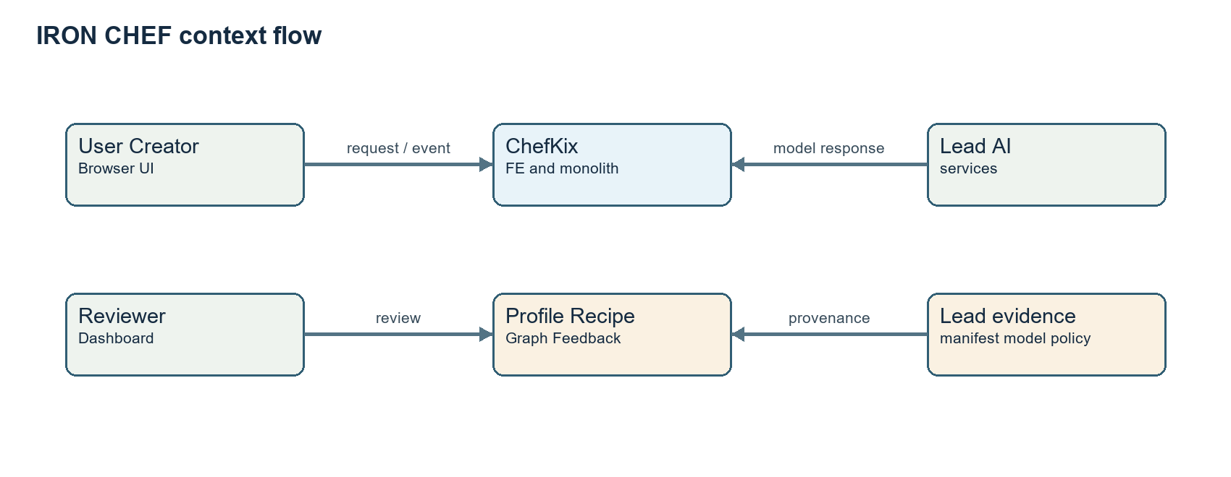
Figure 1. Logical context; detailed request and response paths are specified below.

3 Level one processes
Process | Inputs and outputs
P1 Recipe and profile | Creator recipe and User allergen settings → stored recipe, normalized profile, and context for P3.
P2 Photo detection | Camera/upload image plus caller identity → sourced detections or explicit integration-pending state.
P3 Substitution and safety | Ingredient, recipe context, tags, flags, candidate policy → three-valued card and real candidate receipt.
P4 Graph and compounds | Search/root/depth/limit or ingredient pair → bounded graph with coverage and grounded evidence where available.
P5 Feedback | Session, candidate receipt, choice/outcome → durable event, projection, ingestion, and retry identity.
P6 Evaluation and thesis | Lead manifest and artifact references → protected dashboard, figure caption, and evidence readiness state.

4 DF 01 Photo to ingredients and recipe candidates
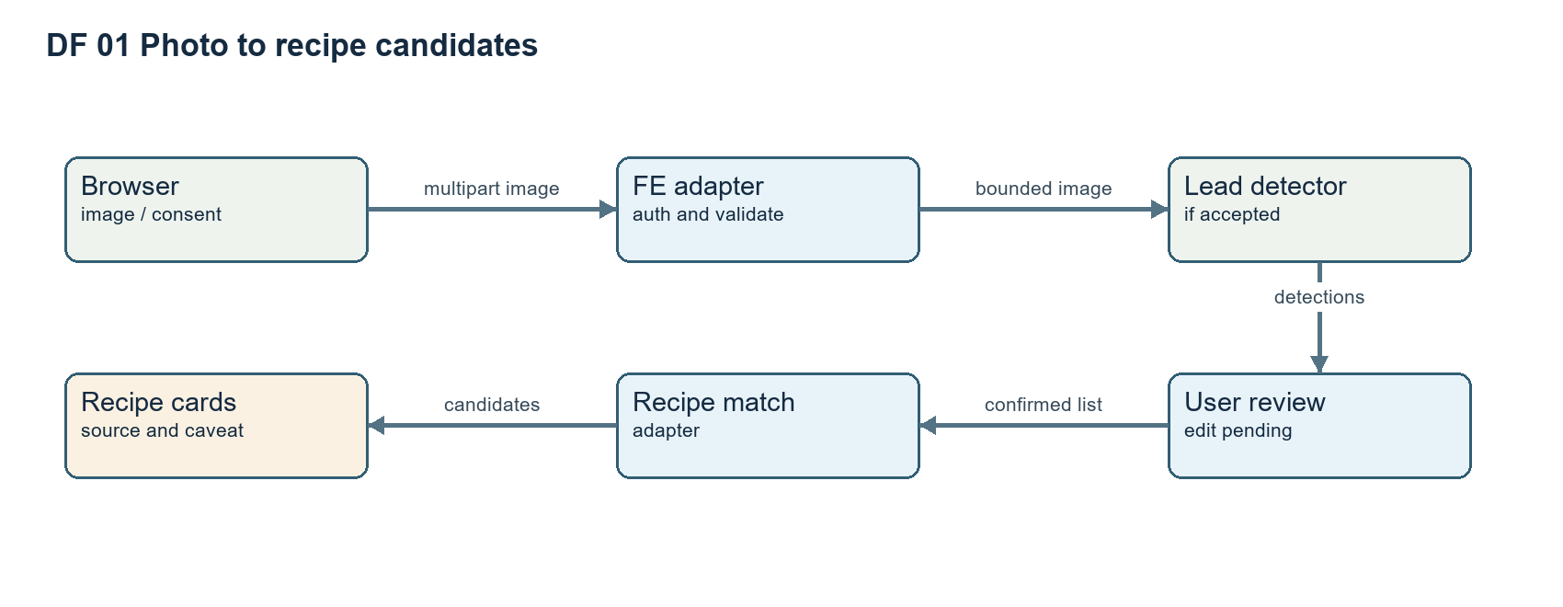
Figure 2. User correction is an open UI gate and must occur before downstream action in the accepted flow.
Step | Input, validation, and failure behavior
Browser | Request camera only after action or accept upload. Denied or unsupported camera offers upload or manual input; a guest screenshot does not prove a device-camera run.
Frontend adapter | Authenticate caller; validate multipart image type, non-zero bytes, and ≤10 MiB. Propagate cancellation and cap upstream work at 30 seconds. Return 400/413 or 503 as appropriate.
Lead detector | Return name, box, confidence, and source only from an accepted configured model. M3 is not yet accepted; malformed or failed response is an error, never fabricated output.
User review | Correct or remove detections and confirm the list. The observed /scan screen does not yet establish this editing control.
Recipe matching | Submit no more than 100 ingredient names of up to 120 characters each through the protected bounded route. Accepted M4 model/index and rights evidence remain open.

5 DF 02 Profile to substitution and safety
Authenticated settings → monolith profile store → normalized allergen flags → substitution request with ingredient, reason, recipe_context, dietary_tags, flags, and session_id → candidate/policy/receipt response → frontend resolver → Safe, Check, or Blocked card → selection or decline. Missing or unreviewed policy never becomes Safe. Custom or unknown terms remain Check without adjudication.
Data | Source and handling
Allergen flags | Saved under the authenticated profile, normalized, forwarded in later requests, and excluded from public evidence logs.
Policy result | Reviewed policy source only. Missing or malformed → Check; conflict → Blocked; Safe only with sufficient reviewed evidence.
Candidate receipt | Preserve source identity for feedback; never synthesize a missing receipt.
Compounds and nutrition | Separate official evidence path with source, grounding, and units. Null means unavailable and never upgrades allergen safety.

6 DF 03 Knowledge graph and compounds
Browser search or root → GET /knowledge/graph with depth 0–2 and limit 1–500 → seed or imported monolith collection → bounded nodes, edges, and coverage → client focus, pan, zoom, and detail. The captured Ginger result has no edge. The four seed edges are substitutions only. Filter labels for chemical similarity and co-occurrence do not create scientific data. Compound profile and pair requests use a separate official source path; ratio is not confidence and overlap does not prove culinary suitability.

7 DF 04 Feedback and research evidence
Cooking session → choice/outcome event with candidate receipt → monolith durable write → projection and AI ingestion/replay. Failed writes, retries, and replay retain event identity and cannot be reported as model learning. Separately, Lead dataset/split/protocol/prediction artifacts → manifest and review decision → frontend schema validation → dashboard/export caption → thesis artifact. The frontend validates structure, not the independent identity, rights, review, or correctness of upstream science.
Store | Owner and current state
Profiles and recipes | Monolith product storage and frontend flows exist; deployed authenticated acceptance remains to be checked.
Knowledge graph | Monolith currently serves a 25-ingredient, four-edge seed. Official G5 import is pending.
Receipts and feedback events | AI and monolith paths exist; representative cross-service outcome and recovery evidence remains pending.
Evaluation manifests | Lead-owned. Frontend schema and captions exist; verified artifacts and scored results remain pending.
Thesis captures | Member and Lead reviewers. Fourteen chapters are mapped; individual source-backed captures and reviews remain pending.

8 Data safety and closure matrix
Flow | Evidence required before closure
Photo | Real devices, provider authentication, accepted detector and retrieval model/index manifests, and image rights. Screen controls are not inference evidence.
Safety | Reviewed policy, authenticated deployed profile-to-policy-to-UI test, and adjudicated benchmark. Compound overlap and absence of a match do not establish Safe.
Graph | Rights/schema/hash-validated import, coverage checks, rollback, and API-backed captures. A seed API is not the canonical graph.
Evaluation | Actual Lead artifacts and checked hashes, split/protocol/seeds, intervals, abstention, and review. A training checkpoint is not a quality score.
Lead v109 verifies secondary Stage 3 through exact step 327/561 and records a Segment 6 launch toward step 374. Completion of Stage 3, inference, scoring, and model quality remain open.

