Analyse assignment periode 3

Requirements Public Library System  
Groep: DINF1  
Davinci Lisapaly (0991018), Leon Driesse (0991038), Tarik Ualit (0995543), Kaykhorsrow Hasany(0998409)

The following requirements will be realized for a public library system:

Librarian

* Should be able to add books
* Should be able to administrate loaned books
* Add new subscribers
* Make backup
* Recover backup
* Can keep track of users and the corresponding loaned books
* Loan an book to an subscriber

Subscriber

* Should be able to search for books and loan books

Publishing Company

* Should be able to search for books and loan books

## Class Diagram

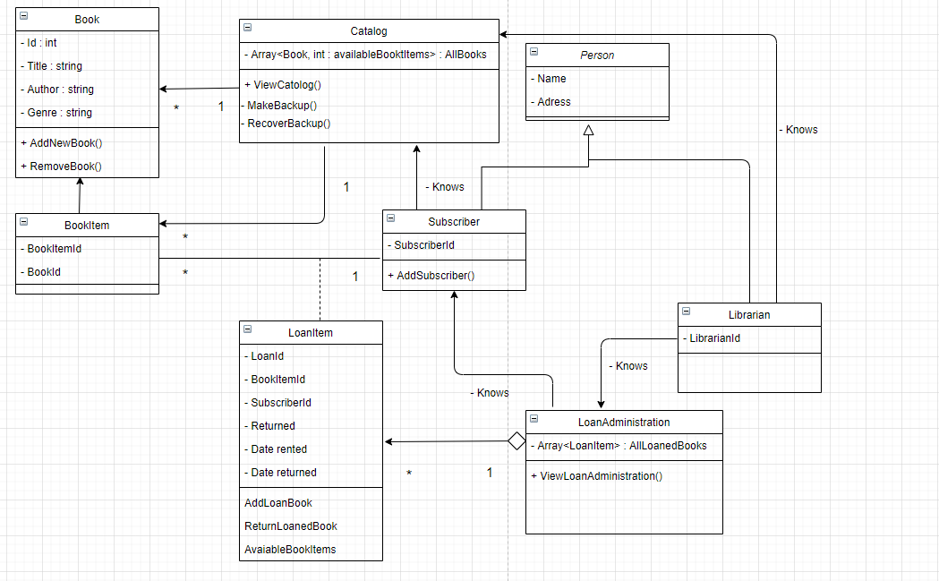

## Use Case Diagram:

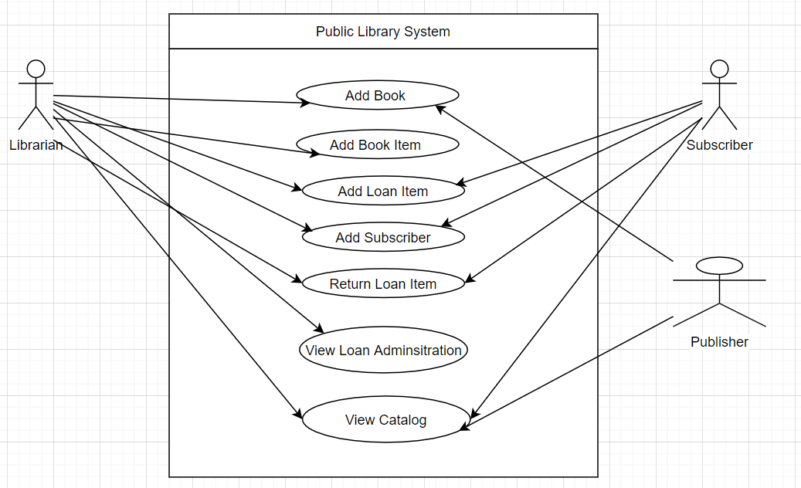

## User Manual

* Start PLS system by running “python PLS.py” in the root directory with an command prompt. The following screen should pop up

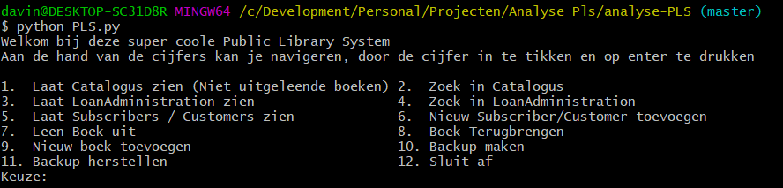

* Insert a number in next to “Keuze” which corresponds to the to the desired action.
* When showing the catalog, the book which aren’t available for rent automatically doesn’t show.
* When searching for an book, you can search on all the properties of the book
* Lending an book requires the id’s corresponding to the available book and subscriber.  
  To know which Book Id & Subscriber Id to select, it is recommended to show the catalog and list of all subscribers first.
* When creating an backup, an backup of today will be made
* When restoring an backup, the application will restart itself with the restored backup data
* The user can return the book, an timestamp will be saved to the loanitem and the property Returned will be set on true. It is recommended to view the LoanAdministration first before returning an book. This way you can see which LoanId you should enter for returning it.
* You can add a new subscriber, the application will ask for an name and an adress. After entering it a new subscriber will be saved and the generated id for that subscriber is also shown