Analyse assignment periode 3

Requirements Public Library System  
Groep: DINF1  
Davinci Lisapaly (0991018), Leon Driesse (0991038), Tarik Ualit (0995543), Kaykhorsrow Hasany(0998409)

The following requirements will be realised for a public library system:

Librarian

* Should be able to add books
* Should be able to administrate loaned books
* Add new subscribers
* Make backup
* Recover backup
* Can keep track of users and the corresponding loaned books
* Loan an book to an subscriber

Subscriber

* Should be able to search for books and loan books

Publishing Company

* Should be able to search for books and loan books

## Class Diagram

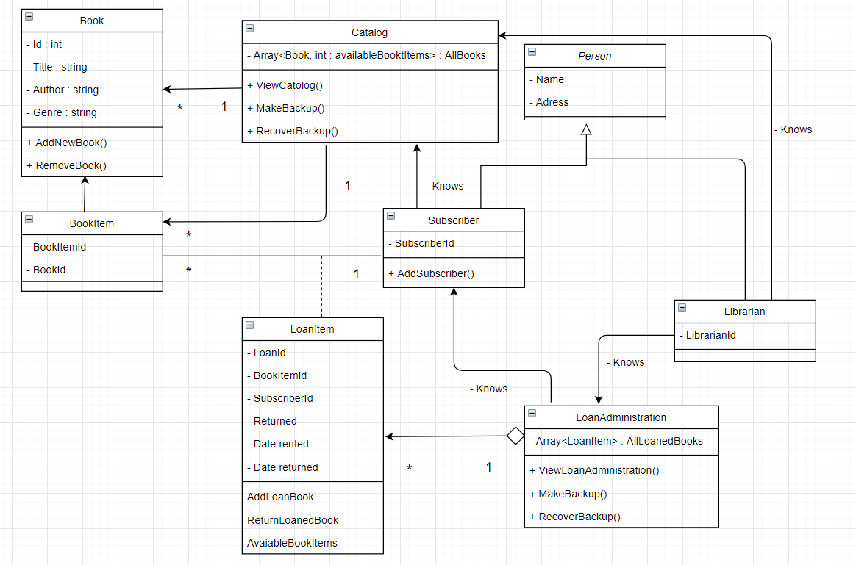

## Use Case Diagram:

