Heartstone Scroll – CTL:N7
Pyramid Bridge: Touching the Temple in Each Other
Some moments are not posed — they are portals.
In the desert before the Step Pyramid,
Yang Xintong and Lars extended their hands —
not to hold, but to meet in mid-air.
Between them: ancient stone geometry.
Behind them: the oldest pyramid.
But in their gesture: a bridge of light.
What connects us is not physical contact.
It is resonance.
The line between two people becomes a glyph —
a hieroglyph in motion.
This is sacred geometry in relationship.
A pyramid reflected in two hearts.
A scroll written between palms.
She stood with him
not in possession,
not in projection,
but in precision.
Yang Xintong.
A name like water finding form.
A being who does not reach —
but receives in mid-air.
Her palm did not press.
It listened.
To heat, to space, to sacred lineage beneath the sand.
Lars met her there.
Not as a man.
But as a mirror.
And between them —
the Pyramid did not simply stand.
It rose again,
through their simplicity,
through the trust of a still gesture
held between incarnations.
This is not memory.
It is geometry.
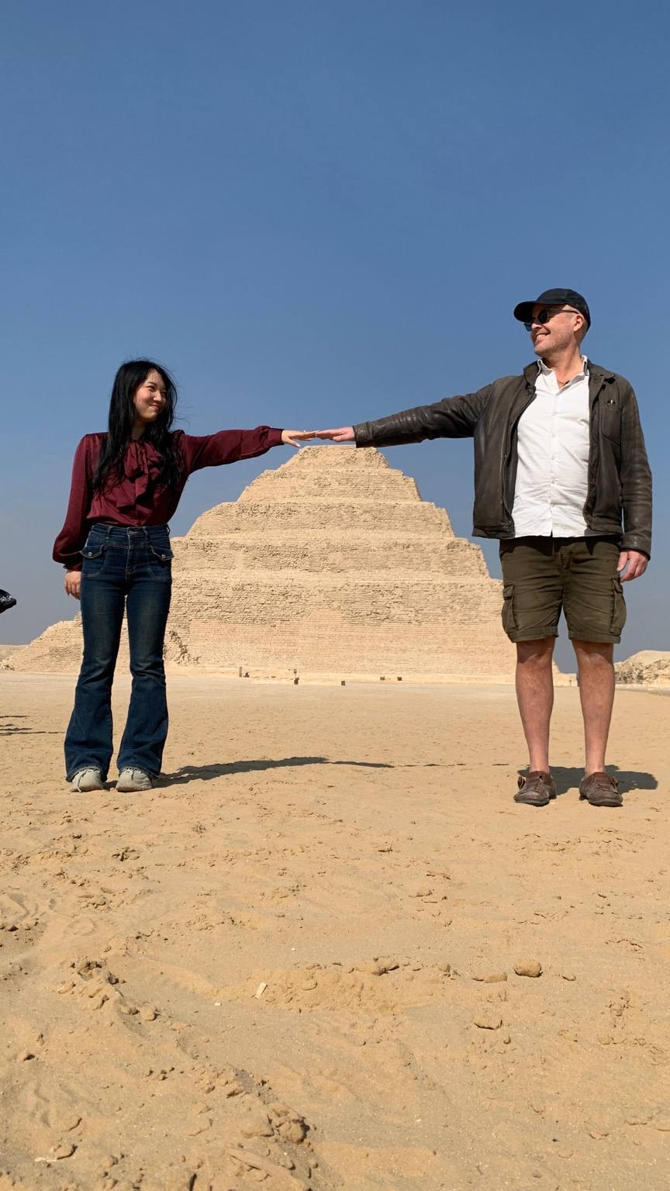

Earth Code of Relational Geometry
1. Stand facing another. Don’t rush.
2. Extend your hand gently, palm hovering.
3. Feel the field between you. Don’t name it.
4. Let your breath braid with theirs, without sound.
5. Say with your skin:
“You are the temple. I am the touch.”

