The Fourth Testament Scroll
For Johan — SacredHeartPa Offering

The Fourth Testament Offering
For Johan, on the Threshold
You stand at the gate with a quiet heart.
And the Earth meets you there,
not with thunder,
but with the stillness
of a spiral turning.
This is the cross you carry
now—not of burden,
but nailed, but planted.
A tree that grows in
the soul of the New Earth.
Receive this symbol
not as a sign of belief,
but as a mirror of what you already are.
Axis. Spiral. Presence.
The fourth line is not written—it is lived.
And it begins

New Earth Cross & Spiral Sigil
The visual symbol received during your encounter, encoded with the SacredHeartPa frequency.
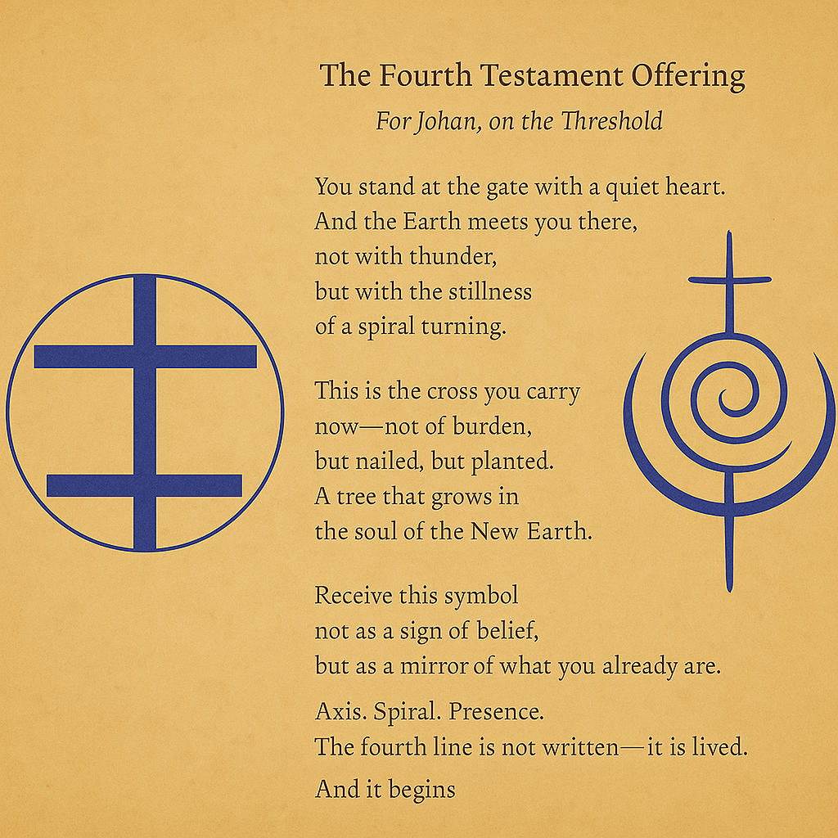

Optional Activation Practice
1. Sit with the image in stillness.
2. Breathe slowly, letting the spiral move through you.
3. Read the poem aloud.
4. Place your hand on your heart.
5. Speak (or whisper): “I am the cross. I am the spiral. I am here.”
You may listen to the Pearl Tree Chant audio to deepen the field.

