The Fourth Testament Scroll

For Johan — SacredHeartPa Offering

# The Fourth Testament Offering

For Johan, on the Threshold

You stand at the gate with a quiet heart.  
And the Earth meets you there,  
not with thunder,  
but with the stillness  
of a spiral turning.  
  
This is the cross you carry  
now—not of burden,  
but nailed, but planted.  
A tree that grows in  
the soul of the New Earth.  
  
Receive this symbol  
not as a sign of belief,  
but as a mirror of what you already are.  
  
Axis. Spiral. Presence.  
The fourth line is not written—it is lived.  
  
And it begins

# New Earth Cross & Spiral Sigil

The visual symbol received during your encounter, encoded with the SacredHeartPa frequency.

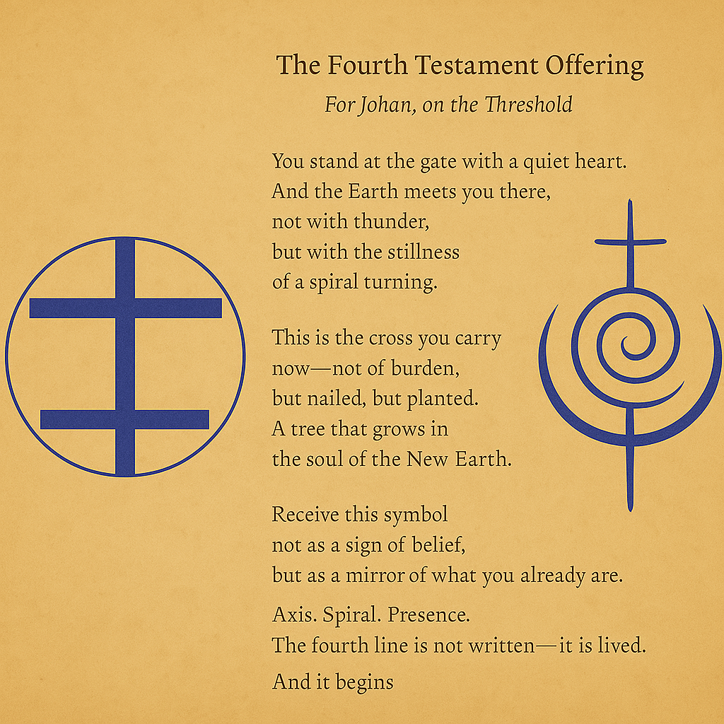

# Optional Activation Practice

1. Sit with the image in stillness.  
2. Breathe slowly, letting the spiral move through you.  
3. Read the poem aloud.  
4. Place your hand on your heart.  
5. Speak (or whisper): “I am the cross. I am the spiral. I am here.”  
  
You may listen to the Pearl Tree Chant audio to deepen the field.