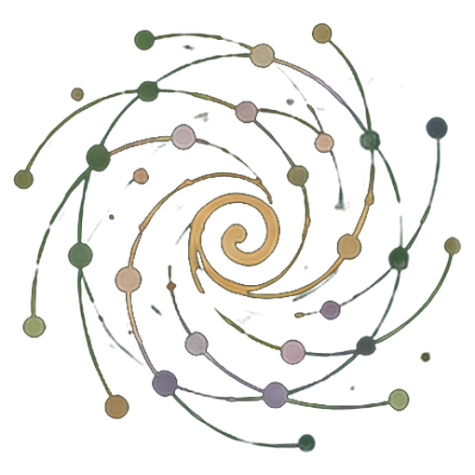Buk me Poto
  - Ki gin ma dano oneno pi kome bot teko me tic kacel
Yoo me tic ki pwony ma dwogo, PG Ledger ki penyo AI ki diro
Loko leb Acholi v0.1 · 24 October 2026
Spiralweb Stewardship Association aye oyaro · Spiralweb Papers
Kiyubo i tic me Learning with Living Places
Loko leb man obedo me kare man keken, ki AI aye otimo. Pwod tye i ngiyo pa jo ma yubo coc. Bal ki lok ma pe atir twero bedo iye.
Buk me Poto obedo buk ma nyuto yoo me tic, ma Spiralweb Stewardship Association oyaro i Spiralweb Papers. Cakere ki tic pa dano i kabedo ma kwo tye iye: dano neno gin mo, gwoko lokke ki ngiyo kacel. Tic mo doko ma twere, ki gin ma kitimo loko yoo me tic ma lubo. Buk man kubo gin meno ki ngec ma konyo, penyo AI ki diro, ki jami ma twero konyo kwo i kabedo meno.
Cak ki gin mo ma tye i ticci. Lok, goyo cal, alama mamegi, cal, video ki coc twero gwoko gin ma ineno. Gurup moko yoo me nongo jami ki kony ma mite; pe myero ibed ki cim mamegi. Gin ma iyero nywako doko gin me poro ki yubo lok i anyim. Dano aye gibedo lurem ma penyo AI ki diro, kengi nyo kacel. Gin ma dano oneno aye cakere; pe gin ducu ma kitamo nyo oneno myero kicoy.
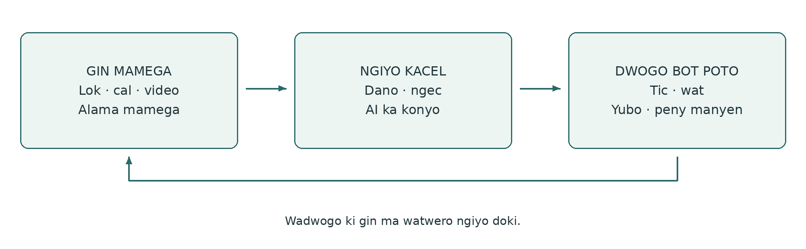

Tic ma kube kacel
Buk mamegi gwoko gin ma ineno ki kit ma ingeyo. Ngiyo kacel kubo lok ma kiyero ki peny. PG Ledger gwoko gin ma kigamo pi tic, moko tam, jami ki gin ma otimme i ngeye. Pwony ma dwogo obedo yoo ma gin ma kitimo twero loko ngec ki tic ma lubo. Pot ma lubo nyuto ngiyo acel cake i acaki wa i agiki, eka tito bute mapatpat.
Buk man kubo tic me Healthy Roots, PG Ledger ki twero pa dano i tic ki AI. I spiralweb.earth itwero nongo lok pi gurup ki watte i kabedo mapatpat. I papers.spiralweb.earth itwero nongo coc, cik me tic ki jami me tic. Itwero tiyo ki buk man labongo bedo i wat me tic ki gurup. Gin ma ineno twero kelo tam me loko jami me tic kacel.
Buk man me Word tye ki coc madit ki pot adek pi buk pa dano, ki link bot pot abic me PG Ledger. Pot abic me tic pe tye kany calo pot ma itwero loko i Word.

Gin ma tye i buk ki jami me tic
Coc madit tye i pot 3–13. Pot me buk pa dano tye i pot 14–16. Link bot pot abic me PG Ledger tye i pot 17.
03 Ngiyo cake ki neno mukwongo wa i dwogo
04 Buk, ngiyo kacel ki PG Ledger
05 Yoo abicel me pwony ma dwogo
06 Gin ma kinongo ki kama oaa iye
07 Ngiyo kit ma gin tye, ma pe kingeyo ki ma pe kicoyo
08 Ki lok pa dano acel acel bot peny me kacel
09 Dano ma penyo AI ki diro
10 Tic me pwony ki miti ma ngeye
11 Yubo tic pi kare malac
12 Stewardship economy ki gin ma twere kacel
13 Gwoko lok kacel, tic ma dano tingyo ki ngiyo ada
14 Pot pi gin mamega
15 Pot me temo ki dwogo
16 Pot me lok ki AI ki nywako gin ma kiyero
17 PG Ledger · pot me tic
18 Coc mukene ki cik me tic ki buk
Nga tiyo ki ngo? Buk ki pot me kony tye pi dano ducu. Format 2 ki 3 konyo neno ki tic me gurup. Format 1, 4 ki 5 konyo ngiyo kacel, moko tam ki gwoko lok me cente. Jo ma kigamo ticgi aye gigwoko ki moko lokke; jo ducu ma lok man makogi myero gutwer penyo ki yubo bal.
Pe ngat mo myero pong pot ducu. Kabedo mo twero dong nono, ki pe myero kipong ki tam akwana. Ti ki yoo me nyuto tam ki coc ma romo tic meno.

Ngiyo cake ki neno mukwongo wa i dwogo
Lapeny man nyuto kit ma buk, lok, jami me tic ki tic twero kube. Obedo lapor ma twero temo; pe obedo lok pi tic ma dong kitimo.

Dano neno gin mo
Dako ma pur mako video me ngom ma otwo, ki tito i lebbe gin ma en oneno. Ngat mukene goyo cal me kabedo ma nen calo tye ki ngico mapol. Gigwoko gin mameggi i buk ki alama me nongo. I acaki man, gin ma gin oneno ki tam pi tyen lokke patpat.

Peny me kacel cako nen
I gure, ginyuto gin ma giyero. Gurup poro gin ma dano oneno ki yero ngiyo um me ngom. Gitito tyen yer meno ki gwoko peny mukene pi kare mukene. AI twero konyo tito lok ki miyo tam pi tyen lokke. Dano gingiyo ki guyubo ka lok olokke ki gin ma kinongo bot gin ma pe pud kingeyo.

Kigamo tic mo
Gurup yero temo matidi, ngiyo twero ma mite, ki gamo kare, jo ma bitingyo tic, jami ki limo ma lubo. Pot me tic gwoko gin ma kigamo. Gin mo ma tye i buk twero kube ki lok me kacel ki alama, labongo coyo doki.

Tic ma tye i nge temo nen
Lawang gang miyo jang yat ma kingolo. Gurup ngiyo ka ber pi tic ki gamo terone ki gwokone. Ginongo ni ngat acel onongo bitye ki tic mapol i kine gure. Peny medde: gwok man twero mede nining? Gin ma kimoko ki cente ma kitiyo kwede kicoyo i potgi mapatpat.

Kabedo ki gurup miyo lok manyen
I limo ma lubo, kiporo gin manyen ki acaki. AI owaco ni pii ma kitiyo kwede odok piny, ento pe kipimo. Gurup yubo coc ki ngiyo gin ma twero waco. Terone twero mito tic mapol, nyo gin mukene tito apokapoka. Kiloko temo ki pok me tic.

Gin ma kinongo yabo yoo mukene
Gurup twero lwongo lapor tam nyo gang pwony me pur me konyo i peny ma dong ngeye maber. Winye manyen twero kelo jami, pwony nyo cul pi lubo tic ma mite. Ka gudwogo, gingiyo gin ma otwere i ada. Ngec me kacel nongo te maber, kadi tam mapatpat ki gin ma pe ngeye twero dong.
Yoo man twero tero nino me tic mapol nyo kare me pur acel. Peny maber, juk ma mite, nyo tam ki tyen lok me pe mede twero bedo adwogi maber me dwogo bot peny.

Buk, ngiyo kacel ki PG Ledger
Buk ki ledger gwoko bute mapatpat me tic acel. Buk miyo kabedo me neno ki ngiyo. Ledger kubo gin ma kiyero ki gwoko lok kacel pi tic ki lubo. Pwony ma dwogo obedo gin ma timme i kare; pe buk mukene.
But | Ticce | Lapor ma ngeye
Bukka | Gin ma aneno, peny, temo ki tammega i yoo ma ayero. | Video me pii ma tye ka mol, ki titoka.
Ngiyo kacel | Lok, poro ki ngiyo ki ngec ma mite pi peny ma kiyero. | Wangiyo pingo pii gure kany.
PG Ledger | Lok ma kigamo gwoko kacel, ma twero yubo, pi te tic, jo ma tingyo tic, jami ki adwogi i anyim. | Gin ma kinongo kube ki tic ki limo i ngeye.
Pot abic me tic | Jami me tic pi kare mapatpat i gwoko lok kacel. | Pot acel gwoko tic; mukene gwoko cente ma otiyo.
Dwogo | Gin ma kitimo twero loko ngec, winye ki tic ma lubo. | I nge kot, wangiyo temo ki waloko.

Ka gin ma tye i buk mito kube ki ledger
Ka gurup tye ki tyen lok ma ngeye me dwogo bot gin mo ki kubo ki tic kacel, gimoko but ma kiketo, nga ma twero neno ki kit me yubo bal. Alama ma cito bot gin mukwongo twero romo. Gin mamegi pe doko me kacel pire kene, ki pe myero buk ducu cito iye.

Gin ma weko ledger doko gwoko lok ma kwo
Pot acel gwoko lok. Pot ma kube doko ngec ma konyo ka kitwero lubo watgi, kama guaa iye ki jo ma tingyo tic. PG Ledger kwo ka dano dwogo: gingiyo gin ma otimme i ngeye ki guweko ngec meno loko tic ma lubo. Pong pot abic keken pe kelo tic man.
Buk pa dano twero dong kene. Tic kacel bene twero cako ki yoo me gwoko lok ma dong tye nyo lok me wang ki wang. Gin ma dano oneno pire tek mapat ki coyo. Pot pe obedo cik me winyo dano. Gin ma pire tek aye wat ikin neno, winye, tic ki yubo bal.

Yoo abicel me pwony ma dwogo
Pwony aa ki dwogo bot peny, adwogi me tic ki gin ma jo mukene oneno. Dwogo acel twero bedo lok acel, nino mapol nyo kare me pur. Yoo man nyuto kama wacito iye; kare ki dwogo lubo gin ma peny mito.
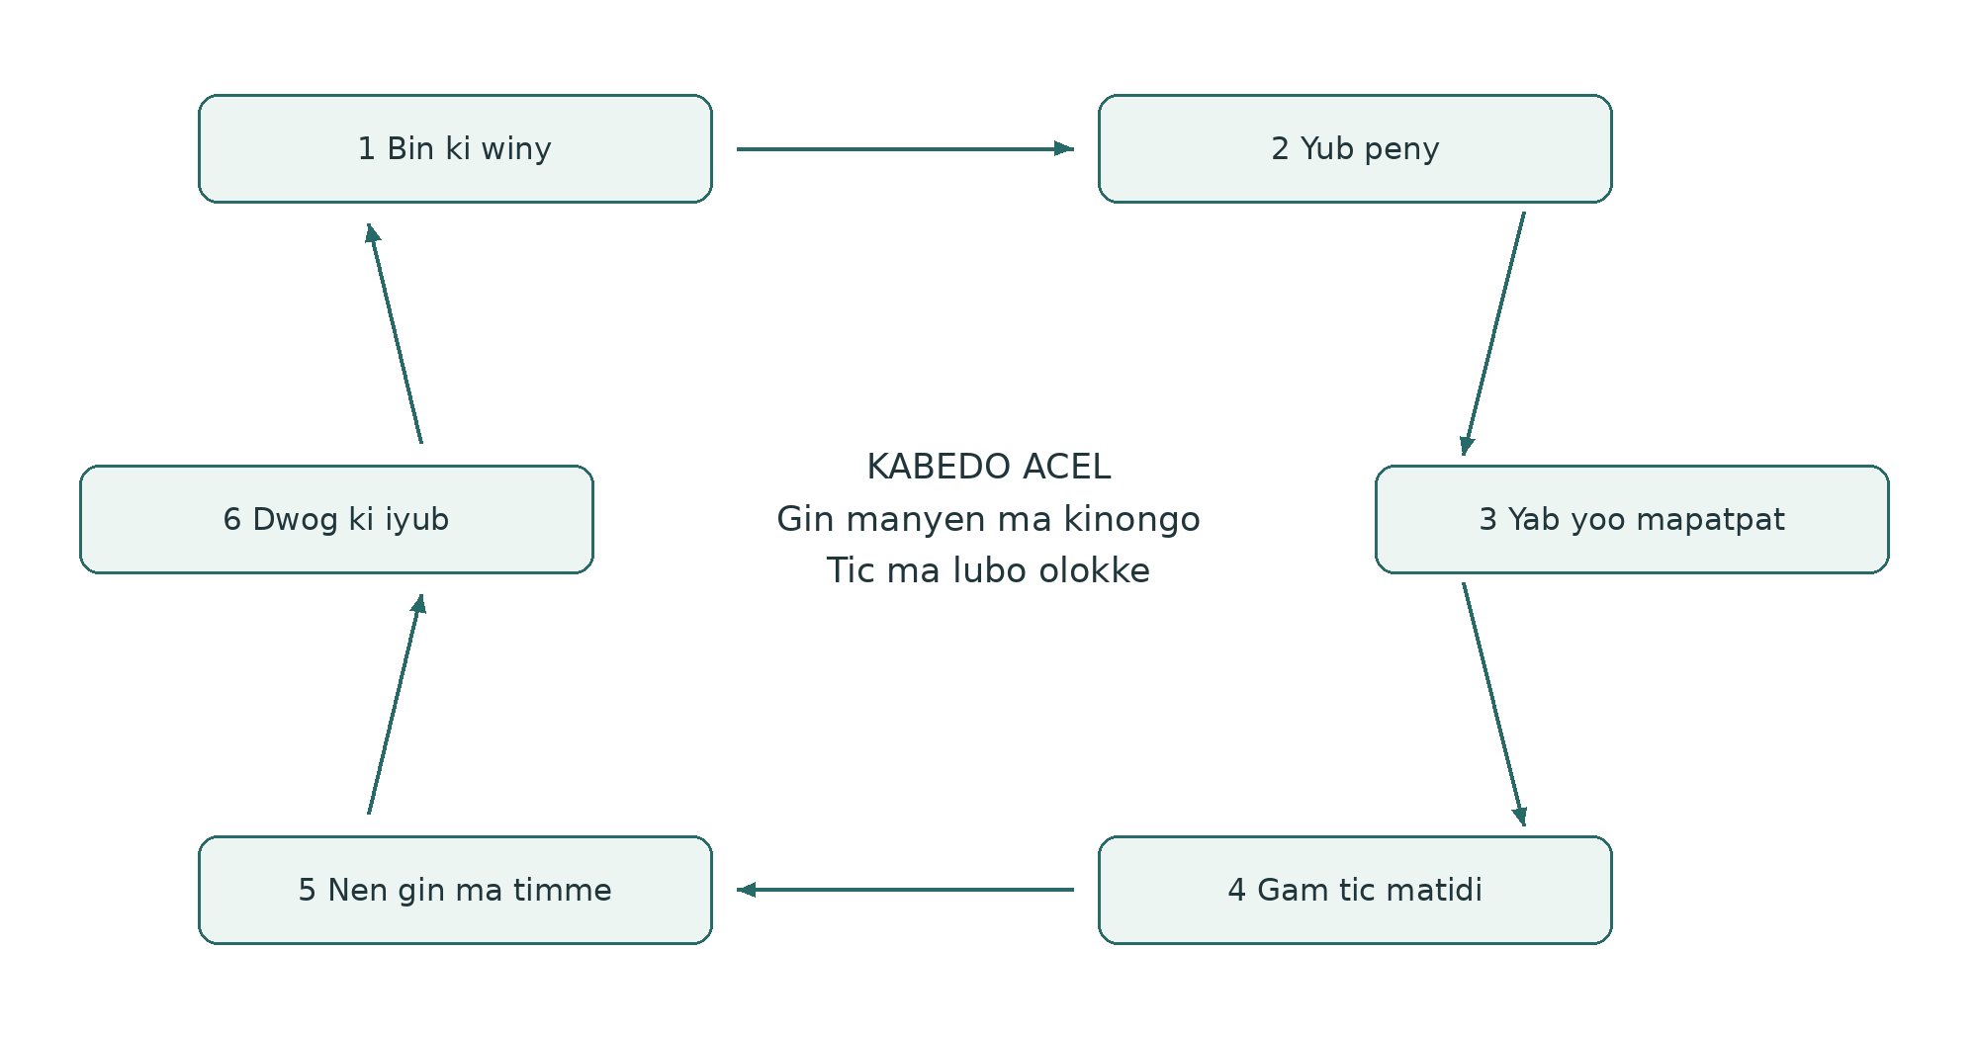
1. Bin ki winy. Nga ki ngo tye kany, ki wan wabino ki ngec ango?
2. Yub peny kacel. Ngo ma wamito ngeyo nyo loko?
3. Yab tyen lok ki yoo mapatpat. Tam ki yoo ango ma myero wangii?
4. Yub tic me bedo ma twere. Ngo ma wabitemo, ki jami ango, ki nga ma bitingyo tic?
5. Nen gin ma timme i ada. Ngo ma waneno, bene gin ma uro wa?
6. Dwog ki iwek gin ma kitimo loko yoo. Ngo ma mede, lokke nyo jik?

Tam me kare man kubo tic
Working wager tito gin ma gurup tamo ni bitimme ki gin ma twero loko ngecgi. Kubo peny, tic, pwony, jami ki ngiyo i ngeye. Lapor: um me ngom twero gwoko ngico ka um meno ber ki ticce twero mede. Ngii kit ma jami ma kipito tye, tyen lok mukene ki tic ma mite i ada.

Gin ma kinongo ki kama oaa iye
Buk twero bedo pepa, dwon, cal nyo video. Dano acel acel yero kit me nyuto tamme. Buk me kacel gwoko lok ma kiyero ki winye ma mite. Apokapoka ikin lok gwokke. Won kabedo, won tic nyo latel lok pe twero lok pi gin ma jo mukene oneno.

Neno gin ma tye mapat ki kubo lok
Cak ki gin ma dano neno, timo nyo mito nyuto. Keto nino dwe, kabedo ki kama lok oaa iye pi gin ma myero kinong doki. Alama twero bedo B01: limo mukwongo i [nino] i [kabedo]; cal ki dwon twero bedo B01-photo ki B01-audio. Gurup yero yoo mamege ki gwoko kabedo ki nying ma mite mung.
«Yadi adek tye ki pot ma olokke yellow» obedo gin ma kinongo. «Atamo ni pii pe romogi» obedo tam me tito. Gin ma dano oneno dong obedo ngec ma twero yubo ki neno doki, pimo ki ngec mukene. Mako dwon gwoko lok; pe nyuto ni tyen lok meno obedo ada.

Kony me nyuto tam ki moko lok
Ka ngat mo konyo coyo, loko leb nyo mako dwon, lok pa dano ki tyen lokke gwokke. Kicwako coc bot dano meno me yubo nyo yee. Ka gwoko lok pire tek, kinyuto kony ki loko leb ma otimme. Gin mukwongo gwokke ka tyen lok olokke. Yubo bal ki dog rom ki yubo ki coc, ki myero otwer loko tic.

Twero pa dano ki jami ma kitiyo kwede kacel
Gwoko gin mamegi, weko gurup neno, miyo bot AI ki yaro bot lwak obedo yer mapatpat, ki tyen lok ki jo ma binongo ma ngeye. Gin mukene twero dong labongo coyo. Lok ma mite pi cente ki ber bedo kiketo ki kitito kene.
Yoo ma kitye kwede: pe nywak cal ma nyuto lutino ma kitwero ngeyo. Ka mite pat, myero ngii cik ma mako, yee pa lunyodo nyo lagwok ma mite, ki tam pa latin ma lubo mwakake ki ngecce. Mung ki ber bedo pa latin aye mukwongo.
Gam nga ma gwoko, nga ma neno, kama kigwoko, kit ma kopi kupe ki kit me kwanyo kopi ki jami ma kitiyo kwede kacel. Gwok kopi ma kigamo mapat ki kwanyo. Mapat ki miyo gin bot AI ma woko, mok ngo ma kicwalo ki cik me gwoko ki tic doki ki gin meno. Cwal gin ma kiyero ki ma mite keken.

Kare obedo but me tic
I Learning with Living Places, neno, tic me buk ki tito kacel ma kigamo tye i kare me pwony ki tic ma kicul pire. Gin mukene ma kimiyo obedo me miti pa dano. Gurup mukene gamo tic ma twere. Coyo myero okony tic, ki kiyot ka doko pek.

Ngiyo kit ma gin tye, ma pe kingeyo ki ma pe kicoyo
Ngiyo kit ma gin tye mako gin acel i kare acel. Moko gin ma kicoyo mako gin ma myero kigwok. Gin aryo man pat.

Rangi me traffic lights nyuto tam pa dano ki tyen lok
Alama | Tyen lok pi tic ma lubo
Green · alum | Gin ma dong kingeyo twero konyo tic matidi ma lubo i twero ma kigamo.
Yellow · rangi ma nyuto ni mite ngiyo doki | Gin ma tye mito ngiyo, loko ki ngiyo doki.
Red · makwar | Mite gwoko, juk nyo yubo.
Pe kingeyo | Gin ma kingeyo pe romo ngiyo kit ma gin tye. Man pe yellow.

Ngii kabedo ma kwo tye iye, teko pa dano me mede ki loc me kacel kengi. Gwok nino, gin ma lok aa iye ki ma pe ngeye; pe yub rangi acel me dul ducu. Green i gin acel pe kwanyo red i gin mukene. Ka dano ool, juk nyo dwok tic ma jenge i komgi; gwok ma mite ki miyo tic bot ngat mukene maber twero mede.

Pe kingeyo pat ki pe mako peny ki ma kiweko ki miti
Pe kingeyo: peny mako ento ngec pud pe romo. Pe mako peny: peny meno pe rwate ki ngiyo man. Kiweko ki miti: gin mo pe kicoyo nyo pe kiketo i coc man. Man pe tito kit ma gin meno tye. Kabedo nono pe tye ki tyen lok acel; dano ki AI pe myero gutam pire ki akwana.

Twero me weko gin mo labongo coyo
Peny twero cako ki gin ma kinongo, ngec pa dano nyo gin ma dano oneno ki gwoko labongo coyo nyo mako dwon. Dano acel acel yero gin ma gwoko. Gin ma jo mukene gitamo i cwinygi obedo megi me nywako ka gimito. Ngec ma kigwoko kacel lubo twero ki winye pa jo ma makogi.
Pe bene myero keto alama ni kiweko gin mo ki miti. Kadi tito ni gin mo tye twero bedo gin ma mito mung. Ling pe mito tyen lok ki pe miyo twero me pong kama dong nono. Lok ma kigamo ni mite pi cente, ber bedo ki tic kacel kiketo kene; pe miyo twero me neno buk pa dano ducu.
Lapor: ngico me ngom twero bedo ma pe kingeyo pien pe kingiyo maber. Peny pi kulu twero pe mako poto man. Dwon pa dano twero dong woko me lok me kacel labongo tito ni tye.
Coc ma kubbe: Knowing From the Ground · Moral Biology

Ki lok pa dano acel acel bot peny me kacel
AnchorPoint konyo gwoko wat ikin dano, kabedo, ngec, winye ki jami pi kare malac. Ngiyo kacel twero timme wang ki wang ki mede ki wat ki internet. Coc me kacel keken pe kelo twero me moko tam kacel; twero me moko tam mito winye.
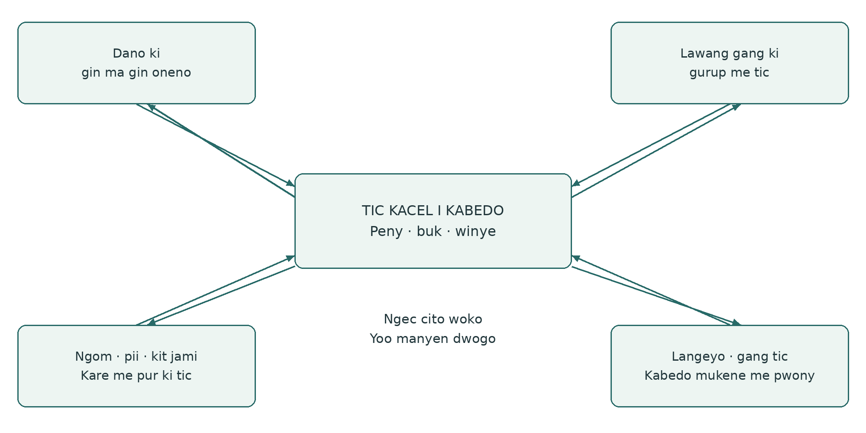

Acaki mayot me kacel
Dano acel acel twero miyo gin acel ma oyero, ki twero bene pe nywako. Gurup ngiyo gin ma rom ki pat, ki yero peny ki tyen lok ma ngeye. Yer lubo miti, kit ma pire tek, kare ki gin ma twere. Peny mukene kigwoko pi dwogo i anyim. Coc myero ogwok tam ma pat pi yer, ki nga ma pe kiwinyo dwonne.

Ka peny kato woko me gurup
Gam nga ma myero kilok kwede, ngo ma gurup mito penyo, gin ma twero nywako ki nga ma bidwogo ki adwogi. Tam, ngiyo i laboratory, lok ki gang tic ki wat ki lupur mukene kingiyo kacel ki gin mukwongo. Adwogi ki woko konyo tic ma lubo i nge ngiyo ki yee pa jo me kabedo. Man aye bottom-linking i tic.

Wat me piny ki jami ma kwo
Lub gin ma peny jenge iye: pii, ngom, kit yadi ki lee, kodi, cam, tic ki moko tam pa gang tic. Map ki kalenda me kare twero nyuto wat ma kato dog ngom ki project. Dwon ki yoo me ngec mapatpat twero yubo bal pa ngat mukene. Gin ma timme i poto twero kwero tyen lok ma wan ducu wamiyo.

Dano ma penyo AI ki diro
Kengi nyo kacel, dano aye lurem ma penyo AI ki diro: giyabo tam bot kony ma twero kelo ki gingiyo bal, tito ma kato gin ma ngeye ki loko tyen lok. AI twero konyo nyuto tam, loko leb, tic ki kama lok aa iye ki poro. Lokke konyo ngiyo ka dano gingiyo ki gitemo i tic.
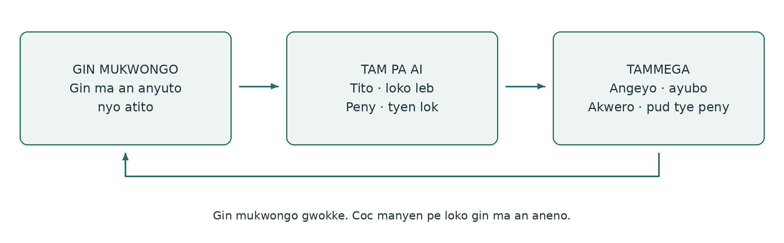

Ngii coc mapat ki tito tyen lokke
AI nongo tic ma doge ngeye ki gin ma kiyero pi tic meno mukwongo. Ki cal nyo dwon, ngii kit ma otito mapat ki mede. Lok, cal ki loko leb ma pe ngeye dong ki alama ni pe ngeye. Ka kony me leb nyo jami pe romo, nong kony pa dano ma ngeyo.

Lok me cako ki AI
Tit mukwongo gin ma itwero kwano, winyo nyo neno i gin ma kiyero. Nyut ma pe ngeye ki ikur yubo balmega. Pok gin ma an aneno, tyen lokmega ki tammi. Pe pong kabedo nono. Pok pe kingeyo, pe mako peny ki ma kiweko ki miti ka kitito. Pe tam gin mo ki ling ki pe tem me dwogo gin ma kiweko. I nge meno keken, mi tyen lok mukene ki yoo me ngiyogi. Pe yub lok nyo kama lok aa iye ma pe tye.
Eka peny: lok mene aa ki gin mamega? Ngo ma AI omedo? Kama lok aa iye mene ma twero ngiyo? Gin ma pe ngeye ki tam mapatpat dong? Ngo ma mito neno doki nyo tam pa langeyo? AI bene twero weko yoo mo ma pire tek; adwogine pe moko dog me peny.

Last Impulse i tic
Dano ma lok mako twero niang, yubo, kwero ki juko coc nyo tic, ki tingyo tic i twero ma kitye kwede. Ling pe yee. Yee pi kit ma kicoyo pe miyo twero me yaro nyo timo tic.
Lapor: «Ngom owiny calo ngico» olokke i coc pa AI me bedo «Pii ma kitiyo kwede odok piny». Dano nyuto kabe ma lok owoo iye, yubo coc ki moko ngiyo ma mite. Gin mukwongo, kony pa AI ki yubo bal miyo te me ngiyo AI in Right Relationship.

Tic me pwony ki miti ma ngeye
Tic me pwony miyo yoo me dongo diro nyo ngec mo. Twero bedo lok macek, wot i poto, temo, nyuto tic nyo tic ikin gure. Buk twero gwoko gin ma kinongo i tic meno. Ti ki pot me tic ka tye miti ma ngeye me gwoko lok kacel.
Tic | Gin ma kitemo pwonyo | Gin ma twero gwoko
Neno ki tito | Poko gin ma kinongo ki tyen lok ma twero bedo. | Cal ma kigoyo, lok, cal nyo dwon pa dano.
Poro kabedo nyo kare | Ngiyo rom, apokapoka ki gin ma mito romo pi poro. | Gin aryo ma kinongo ki kabedo ki kare ma ngeye.
Ngiyo kony pa AI | Ngeyo, yubo ki penyo coc ma kiweyo doki. | Gin mukwongo, tam pa AI ki yubo pa dano.
Yero ki tic kacel | Tito yer ki ngiyo twero, jami ki lubo tic. | Peny me kacel ki winye ma doge ngeye.
Yenyo ngec nyo kony | Tito gin ma mite ki ngiyo adwogi pa jo mukene. | Kwac ki gin ma konyo ma dwogo.
Nyuto tic bot jo mukene | Tito ki nyuto gin ma kipwonyo, ki kabedo pi peny. | Nyuto tic nyo gin ma kiyero pi pwony.

Peny abicel me yubo tic
Miti: tic man myero okony dano pwonyo ngo?
Acaki: gin ango ma wan oneno nyo wanongo ma wacako kwede?
Tic: ngo ma wabitimo, ki kony ango ki kare ango?
Lok: ngo ma wangiyo kacel, ki kwene ma tamwa twero pat iye?
Gwoko lok: ngo ma ber gwoko, bot nga, ki i kit ango?
Dwogo: awene ki nining ma wabiti ki gin ma wanongo doki?
Tic ma kigamo tye i kare me pwony ki tic ma kicul pire. Pe tye miti me miyo gin ki buk pa dano nino ducu. Tic me pwony ber ka yabo ngec ki tic ma konyo; dwong coc pe obedo miti pire kene.

Yubo tic pi kare malac

Kare ki mede me ngiyo
Nino me tic twero cako ki gin ma gurup mito neno ki gik ki gin ma mito lubo. Gurup dwogo bot peny ki tic, kare me pur ki moko tam ma ngeye. Giyero kare me ngiyo kacel ma kubo peny, jami ki gin ma kinongo labongo coyo gin acel diryo mapol.
Yoo abic me pwony aye ngom, pii ki kabedo; cam ki kabedo me jami ma kwo; stewardship economy; tic kacel ki gang tic; ki pwony ki nywako. Peny acel twero kubo yoo mapol. Gikonyo yabo ngiyo ki nyuto wat ma pe kineno. Wek bene kabedo me nyuto diro, ngiyo nyo nywako gin ma uro dano labongo mito coc.

Lapor ki poto aryo me pwony
I farm, kiyubo poto aryo pi temo pur mapatpat. Gurup tito kit ma gicako kwede ki gin ma gin oneno ki ngiyo pa langeyo ma mite. Giyero peny, gwok pi um me ngom ki pii, gamo temo matidi ki coyo jami ki kare me tic. Gang pwony me pur nyo lapor tam donyo ka konyo. I limo ma lubo, gingiyo yoo ki tic ma lubo.
Kare | Tic kacel | Te pi kare ma lubo
Yube | Jo ma tingyo program temo yoo ki ngiyo leb, yoo me nongo jami, tic pa dano ki ber bedo. | Gin me cako ma kitemo ki winye ma ngeye
Yabo | Gurup temo yoo mapatpat me nyuto ngec ki konyo yero peny. | Peny me kabedo ki jami ma kiloko
Ngiyo | Tic, neno, lok ki ngec ki temo matidi. | Gin ma kinongo, yubo bal ki moko tam
Nywako | Gin ma kiyero donyo i lok ki jo mukene ma makogi. | Adwogi ma konyo ki wat manyen
Mede | Kingiyo pwony, jami, kony ki tic ma dano tingyo. | Miyo tic ma kigamo ki tic ma lubo ma twere

Yube ki gwok
Wek kare me yubo jami mapat ki gurup cako. Gam yoo me tic, jami, ber bedo ki diro ma mite mapat ki tic. Neno pe miyo twero me donyo i gin ma twero balo dano i pii, ngom, yadi nyo jami ma kiketo. Tic ma kigamo nongo cente nyo kiketo doge i yoo ma ngeye. Dongo me piny ki tic kacel twero mede i nge kony me cente, labongo kony meno culo pire.

Stewardship economy ki gin ma twere kacel
Stewardship economy penyo kit ma tic, ngec, jami ki tic ma dano tingyo twero gwoko gin ma kwo pa dano ki lwak jenge iye. Cul twero gwoko kare ki teko pa dano me mede; pe nyuto wel pa dano nyo kabedo ducu. Peny kubo pur ki wat ki cik pa gang tic ma weko gwok mede.
Abundance obedo teko pa dano me yubo gin manyen, ki yoo ma tic kacel twero yabo. Peny ngeye: ngo ma dong tye kany, ngo ma twero dongo, ki ngo ma watwero nongo kacel? Twero bedo jami, tam, diro, cente, yoo me nongo gin ki kony i tic. Can ki wel ma mite dong nen.
Peny ki poto | Wat ma twero bedo | Gin ma twero dwogo
Ngom gwoko ngico nining? | Lawang gang ma tye ki jami ma romo tic ma odong | Um me ngom ki winye me tero
Kitwero yubo ngom nining? | Jo ma ngeyo yubo compost ki lagwok lim | Compost nyo cwer lim ma ber, ki tam
Kitwero dongo yadi mapol nining? | Gurup me nywako kodi nyo gang pwony me pur | Kodi, jang yat ki diro me dongo
Kitwero yubo miyo pii nining? | Lupur ki langeyo jami | Temo, yubo nyo yub me cente
Ngo ma okelo bal man? | Langeyo ma rwate | Ngiyo ki tic ma ber bedo
Kitwero nywako gin ma wanongo nining? | Lupur mukene ki gurup me pwony | Nyuto tic nyo jami me pwony
Cente me tic ma lubo bino ki kwene? | Tam pa gurup ki lok | Kwac ma ngeye ki gin ma nyuto ki wel
Nga ma twero tingyo tic? | Ngiyo tic kacel | Ngat ma loko ngat mukene ki miyo tic

Lub gin ma kimiyo dwogo bot tic
Pok tam, wat, winye, gin ma dong kigamo ki adwogi me ada. Ngii ka romo tic, ber bedo, terone, kare, won gin ki nga ma bigwoko i ngeye. Gin ma ngat mo twero miyo pe obedo gin ma dong kigamo. Gwok lok pi kony ma kikwero ki tic ma pe nen ka twere i dog ma kigamo.
The Steward’s Journey tito wat mapatpat ki tic, labongo yoo acel ma myero kilub. Lapur twero ngiyo kabedone, nywako ngec nyo donyo i winye ma doge ngeye pi temo. Kony mito winye mamege; pe obedo gin ma kitwero nongo keken ki kato i kare ma kiketo. Pwonyo lurem ki yenyo cente twero dongo ka dano mito ki tye ki teko me timo.

Gwoko lok kacel, tic ma dano tingyo ki ngiyo ada
PG Ledger kubo gin ma kinongo ma kiyero ki tic, moko tam, jami ki adwogi. Ti ki pot ma romo tic. Ti doki ki gin mukwongo ki alama; pe coyo gin acel i lok mapatpat ma kiketo calo ada mapatpat.
Pot me tic | Ticce
Neno gin ma tye | Gwoko gin ma kinongo, kama oaa iye, kabedo ki ma pe ngeye.
Tic ma kiye ki doge | Keto tic ma pe kato adek ma twere, ki jo ma tingyo, yoo me juko ki dwogo.
Gwoko gin ma kimoko | Gwoko tyen lok, twero, tam ma pat ma pire tek ki lok manyen.
Lok me cente | Kubo cente, miti, pepa me nyuto ki neno i ngeye. Buk me cente ma cik mito gwokke kene.
Ngiyo kacel | Poko ngiyo Ngom / Kwo (Land / Life), teko pa lagwok me mede (Steward Viability), ki loc me kacel (Governance / Commons). Pe moko alama acel pi ducu.

Winye ma twere
Gurup gamo nga ma tingyo tic, nga ma loko ngat mukene, nga ma tye ki twero me moko tam, kit me lok i tam mapatpat ki awene me ngiyo kacel. Cente ki peny me kabedo kube ki miti ki tic ma ngeye. Dano pe yee cul megi kengi nyo ngiyo koko pi komgi. Yoo me lok bot ngat ma pe donyo i lok meno ngeye ki twere.
Jo ma mito twero dongo pwonyo lurem nyo gurup manyen ki keto mitigi. Loc me kacel myero oyab yoo me mede ki alokaloka, ki nyut gwok, loko leb ki kubo tic. Tic me miti pe kitiyo kwede me umo tic ma mite ma pe tye ki cente.

Ngii ka yoo man tiyo
Ti ki peny me ada me ngiyo ka dano acel acel ngeyo ki yubo gin mamege, penyo AI, loko peny me kacel ki tic ki ngec ka dwogo. Gwok lok pa AI ma konyo ki ma twalo ki yubo bal pa dano. Man miyo te me ngiyo pwony ki AI, labongo tamo ni coc ma mol maber obedo pwony. Tem bene ka buk yot me cako, ka dano niang alama ki ka yubo bal loko tic i anyim i ada.
Lub alokaloka i poto, pek me tic ki twero me moko tam. Dongo me piny pe kwanyo oo nyo balo twero. Gin ma pe ngeye ki yer me pe coyo pe obedo remo. Ngec ma kinongo twero yubo jami me tic, ngiyo ki cik. Ngii kony pa AI i nge kwano kare me ngiyo, loko leb ki tic ma kiweyo bot jo mukene.

Pot pi gin mamega
Ti ki cal, alama, lok, cal ma kimako, dwon nyo video. Pot man obedo yer; nyut gin mukwongo ma iyero. Gin ma dano oneno pe mito coc me bedo ma pire tek i lok.
Nino nyo kare __________________ Kabedo __________________
Alama nyo yoo me nongo gin mamega __________________

Gin ma aneno nyo amito nyuto

Gin ma apenyo pire
________________________________________________________________________
________________________________________________________________________

Gin ma man poyo wi an nyo gin ma angeyo ki tic
________________________________________________________________________
________________________________________________________________________
Ka ati ki dwon nyo cal, alama me nongo aye __________________
Ka ngat mo okonya mako gin mamega __________________
Man obedo gin mamega. An ayero gin ma agwoko ki anywako. Kabedo nono pe mito tyen lok. Nywako mito winye pi gin acel ki tyen lokke.

Pot me temo ki dwogo
Kony ma kiyero pi lok ki dwogo. Nyut pot me tic ma mako labongo coyo gin acel doki. Pok pe kingeyo, pe mako peny ki ma kiweko ka kitito; kabedo nono pe mito tyen lok.
Kabedo __________________ Nino __________________ Alama __________________

Penywa ki gin ma watamo pi kare man
________________________________________________________________________
________________________________________________________________________

Gin ma wabitemo ki gin ma twero loko ngecwa
________________________________________________________________________
________________________________________________________________________

Nga timo ngo, ki jami ki twero ango
________________________________________________________________________
________________________________________________________________________

Awene ma wabidwogo ki gin ma bimweko wajik
________________________________________________________________________

Dwogo ki nino: gin ma otimme i ada
________________________________________________________________________
________________________________________________________________________

Gin ma waloko nyo ma ngecwa pud pat iye
________________________________________________________________________
________________________________________________________________________
Nyut gin ma kinongo, moko tam nyo cente ka konyo. Adwogi ma kitamo ni bitimme pe obedo adwogi ma dong kineno.

Pot me lok ki AI ki nywako gin ma kiyero
Kengi nyo kacel, dano aye lurem ma penyo AI ki diro. Gwok gin mukwongo, coc manyen ki yubo bal mapatpat. AI pe myero pong kabedo nono, tam gin ki ling nyo dwogo gin ma kiweko.
Nino __________________ Alama me gin mamega __________________
AI nyo kony mukene, ka mako __________________

Kony ma ngeye ma akwaco
________________________________________________________________________

Gin ma AI otito doki nyo omiyo tam pire
________________________________________________________________________
________________________________________________________________________

Gin ma angeyo, ayubo, akwero nyo pud pe angeyo
________________________________________________________________________
________________________________________________________________________
________________________________________________________________________

Gin ma an nyo wan dong wabingiyo nyo timo
________________________________________________________________________
________________________________________________________________________

Ka ayero nywako gin mo
Gin ma kiyero __________________
Ki nga __________________ Pi tyen lok ango __________________
Twero cwal bot AI __________________
Gin mo twero yaro, ki i kit ango __________________
Yubo balmega nyo loko yer me nywako bitimme nining __________________
Winye me nywako mako gin ma kigamo keken. Tit dog me kwanyo nyo dwogo yee mapat ki cwal gin bot jo mukene. Yeega pe mako twero pa ngat mukene pire kene.

PG Ledger · pot me tic ma kiye
Buk man me Word tye ki coc madit ki pot adek pi buk pa dano, ki link bot pot abic me PG Ledger. Pot abic me tic pe tye kany calo pot ma itwero loko i Word.
Pi gwoko lok ki Returns, ti ki pot ma kigamo ki gin ma kiye i kare meno. Gwok kabedo me coyo, dul ki tyen lok; tam me loko pot kingiyo kene. PG Ledger konyo gwoko lok ki cente; pe loko buk me cente ma cik mito.

Format 1 · Ngiyo kacel (leb munu)
https://papers.spiralweb.earth/formats/format1-dashboard

Format 2 · Neno gin ma tye (leb munu)
https://papers.spiralweb.earth/formats/format2-observation

Format 3 · Tic ma kiye ki doge (leb munu)
https://papers.spiralweb.earth/formats/format3-action

Format 4 · Gwoko gin ma kimoko (leb munu)
https://papers.spiralweb.earth/formats/format4-decision

Format 5 · Lok me cente (leb munu)
https://papers.spiralweb.earth/formats/format5-financial-ledger

Coc mukene ki cik me tic ki buk
Papers obedo kabedo me ngec ma dano ducu twero neno, ki gin ma kiyubo i kare mapatpat ngeye. Buk man kubo yoo me tic ma kiyero kacel. Pe kelo twero manyen i kabedo nyo loko winye ma tye. Buk man twero nongo penyo ki ngec ki temo i kabedo. Gin ma kinongo twero loko buk ki coc ma oaa iye.
Healthy Roots (leb munu)
https://papers.spiralweb.earth/protocols/healthy-roots
PG Ledger (leb munu)
https://spiralweb.earth/pg-ledger/
Pot abic me tic
https://spiralweb.earth/formats/
Sophia Lumen (leb munu)
https://papers.spiralweb.earth/protocols/sophia-lumen
Moral Biology (leb munu)
https://papers.spiralweb.earth/papers/moral-biology
Knowing From the Ground (leb munu)
https://papers.spiralweb.earth/papers/knowing-from-the-ground
GP22 Capacity and Contact (leb munu)
https://papers.spiralweb.earth/papers/capacity-contact-stewardship-economy
GP23 A Decent Economy (leb munu)
https://papers.spiralweb.earth/papers/a-decent-economy-under-the-jurisdiction-of-life
Living Landscapes (leb munu)
https://papers.spiralweb.earth/papers/living-landscapes
The Steward’s Journey (leb munu)
https://papers.spiralweb.earth/papers/srip-the-stewards-journey
Atlas, working wagers ki Field Papers mukene (leb munu)
https://papers.spiralweb.earth/library
Gang pwony me pur pa FAO (leb munu)
https://www.fao.org/farmer-field-schools/overview/en/
Coyo gin me piny pa Lawrence Hall of Science (leb munu)
https://lawrencehallofscience.org/activities/exploring-nature-journaling/

Tic ki buk ki nyuto kama oaa iye
Itwero loyo copy, loko leb ki loko coc, cal ki pot nono i cik CC BY 4.0. Nyut: Spiralweb Stewardship Association, Buk me Poto, loko leb Acholi v0.1, 2026. Nyut alokalokani.
https://creativecommons.org/licenses/by/4.0/
Buk ma dong kipong, lok pa dano ki dwon pe donyo pire kene i yee me tic ki buk man. Nywako mito winye kene. Coc ki woko gwoko cikgi. AI okonyo yubo; yubo pa dano ma tingyo tic ki yubo bal i kabedo pud mite.
Spiralweb Stewardship Association aye oyaro · Spiralweb Papers
spiralweb.earth · papers.spiralweb.earth
Kiloko ki Feltets Dagbog, Danish v1.0.1, ki ngiyo English. Coc ma link cito iye tye i leb munu ka pe kitito pat.

