**Introduction**

In this assignment I have chosen a **drawing application** for the control design. Basically it is an application allow the user to draw something on the canvas. The user can select a tool to draw on the canvas by mouse (click and move), then the drawing will display on the canvas.

There are 6 features in this application:

1. Colour picker
   * A colour dialog will show up when the user clicked the colour button. It allows user to change the drawing colour.
2. Pen tool
   * User can do the free drawing on canvas by mouse like using a pen.
3. Line tool
   * This tool can help user to draw a straight line from the start point which is mouse first clicked point to the end point which is the mouse released.
4. Rectangle tool
   * This tool can help user to draw a perfect rectangle. The rectangle size can be change by mouse move. The size is calculated by start point to end point distance.
5. Ellipse tool
   * This tool can help user to draw an ellipse. The ellipse size can be change by mouse move. The size is calculated by start point to end point distance.
6. Clear button
   * A button to clear all the drawing on the canvas.

**Use case diagram**

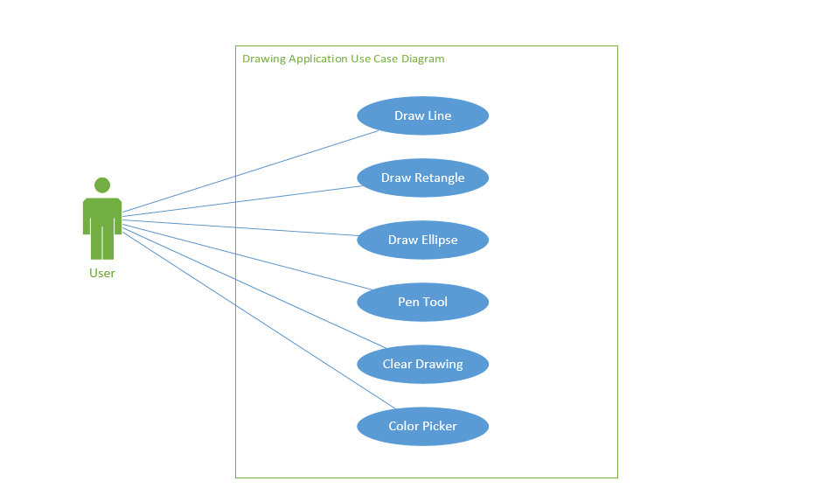

**Sequence diagram**

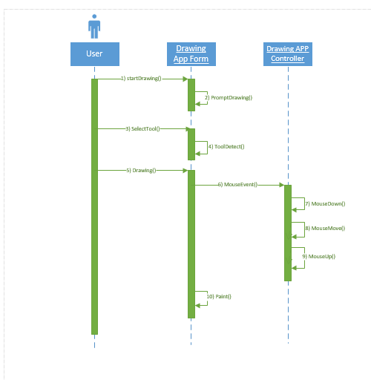

**Class diagram**

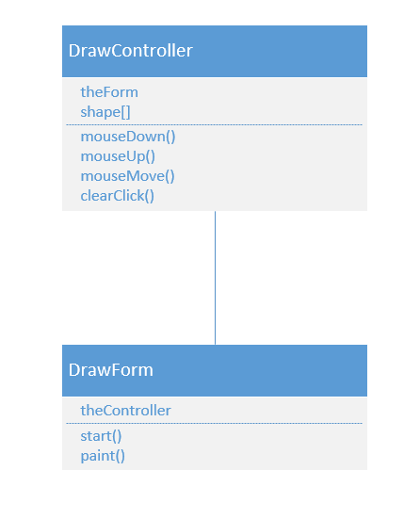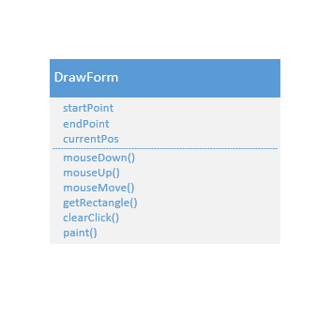

**Test cases for Drawing application**

|  |  |  |  |
| --- | --- | --- | --- |
| **Requirement to test** | **Test Data Input** | **Expected Outcomes** | **Actual Outcomes** |
| Click Colour Button and change the colour in the dialog to draw something on canvas | Click on Colour button and pick a colour in the dialog, then draw something on canvas by mouse | A colour dialog will show up allow user to change the drawing colour. After user picked a colour, drawing colour will changedC:\Users\leioy\AppData\Local\Microsoft\Windows\INetCacheContent.Word\33.png | A colour dialog is show up allow user to change the drawing colour. After user picked a colour, drawing colour is changedC:\Users\leioy\AppData\Local\Microsoft\Windows\INetCacheContent.Word\33.png |
| Click on rectangle button and draw a rectangle. | Click on rectangle button and draw a rectangle | A rectangle will draw on canvasC:\Users\leioy\AppData\Local\Microsoft\Windows\INetCacheContent.Word\Capture.png | A rectangle drawn on canvasC:\Users\leioy\AppData\Local\Microsoft\Windows\INetCacheContent.Word\Capture.png |
| Click on line button and draw a line. | Click on line button and draw a line | A line will draw on canvasC:\Users\leioy\AppData\Local\Microsoft\Windows\INetCacheContent.Word\3.png | A line drawn on canvasC:\Users\leioy\AppData\Local\Microsoft\Windows\INetCacheContent.Word\3.png |
| Click on ellipse button and draw an ellipse. | Click on ellipse button and draw an ellipse | An ellipse will draw on canvasC:\Users\leioy\AppData\Local\Microsoft\Windows\INetCacheContent.Word\2.png | An ellipse drawn on canvasC:\Users\leioy\AppData\Local\Microsoft\Windows\INetCacheContent.Word\2.png |
| Click on pen button and draw something on the canvas. | Click on pen button and draw something on canvas | Some draw is drawn on canvasC:\Users\leioy\AppData\Local\Microsoft\Windows\INetCacheContent.Word\12.png | Some draw is drawn on canvasC:\Users\leioy\AppData\Local\Microsoft\Windows\INetCacheContent.Word\12.png |
| Click on clear button to clear all the drawing | Click on clear button | All the drawing cleared | All the drawing is cleared |