**Use case diagram**

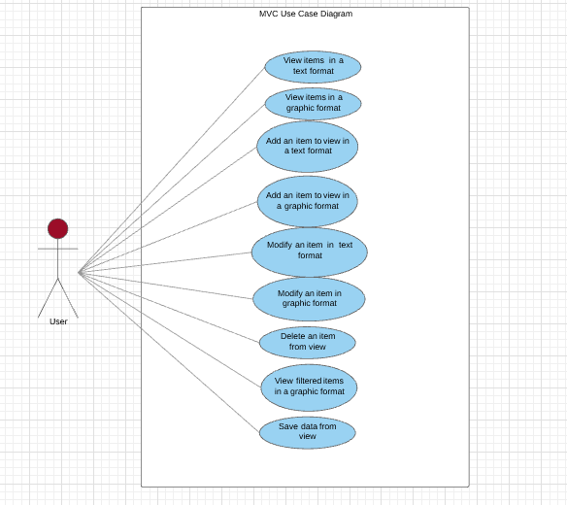

**Activity diagram**

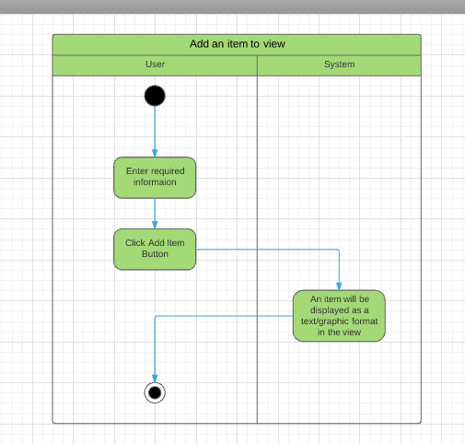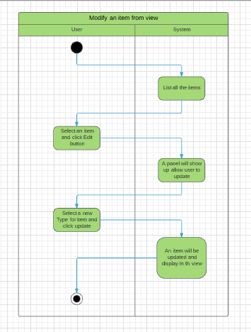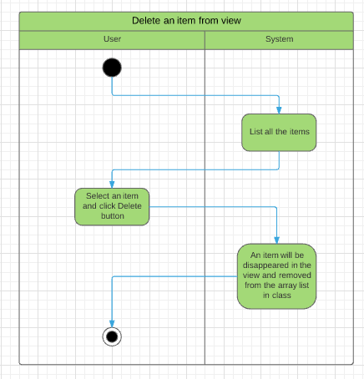

**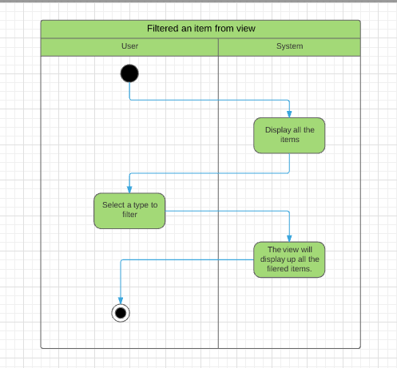**

**Class diagram**

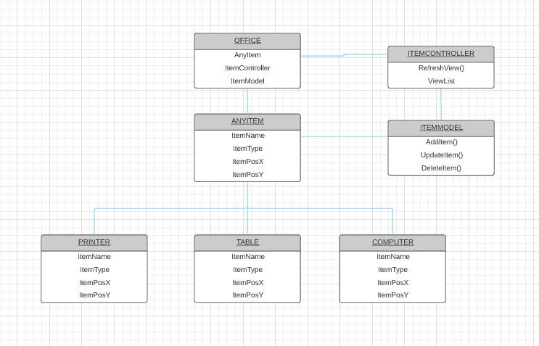

**Test Cases for *MVC\_Assignment1B***

|  |  |  |  |
| --- | --- | --- | --- |
| **Requirement to test** | **Test Data Input** | **Expected Outcomes** | **Actual Outcomes** |
| View1 show up allow user to view in a graphic format when application is running | View1 will directly show up, if not user can open it via click “show views” in main form | User can view item in a graphic format in View1 | User can view item in a graphic format in View1  View1_view |
| View1 show up allow user to add in a graphic format | Enter all the information required and click on add item button | An item will be added in View1 and display in a graphic format to user | View1_add |
| View1 show up allow user to modify in a graphic format | Put the mouse cursor on top an item which is user want to modify and right click. A menu should show up and click on edit. A panel show up allow user to select a new type and click on update. | An item will be modified and display in a graphic format to user | View1_update1  View1_update2 |
| View1 show up allow user to delete in a graphic format | Put the mouse cursor on top an item which is user want to delete and right click. A menu should show up and click on delete. | An item will be deleted and disappear in View1 | View1_delete  View1_delete2 |
| View2 show up allow user to view in a text format when application is running | View2 will directly show up, if not user can open it via click “show views” in main form | User can view item in a text format in View2 | View2_add |
| View2 show up allow user to add in a text format | Enter all the information required and click on add item button | An item will be added and display in a text format to user | View2_add |
| View2 show up allow user to modify in a text format | Select an item in list box and click edit. A panel show up allow user to select a new type and click on update. | An item will be modified and display in a text format to user | View2_update1  View2_update2 |
| View2 show up allow user to delete in a text format | Select an item in list box and click delete. | An item will be deleted and disappear in View2 | View2_delete1  View2_delete2 |
| View3 show up, user can only read and flite out the object from the other view in a graphic format when application is running | View3 will directly show up, if not user can open it via click “show views” in main form | User can view all the item in a graphic format in View3 | View3_view |
| View3 show up, user can flite out the object from the other view in a graphic format. | Select an item in filter to display. | Selected item will be displayed in a graphic in View3. | View3_view1  View3_view2  View3_view3 |
| Updates all the views | All the Views will be updated after user add, modify or deleted. | All the Views will be updated after user add, modify or deleted. | 1 |
| Object Serialisation to store the data | On the top of the view click file -> save then a save dialog will show up and click save. | A .dat file will be created on your computer. | save  save2  save3 |
|  |  |  |  |