PotholePal: day three, the bug list
Wednesday 21 October 2026 · The City Fix Team (Lesiamo, Crystal, Kgosi, Raymond)
This document answers the issue list in "A few issues and bugs needed to be handled.docx", plus the location problem reported after that list was written and the phone testing question. Every fix below was clicked through in the browser today, and the checks at the end were all run after the last file was saved.

What was done, in one look
Issue raised | What changed
Map dots do nothing when tapped (home page and map page) | Every dot now opens that report's details page. Works on both maps.
Home page says "Vereeniging, Gauteng" with a down arrow | Reads "Emphuleni District" now, arrow removed.
Equalizer symbol above the map search bar | Removed. The filter chips under the search already do that job.
Cog button on the notifications page | Removed.
Profile page: dead cog, My Impact, Leaderboard, Settings, Help and Support, Municipality portal | All removed. What is left (My Reports, Sign out) works. The staff portal still exists at the /staff address for the demo.
Photo step should use the phone's real camera, with flip and flash | The viewfinder is now a live camera feed. Flip swaps front and back, the flash button turns the torch on where the device has one, and the shutter takes the picture.
Location map inaccurate, edit location dead, live location ignored | Step 2 is a real map with a draggable pin, a "Use my current location" button, an address that is worked out from wherever the pin sits, and a Confirm Location button that now does something.
Reports labelled Three Rivers or Duncanville sit in Vereeniging on the map; report locations do not match the live map | Suburb coordinates were re-sourced from OpenStreetMap and every report address now names its own suburb. Details below.
Users outside Emphuleni should see a message | Drop the pin outside the district on step 2 and a message appears and Confirm Location stays switched off.
Phone testing did not work | The laptop is on a new network, so the address changed, and the firewall rule from yesterday was gone. Both are fixed, and there is a new https address so the camera and live location work on the phone. Full steps in the phone section.
Register, forgot password, one login for both sides (asked for after sign-off) | New screens at /register and /forgot, and /login now sends staff to the municipal dashboard and residents to the app based on their account. The separate staff login page is gone.

Map dots open the report
The map component now takes an id with each dot and a callback for when it is tapped. Home passes the resident's list and the map page passes its filtered list; both send you to the same report details screen you reach from My Reports. The dots got a pointer cursor so they read as tappable.
- Test it: on the home page or the map page, tap any coloured dot.
- Expected: that report's details screen opens, photo and progress timeline included.
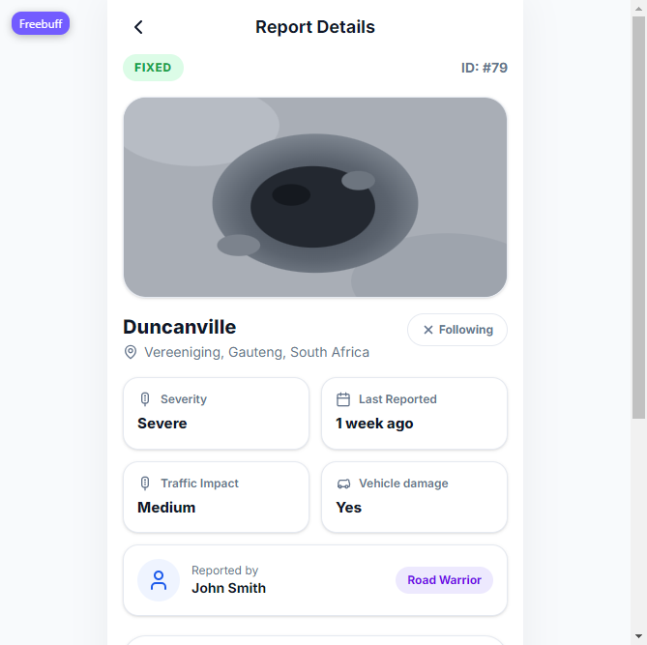
Tapping a dot opens the full report (this one from the home map).

Dead controls removed
The rule the team agreed on: nothing on the screen that looks clickable but is not. The notifications cog, the profile cog, the four dead profile rows and the municipality portal button are gone, and the map page header lost the equalizer button. The profile menu keeps My Reports, which leads somewhere, and Sign out.
The staff portal was not deleted, only its entry point on the profile page. For the demo it opens at http://localhost:3001/staff (or /staff on any address the app is served from).
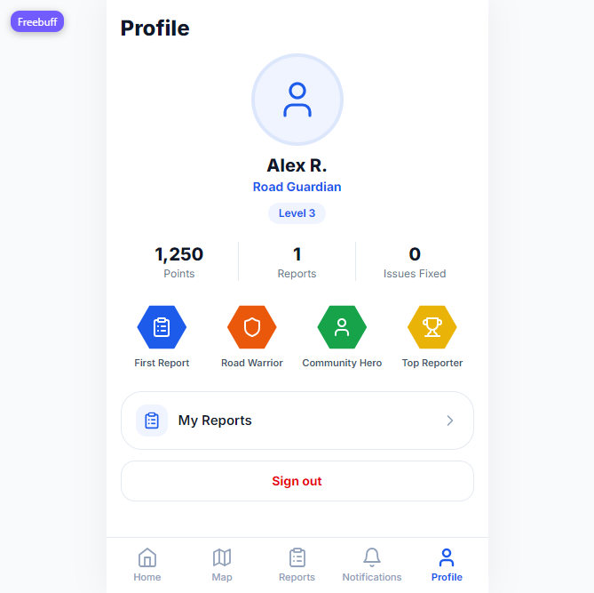
Profile page after the cleanup: working rows only.
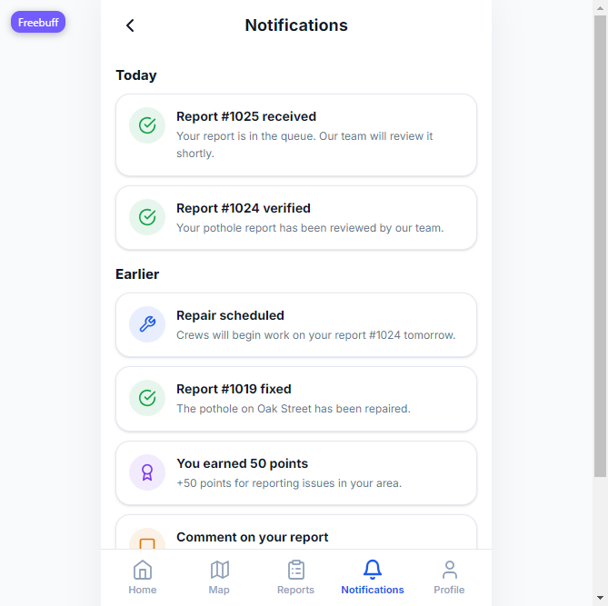
Notifications header without the cog.

The camera step is a real camera
Step 1 asks the browser for the device camera and shows the live feed in the viewfinder. The shutter copies the current frame into a JPEG and carries on with the flow. The front camera view is mirrored so a selfie looks the same on screen and in the saved photo.
Control | Behaviour
Shutter | Captures the live frame and moves to step 2.
Flip | Switches between the back and front cameras.
Flash | Turns the torch on during the shot. Phones that expose a torch (Android Chrome) light up; devices without one show the button greyed out instead of failing.
Gallery | Picks an existing photo from the device, same as before.
Continue with sample photo | Still there for laptops with no camera.

If the camera cannot run, the viewfinder says so in one line: permission refused, no camera on the machine, or a page opened over plain http. The gallery, the shutter's built-in photo picker and the sample button keep the flow moving either way. The live feed itself was tested today on this laptop: the picture appeared in the viewfinder, and flip and shutter both worked. The camera on a phone needs the https address further down.
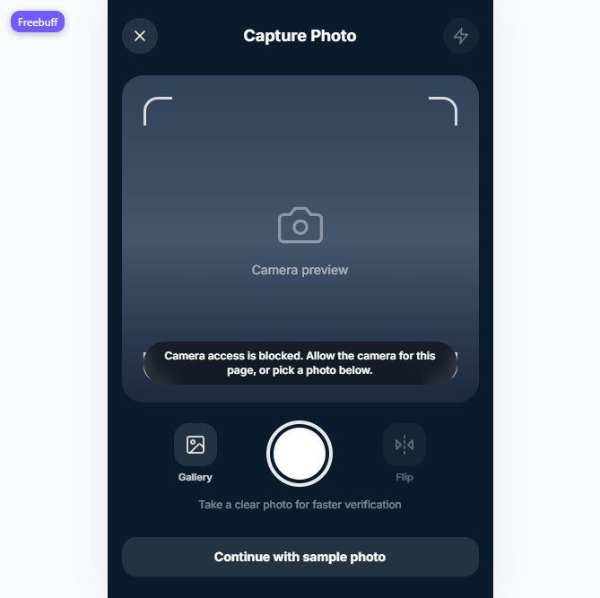
The blocked-camera message with the fallbacks underneath it.

Step 2: a location you can actually edit
The old step 2 showed a Google embed you could not touch, with a Confirm button that did nothing. It is now the same map component the rest of the app uses, with a pin you can drag anywhere and a map you can tap to move it.
- The address under the map always comes from the pin. Move the pin and the label follows: the nearest known suburb appears immediately, then OpenStreetMap's reverse geocoder replaces it with the street address when it answers.
- "Use my current location" drops the pin on the device's GPS position, so a phone opens on the spot the reporter is standing on.
- Confirm Location saves the pin and address into the draft and moves to step 3. The pencil next to Location on the review page leads back here.
- Precise location needs the browser to allow it; if it is refused, the page says which button to use instead and the pin still works.
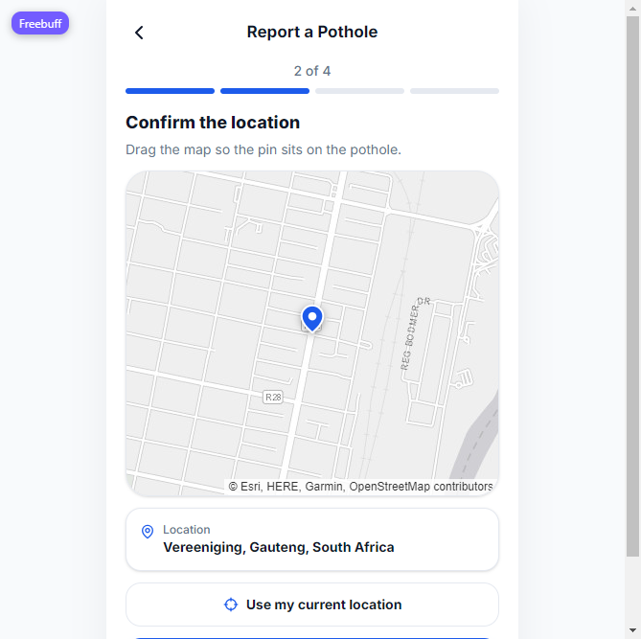
The rebuilt location step: draggable pin, address from the pin, live location button.

The district message
Step 2 checks every pin position against the Emphuleni District. A pin outside the district puts an amber message at the top of the page and keeps Confirm Location switched off; moving the pin back inside clears it. The same check runs on the position that comes back from "Use my current location", so a reporter standing in Johannesburg or the Free State gets the message before they can submit anything.
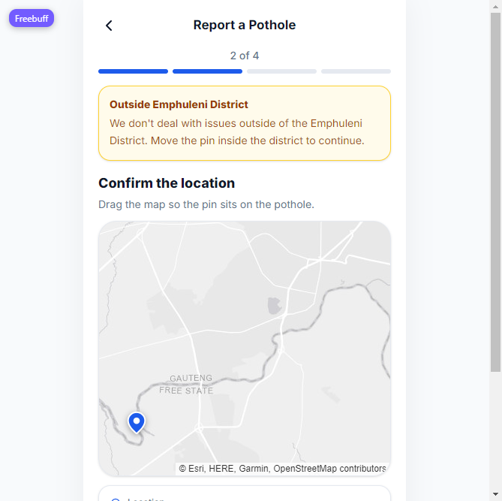
Pin dropped south of the Vaal: the message appears and Confirm Location is disabled.

Report locations now match the map
Two things were wrong. The suburb coordinates in the seed data were guesses, and several of them pointed at the middle of Vereeniging, so a report named Three Rivers or Sonland Park dropped its dot in the wrong town. On top of that every report row carried the same address, "Vereeniging, Gauteng, South Africa", no matter which suburb it belonged to, which is why the details page contradicted the map.
The seven suburb positions were looked up in OpenStreetMap (Nominatim for most, the raw Overpass data for the rest) on 21 October 2026. The movement per suburb:
Suburb | Old point | New point | What the fix corrects
Three Rivers | -26.6639, 27.9219 | -26.6547, 27.9781 | Was about 6 km west, inside Vereeniging
Three Rivers East | -26.6561, 27.9104 | -26.6636, 27.9997 | Was about 9 km west
Sonland Park | -26.6803, 27.9386 | -26.6092, 27.9089 | Was about 8 km south, in Vereeniging
Duncanville | -26.6889, 27.9361 | -26.6542, 27.9299 | Was about 4 km south
Arcon Park | -26.6702, 27.9472 | -26.6331, 27.9433 | Was about 4 km south
Peacehaven | -26.6961, 27.9495 | -26.6633, 27.9486 | Was about 3.6 km south
Riverview | -26.6572, 27.9331 | -26.7381, 27.8493 | Was about 10 km north-east of the real place

The address rule changed with it. Designed reports, the 90 synthetic rows and the fallback for a submission with no address all read "<Suburb>, Emphuleni District, Gauteng" now, so the heading, the address line and the dot on the map name the same place. The 90 synthetic dots are still scattered around their suburb centre, so each cluster sits on its own label.
The same coordinates drive the server's nearest-suburb rule, so a new report submitted near Three Rivers gets labelled Three Rivers, not Vereeniging.
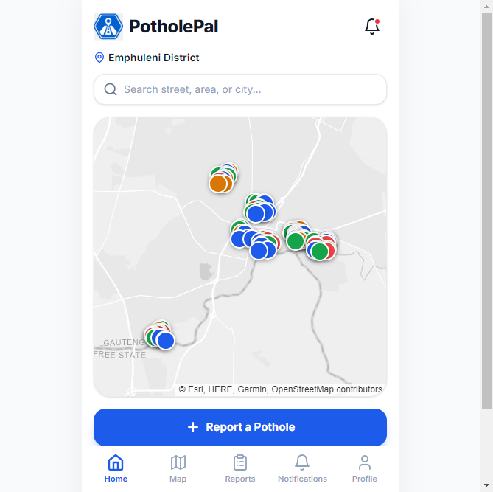
After the reseed: dots spread over the real suburb positions instead of one blob in Vereeniging (Sonland Park north, Three Rivers east, Riverview south-west).
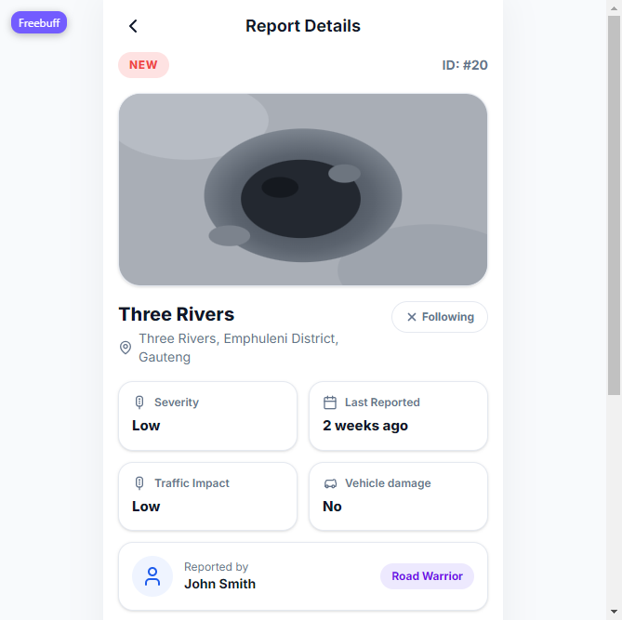
A report's heading, address and map position now say the same suburb.

Running it in the browser

Demo mode: one process, use this for the presentation
npm run build
cd server && npm start
http://localhost:3001
That build makes the front end, and the server then serves both the app and the API from one address. Deep links such as /map or /report-details/1024 load correctly. Wait for these two lines before signing in:
PotholePal API on http://localhost:3001 (db: PotholePal)
PotholePal HTTPS on https://localhost:3443 (for phones)

Development mode: hot reload, two terminals
Terminal 1: cd server && npm start (API on 3001)
Terminal 2: npm run dev (front end on 5173)
http://localhost:5173
Vite forwards /api and /uploads to the server. Use this while editing the front end, and demo mode on the day.

Sign-ins and the two-sided demo
Who | Where to sign in | Credentials
Resident | /login | alex@potholepal.test / resident123
Staff, portal owner | /login | staff@potholepal.test / staff123
Staff, second account | /login | nkosi@municipalstaff.com / staff123

One page serves both sides: the role stored on the account decides whether you continue into the resident app or the municipal dashboard, so there is no second portal address to remember. New residents register from that same page and any user can recover a password from it. Open the resident side in one browser and the staff side in another (Chrome and Edge, for example). A status change on the staff side reaches the resident screen within ten seconds without a reload.

Accounts: sign up, password reset, one login
Three account features were added after the bug list was signed off. Between them they change how everyone gets in.
- Register (the Create an account link on the login page, or /register) asks for a name, an email and a password with a confirm field, creates the account and signs the person straight in. The server forces the resident role and refuses the municipalstaff.com domain, so nobody can register their way into the municipal portal, and passwords are hashed with bcrypt before they touch the database.
- Forgot password (/forgot) asks for the email, then shows a six digit code in a panel that says plainly it is demo mode with no email service connected. The code is stored as a hash. It expires after 15 minutes and can only be used once. Entering it with a new password signs the user in on the spot and ends every other session for that account. Connecting a real mail service later means sending that same code by email; the endpoint already hands it back in the response.
- One login (/login) serves residents and staff. The role in the database decides the destination, so nkosi@municipalstaff.com with staff123 and staff@potholepal.test with staff123 both open the municipal dashboard, while alex@potholepal.test with resident123 opens the resident app. The old staff login page was deleted, and visiting /staff without a staff session redirects to /login.
- Every password field carries an eye button that shows or hides what was typed, on the login, register and reset screens.
- A wrong password now prints its message inside the form. Before this change the page quietly reloaded and the message was lost.
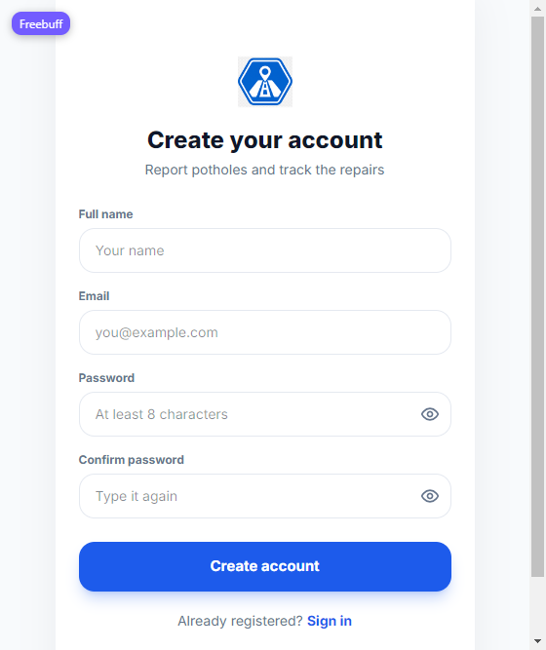
The registration screen, with the eye buttons on both password fields.
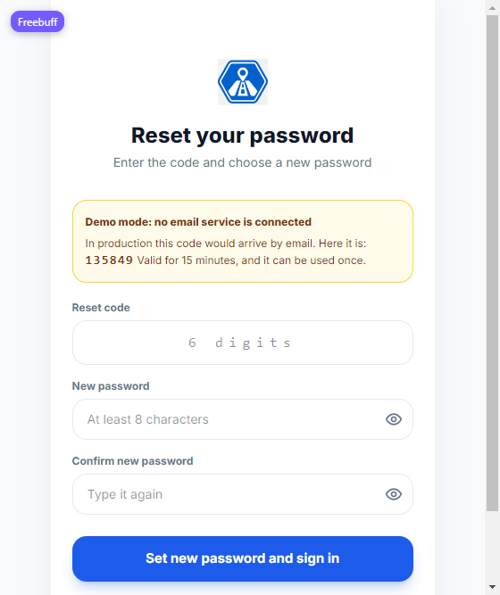
Password reset step two: the demo code panel, the code field and the new password.
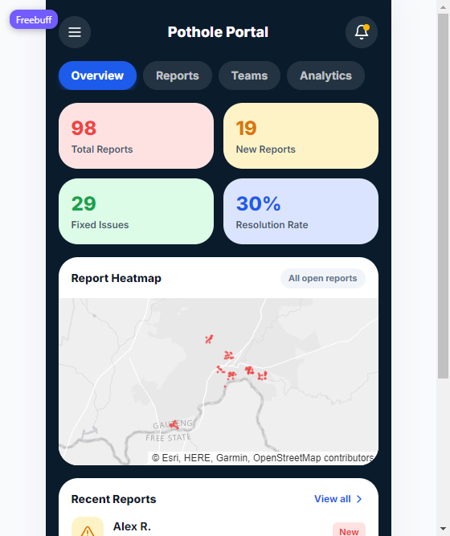
Staff credentials typed into the one login page land on the municipal dashboard.

Testing it on your phone
Yesterday's address stopped working because the laptop joined a different network: the Wi-Fi is now MTN-5G-9C43F5 and the laptop's address is 192.168.0.187, not the 192.168.1.221 from the old instructions. The firewall rule from yesterday was gone with it. Both are back, and there is one more piece: browsers only switch on the camera and precise location on a secure page, and an address like http://192.168.0.187 is not one. The server now also listens on https, so use the https address from the phone.
- Put the phone and the laptop on the same Wi-Fi (not mobile data, not a guest network).
- On the laptop, if the server is not already running: npm run build, then cd server && npm start.
- On the phone, open https://192.168.0.187:3443
- The browser warns about the certificate the first time. That warning is expected: the certificate is generated locally for this laptop. On Android Chrome tap Advanced, then Proceed to 192.168.0.187 (unsafe). On iPhone Safari tap Show Details, then visit this website. The browser remembers the choice.
- Sign in with alex@potholepal.test / resident123 and test the flow. The live camera and precise location both run on this address.
- Add it to the home screen for an app icon: Safari's Share button then Add to Home Screen, or Chrome's menu then Add to home screen.
The phone still not opening the page? Check in this order: same Wi-Fi, server running (both lines in its log), and the laptop's current address from ipconfig (IPv4 under the Wi-Fi adapter). The firewall rule covering both ports is netsh advfirewall firewall show rule name="PotholePal demo".
A changed address means one command: npm run certs inside server/ from Git Bash, then start the server again. Regenerate whenever the browser says the certificate does not cover the address you opened.

Alternatives when https is in the way
- http://192.168.0.187:3001 still works for browsing the app on the phone. The browser keeps the live camera and precise location off on plain http, so use Gallery for the photo and drag the pin to set the location. Everything else is identical.
- Test the camera and live location on the laptop instead: they work at http://localhost:3001 because browsers trust their own machine.
- Routers that isolate wireless clients stop the two from seeing each other. In that case, connect the laptop to the phone's hotspot, run ipconfig for the new address and open that from the phone.

What was verified today
Check | Result
eslint (npm run lint) | 0 errors, 0 warnings
vite build (npm run build) | Succeeded, app bundle 478 kB
API smoke suite (server/smoke-test.sh, from the project root) | 26 of 26 passed
Login, resident and staff | Passed in the browser
Dot opens report details | Passed on home map and map page
Dead controls removed | Notifications, profile and map headers checked in the browser
Live camera, flip, shutter | Live feed shown and captured on this laptop
Camera blocked fallback | Message and gallery/sample buttons shown
Pin drag, address follows pin | Passed, street addresses returned by OpenStreetMap
Use my current location | Error path shown in this browser; works on a normal phone or laptop browser
District message and disabled confirm | Passed, pin south of the Vaal
Confirm Location to step 3 | Passed, photo carried across
Report addresses match their suburb | Passed, e.g. report #20 reads Three Rivers in all three places
Console after the final build | No errors
http://localhost:3001 | 200
https://localhost:3443 | 200
http://192.168.0.187:3001 and https://192.168.0.187:3443 | 200 and 200
Firewall rule PotholePal demo | Ports 3001 and 3443, inbound allow, all profiles
Database after reset | 97 reports (ids 1-90 and 1018-1024), next report #1025, 6 notifications, 6 accounts
Register endpoint (curl) | 201 for a new resident, 409 for a duplicate email, 400 for short passwords and the reserved staff domain
Reset endpoint (curl) | Code delivered in 6 digits, wrong code 400, right code 200 and signed in, code reuse 400, old password 401, new password 200
Unified login (curl and browser) | nkosi@municipalstaff.com and staff@potholepal.test both return role staff and land on the dashboard; alex returns role resident
Browser walkthrough | Register lands on the home screen, reset signs the user straight in, /staff without a session redirects to /login, eye toggles the field, wrong password shows inline without a reload

Known limits worth saying out loud in Q and A
- The flash button depends on the device exposing a torch. Android phones do; most laptops do not, and the button shows as disabled there.
- The district edge is a straight bounding box around the municipality, not the official boundary polygon. A pin within a kilometre of the border can read either way; points a few kilometres out, like Johannesburg or the Free State, are caught correctly.
- Address lookup uses OpenStreetMap's free reverse geocoder, so the phone or laptop needs internet. Offline, the nearest suburb label appears straight away instead.
- Sessions live in the server's memory. Restarting the server signs everyone out, which is also why the demo should start the server before anyone logs in.
- The district message appears on the location step of a report. The app does not ask for location the moment it opens.
- There is no Android package yet; the phone test is the browser with a home screen icon.
- Password reset codes appear on screen rather than by email, because this demo has no mail service. The panel says so, and swapping in a mail provider is a small change to one endpoint.

