Local image without any styles:

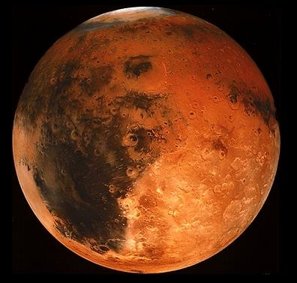

Local image with styles:

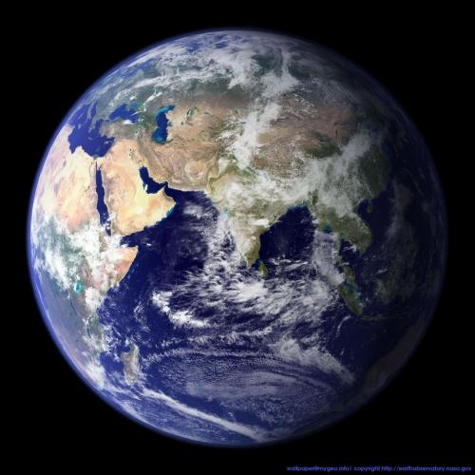

Remote image from: http://php.net/images/logos/php-med-trans-light.gif



Wrapping style inline



Hello World! Hello World! Hello World! Hello World! Hello World! Hello World! Hello World! Hello World! Hello World! Hello World! Hello World! Hello World! Hello World! Hello World! Hello World!

Wrapping style behind



Hello World! Hello World! Hello World! Hello World! Hello World! Hello World! Hello World! Hello World! Hello World! Hello World! Hello World! Hello World! Hello World! Hello World! Hello World!

Wrapping style infront



Hello World! Hello World! Hello World! Hello World! Hello World! Hello World! Hello World! Hello World! Hello World! Hello World! Hello World! Hello World! Hello World! Hello World! Hello World!

Wrapping style square



Hello World! Hello World! Hello World! Hello World! Hello World! Hello World! Hello World! Hello World! Hello World! Hello World! Hello World! Hello World! Hello World! Hello World! Hello World!

Wrapping style tight



Hello World! Hello World! Hello World! Hello World! Hello World! Hello World! Hello World! Hello World! Hello World! Hello World! Hello World! Hello World! Hello World! Hello World! Hello World!

Absolute positioning: see top right corner of page



Relative positioning: Horizontal position center relative to column,

Vertical position top relative to line

