

|  |  |
| --- | --- |
| **Functional Requirements Specification** | |
| **KAY STAR GENERAL TRADDING (KSGT)**  **E-COMMERCE WEBSITE** | |
|  | |
| Document No: | **1** |
| Revision: | **1.0** |
| Effective Date: | **March , 2014** |
| Electronic File: | **00001** |



LogoCMYK2Notice

© 2014 KSGT. All rights reserved.

No part of this document may be reproduced or transmitted in any form or by any means

without the express written permission of KSGT.

Document enquiries can be directed to:

Attention: Johannes Lesimola

Email: Lesimola1@hotmail.com

Telephone: 0735736324

Student Number: 211305983

Or

Attention: Arnaud Bongongo

Email: Bongongo_arnaud@yahoo.com

Telephone: 0798484131

Student Number: 208205951

Approval

The signatories hereof, being duly authorised thereto, by their signatures hereto authorise the execution of the work detailed herein, or confirm their acceptance of the contents hereof and authorise the implementation/adoption thereof, as the case may be, for and on behalf of the parties represented by them.

**Information Communication Technology**

|  |  |  |
| --- | --- | --- |
|  |  |  |
| Chief Information Officer : Ms. C. Dinto |  | Date |
| Director SDM: Mr. C. Zion |  | Date |
| Deputy Director Applications: Mr. K. Arno |  | Date |
| Assistant Director : Systems Analysis: Mr J. Lesimola |  | Date |
|  |  |  |

Table of Contents

1. Scope 4

1.1. Identification 4

1.2. Document purpose 4

2. Business Objectives 4

3. Requirements 4

3.1 Role Definitions. 4

3.1.1 Use Cases. 5

4. Functional Specification 7

4.1 Gallery 10

4.2 Boardroom Bookings 11

4.3 Car Parking Bookings 11

4.3.1 Example/illustration of Links 12

4.4 Internal notices/news letters 12

4.5 Document Management 13

4.6 Opinion Poll 13

4.7 Task Management 14

4.8 Discussion Forum 14

4.9 Virtual Library Tool 15

4.9.1 Example/illustration of how to access Virtual Library Links 15

4.10 Departmental Committees’ Schedules 15

4.10.1 Example/illustration of departmental Committees’ Schedules 16

4.11 Human Resources Publications 16

4.11.1 Example/illustration HR Information publication 17

4.12 Vacancies 17

4.12.1 Example/illustration of how to access vacancies 17

4.13 Internal Administration Procedures 18

13.1. Example/illustration of departmental Administration Procedures 18

4.14 Employee Contacts Directory 19

4.14.1 Example/illustration of Contacts Directory 19

4.15 DPSA Link 19

4.15.1 Example/illustration of Links 20

4.16 News section linked to GCIS 20

16.1. Example/illustration of Links. 20

4.17 Recreational Calendar and Sports report 21

Calendar of Departmental events as well as reports related to those recreational/sports activities (currently focusing only on jersey no 10). This function must also have a clear hierarchical flow of information and clustering per Branch. 21

4.17.1 Example/illustration of Recreational Calendar and Sports report 21

4.18 HR Calendar 21

This is a calendar of HR related activities, e.g. Wellness Workshops (HIV/AIDS testing, etc.). 21

18.1 Example/illustration of Related Activities 22

4.19 Regional Office address and GPS Coordinates 22

These can also be linked to Google maps for directions and location on the South African Map. 22

19.1. Example/illustration of Links (see 6.1) for Google map and for Contacts 23

4.20 Weekly Articles/News Letters 23

This section is dedicated to sharing information in the department. 23

20.1. Example/illustration of Weekly Article and news letter 23

5. Security 24

6. Acronyms 25

Section 1

# Scope

## Identification

This document is a Functional Requirements Specification (FRS) for the complete design of the Kay Star general trading e-commerce website.

## Document purpose

This document provides outline functional specifications and requirements for the KAY STAR GENERAL TRATING E-Commerce web site projects, phases 2 through 4. Phases 2 and 3 are described in great detail – Phase 4 is left more ambiguous, as Phase 4 specifications will be determined at a later date.

It is designed to guide system development and design, including:

* Database structure
* Site information architecture
* Site functionality
* Administrative toolset
* Use cases

# What this specification does not do

This is not a project plan. It is a guide for system architecture and development, not for phasing, timelines or deliverables. Portent will provide project scheduling information as necessary.

# A ‘Living Document’

Finally, this specification will change, continuously, as the project proceeds. We will add details and edit existing information as the database structure, site architecture and use cases evolve in the course of the project.

# Document structure

This document is divided into five sections:

* Planning
* Basics
* Shopping and searching
* Final

Other information, such as detailed designs, will be generated during each phase.

# Assumptions

* The KAYSTAR content management system will be JOOMLA (PHP).
* The system will use a MySQL database.
* The KAYSTAR web site will run on Windows 2008 servers.
* PHP

Section 2

Project Overview

Goals, Audience, Phases and Tools

The KAY STAR GENERAL TRADING project is divided into four separate phases, each with its own goals, and a steadily evolving audience focus. Project goals and audience were developed based on discussions with KSGT staff, researching competitor web sites, and a survey posted on the KSGT web site.

# Goals

As developed in the strategic brief, the overall goal of this project is threefold:

* Attract and excite a diverse audience
* Provide useful, timely content in a compelling, easy-to-use design
* Allow KSGT staff to maintain most site content using only their web browser
* Have basic shopping cart functionality
* Generate Invoice
* Have email notification function
* Transaction and payments workflow functions
* Report and sales summaries
* Customer should be able to view there order history
* Support for products / inventory management
* Sell shippable items
* Products image upload
* Price management
* Basic inventory level management

# Project Phases

This project is divided into four phases:

**In Phase 1**, KSGT and IT Solution created a site map, strategic brief and this specification, as well as hosting hardware specifications.

**In Phase 2,** Portent will create the visual design for the BIGORG web site. We will also implement the core content management engine build and deploy the video library.

**Phase 3,** will extend the content management system to all site areas.

**Phase 4,** will introduce additional interactive tools and ‘microsites’ that individuals can

# Tools

The new KSGT web site will use a content management system. This system will permit staff to edit content using their web browser, without learning HTML.

The first implementation of this system will come in Phase 2 – the site will use the content management engine to allow easy uploads of contend. At the end of phase

# Email

The new site will also implement an opt-in email system. Visitors will be able to subscribe to receive notification of new site content, or email newsletters dealing with general or specific topics.

Section 3

Hardware and Hosting

Server and hosting specifications and configuration

KSGT’s servers will be hosted at IT Solution Internet Advertising. Adhost is Portent Interactive primary hosting partner.

* Bandwidth and Hosting Environment:
* Redundant OC-3 connections
* Bandwidth scalable to OC-12
* Fast Ethernet switched environment
* Uninterruptible power supply (UPS)
* 24-hour dedicated backup diesel generator
* Scalable bandwidth up to 100 Mbps per port
* Climate-controlled room with dedicated HVAC system
* Real System G2 Server
* KSGT will be hosted on two servers: One to host the actual website and Database

Section 4

Use Cases

Workflow diagrams

This section includes diagrams of typical workflows for site component. Use cases display, step-by-step, how users interact with the system.

Security Login



Adding/editing users:



**Content Management**

Adding/editing/deleting nodes:



**Content addition and approval:**



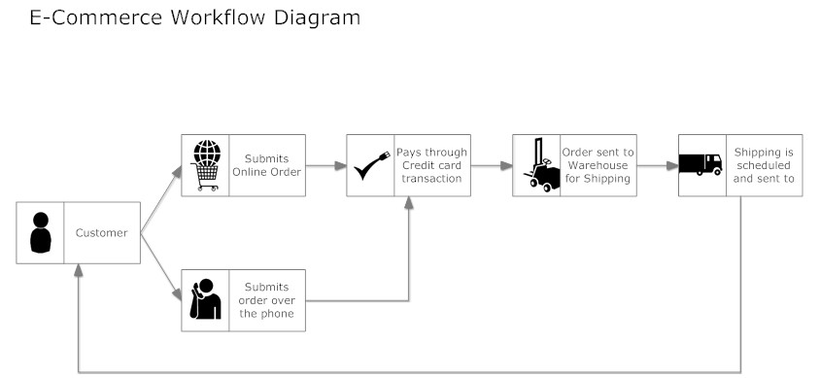

**ERD**

login

has

has

list

Order

Place

Register

has

Customer

Sales rep

store

Product

Warehouse