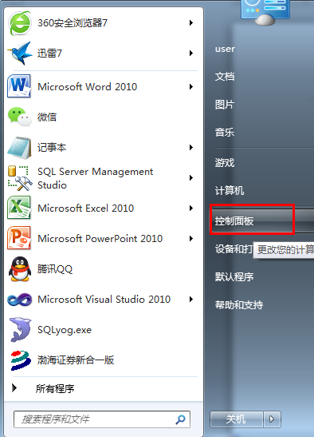

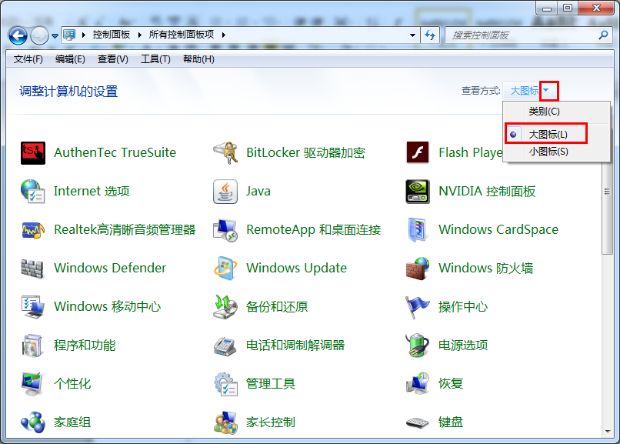

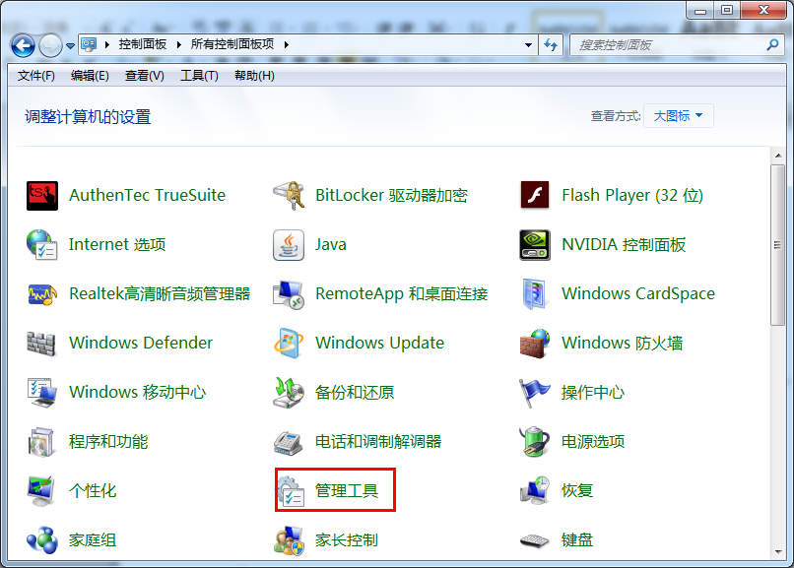

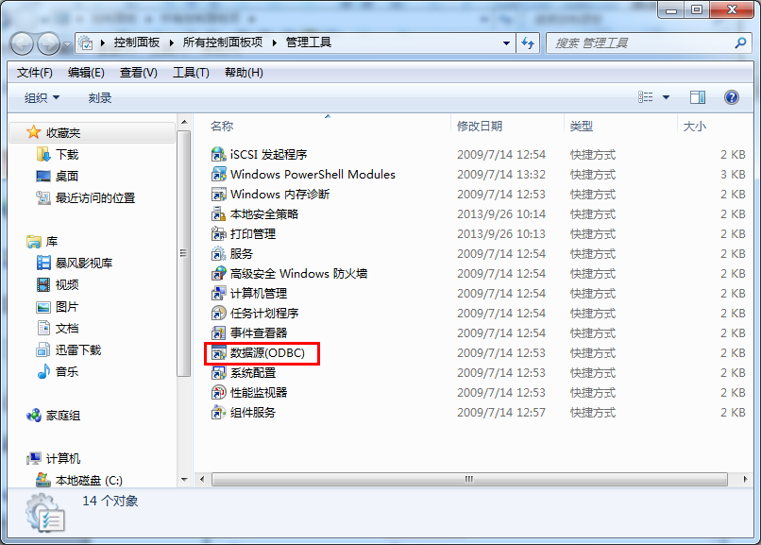

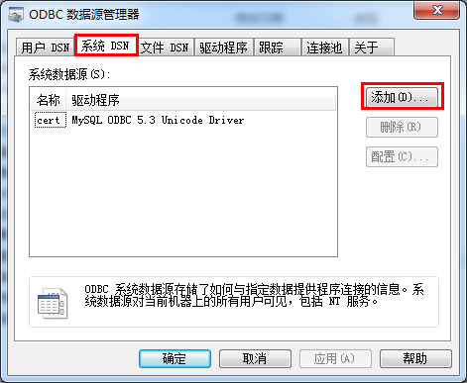

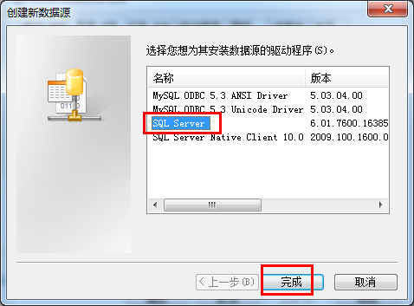

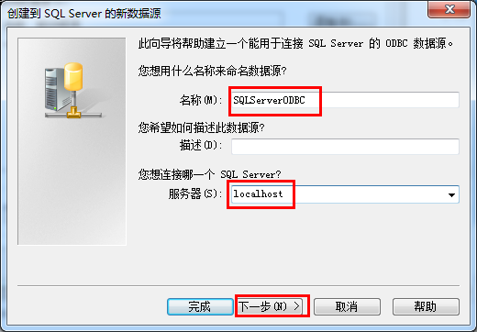

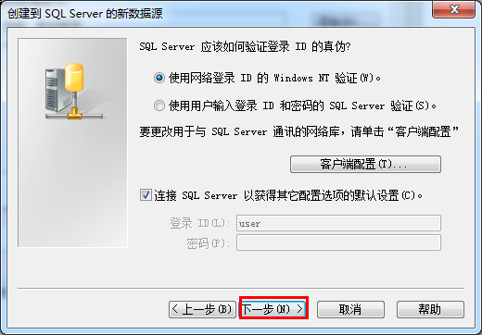

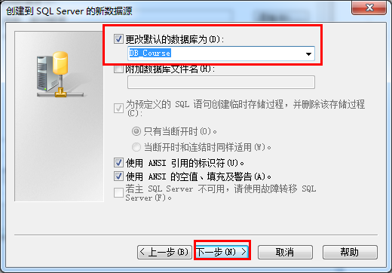

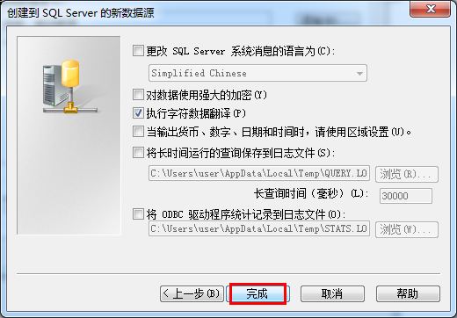

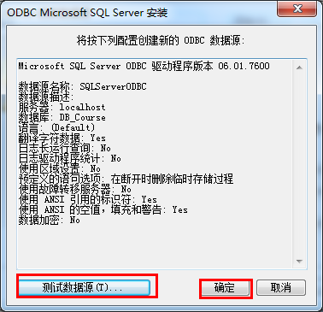

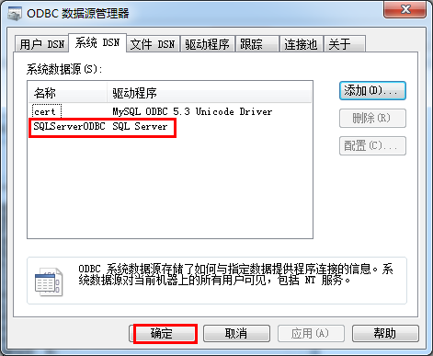

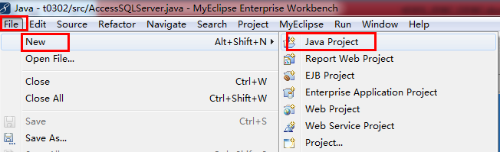

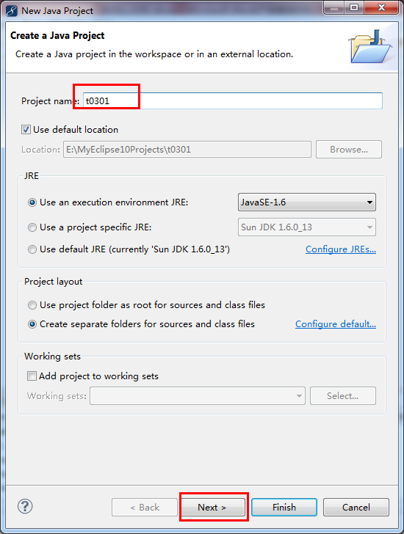

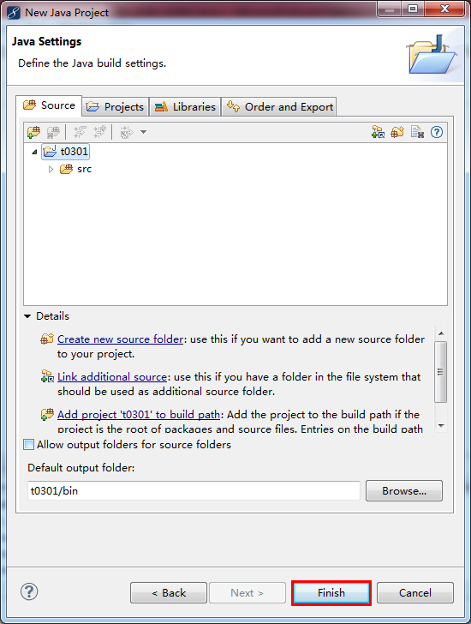

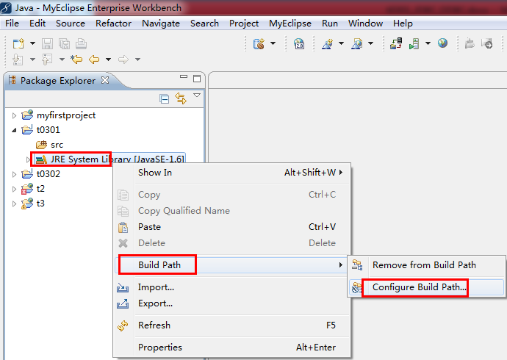

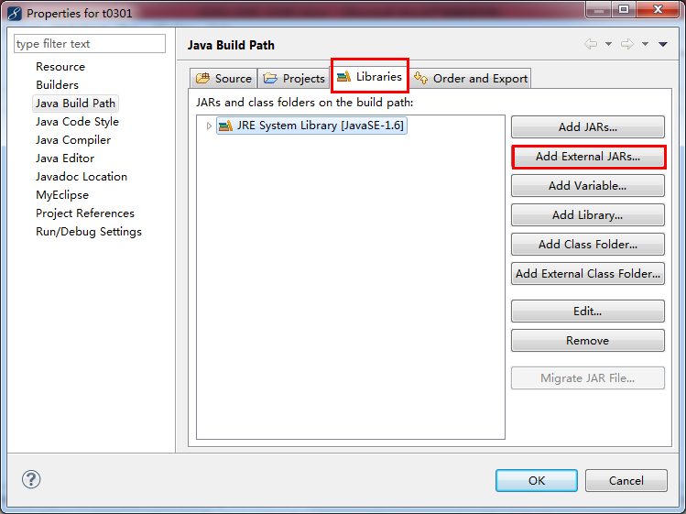

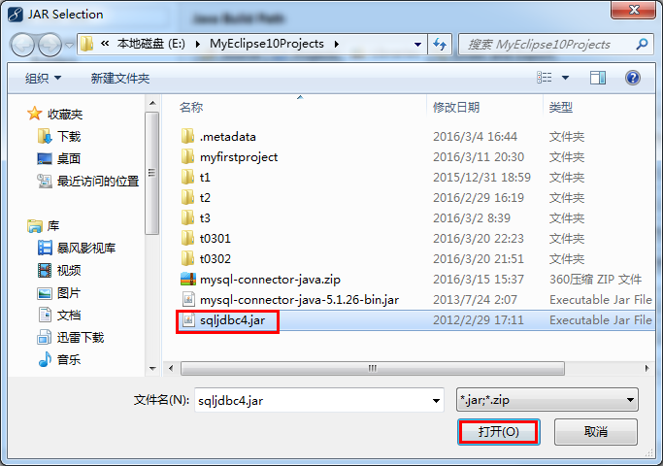

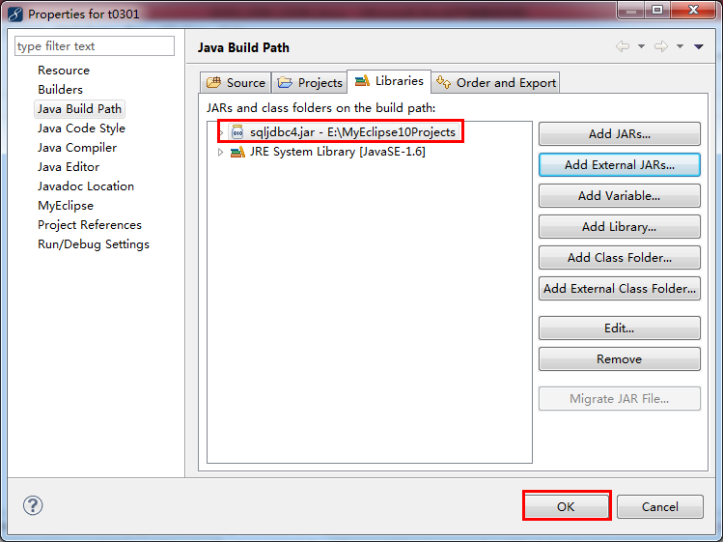

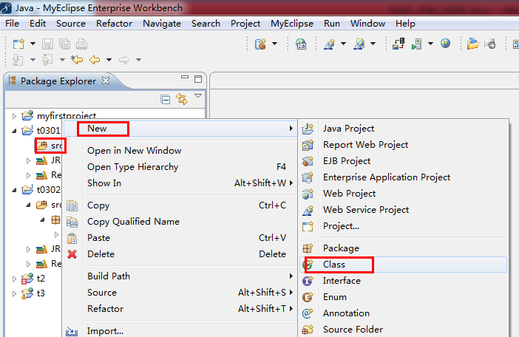

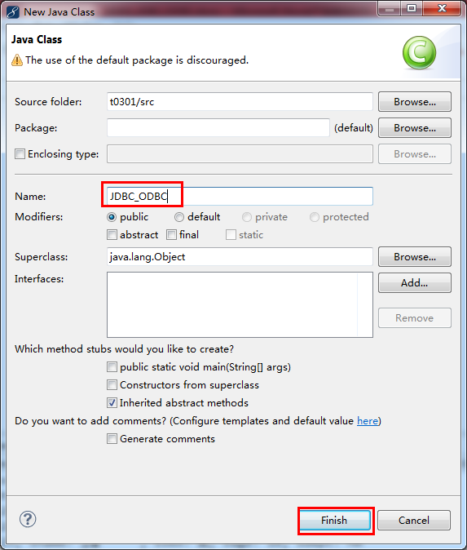

//STEP 1. Import required packages

**import** java.sql.*;

**public** **class** JDBC_ODBC {

// JDBC驱动程序名和数据库连接字符串

**static** **final** String *JDBC_DRIVER* = "sun.jdbc.odbc.JdbcOdbcDriver";

**static** **final** String *DB_CONNSTR* = "jdbc:odbc:sqlodbc";

// 用户名和密码

**static** **final** String *USER* = "sa";

**static** **final** String *PASS* = "m112233";

**public** **static** **void** main(String[] args) {

Connection conn = **null**;

Statement stmt = **null**;

**try**{

//STEP 2: Register JDBC driver

Class.*forName*(*JDBC_DRIVER*);

//STEP 3: Open a connection

System.*out*.println("Connecting to database...");

conn = DriverManager.*getConnection*(*DB_CONNSTR*,*USER*,*PASS*);

//STEP 4: Execute a query

System.*out*.println("Creating statement...");

stmt = conn.createStatement();

String sql;

sql = "SELECT * FROM student";

ResultSet rs = stmt.executeQuery(sql);

//STEP 5: Extract data from result set

**while**(rs.next()){

//Retrieve by column name

String sno = rs.getString("sno");

String sname = rs.getString("sname");

String ssex = rs.getString("ssex");

String sage = rs.getString("sage");

String sdept = rs.getString("sdept");

//Display values

System.*out*.print("sno: " + sno);

System.*out*.print(", sname: " + sname);

System.*out*.print(", ssex: " + ssex);

System.*out*.print(", sage: " + sage);

System.*out*.println(", sdept: " + sdept);

}

//STEP 6: Clean-up environment

rs.close();

stmt.close();

conn.close();

}**catch**(SQLException se){

//Handle errors for JDBC

se.printStackTrace();

}**catch**(Exception e){

//Handle errors for Class.forName

e.printStackTrace();

}**finally**{

//finally block used to close resources

**try**{

**if**(stmt!=**null**)

stmt.close();

}**catch**(SQLException se2){

}// nothing we can do

**try**{

**if**(conn!=**null**)

conn.close();

}**catch**(SQLException se){

se.printStackTrace();

}//end finally try

}//end try

System.*out*.println("Goodbye!");

}//end main

}

由于用的是64位的jdk，对odbc支持的不好。看机房的32位版本是否有问题？