**Executive Summary**

Lesley Potts-Langdon

Southern New Hampshire University

MBA530: Leading People and Organizations

Cheryl Stern

August 22, 2021

**Executive Summary**

**Purpose and Respondents**

Some of our employees are reporting high levels of burnout. I have analyzed a recent survey to gain some insight as to how many employees are affected and to identify possible ways to reduce this issue. One hundred and seventeen employees responded to the survey. Of those, 61 are female, 49 males, and the remainder opted out of that question. Two are under 30 years old, 26 are aged 30 to 30, 45 are aged 40 to 49, 42 are 50 or over, and 2 opted out. We also looked at tenure with the company and leadership level.

**Results**

We are going to look at the survey results in a few different ways to narrow down to the groups most likely to suffer burn out and to identify ways we can reduce it.

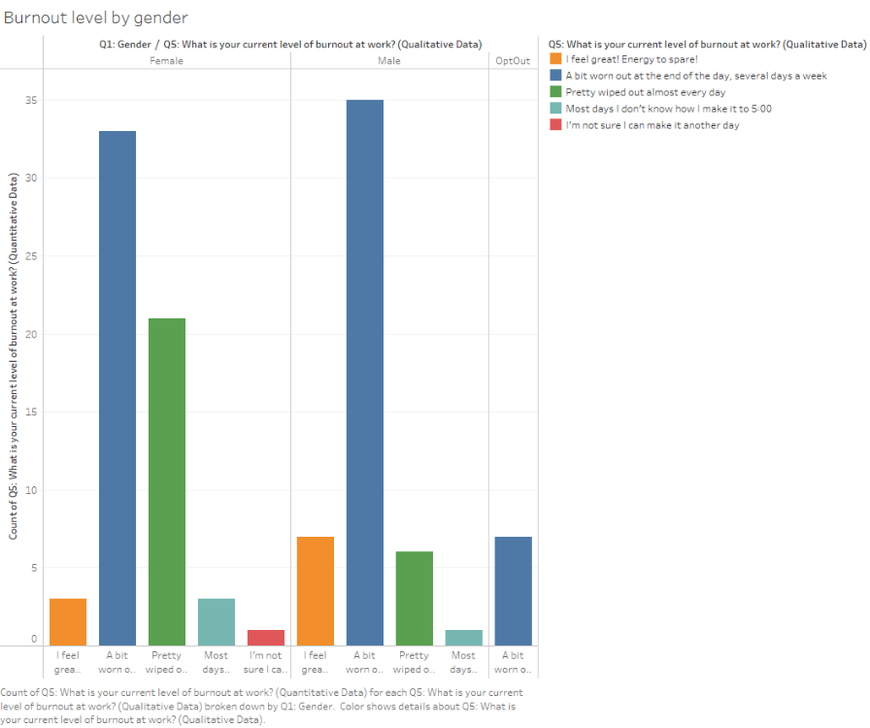Looking at strictly a gender breakdown, 21 females feel “Pretty wiped out almost every day”, represented with the green bar. The most common responses were that and “A bit worn out at the end of the day, several days a week”, in dark blue, with 102 total responses out of the 117 surveys.

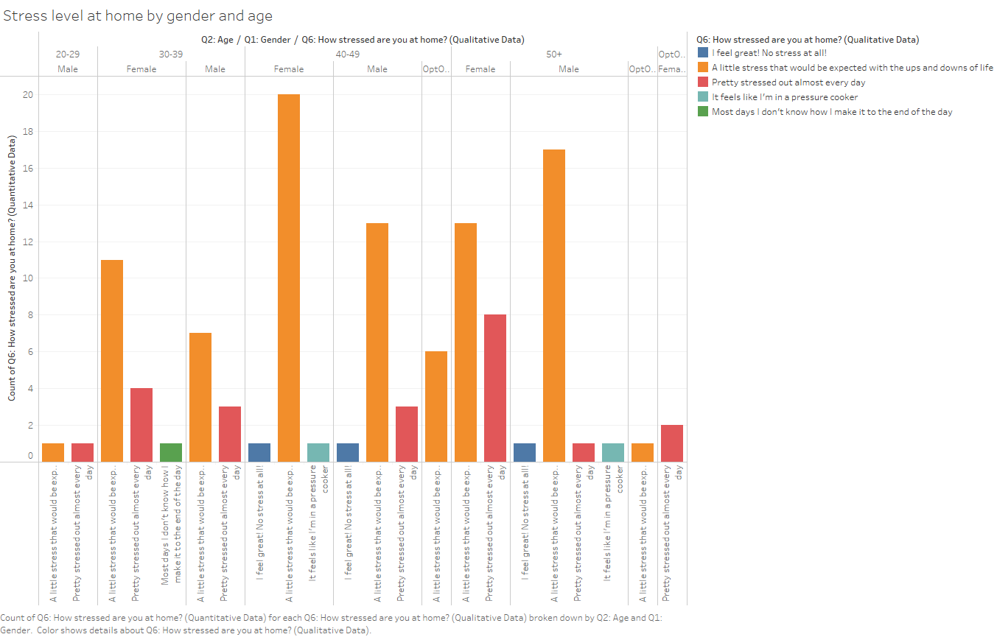 Next, we looked at stress levels at home. The most common response by far was “A little stress that would be expected with the ups and downs of life”, that response is represented in orange on the graph. Out of the male respondents, those aged 50 and over were most likely to respond that way with 17 out of 20 giving this answer. For females, 20 out of 22 had this response.

We were happy to see that a decisive majority of employees at every level of leadership responded either “Agree”, light blue, or “Strongly Agree”, green, to the question “I love what I do”. When we dial down to those who “Strongly Agree”, 36.4% of Directors and 36.9% of Managers had that reply. The other two leadership levels were just over 30%.

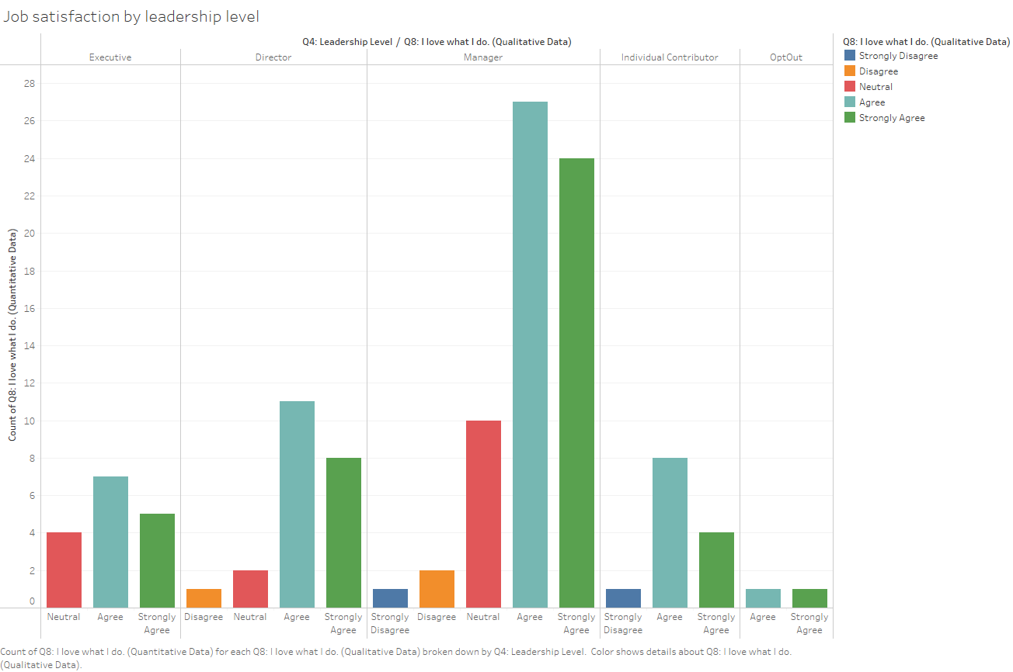

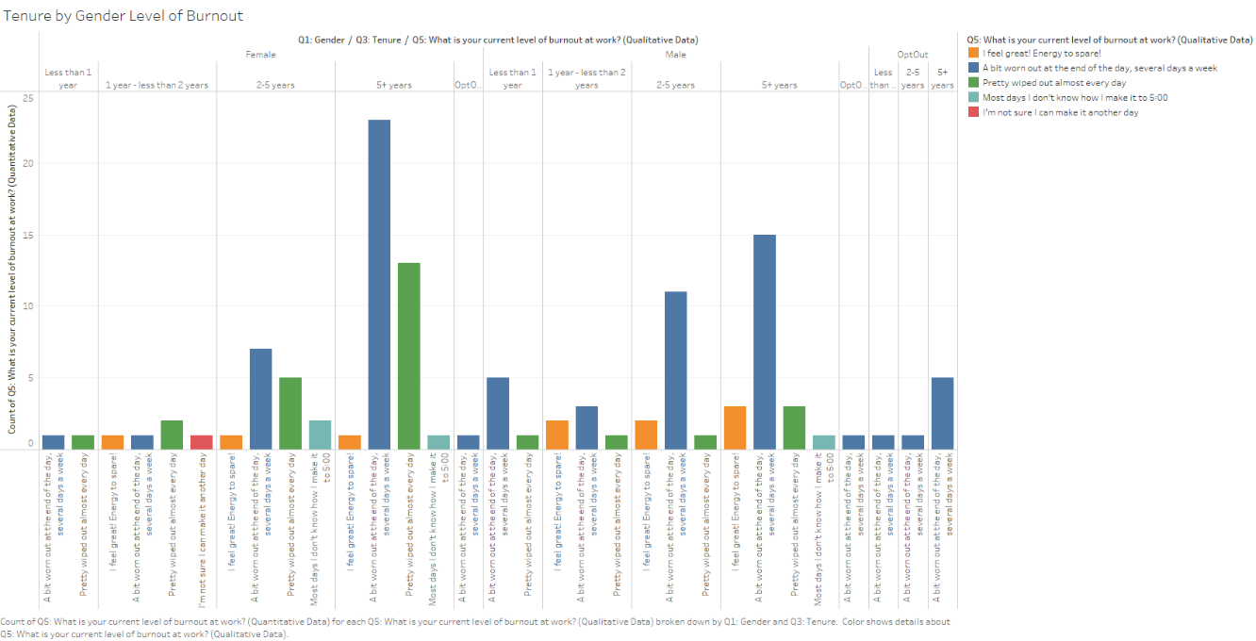Finally, we looked at how tenure contributes to burn out. We received responses from 38 females and 22 males with a tenure of five years or more. Of those, three males responded “I feel great! Energy to spare!”, the orange bar, while only one female feels that way.

**Recommendations**

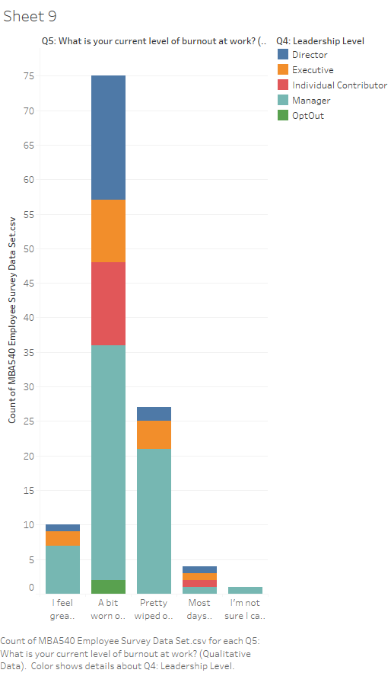Our greatest concern should be directed towards the workers that are “Pretty wiped out almost every day” and those with higher burn out risk. We have identified trends in gender, age, and tenure but it would be difficult, and potentially discriminatory, to try to make any changes based on those metrics. When we look at trends by leadership level, we see that management is where we can have the greatest impact. With 23 managers out of 64 feeling “Pretty wiped out almost every day” or more, I recommend that we look at ways we can reduce the stress level of our management ranks.