1. ls

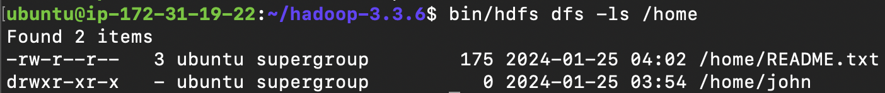

List the content of current directory. In the above example, it shows that there are 2 files or directories in directory *`/home*`

2. mkdir



Make/create a directory in HDFS as specified

Here I created a folder named `*Lesley*` under *`/home*`. Command `*ls*` shows that there’s no item under this directory.

3. put



Put/copy an item from local to HDFS

In the above lines of commands, I moved README.txt from local default folder to */home/Lesley*.

4. get

Get/copy a whole directory or a file from HDFS to local directory or file. If the local directory does not exist, it will automatically make one.

The above example 1 copies a file README.txt to local default folder.

The above example 2 copies the whole HDFS directory */home/Lesley* to local folder *HDFS_Docs*.

5. rm



Remove/delete a file (not a directory) in HDFS

6. rmdir

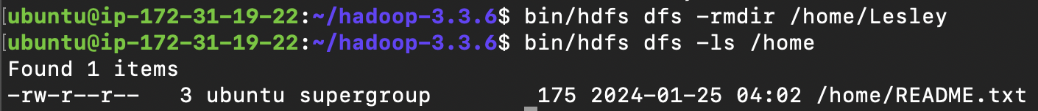

Remove/delete an empty directory in HDFS.

In step 5, we know that the directory Lesley is empty, so now it can be safely removed. From the above code we can see that under */home* there’s no longer */home/Lesley.* It is emoved successfully.

7. cp

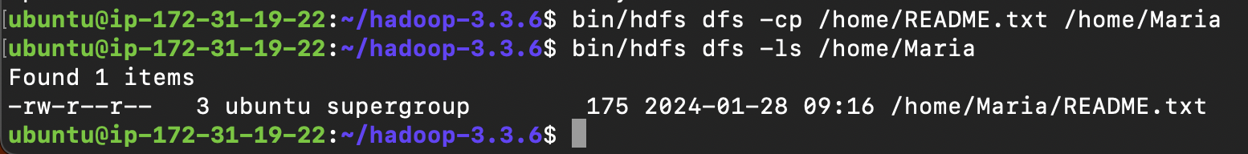

Copy a file or multiple files from specified path to another directory/path. When copying multiple files, the destination must be a directory, not a file name.

In the example, I copied README.txt from */home* to */home/Maria*.

8. cat

Display the content under the specified path. It must be a file, not a directory.