**CRUD in REST**

**GET**

**PUT**

会overwrite信息

**PATCH**

补充的信息，不会overwrite



**200/major.json**

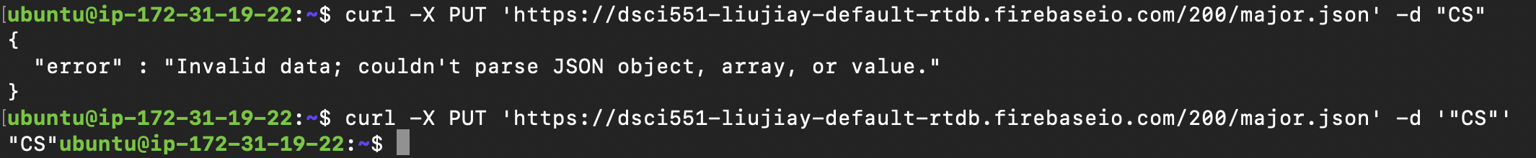

**POST**



It generates a random key

**DELETE**



这里我把Jennifer放错地方了，所以要用delete删掉



**Parameters**

这里应该就是在用ppt37页的指令

1. Filtering by key

* orderBy=”$key”



1. Filtering by child key

* orderBy=”<path-to-child-key>”
* e.g., orderBy = “name”



疑问：为什么顺序不对？难道不应该是年龄从小到大吗？

不！！它显示全部的！！要像下面这样写才有效filter

1. filtering by value

* orderBy=”$value”

这个错误出现的原因，是我们没有在Rules里面加上一条下面这个语句

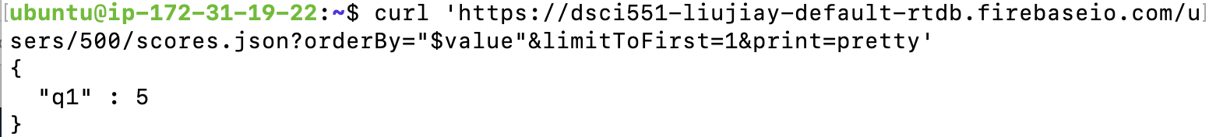

如果不输入任何-X GET或者-X PUT或者 -X PATCH 或者-X DELETE指令，那默认就是 -X GET。见PPT 26. 看下面的两个例子就是完全等效的指令。



