MOEN INTEGRATED ENERGY PROJECT SYSTEM
Current System Workflow, Email Alerts
& Document Automation
A technical brief on the request-to-BoQ-deduction process
Document | Technical brief
System | MOEN-IMS — Integrated Energy Project System (IEPS)
Scope | End-to-end workflow, from material request to Bill of Quantity deduction
Audience | Project management and technical stakeholders
Prepared by | Leslie Nii Adjei
Date | 24 May 2026
Version | 1.0 — reflects the current (May 2026) build

Contents

1. Introduction
This brief sets out how the MOEN Integrated Energy Project System (MOEN-IMS) currently moves materials from an initial request through to the point where the issued quantity is posted against a project's Bill of Quantity (BoQ). It is written for a mixed audience of project managers and technical staff.
It covers three things: the current request-to-BoQ-deduction workflow; the email alert that now accompanies every step of that workflow; and the new document-automation capability that generates approval memos and release letters automatically.
Two changes define the current build. Previously, approval memos and release letters were typed by hand for every release, and staff were notified only inside the application. The system now generates those documents in a single action and pushes an email notification at each handover, so no step depends on someone remembering to check a screen.

2. Workflow at a glance
The table below summarises the nine stages a material release passes through. Each stage is described in detail in Section 3.
# | Stage | Owner | Outcome
1 | Material request raised | Schedule Officer | Request logged; warehouse stock soft-reserved
2 | Approval documents generated | Schedule Officer / Management | Approval memo and release letter PDFs created
3 | Signature and signed-scan upload | Leadership / Officers | Signed documents scanned and verified by QR
4 | Request processed by the store | Storekeeper | Quantities verified; processed amount recorded
5 | Order completed — materials issued | Storekeeper | Warehouse stock deducted for the issued quantity
6 | Transport assigned | Transport Officer | Carrier, vehicle and driver attached to the order
7 | Delivery to site | Transporter | Materials moved; status tracked to Delivered
8 | Site receipt logged | Consultant | Delivery confirmed with waybill, photos and condition
9 | BoQ deduction | System | Received quantity posted against the project BoQ

3. The workflow in detail
Each stage below names the responsible actor, the status the record carries afterwards, and the email alert the system raises.

Step 1 — Material request raised
A Schedule Officer opens the material request form and selects the items required for a project, together with the project's region, district, community, consultant or contractor, package number and a priority level. On submission the system generates a unique request code (in the form REQ-YYYYMMDD-…) and immediately places a soft hold — a reserved quantity — on the relevant warehouse stock, so the same materials cannot be promised to two requests at once. The request enters the workflow with a Pending status.
Actor: Schedule Officer Resulting status: Pending Email alert: Store Officers and Management notified of the new release request.
[ SCREENSHOT TO BE INSERTED ]
The material request form, where a release request is raised against a project.
Figure 1. The material request form, where a release request is raised against a project.

Step 2 — Approval documents generated
From the release record, a Schedule Officer or Management user selects Generate memo & letter. In a single action the system allocates a release code in the form RE-YYYY-NNNN and produces two PDF documents — an approval memo and a release letter. These were previously typed by hand; they are now generated from data already held in the system. The feature is described in full in Section 5.
Actor: Schedule Officer / Management Resulting status: Memo generated Email alert: In-app status update; documents available for download.

Step 3 — Signature and signed-scan upload
The generated documents are printed and signed by the relevant authority. The signed copy is scanned and uploaded back into the system, which reads the QR code printed on the document and confirms that it matches the expected release code. A second officer — who must be different from the person who uploaded the scan — confirms it, satisfying a two-person review rule. The release then advances to an approved state.
Actor: Leadership and two reviewing Officers Resulting status: Awaiting scan → Approved Email alert: Workflow status advances; audit-log entry written for each transition.

Step 4 — Request processed by the store
With an authorised release in place, a Storekeeper reviews the request, verifies that the stock is available, and enters the quantity actually processed. The request may be processed in full or in part — a partial release keeps the order open so the remaining quantity can be fulfilled later. The order moves into a Processing (In Progress) status.
Actor: Storekeeper Resulting status: In Progress / Partially Fulfilled Email alert: The original requester and Management are notified that the request is being processed.

Step 5 — Order completed and stock deducted
When the materials physically leave the store, the Storekeeper marks the order Completed. At that moment the system deducts the issued quantity from the warehouse inventory, converting the earlier soft hold into a real stock movement. The system also creates a placeholder transport record in an “Awaiting Transporter” state, so the delivery cannot be forgotten.
Actor: Storekeeper Resulting status: Completed Email alert: The requester and Management are notified that the order is complete.

Step 6 — Transport assigned
A Transport Officer assigns a transporter, a vehicle and a driver to the completed order, and records the quantity being moved. Large orders can be split across more than one transporter, with each consignment tracked separately.
Actor: Transport Officer Resulting status: Scheduled Email alert: Management is notified that a transport has been assigned.

Step 7 — Delivery to site
The transporter updates the consignment as it moves — first to In Transit, then to Delivered on arrival at the project site. Each change is visible in the system in real time.
Actor: Transporter Resulting status: In Transit → Delivered Email alert: The receiving group is notified at each status change.

Step 8 — Site receipt logged
On site, a Consultant logs a site receipt: they confirm the quantity received, upload the waybill and acknowledgement sheet, attach site photographs, and record the condition of the materials (Good, Damaged or Incomplete). This is the point at which a delivery becomes verified evidence rather than an expectation.
Actor: Consultant Resulting status: Receipt logged Email alert: Management and Store Officers are notified that materials were received on site.

Step 9 — BoQ deduction
On the confirmed site receipt, the system posts the received quantity against the project's Bill of Quantity. The BoQ's received quantity increases and the contract balance — contract quantity minus received quantity — decreases accordingly. This deduction is the end of the request-to-BoQ-deduction chain: a request that began as a line on a form is now reflected in the project's contractual position.
If the received quantity pushes the BoQ line beyond its contracted amount, the system flags an over-issuance and opens a justification workflow, in which project staff record a category and reason and Management reviews the outcome.
Actor: System (automatic) Resulting status: BoQ updated Email alert: Management is notified of new BoQ entries and of any over-issuance justification submitted.
[ SCREENSHOT TO BE INSERTED ]
The Bill of Quantity view, showing contract quantity, received quantity and the running balance.
Figure 2. The Bill of Quantity view, showing contract quantity, received quantity and the running balance.

4. An email alert at every step
Every state change in the workflow now raises an email alert in addition to the in-app notification. Alerts are delivered through Microsoft 365 using the Microsoft Graph API, so they arrive in the recipients' normal Outlook inboxes — no separate login or portal check is required.

How an alert is raised
When a record is created or its status changes, the system reacts automatically: it builds a notification, resolves the recipient role (for example “Store Officers” or “Management”) into a set of email addresses, composes an HTML message, and sends it through a staff account that holds valid Microsoft 365 credentials.
Delivery is fault-tolerant by design. If no valid sender account is available, if the recipient list is empty, or if the Microsoft Graph call fails, the failure is recorded in the system log and the workflow simply continues. A notification problem can never block, delay or crash a material transaction.

Notification coverage
The table below lists every workflow event that currently raises an alert, and who receives it. Each event delivers both an in-app notification and a Microsoft 365 email.
Workflow event | Recipients | Channel
New release request created | Store Officers, Management | In-app + email
Order moves to Processing | Original requester, Management | In-app + email
Order marked Completed | Original requester, Management | In-app + email
Transport assigned | Management | In-app + email
Transport marked In Transit | Receiving group | In-app + email
Transport marked Delivered | Receiving group | In-app + email
Site receipt logged | Management, Store Officers | In-app + email
Low / critical stock reached | Store Officers, Management | In-app + email
BoQ entry created | Management | In-app + email
BoQ over-issuance justification submitted | Management | In-app + email

[ SCREENSHOT TO BE INSERTED ]
An example workflow email alert as received in Outlook (and the in-app notifications list).
Figure 3. An example workflow email alert as received in Outlook (and the in-app notifications list).
Planned enhancement. Escalating reminder emails for approvals left unattended (at 24, 48 and 72 hours) are specified and scheduled as the next addition to this area; the per-event alerts described above are live in the current build.

5. New feature — automatic document generation
Until recently, the approval memo and release letter for every material release were typed by hand in a word processor — a slow step, and one prone to inconsistent wording and transcription error. The current build generates both documents automatically, as PDFs, from the data already in the system.
Both documents are produced in a single action from the release record, shown below. The same action allocates the release code and advances the workflow status.
[ SCREENSHOT TO BE INSERTED ]
The release record, showing the Generate memo & letter action and the workflow status badge.
Figure 4. The release record, showing the Generate memo & letter action and the workflow status badge.

5.1 Automatically generated approval memos
The approval memo is produced as a PDF that follows the standard memorandum format: a TO / FROM / DATE / SUBJECT header block, the body paragraphs, and a signature block. The signatory is not hard-coded — it is drawn from a Signatory table that an administrator can edit, so a change in leadership is a database update rather than a code change. The memo carries the release code (RE-YYYY-NNNN) in its header and footer, and a QR code that encodes the same value.

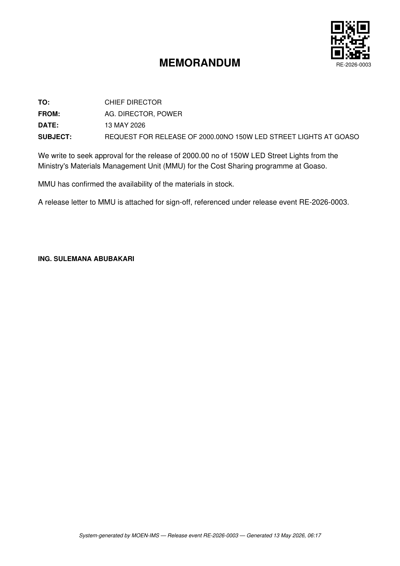
Figure 5. A system-generated approval memo — release RE-2026-0003, 2,000 LED street lights for Goaso.

5.2 Automatically generated release letters
The release letter is generated in the same action. It follows the official letter format — an addressee block, a bold subject line, the body, a signature block carrying the “FOR: HON. MINISTER” line, and a circulation (cc) list. Its wording adapts to the project type, so SHEP, Cost Sharing and Streetlights releases each read correctly. The release code is printed prominently and embedded in a QR code in a fixed corner of the page — this is what later allows an uploaded scan to be matched automatically to the correct release.

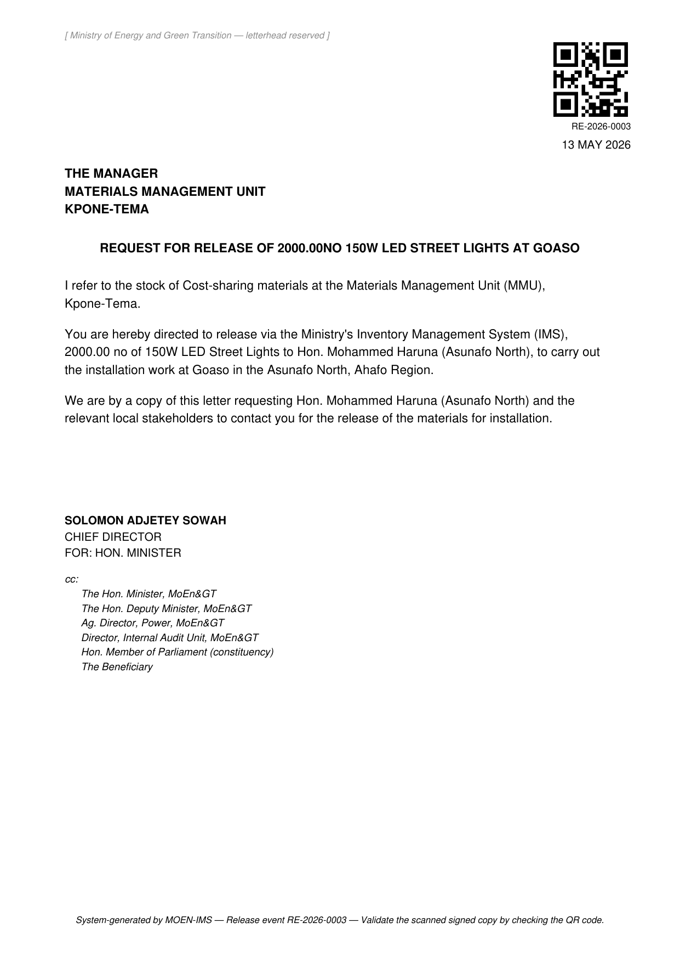
Figure 6. A system-generated release letter — release RE-2026-0003, addressed to the Materials Management Unit.

5.3 Shared safeguards
Both documents are underpinned by the same set of controls:
Safeguard | What it does
Unique release code | Every release receives an RE-YYYY-NNNN code, allocated atomically and rolling over each year, so two releases can never share a reference.
QR validation on upload | When a signed scan is uploaded, the QR code is decoded and checked against the expected release code; a scan of the wrong document is flagged rather than accepted silently.
Two-person review | The officer who uploads a signed scan cannot also be the officer who confirms it, keeping a separation of duties on every approval.
Tracked workflow status | Each release is tracked through draft, memo generated, awaiting scan, approved and released, so its position is always visible.
Audit log | Every status transition writes an audit-log entry, giving a complete forensic trail of who did what and when.
Idempotent regeneration | Regenerating the documents refreshes the PDFs without re-issuing the release code, so corrections are safe.

6. Summary
Taken together, the current build gives the MOEN-IMS release process three properties it did not have before.
Property | What it means in practice
End-to-end traceability | A request can be followed from the form that created it, through processing, transport and site receipt, to the exact quantity deducted from the project Bill of Quantity.
An alert at every handover | Each role is emailed when work reaches them, so the workflow advances without anyone needing to poll a screen — and a failed alert never stalls a transaction.
Signed-ready documents in one click | Approval memos and release letters are generated automatically, consistently formatted, uniquely coded and QR-verifiable, replacing manual typing.
End of brief.

