Load测试截图

# 基本信息

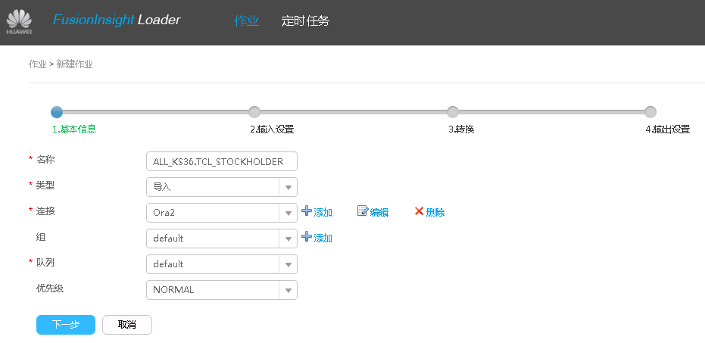

# 输入设置

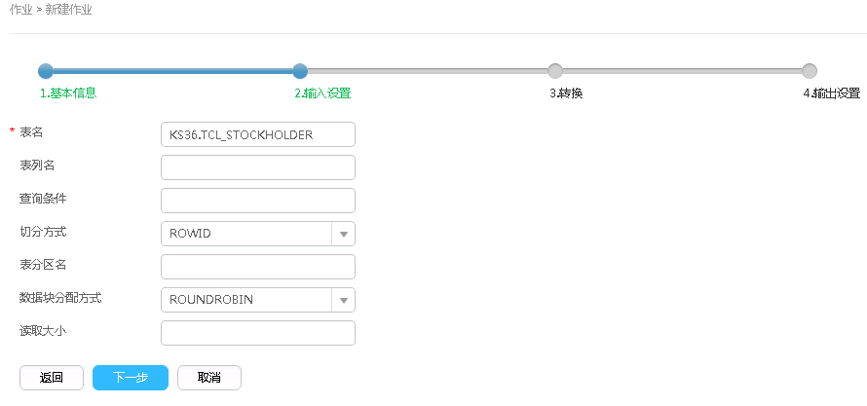

# 转换

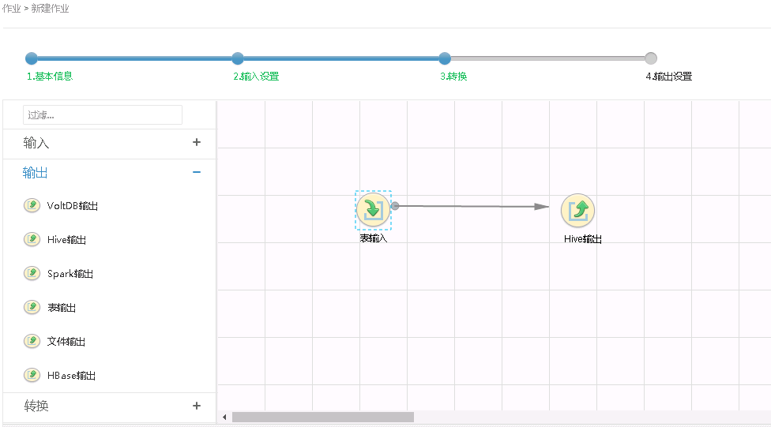

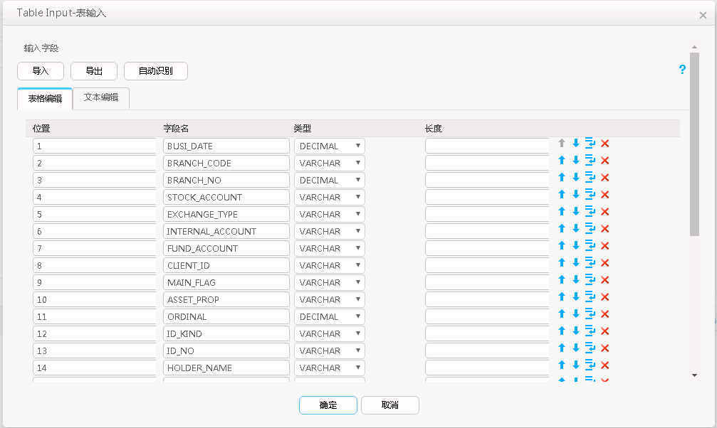

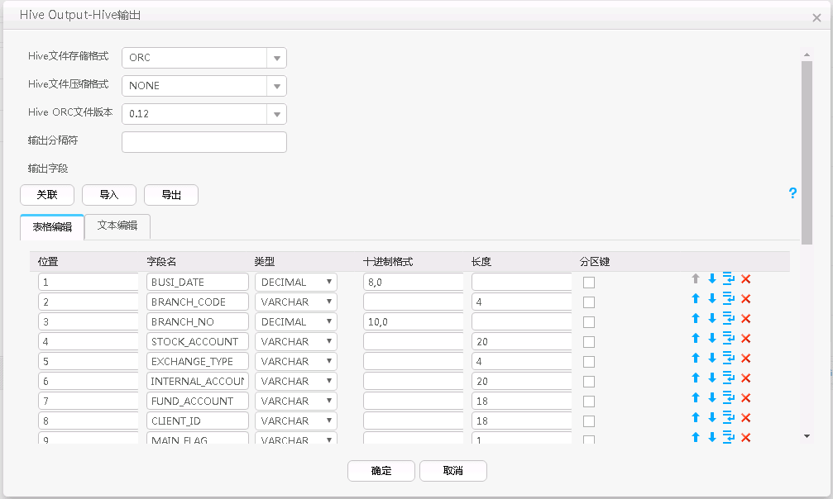

# 输出设置

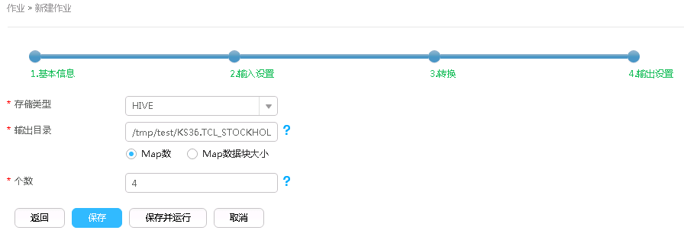

# 运行结果

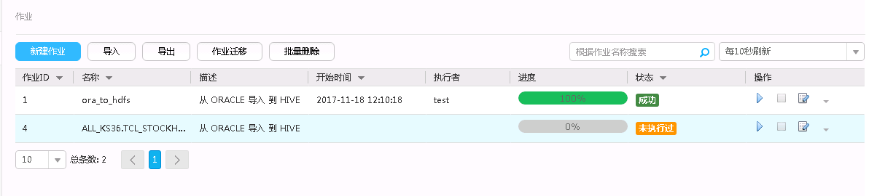

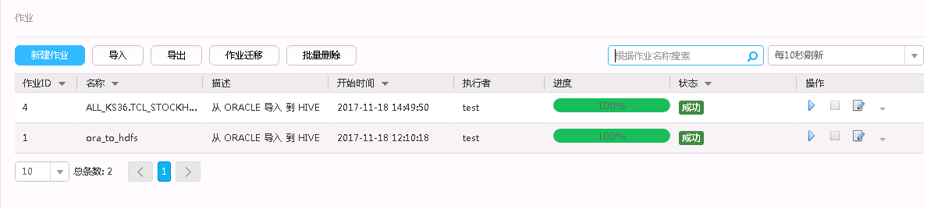

# 遇到的问题

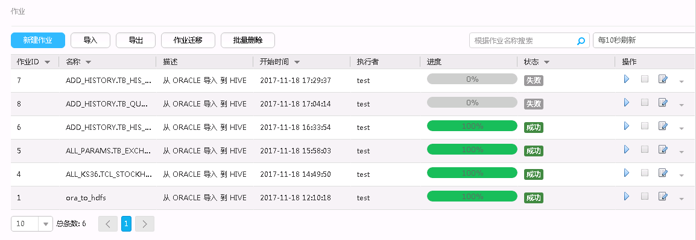

Log Type: localization.log

Log Upload Time: Sat Nov 18 17:30:29 +0800 2017

Log Length: 0

Log Type: stderr

Log Upload Time: Sat Nov 18 17:30:29 +0800 2017

Log Length: 1988

Java HotSpot(TM) 64-Bit Server VM warning: UseCMSCompactAtFullCollection is deprecated and will likely be removed in a future release.

Java HotSpot(TM) 64-Bit Server VM warning: CMSFullGCsBeforeCompaction is deprecated and will likely be removed in a future release.

Nov 18, 2017 5:29:52 PM com.sun.jersey.guice.spi.container.GuiceComponentProviderFactory register

INFO: Registering org.apache.hadoop.mapreduce.v2.app.webapp.JAXBContextResolver as a provider class

Nov 18, 2017 5:29:52 PM com.sun.jersey.guice.spi.container.GuiceComponentProviderFactory register

INFO: Registering org.apache.hadoop.yarn.webapp.GenericExceptionHandler as a provider class

Nov 18, 2017 5:29:52 PM com.sun.jersey.guice.spi.container.GuiceComponentProviderFactory register

INFO: Registering org.apache.hadoop.mapreduce.v2.app.webapp.AMWebServices as a root resource class

Nov 18, 2017 5:29:52 PM com.sun.jersey.server.impl.application.WebApplicationImpl _initiate

INFO: Initiating Jersey application, version 'Jersey: 1.9 09/02/2011 11:17 AM'

Nov 18, 2017 5:29:53 PM com.sun.jersey.guice.spi.container.GuiceComponentProviderFactory getComponentProvider

INFO: Binding org.apache.hadoop.mapreduce.v2.app.webapp.JAXBContextResolver to GuiceManagedComponentProvider with the scope "Singleton"

Nov 18, 2017 5:29:53 PM com.sun.jersey.guice.spi.container.GuiceComponentProviderFactory getComponentProvider

INFO: Binding org.apache.hadoop.yarn.webapp.GenericExceptionHandler to GuiceManagedComponentProvider with the scope "Singleton"

Nov 18, 2017 5:29:53 PM com.sun.jersey.guice.spi.container.GuiceComponentProviderFactory getComponentProvider

INFO: Binding org.apache.hadoop.mapreduce.v2.app.webapp.AMWebServices to GuiceManagedComponentProvider with the scope "PerRequest"

log4j:WARN No appenders could be found for logger (org.apache.hadoop.mapreduce.v2.app.MRAppMaster).

log4j:WARN Please initialize the log4j system properly.

log4j:WARN See http://logging.apache.org/log4j/1.2/faq.html#noconfig for more info.

Log Type: stdout

Log Upload Time: Sat Nov 18 17:30:29 +0800 2017

Log Length: 319

[GC (Allocation Failure) 272000K->18257K(985920K), 0.0192002 secs]

[GC (CMS Initial Mark) 18261K(985920K), 0.0013487 secs]

[GC (CMS Final Remark) 167484K(985920K), 0.0204185 secs]

[GC (Allocation Failure) 290257K->21257K(985920K), 0.0479962 secs]

[GC (Allocation Failure) 293257K->21643K(985920K), 0.0220874 secs]

Log Type: syslog

Log Upload Time: Sat Nov 18 17:30:29 +0800 2017

Log Length: 964918

Showing 4096 bytes of 964918 total. Click here for the full log.

_conf.xml_tmp

2017-11-18 17:30:21,888 INFO [eventHandlingThread] org.apache.hadoop.mapreduce.jobhistory.JobHistoryEventHandler: Moved tmp to done: hdfs://hacluster:8020/mr-history/tmp/test/job_1510915910842_0017.summary_tmp to hdfs://hacluster:8020/mr-history/tmp/test/job_1510915910842_0017.summary

2017-11-18 17:30:21,890 INFO [eventHandlingThread] org.apache.hadoop.mapreduce.jobhistory.JobHistoryEventHandler: Moved tmp to done: hdfs://hacluster:8020/mr-history/tmp/test/job_1510915910842_0017_conf.xml_tmp to hdfs://hacluster:8020/mr-history/tmp/test/job_1510915910842_0017_conf.xml

2017-11-18 17:30:21,891 INFO [eventHandlingThread] org.apache.hadoop.mapreduce.jobhistory.JobHistoryEventHandler: Moved tmp to done: hdfs://hacluster:8020/mr-history/tmp/test/job_1510915910842_0017-1510997386950-test-Loader%3A+ADD_HISTORY.TB_HIS_DONE_1510997377795-1510997421582-92-0-FAILED-default-1510997393670-test.jhist_tmp to hdfs://hacluster:8020/mr-history/tmp/test/job_1510915910842_0017-1510997386950-test-Loader%3A+ADD_HISTORY.TB_HIS_DONE_1510997377795-1510997421582-92-0-FAILED-default-1510997393670-test.jhist

2017-11-18 17:30:21,892 INFO [Thread-318] org.apache.hadoop.mapreduce.jobhistory.JobHistoryEventHandler: Stopped JobHistoryEventHandler. super.stop()

2017-11-18 17:30:21,895 INFO [Thread-318] org.apache.hadoop.mapreduce.v2.app.rm.RMCommunicator: Setting job diagnostics to Task failed task_1510915910842_0017_m_000082

Job failed as tasks failed. failedMaps:1 failedReduces:0

2017-11-18 17:30:21,895 INFO [Thread-318] org.apache.hadoop.mapreduce.v2.app.rm.RMCommunicator: History url is https://host03:26014/jobhistory/job/job_1510915910842_0017

2017-11-18 17:30:21,900 INFO [Thread-318] org.apache.hadoop.mapreduce.v2.app.rm.RMCommunicator: Waiting for application to be successfully unregistered.

2017-11-18 17:30:22,902 INFO [Thread-318] org.apache.hadoop.mapreduce.v2.app.rm.RMContainerAllocator: Final Stats: PendingReds:0 ScheduledMaps:0 ScheduledReds:0 AssignedMaps:7 AssignedReds:0 CompletedMaps:93 CompletedReds:0 ContAlloc:130 ContRel:7 HostLocal:0 RackLocal:0

2017-11-18 17:30:22,902 INFO [Thread-318] org.apache.hadoop.mapreduce.v2.app.MRAppMaster: Deleting staging directory hdfs://hacluster /tmp/hadoop-yarn/staging/test/.staging/job_1510915910842_0017

2017-11-18 17:30:22,905 INFO [Thread-318] org.apache.hadoop.ipc.Server: Stopping server on 27102

2017-11-18 17:30:22,905 INFO [IPC Server listener on 27102] org.apache.hadoop.ipc.Server: Stopping IPC Server listener on 27102

2017-11-18 17:30:22,905 INFO [IPC Server Responder] org.apache.hadoop.ipc.Server: Stopping IPC Server Responder

2017-11-18 17:30:22,906 INFO [TaskHeartbeatHandler PingChecker] org.apache.hadoop.mapreduce.v2.app.TaskHeartbeatHandler: TaskHeartbeatHandler thread interrupted

2017-11-18 17:30:22,907 INFO [Thread-318] org.apache.hadoop.mapreduce.v2.app.MRAppMaster: Job end notification started for jobID : job_1510915910842_0017

2017-11-18 17:30:22,907 INFO [Thread-318] org.mortbay.log: Job end notification attempts left 0

2017-11-18 17:30:22,907 INFO [Thread-318] org.mortbay.log: Job end notification trying https://172.21.6.86:21351/loader//v1/submission/notification/7

2017-11-18 17:30:23,046 WARN [Thread-318] org.mortbay.log: Job end notification to https://172.21.6.86:21351/loader//v1/submission/notification/7 failed with code: 401 and message "Unauthorized"

2017-11-18 17:30:24,046 WARN [Thread-318] org.mortbay.log: Job end notification failed to notify : https://172.21.6.86:21351/loader//v1/submission/notification/7

2017-11-18 17:30:29,046 INFO [Thread-318] org.apache.hadoop.ipc.Server: Stopping server on 27100

2017-11-18 17:30:29,046 INFO [IPC Server listener on 27100] org.apache.hadoop.ipc.Server: Stopping IPC Server listener on 27100

2017-11-18 17:30:29,047 INFO [IPC Server Responder] org.apache.hadoop.ipc.Server: Stopping IPC Server Responder

2017-11-18 17:30:29,048 INFO [Thread-318] org.mortbay.log: Stopped HttpServer2$SelectChannelConnectorWithSafeStartup@host01:27101

2017-11-18 17:30:29,250 INFO [Thread-318] org.apache.hadoop.util.ExitUtil: Exiting with status 0