## 环境介绍

|  |  |  |
| --- | --- | --- |
| 操作系统 | 服务器 | 软件版本 |
| Centos 7 | 172.16.1.152 | 17.03.1-ce |
| Centos 7 | 172.16.1.153 | 17.03.1-ce |
| Centos 7 | 172.16.1.154 | 17.03.1-ce |

## 三台机器上Docker17.03.2-ce安装

|  |
| --- |
| [root@yw-docker-03] systemctl stop firewalld.service  [root@yw-docker-03] systemctl disable firewalld.service  [root@yw-docker-03] vi /etc/selinux/config（修改为disabled）  [root@yw-docker-03] cd /etc/yum.repos.d/  [root@yw-docker-03] wget <https://download.docker.com/linux/centos/docker-ce.repo>  [root@yw-docker-03] yum install -y yum-utils device-mapper-persistent-data lvm2  [root@yw-docker-03]yum-config-manager --add-repo http://mirrors.aliyun.com/docker-ce/linux/centos/docker-ce.repo  [root@yw-docker-03] yum install -y --setopt=obsoletes=0 docker-ce-17.03.2.ce-1.el7.centos.x86_64 docker-ce-selinux-17.03.2.ce-1.el7.centos.noarch  [root@yw-docker-03] systemctl enable docker && systemctl restart docker |

## 三台机器环境准备

升级openssh到6.7以上

|  |
| --- |
| [root@yw-docker-03] yum install openssh* |

安装RKE，下载地址：<https://github.com/rancher/rke/releases>，上传到172.16.1.152

|  |
| --- |
| [root@yw-docker-03] mv rke_linux-amd64 rke  [root@yw-docker-03]chmod +x rke  [root@yw-docker-03]./rke –version |

由于centos**可能**不允许root搭建集群，所以建立docker_user用户，设置密码后重启服务器

|  |
| --- |
| [root@yw-docker-03] useradd docker_user  [root@yw-docker-03] usermod -aG docker docker_user |

172.16.1.152服务器，docker_user配置免密登陆

|  |
| --- |
| [docker_user@yw-docker-03] ssh-keygen  [root@yw-docker-03] ssh-copy-id docker_user@172.16.1.152  [root@yw-docker-03] ssh-copy-id docker_user @172.16.1.153  [root@yw-docker-03] ssh-copy-id docker_user @172.16.1.154 |

rancher-cluster.yml文件

|  |
| --- |
| nodes:  - address: 172.16.1.152  internal_address: 172.16.1.152  user: docker_user  role: [controlplane,worker,etcd]  - address: 172.16.1.153  internal_address: 172.16.1.153  user: docker_user  ssh_key_path: /home/docker_user/.ssh/id_rsa  role: [controlplane,worker,etcd]  - address: 172.16.1.154  internal_address: 172.16.1.154  user: docker_user  ssh_key_path: /home/docker_user/.ssh/id_rsa  role: [controlplane,worker,etcd]  services:  etcd:  snapshot: true  creation: 6h  retention: 24h |

## 安装kubernetes(root用户执行，否则可能安装失败)

|  |
| --- |
| [root@yw-docker-03]chown docker_user:docker_user rancher-cluster.yml  [root@yw-docker-03]./rke up --config ./rancher-cluster.yml |

## 验证

**INFO[0251] Finished building Kubernetes cluster successfully，显示以上信息表示安装成功**

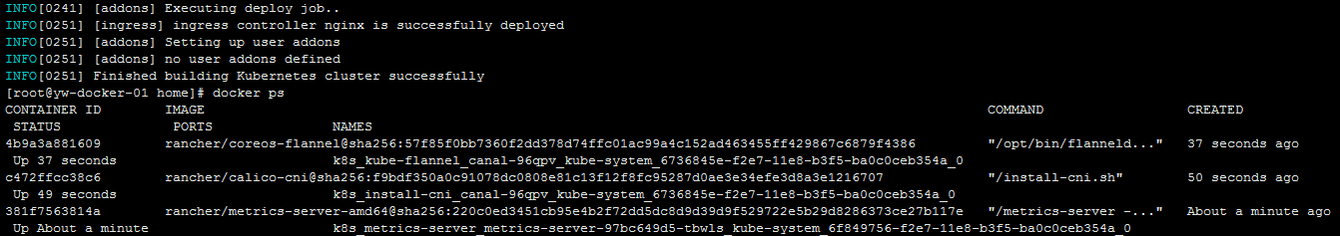

## 安装kubectl

下载地址：https://www.cnrancher.com/docs/rancher/v2.x/cn/installation/download/

|  |
| --- |
| [root@yw-docker-03] mv kubectl_linux-amd64 kubectl  [root@yw-docker-03] cp kubectl /usr/local/bin/kubectl  [root@yw-docker-03] export KUBECONFIG=$(pwd)/kube_config_rancher-cluster.yml  [root@yw-docker-03] kubectl proxy --port=8080 &  [root@yw-docker-03] kubectl -n kube-system create serviceaccount tiller  [root@yw-docker-03]kubectl create clusterrolebinding tiller --clusterrole cluster-admin --serviceaccount=kube-system:tiller  [root@yw-docker-01 home]# kubectl get nodes  NAME STATUS ROLES AGE VERSION  172.16.1.152 Ready controlplane,etcd,worker 1h v1.11.3  172.16.1.153 Ready controlplane,etcd,worker 1h v1.11.3  172.16.1.154 Ready controlplane,etcd,worker 1h v1.11.3 |

## 安装helm

下载地址：https://github.com/helm/helm/releases

|  |
| --- |
| [root@yw-docker-03] tar –zxvf helm-v2.11.0-linux-amd64.tar.gz  [root@yw-docker-03] cp helm/usr/local/bin/helm  [root@yw-docker-03]helm help  [root@yw-docker-03]helm init --service-account tiller --tiller-image registry.cn-hangzhou.aliyuncs.com/google_containers/tiller:v2.11.0 --stable-repo-url https://kubernetes.oss-cn-hangzhou.aliyuncs.com/charts |

## 安装RancherHA

|  |
| --- |
| [root@yw-docker-03] helm repo add rancher-stable https://releases.rancher.com/server-charts/stable  [root@yw-docker-03] helm repo update  [root@yw-docker-03] helm install stable/cert-manager --name cert-manager --namespace kube-system  [root@yw-docker-03] helm install rancher-stable/rancher --name rancher --namespace cattle-system --set hostname=rancher.bsb.com  [root@yw-docker-03] |

## 验证登陆rancher.bsb.com

