一．

上传lepus安装包：

rz Lepus数据库企业监控系统3.8 Beta版本官方下载.zip

然后解压缩unzip，得到Lepus_v3.8_beta

# 一．安装http

## 1 移除系统自带的rpm包的http mysql php

# yum remove httpd mysql mysql-server php php-cli php-common php-devel php-gd -y

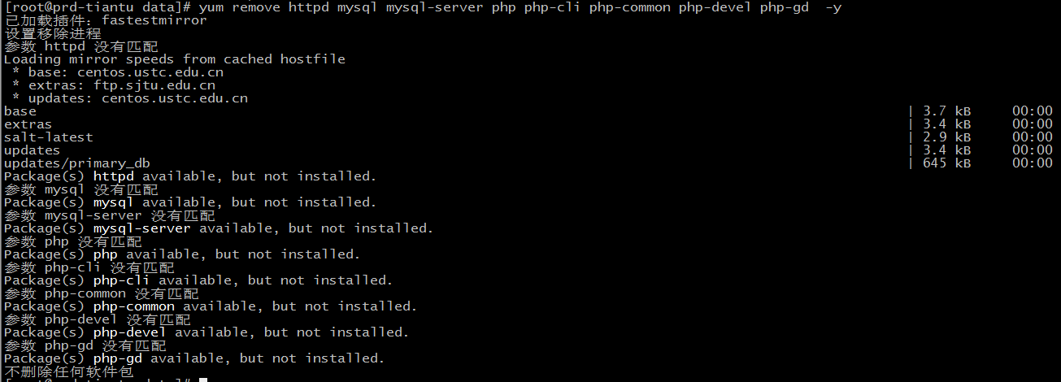

## 2 安装必备的开发包

# yum -y install ntp vim-enhanced gcc gcc-c++ flex bison autoconf automake bzip2-devel \

ncurses-devel zlib-devel libjpeg-devel libpng-devel libtiff-devel freetype-devel libXpm-devel \

gettext-devel pam-devel libtool libtool-ltdl openssl openssl-devel fontconfig-devel \

libxml2-devel curl-devel libicu libicu-devel libmcrypt libmcrypt-devel libmhash libmhash-devel

下面为安装结果：

----------------------------------------------------------------------------------------------------------------------------------------------------------------------

[root@prd-tiantu data]# yum -y install ntp vim-enhanced gcc gcc-c++ flex bison autoconf automake bzip2-devel \

> ncurses-devel zlib-devel libjpeg-devel libpng-devel libtiff-devel freetype-devel libXpm-devel \

> gettext-devel pam-devel libtool libtool-ltdl openssl openssl-devel fontconfig-devel \

> libxml2-devel curl-devel libicu libicu-devel libmcrypt libmcrypt-devel libmhash libmhash-devel

已加载插件：fastestmirror

设置安装进程

Loading mirror speeds from cached hostfile

* base: centos.ustc.edu.cn

* extras: ftp.sjtu.edu.cn

* updates: centos.ustc.edu.cn

包 2:vim-enhanced-7.4.629-5.el6_8.1.x86_64 已安装并且是最新版本

包 gcc-4.4.7-23.el6.x86_64 已安装并且是最新版本

包 zlib-devel-1.2.3-29.el6.x86_64 已安装并且是最新版本

包 pam-devel-1.1.1-24.el6.x86_64 已安装并且是最新版本

包 libtool-ltdl-2.2.6-15.5.el6.x86_64 已安装并且是最新版本

包 openssl-1.0.1e-57.el6.x86_64 已安装并且是最新版本

包 openssl-devel-1.0.1e-57.el6.x86_64 已安装并且是最新版本

No package libmcrypt available.

No package libmcrypt-devel available.

No package libmhash available.

No package libmhash-devel available.

解决依赖关系

--> 执行事务检查

---> Package autoconf.noarch 0:2.63-5.1.el6 will be 安装

---> Package automake.noarch 0:1.11.1-4.el6 will be 安装

---> Package bison.x86_64 0:2.4.1-5.el6 will be 安装

---> Package bzip2-devel.x86_64 0:1.0.5-7.el6_0 will be 安装

---> Package flex.x86_64 0:2.5.35-9.el6 will be 安装

---> Package fontconfig-devel.x86_64 0:2.8.0-5.el6 will be 安装

--> 处理依赖关系 fontconfig = 2.8.0-5.el6，它被软件包 fontconfig-devel-2.8.0-5.el6.x86_64 需要

---> Package freetype-devel.x86_64 0:2.3.11-17.el6 will be 安装

--> 处理依赖关系 freetype = 2.3.11-17.el6，它被软件包 freetype-devel-2.3.11-17.el6.x86_64 需要

---> Package gcc-c++.x86_64 0:4.4.7-23.el6 will be 安装

--> 处理依赖关系 libstdc++-devel = 4.4.7-23.el6，它被软件包 gcc-c++-4.4.7-23.el6.x86_64 需要

--> 处理依赖关系 libstdc++ = 4.4.7-23.el6，它被软件包 gcc-c++-4.4.7-23.el6.x86_64 需要

---> Package gettext-devel.x86_64 0:0.17-18.el6 will be 安装

--> 处理依赖关系 gettext-libs = 0.17-18.el6，它被软件包 gettext-devel-0.17-18.el6.x86_64 需要

--> 处理依赖关系 gettext = 0.17-18.el6，它被软件包 gettext-devel-0.17-18.el6.x86_64 需要

--> 处理依赖关系 libgettextsrc-0.17.so()(64bit)，它被软件包 gettext-devel-0.17-18.el6.x86_64 需要

--> 处理依赖关系 libgettextpo.so.0()(64bit)，它被软件包 gettext-devel-0.17-18.el6.x86_64 需要

--> 处理依赖关系 libgettextlib-0.17.so()(64bit)，它被软件包 gettext-devel-0.17-18.el6.x86_64 需要

--> 处理依赖关系 libgcj_bc.so.1()(64bit)，它被软件包 gettext-devel-0.17-18.el6.x86_64 需要

--> 处理依赖关系 libasprintf.so.0()(64bit)，它被软件包 gettext-devel-0.17-18.el6.x86_64 需要

---> Package libXpm-devel.x86_64 0:3.5.10-2.el6 will be 安装

--> 处理依赖关系 libXpm = 3.5.10-2.el6，它被软件包 libXpm-devel-3.5.10-2.el6.x86_64 需要

--> 处理依赖关系 pkgconfig(x11)，它被软件包 libXpm-devel-3.5.10-2.el6.x86_64 需要

--> 处理依赖关系 libXpm.so.4()(64bit)，它被软件包 libXpm-devel-3.5.10-2.el6.x86_64 需要

---> Package libcurl-devel.x86_64 0:7.19.7-53.el6_9 will be 安装

--> 处理依赖关系 libcurl = 7.19.7-53.el6_9，它被软件包 libcurl-devel-7.19.7-53.el6_9.x86_64 需要

--> 处理依赖关系 libidn-devel，它被软件包 libcurl-devel-7.19.7-53.el6_9.x86_64 需要

---> Package libicu.x86_64 0:4.2.1-14.el6 will be 安装

---> Package libicu-devel.x86_64 0:4.2.1-14.el6 will be 安装

---> Package libjpeg-turbo-devel.x86_64 0:1.2.1-3.el6_5 will be 安装

--> 处理依赖关系 libjpeg-turbo(x86-64) = 1.2.1-3.el6_5，它被软件包 libjpeg-turbo-devel-1.2.1-3.el6_5.x86_64 需要

---> Package libpng-devel.x86_64 2:1.2.49-2.el6_7 will be 安装

--> 处理依赖关系 libpng = 2:1.2.49-2.el6_7，它被软件包 2:libpng-devel-1.2.49-2.el6_7.x86_64 需要

---> Package libtiff-devel.x86_64 0:3.9.4-21.el6_8 will be 安装

--> 处理依赖关系 libtiff = 3.9.4-21.el6_8，它被软件包 libtiff-devel-3.9.4-21.el6_8.x86_64 需要

---> Package libtool.x86_64 0:2.2.6-15.5.el6 will be 安装

---> Package libxml2-devel.x86_64 0:2.7.6-21.el6_8.1 will be 安装

---> Package ncurses-devel.x86_64 0:5.7-4.20090207.el6 will be 安装

--> 处理依赖关系 ncurses-libs = 5.7-4.20090207.el6，它被软件包 ncurses-devel-5.7-4.20090207.el6.x86_64 需要

---> Package ntp.x86_64 0:4.2.6p5-12.el6.centos.2 will be 安装

--> 处理依赖关系 ntpdate = 4.2.6p5-12.el6.centos.2，它被软件包 ntp-4.2.6p5-12.el6.centos.2.x86_64 需要

--> 处理依赖关系 libedit.so.0()(64bit)，它被软件包 ntp-4.2.6p5-12.el6.centos.2.x86_64 需要

--> 执行事务检查

---> Package fontconfig.x86_64 0:2.8.0-3.el6 will be 升级

---> Package fontconfig.x86_64 0:2.8.0-5.el6 will be an update

---> Package freetype.x86_64 0:2.3.11-14.el6_3.1 will be 升级

---> Package freetype.x86_64 0:2.3.11-17.el6 will be an update

---> Package gettext.x86_64 0:0.17-18.el6 will be 安装

--> 处理依赖关系 cvs，它被软件包 gettext-0.17-18.el6.x86_64 需要

---> Package gettext-libs.x86_64 0:0.17-18.el6 will be 安装

---> Package libX11-devel.x86_64 0:1.6.4-3.el6 will be 安装

--> 处理依赖关系 libX11 = 1.6.4-3.el6，它被软件包 libX11-devel-1.6.4-3.el6.x86_64 需要

--> 处理依赖关系 pkgconfig(xcb) >= 1.11.1，它被软件包 libX11-devel-1.6.4-3.el6.x86_64 需要

--> 处理依赖关系 pkgconfig(xproto)，它被软件包 libX11-devel-1.6.4-3.el6.x86_64 需要

--> 处理依赖关系 pkgconfig(xcb)，它被软件包 libX11-devel-1.6.4-3.el6.x86_64 需要

--> 处理依赖关系 pkgconfig(kbproto)，它被软件包 libX11-devel-1.6.4-3.el6.x86_64 需要

---> Package libXpm.x86_64 0:3.5.10-2.el6 will be 安装

---> Package libcurl.x86_64 0:7.19.7-37.el6_4 will be 升级

--> 处理依赖关系 libcurl = 7.19.7-37.el6_4，它被软件包 curl-7.19.7-37.el6_4.x86_64 需要

---> Package libcurl.x86_64 0:7.19.7-53.el6_9 will be an update

---> Package libedit.x86_64 0:2.11-4.20080712cvs.1.el6 will be 安装

---> Package libgcj.x86_64 0:4.4.7-23.el6 will be 安装

--> 处理依赖关系 zip >= 2.1，它被软件包 libgcj-4.4.7-23.el6.x86_64 需要

---> Package libidn-devel.x86_64 0:1.18-2.el6 will be 安装

---> Package libjpeg-turbo.x86_64 0:1.2.1-1.el6 will be 升级

---> Package libjpeg-turbo.x86_64 0:1.2.1-3.el6_5 will be an update

---> Package libpng.x86_64 2:1.2.49-1.el6_2 will be 升级

---> Package libpng.x86_64 2:1.2.49-2.el6_7 will be an update

---> Package libstdc++.x86_64 0:4.4.7-4.el6 will be 升级

---> Package libstdc++.x86_64 0:4.4.7-23.el6 will be an update

---> Package libstdc++-devel.x86_64 0:4.4.7-23.el6 will be 安装

---> Package libtiff.x86_64 0:3.9.4-9.el6_3 will be 升级

---> Package libtiff.x86_64 0:3.9.4-21.el6_8 will be an update

---> Package ncurses-libs.x86_64 0:5.7-3.20090208.el6 will be 升级

---> Package ncurses-libs.x86_64 0:5.7-4.20090207.el6 will be an update

--> 处理依赖关系 ncurses-base = 5.7-4.20090207.el6，它被软件包 ncurses-libs-5.7-4.20090207.el6.x86_64 需要

---> Package ntpdate.x86_64 0:4.2.6p5-12.el6.centos.2 will be 安装

--> 执行事务检查

---> Package curl.x86_64 0:7.19.7-37.el6_4 will be 升级

---> Package curl.x86_64 0:7.19.7-53.el6_9 will be an update

---> Package cvs.x86_64 0:1.11.23-16.el6 will be 安装

---> Package libX11.x86_64 0:1.5.0-4.el6 will be 升级

---> Package libX11.x86_64 0:1.6.4-3.el6 will be an update

--> 处理依赖关系 libX11-common = 1.6.4-3.el6，它被软件包 libX11-1.6.4-3.el6.x86_64 需要

---> Package libxcb-devel.x86_64 0:1.12-4.el6 will be 安装

--> 处理依赖关系 libxcb = 1.12-4.el6，它被软件包 libxcb-devel-1.12-4.el6.x86_64 需要

--> 处理依赖关系 pkgconfig(xau) >= 0.99.2，它被软件包 libxcb-devel-1.12-4.el6.x86_64 需要

--> 处理依赖关系 libxcb-xkb.so.1()(64bit)，它被软件包 libxcb-devel-1.12-4.el6.x86_64 需要

--> 处理依赖关系 libxcb-xinput.so.0()(64bit)，它被软件包 libxcb-devel-1.12-4.el6.x86_64 需要

--> 处理依赖关系 libxcb-sync.so.1()(64bit)，它被软件包 libxcb-devel-1.12-4.el6.x86_64 需要

--> 处理依赖关系 libxcb-present.so.0()(64bit)，它被软件包 libxcb-devel-1.12-4.el6.x86_64 需要

--> 处理依赖关系 libxcb-dri3.so.0()(64bit)，它被软件包 libxcb-devel-1.12-4.el6.x86_64 需要

---> Package ncurses-base.x86_64 0:5.7-3.20090208.el6 will be 升级

---> Package ncurses-base.x86_64 0:5.7-4.20090207.el6 will be an update

---> Package xorg-x11-proto-devel.noarch 0:7.7-14.el6 will be 安装

---> Package zip.x86_64 0:3.0-1.el6_7.1 will be 安装

--> 执行事务检查

---> Package libX11-common.noarch 0:1.5.0-4.el6 will be 升级

---> Package libX11-common.noarch 0:1.6.4-3.el6 will be an update

---> Package libXau-devel.x86_64 0:1.0.6-4.el6 will be 安装

---> Package libxcb.x86_64 0:1.8.1-1.el6 will be 升级

---> Package libxcb.x86_64 0:1.12-4.el6 will be an update

--> 完成依赖关系计算

依赖关系解决

======================================================================================================================================

软件包 架构 版本 仓库 大小

======================================================================================================================================

正在安装:

autoconf noarch 2.63-5.1.el6 base 781 k

automake noarch 1.11.1-4.el6 base 550 k

bison x86_64 2.4.1-5.el6 base 637 k

bzip2-devel x86_64 1.0.5-7.el6_0 base 250 k

flex x86_64 2.5.35-9.el6 base 285 k

fontconfig-devel x86_64 2.8.0-5.el6 base 209 k

freetype-devel x86_64 2.3.11-17.el6 base 365 k

gcc-c++ x86_64 4.4.7-23.el6 base 4.7 M

gettext-devel x86_64 0.17-18.el6 base 155 k

libXpm-devel x86_64 3.5.10-2.el6 base 33 k

libcurl-devel x86_64 7.19.7-53.el6_9 base 247 k

libicu x86_64 4.2.1-14.el6 base 4.9 M

libicu-devel x86_64 4.2.1-14.el6 base 617 k

libjpeg-turbo-devel x86_64 1.2.1-3.el6_5 base 96 k

libpng-devel x86_64 2:1.2.49-2.el6_7 base 112 k

libtiff-devel x86_64 3.9.4-21.el6_8 base 470 k

libtool x86_64 2.2.6-15.5.el6 base 564 k

libxml2-devel x86_64 2.7.6-21.el6_8.1 base 1.1 M

ncurses-devel x86_64 5.7-4.20090207.el6 base 641 k

ntp x86_64 4.2.6p5-12.el6.centos.2 base 600 k

为依赖而安装:

cvs x86_64 1.11.23-16.el6 base 712 k

gettext x86_64 0.17-18.el6 base 1.8 M

gettext-libs x86_64 0.17-18.el6 base 112 k

libX11-devel x86_64 1.6.4-3.el6 base 983 k

libXau-devel x86_64 1.0.6-4.el6 base 14 k

libXpm x86_64 3.5.10-2.el6 base 51 k

libedit x86_64 2.11-4.20080712cvs.1.el6 base 74 k

libgcj x86_64 4.4.7-23.el6 base 19 M

libidn-devel x86_64 1.18-2.el6 base 137 k

libstdc++-devel x86_64 4.4.7-23.el6 base 1.6 M

libxcb-devel x86_64 1.12-4.el6 base 1.1 M

ntpdate x86_64 4.2.6p5-12.el6.centos.2 base 79 k

xorg-x11-proto-devel noarch 7.7-14.el6 base 288 k

zip x86_64 3.0-1.el6_7.1 base 259 k

为依赖而更新:

curl x86_64 7.19.7-53.el6_9 base 197 k

fontconfig x86_64 2.8.0-5.el6 base 186 k

freetype x86_64 2.3.11-17.el6 base 361 k

libX11 x86_64 1.6.4-3.el6 base 587 k

libX11-common noarch 1.6.4-3.el6 base 171 k

libcurl x86_64 7.19.7-53.el6_9 base 169 k

libjpeg-turbo x86_64 1.2.1-3.el6_5 base 174 k

libpng x86_64 2:1.2.49-2.el6_7 base 182 k

libstdc++ x86_64 4.4.7-23.el6 base 296 k

libtiff x86_64 3.9.4-21.el6_8 base 346 k

libxcb x86_64 1.12-4.el6 base 180 k

ncurses-base x86_64 5.7-4.20090207.el6 base 61 k

ncurses-libs x86_64 5.7-4.20090207.el6 base 245 k

事务概要

======================================================================================================================================

Install 34 Package(s)

Upgrade 13 Package(s)

总下载量：46 M

下载软件包：

(1/47): autoconf-2.63-5.1.el6.noarch.rpm | 781 kB 00:00

(2/47): automake-1.11.1-4.el6.noarch.rpm | 550 kB 00:00

(3/47): bison-2.4.1-5.el6.x86_64.rpm | 637 kB 00:00

(4/47): bzip2-devel-1.0.5-7.el6_0.x86_64.rpm | 250 kB 00:00

(5/47): curl-7.19.7-53.el6_9.x86_64.rpm | 197 kB 00:00

(6/47): cvs-1.11.23-16.el6.x86_64.rpm | 712 kB 00:00

(7/47): flex-2.5.35-9.el6.x86_64.rpm | 285 kB 00:00

(8/47): fontconfig-2.8.0-5.el6.x86_64.rpm | 186 kB 00:00

(9/47): fontconfig-devel-2.8.0-5.el6.x86_64.rpm | 209 kB 00:00

(10/47): freetype-2.3.11-17.el6.x86_64.rpm | 361 kB 00:00

(11/47): freetype-devel-2.3.11-17.el6.x86_64.rpm | 365 kB 00:00

(12/47): gcc-c++-4.4.7-23.el6.x86_64.rpm | 4.7 MB 00:00

(13/47): gettext-0.17-18.el6.x86_64.rpm | 1.8 MB 00:00

(14/47): gettext-devel-0.17-18.el6.x86_64.rpm | 155 kB 00:00

(15/47): gettext-libs-0.17-18.el6.x86_64.rpm | 112 kB 00:00

(16/47): libX11-1.6.4-3.el6.x86_64.rpm | 587 kB 00:00

(17/47): libX11-common-1.6.4-3.el6.noarch.rpm | 171 kB 00:00

(18/47): libX11-devel-1.6.4-3.el6.x86_64.rpm | 983 kB 00:00

(19/47): libXau-devel-1.0.6-4.el6.x86_64.rpm | 14 kB 00:00

(20/47): libXpm-3.5.10-2.el6.x86_64.rpm | 51 kB 00:00

(21/47): libXpm-devel-3.5.10-2.el6.x86_64.rpm | 33 kB 00:00

(22/47): libcurl-7.19.7-53.el6_9.x86_64.rpm | 169 kB 00:00

(23/47): libcurl-devel-7.19.7-53.el6_9.x86_64.rpm | 247 kB 00:00

(24/47): libedit-2.11-4.20080712cvs.1.el6.x86_64.rpm | 74 kB 00:00

(25/47): libgcj-4.4.7-23.el6.x86_64.rpm | 19 MB 00:02

(26/47): libicu-4.2.1-14.el6.x86_64.rpm | 4.9 MB 00:00

(27/47): libicu-devel-4.2.1-14.el6.x86_64.rpm | 617 kB 00:00

(28/47): libidn-devel-1.18-2.el6.x86_64.rpm | 137 kB 00:00

(29/47): libjpeg-turbo-1.2.1-3.el6_5.x86_64.rpm | 174 kB 00:00

(30/47): libjpeg-turbo-devel-1.2.1-3.el6_5.x86_64.rpm | 96 kB 00:00

(31/47): libpng-1.2.49-2.el6_7.x86_64.rpm | 182 kB 00:00

(32/47): libpng-devel-1.2.49-2.el6_7.x86_64.rpm | 112 kB 00:00

(33/47): libstdc++-4.4.7-23.el6.x86_64.rpm | 296 kB 00:00

(34/47): libstdc++-devel-4.4.7-23.el6.x86_64.rpm | 1.6 MB 00:00

(35/47): libtiff-3.9.4-21.el6_8.x86_64.rpm | 346 kB 00:00

(36/47): libtiff-devel-3.9.4-21.el6_8.x86_64.rpm | 470 kB 00:00

(37/47): libtool-2.2.6-15.5.el6.x86_64.rpm | 564 kB 00:00

(38/47): libxcb-1.12-4.el6.x86_64.rpm | 180 kB 00:00

(39/47): libxcb-devel-1.12-4.el6.x86_64.rpm | 1.1 MB 00:00

(40/47): libxml2-devel-2.7.6-21.el6_8.1.x86_64.rpm | 1.1 MB 00:00

(41/47): ncurses-base-5.7-4.20090207.el6.x86_64.rpm | 61 kB 00:00

(42/47): ncurses-devel-5.7-4.20090207.el6.x86_64.rpm | 641 kB 00:00

(43/47): ncurses-libs-5.7-4.20090207.el6.x86_64.rpm | 245 kB 00:00

(44/47): ntp-4.2.6p5-12.el6.centos.2.x86_64.rpm | 600 kB 00:00

(45/47): ntpdate-4.2.6p5-12.el6.centos.2.x86_64.rpm | 79 kB 00:00

(46/47): xorg-x11-proto-devel-7.7-14.el6.noarch.rpm | 288 kB 00:00

(47/47): zip-3.0-1.el6_7.1.x86_64.rpm | 259 kB 00:00

--------------------------------------------------------------------------------------------------------------------------------------

总计 5.3 MB/s | 46 MB 00:08

运行 rpm_check_debug

执行事务测试

事务测试成功

执行事务

正在升级 : libstdc++-4.4.7-23.el6.x86_64 1/60

正在升级 : freetype-2.3.11-17.el6.x86_64 2/60

正在升级 : fontconfig-2.8.0-5.el6.x86_64 3/60

正在升级 : libcurl-7.19.7-53.el6_9.x86_64 4/60

正在安装 : autoconf-2.63-5.1.el6.noarch 5/60

正在安装 : automake-1.11.1-4.el6.noarch 6/60

正在升级 : libjpeg-turbo-1.2.1-3.el6_5.x86_64 7/60

正在安装 : xorg-x11-proto-devel-7.7-14.el6.noarch 8/60

正在升级 : libxcb-1.12-4.el6.x86_64 9/60

正在安装 : libXau-devel-1.0.6-4.el6.x86_64 10/60

正在安装 : libxcb-devel-1.12-4.el6.x86_64 11/60

正在升级 : libtiff-3.9.4-21.el6_8.x86_64 12/60

正在安装 : freetype-devel-2.3.11-17.el6.x86_64 13/60

正在安装 : gettext-libs-0.17-18.el6.x86_64 14/60

正在安装 : libstdc++-devel-4.4.7-23.el6.x86_64 15/60

正在安装 : libicu-4.2.1-14.el6.x86_64 16/60

正在安装 : cvs-1.11.23-16.el6.x86_64 17/60

正在安装 : gettext-0.17-18.el6.x86_64 18/60

正在安装 : ntpdate-4.2.6p5-12.el6.centos.2.x86_64 19/60

正在安装 : libidn-devel-1.18-2.el6.x86_64 20/60

正在升级 : libX11-common-1.6.4-3.el6.noarch 21/60

正在升级 : libX11-1.6.4-3.el6.x86_64 22/60

正在安装 : libX11-devel-1.6.4-3.el6.x86_64 23/60

正在安装 : libXpm-3.5.10-2.el6.x86_64 24/60

正在安装 : zip-3.0-1.el6_7.1.x86_64 25/60

正在安装 : libgcj-4.4.7-23.el6.x86_64 26/60

正在升级 : 2:libpng-1.2.49-2.el6_7.x86_64 27/60

正在升级 : ncurses-base-5.7-4.20090207.el6.x86_64 28/60

正在升级 : ncurses-libs-5.7-4.20090207.el6.x86_64 29/60

正在安装 : libedit-2.11-4.20080712cvs.1.el6.x86_64 30/60

正在安装 : ntp-4.2.6p5-12.el6.centos.2.x86_64 31/60

正在安装 : ncurses-devel-5.7-4.20090207.el6.x86_64 32/60

正在安装 : 2:libpng-devel-1.2.49-2.el6_7.x86_64 33/60

正在安装 : gettext-devel-0.17-18.el6.x86_64 34/60

正在安装 : libXpm-devel-3.5.10-2.el6.x86_64 35/60

正在安装 : libcurl-devel-7.19.7-53.el6_9.x86_64 36/60

正在安装 : libicu-devel-4.2.1-14.el6.x86_64 37/60

正在安装 : gcc-c++-4.4.7-23.el6.x86_64 38/60

正在安装 : fontconfig-devel-2.8.0-5.el6.x86_64 39/60

正在安装 : libtiff-devel-3.9.4-21.el6_8.x86_64 40/60

正在安装 : libjpeg-turbo-devel-1.2.1-3.el6_5.x86_64 41/60

正在安装 : libtool-2.2.6-15.5.el6.x86_64 42/60

正在升级 : curl-7.19.7-53.el6_9.x86_64 43/60

正在安装 : libxml2-devel-2.7.6-21.el6_8.1.x86_64 44/60

正在安装 : flex-2.5.35-9.el6.x86_64 45/60

正在安装 : bzip2-devel-1.0.5-7.el6_0.x86_64 46/60

正在安装 : bison-2.4.1-5.el6.x86_64 47/60

清理 : libX11-1.5.0-4.el6.x86_64 48/60

清理 : libtiff-3.9.4-9.el6_3.x86_64 49/60

清理 : curl-7.19.7-37.el6_4.x86_64 50/60

清理 : fontconfig-2.8.0-3.el6.x86_64 51/60

清理 : ncurses-libs-5.7-3.20090208.el6.x86_64 52/60

清理 : ncurses-base-5.7-3.20090208.el6.x86_64 53/60

清理 : libX11-common-1.5.0-4.el6.noarch 54/60

清理 : freetype-2.3.11-14.el6_3.1.x86_64 55/60

清理 : libcurl-7.19.7-37.el6_4.x86_64 56/60

清理 : libjpeg-turbo-1.2.1-1.el6.x86_64 57/60

清理 : libstdc++-4.4.7-4.el6.x86_64 58/60

清理 : libxcb-1.8.1-1.el6.x86_64 59/60

清理 : 2:libpng-1.2.49-1.el6_2.x86_64 60/60

Verifying : bison-2.4.1-5.el6.x86_64 1/60

Verifying : libX11-devel-1.6.4-3.el6.x86_64 2/60

Verifying : ncurses-libs-5.7-4.20090207.el6.x86_64 3/60

Verifying : libXpm-3.5.10-2.el6.x86_64 4/60

Verifying : gettext-libs-0.17-18.el6.x86_64 5/60

Verifying : freetype-2.3.11-17.el6.x86_64 6/60

Verifying : fontconfig-2.8.0-5.el6.x86_64 7/60

Verifying : libxcb-1.12-4.el6.x86_64 8/60

Verifying : xorg-x11-proto-devel-7.7-14.el6.noarch 9/60

Verifying : libtiff-devel-3.9.4-21.el6_8.x86_64 10/60

Verifying : libstdc++-devel-4.4.7-23.el6.x86_64 11/60

Verifying : freetype-devel-2.3.11-17.el6.x86_64 12/60

Verifying : libjpeg-turbo-devel-1.2.1-3.el6_5.x86_64 13/60

Verifying : automake-1.11.1-4.el6.noarch 14/60

Verifying : libXau-devel-1.0.6-4.el6.x86_64 15/60

Verifying : libjpeg-turbo-1.2.1-3.el6_5.x86_64 16/60

Verifying : bzip2-devel-1.0.5-7.el6_0.x86_64 17/60

Verifying : libxcb-devel-1.12-4.el6.x86_64 18/60

Verifying : autoconf-2.63-5.1.el6.noarch 19/60

Verifying : ncurses-base-5.7-4.20090207.el6.x86_64 20/60

Verifying : libtiff-3.9.4-21.el6_8.x86_64 21/60

Verifying : 2:libpng-1.2.49-2.el6_7.x86_64 22/60

Verifying : curl-7.19.7-53.el6_9.x86_64 23/60

Verifying : zip-3.0-1.el6_7.1.x86_64 24/60

Verifying : libX11-common-1.6.4-3.el6.noarch 25/60

Verifying : ncurses-devel-5.7-4.20090207.el6.x86_64 26/60

Verifying : libicu-4.2.1-14.el6.x86_64 27/60

Verifying : gcc-c++-4.4.7-23.el6.x86_64 28/60

Verifying : libidn-devel-1.18-2.el6.x86_64 29/60

Verifying : libcurl-devel-7.19.7-53.el6_9.x86_64 30/60

Verifying : flex-2.5.35-9.el6.x86_64 31/60

Verifying : libX11-1.6.4-3.el6.x86_64 32/60

Verifying : libcurl-7.19.7-53.el6_9.x86_64 33/60

Verifying : ntpdate-4.2.6p5-12.el6.centos.2.x86_64 34/60

Verifying : gettext-0.17-18.el6.x86_64 35/60

Verifying : 2:libpng-devel-1.2.49-2.el6_7.x86_64 36/60

Verifying : libXpm-devel-3.5.10-2.el6.x86_64 37/60

Verifying : libedit-2.11-4.20080712cvs.1.el6.x86_64 38/60

Verifying : fontconfig-devel-2.8.0-5.el6.x86_64 39/60

Verifying : libicu-devel-4.2.1-14.el6.x86_64 40/60

Verifying : libstdc++-4.4.7-23.el6.x86_64 41/60

Verifying : gettext-devel-0.17-18.el6.x86_64 42/60

Verifying : cvs-1.11.23-16.el6.x86_64 43/60

Verifying : libxml2-devel-2.7.6-21.el6_8.1.x86_64 44/60

Verifying : libtool-2.2.6-15.5.el6.x86_64 45/60

Verifying : ntp-4.2.6p5-12.el6.centos.2.x86_64 46/60

Verifying : libgcj-4.4.7-23.el6.x86_64 47/60

Verifying : libxcb-1.8.1-1.el6.x86_64 48/60

Verifying : fontconfig-2.8.0-3.el6.x86_64 49/60

Verifying : ncurses-base-5.7-3.20090208.el6.x86_64 50/60

Verifying : libstdc++-4.4.7-4.el6.x86_64 51/60

Verifying : libjpeg-turbo-1.2.1-1.el6.x86_64 52/60

Verifying : ncurses-libs-5.7-3.20090208.el6.x86_64 53/60

Verifying : libtiff-3.9.4-9.el6_3.x86_64 54/60

Verifying : freetype-2.3.11-14.el6_3.1.x86_64 55/60

Verifying : libX11-1.5.0-4.el6.x86_64 56/60

Verifying : 2:libpng-1.2.49-1.el6_2.x86_64 57/60

Verifying : libX11-common-1.5.0-4.el6.noarch 58/60

Verifying : curl-7.19.7-37.el6_4.x86_64 59/60

Verifying : libcurl-7.19.7-37.el6_4.x86_64 60/60

已安装:

autoconf.noarch 0:2.63-5.1.el6 automake.noarch 0:1.11.1-4.el6 bison.x86_64 0:2.4.1-5.el6

bzip2-devel.x86_64 0:1.0.5-7.el6_0 flex.x86_64 0:2.5.35-9.el6 fontconfig-devel.x86_64 0:2.8.0-5.el6

freetype-devel.x86_64 0:2.3.11-17.el6 gcc-c++.x86_64 0:4.4.7-23.el6 gettext-devel.x86_64 0:0.17-18.el6

libXpm-devel.x86_64 0:3.5.10-2.el6 libcurl-devel.x86_64 0:7.19.7-53.el6_9 libicu.x86_64 0:4.2.1-14.el6

libicu-devel.x86_64 0:4.2.1-14.el6 libjpeg-turbo-devel.x86_64 0:1.2.1-3.el6_5 libpng-devel.x86_64 2:1.2.49-2.el6_7

libtiff-devel.x86_64 0:3.9.4-21.el6_8 libtool.x86_64 0:2.2.6-15.5.el6 libxml2-devel.x86_64 0:2.7.6-21.el6_8.1

ncurses-devel.x86_64 0:5.7-4.20090207.el6 ntp.x86_64 0:4.2.6p5-12.el6.centos.2

作为依赖被安装:

cvs.x86_64 0:1.11.23-16.el6 gettext.x86_64 0:0.17-18.el6 gettext-libs.x86_64 0:0.17-18.el6

libX11-devel.x86_64 0:1.6.4-3.el6 libXau-devel.x86_64 0:1.0.6-4.el6 libXpm.x86_64 0:3.5.10-2.el6

libedit.x86_64 0:2.11-4.20080712cvs.1.el6 libgcj.x86_64 0:4.4.7-23.el6 libidn-devel.x86_64 0:1.18-2.el6

libstdc++-devel.x86_64 0:4.4.7-23.el6 libxcb-devel.x86_64 0:1.12-4.el6 ntpdate.x86_64 0:4.2.6p5-12.el6.centos.2

xorg-x11-proto-devel.noarch 0:7.7-14.el6 zip.x86_64 0:3.0-1.el6_7.1

作为依赖被升级:

curl.x86_64 0:7.19.7-53.el6_9 fontconfig.x86_64 0:2.8.0-5.el6 freetype.x86_64 0:2.3.11-17.el6

libX11.x86_64 0:1.6.4-3.el6 libX11-common.noarch 0:1.6.4-3.el6 libcurl.x86_64 0:7.19.7-53.el6_9

libjpeg-turbo.x86_64 0:1.2.1-3.el6_5 libpng.x86_64 2:1.2.49-2.el6_7 libstdc++.x86_64 0:4.4.7-23.el6

libtiff.x86_64 0:3.9.4-21.el6_8 libxcb.x86_64 0:1.12-4.el6 ncurses-base.x86_64 0:5.7-4.20090207.el6

ncurses-libs.x86_64 0:5.7-4.20090207.el6

完毕！

## 3.安装apache（httpd2.4.29）

tar -xvf httpd-2.4.29.tar.gz

./configure --prefix=/data/apache \

--enable-so \

--enable-rewrite \

--enable-mods-shared=most \

--sysconfdir=/data/httpd \

--with-apr=/data/apr \

--with-apr-util=/data/apr-util \

--with-pcre=/data/pcre

Make

Make install



cp /data/apache/bin/apachectl /etc/init.d/httpd

service httpd stop

service httpd start

# 二．安装mysql

tar -xvf Percona-Server-5.6.30-rel76.3-Linux.x86_64.ssl101.tar.gz

mv Percona-Server-5.6.30-rel76.3-Linux.x86_64.ssl101 percona

mkdir -p /data/database/percona_database/{data,logs,tmp,etc}/

vi /data/database/percona_database/etc/my.cnf

----------------------------------------------------------------------------------------------------------------

[client]

port = 3306

socket = /data/database/percona_database/tmp/mysql.sock

[mysqld]

port = 3306

socket = /data/database/percona_database/tmp/mysql.sock

datadir = /data/database/percona_database/data

basedir = /data/percona

slave_load_tmpdir = /data/database/percona_database/tmp

tmpdir = /data/database/percona_database/tmp

default-storage-engine=InnoDB

expire-logs-days = 7

lower_case_table_names = 1

#skip-slave-start

skip-name-resolve

skip-external-locking

key_buffer_size = 128M

max_allowed_packet = 128M

table_open_cache = 1024

sort_buffer_size = 32M

read_buffer_size = 32M

read_rnd_buffer_size = 32M

myisam_sort_buffer_size = 32M

thread_concurrency = 8

query_cache_type = 0

thread_cache_size = 128

max_binlog_size = 512M

max_connections = 2000

max_user_connections = 1600

max_connect_errors = 99999999

connect_timeout = 90

tmp_table_size = 28M

max_heap_table_size = 28M

log-bin = lepus-bin

binlog_cache_size = 32M

slow_query_log = 1

slow-query-log-file = /data/database/percona_database/logs/gw.slow

pid_file = /data/database/percona_database/tmp/gw.pid

log_error = /data/database/percona_database/logs/gw.err

general_log_file = /data/database/percona_database/logs/gw.log

#log-queries-not-using-indexes = true

long_query_time = 1

log-slave-updates

binlog_format = ROW

server-id = 71113306

innodb_file_per_table = 1

innodb_data_home_dir = /data/database/percona_database/data

innodb_log_group_home_dir = /data/database/percona_database/data

innodb_buffer_pool_size = 2048M

innodb_additional_mem_pool_size = 512M

#innodb_log_file_size = 512M

innodb_log_buffer_size = 32M

innodb_flush_log_at_trx_commit = 0

#innodb_io_capacity = 500

#innodb_support_xa = false

innodb_lock_wait_timeout = 30

init-connect = 'set names utf8'

#init-connect = 'insert into log.user_log (cur_user,n_user) values (current_user(),user())'

character_set_server = utf8

#pool

thread_handling=pool-of-threads

show-slave-auth-info

#init-file=/home/mariadb/init_mysql.txt

[mysqldump]

quick

max_allowed_packet = 64M

[mysql]

no-auto-rehash

[myisamchk]

key_buffer_size = 32M

sort_buffer_size = 32M

read_buffer = 2M

write_buffer = 2M

[mysqlhotcopy]

interactive-timeout

--------------------------------------------------------------------

cd /data/percona/

./scripts/mysql_install_db --defaults-file=/data/database/percona_database/etc/my.cnf --basedir=/data/percona/

chown -R mysql:mysql /data/database/

cp /data/percona/bin/mysqld_safe /data/percona/bin/mysqld_safe.bak

vi /data/percona/bin/mysqld_safe

将/usr/local/Percona-Server-5.6.30-rel76.3-Linux.x86_64.ssl101修改为/data/percona

Su – mysql

/data/percona/bin/mysqld_safe --defaults-file=/data/database/percona_database/etc/my.cnf &

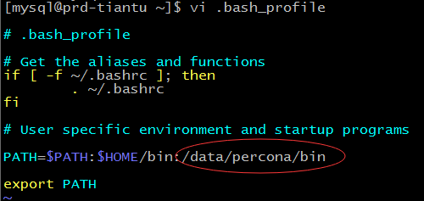

mysql -uroot -p --socket=/data/database/percona_database/tmp/mysql.sock

delete from mysql.user where user='' or host<>'localhost';

set password for root@'localhost'=password('Lepusadmin');

flush privileges;

# 三．安装php

Yum install -y perl*

yum install -y epel-release

epel安装成功后再安装下面的：

yum install -y libmcrypt-devel

2.

tar -xvf php-5.6.36.tar.gz

cd php-5.6.36

./configure --prefix=/data/php \

--mandir=/usr/local/share/man \

--infodir=/usr/local/share/info \

--with-apxs2=/data/apache/bin/apxs \

--enable-cgi --with-mysql=/data/percona/ \

--with-config-file-path=/data/php/etc \

--with-pdo-mysql=/data/percona/bin/mysql \

--with-mysqli=/data/percona/bin/mysql_config \

--enable-zip --enable-sqlite-utf8 -enable-sockets \

--enable-soap --enable-pcntl --enable-mbstring \

--enable-intl --enable-calendar --enable-bcmath \

--enable-exif --with-mcrypt --with-mhash --with-gd \

--with-png-dir --with-jpeg-dir --with-freetype-dir \

--with-libxml-dir --with-curl --with-curlwrappers \

--with-zlib --with-openssl --with-kerberos=shared \

--with-gettext=shared --with-xmlrpc=shared

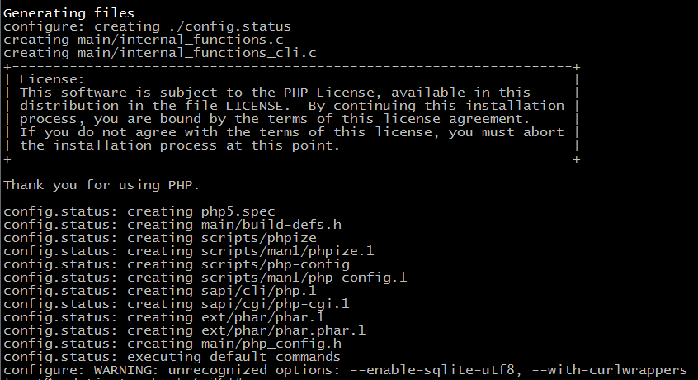

Make

Make test

Make install

## 整合apache和php

# vi /data/httpd/httpd.conf

查找AddType application/x-gzip .gz .tgz,在该行下面添加

AddType application/x-httpd-php .php

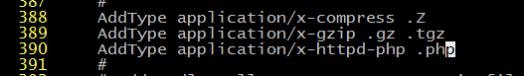

查找DirectoryIndex index.html 把该行修改成

DirectoryIndex index.html index.htm index.php

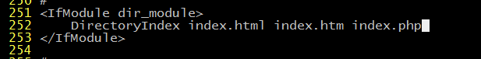

:wq 保存退出

测试apache和php是否整合成功,下面我们测试apache和php是否整合成功，在apache文档跟目录下新建一个小小的php程序

# cd /data/apache/htdocs

# sudo vi index.php //在index.php文件中写入下面三行

<?php

phpinfo();

?>

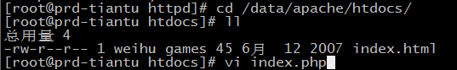

重启apache服务

# service httpd restart

访问，在浏览器中输入http://localhost/index.php 出现php信息界面则说明整合成功。

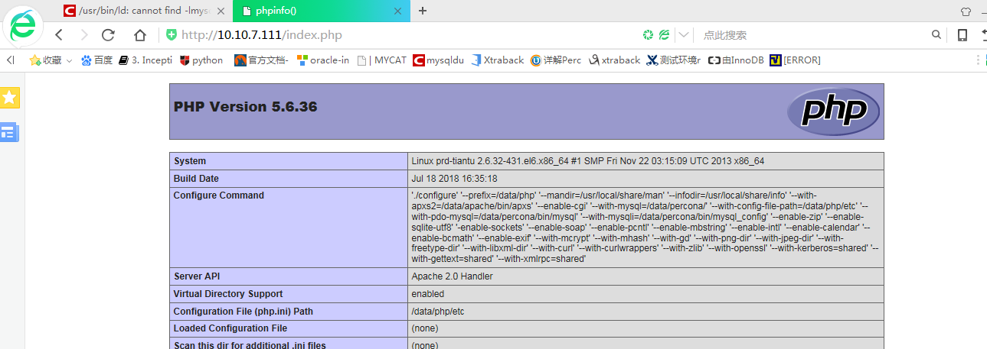

# 四．安装python

## 1.安装python环境

Python版本要求为Python2.6以上,不支持Python3

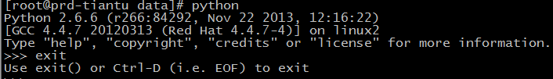

已经有了

## 2.安装 MySQLdb for python （必须安装）

tar -xvf MySQL-python-1.2.3.tar.gz

cd MySQL-python-1.2.3

# which mysql_config

/data/percona/bin/mysql_config

vi site.cfg

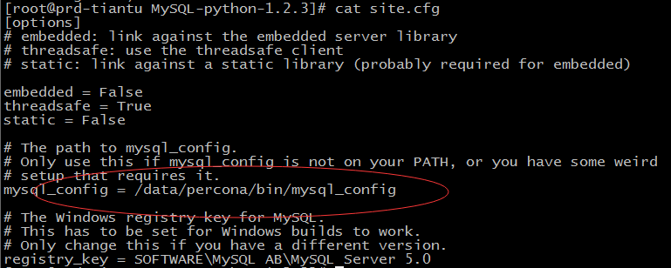

python setup.py build

python setup.py install

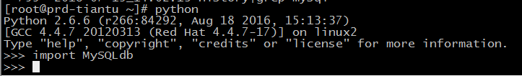

## 3.安装cx_oracle for python （如果需要监控Oracle则必须安装）

rpm -ivh oracle-instantclient11.2-basic-11.2.0.4.0-1.x86_64.rpm

rpm -ivh oracle-instantclient11.2-devel-11.2.0.4.0-1.x86_64.rpm

rpm -ivh oracle-instantclient11.2-sqlplus-11.2.0.4.0-1.x86_64.rpm

vi /root/.bash_profile

加入：

ORACLE_HOME="/usr/lib/oracle/11.2/client64"

PATH=$PATH:$ORACLE_HOME/bin

export PATH

LD_LIBRARY_PATH=$ORACLE_HOME/lib:/usr/lib:/usr/local/lib

export LD_LIBRARY_PATH

source ~/.bash_profile

vim /etc/ld.so.conf

加入：

/usr/lib/oracle/11.2/client64/lib

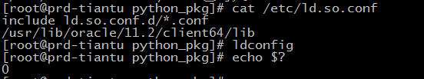

tar -xvf cx_Oracle-5.1.2.tar.gz

cd cx_Oracle-5.1.2

python setup.py build

python setup.py install

## 测试安装是否正常

[root@prd-tiantu python]# pwd

/data/Lepus_v3.8_beta/python

[root@prd-tiantu python]# python test_driver_mysql.py

MySQL python drivier is ok!

[root@prd-tiantu python]# python test_driver_oracle.py

Oracle python drivier is ok!

[root@prd-tiantu python]# python test_driver_redis.py

No module named redis

[root@prd-tiantu python]# python test_driver_mongodb.py

No module named pymongo

## 4.安装python mongodb

tar -xvf pymongo-2.8.1.tar.gz

cd pymongo-2.8.1

python setup.py install

[root@prd-tiantu lepus]# python test_driver_mongodb.py

MongoDB python drivier is ok!

## 5.安装python redis

tar -xvf redis-2.10.3.tar.gz

cd redis-2.10.3

python setup.py install

[root@prd-tiantu lepus]# python test_driver_redis.py

Redis python drivier is ok!

# 五．安装lepus

## Mysql中执行

create database lepus default character set utf8;

grant select,insert,update,delete,create on lepus.* to 'lepus_user'@'localhost' identified by 'lepus_user';

导入SQL文件夹里的SQL文件(表结构和数据文件)

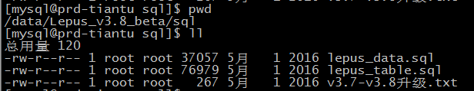





## 安装lepus程序

进入到软件包的python文件夹

# cd python/

授予install.sh可执行权限

# chmod +x install.sh

执行安装

# ./install.sh

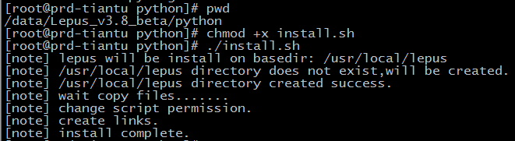

## 修改配置文件

进入到安装目录，默认为/usr/local/lepus

# cd /usr/local/lepus/

# vim etc/config.ini

###监控机MySQL数据库连接地址###

[monitor_server]

host="127.0.0.1"

port=3306

user=" lepus_user "

passwd="xxxxxx"

dbname="lepus"

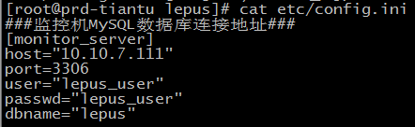

## 启动Lepus （可选）

此时，你可以执行启动命令启动lepus采集进程

[root@ebs-cloud lepus]# lepus start

nohup: 把输出追加到"nohup.out"

lepus server start success!

但是因为没有添加主机，所以查看日志会看到如下提示，属于正常提示。您也可以在部署完Lepus WEB控制台后再进行启动。

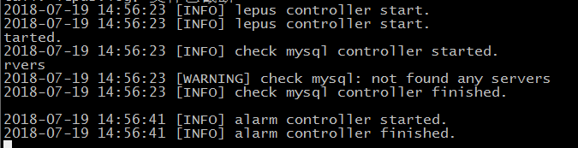

## Lepus采集程序安装完毕!

复制PHP文件夹里的文件到Apache对应的网站虚拟目录（备注：根本不同的安装方式，这个目录是不一样的，如果采用xampp安装的Apache环境，则默认程序目录为/opt/lampp/htdocs/），例如

# cp -rf php/* /data/apache/htdocs/

打开application\config\database.php文件，修改PHP连接监控服务器的数据库信息

$db['default']['hostname'] = 'localhost';

$db['default']['username'] = 'lepus_user';

$db['default']['password'] = 'xxxxxx';

$db['default']['database'] = lepus;

$db['default']['dbdriver'] = 'mysql';

9)登录进行添加主机和监控

通过浏览器输入IP地址或域名打开监控界面，即可登录系统。.默认管理员账号密码admin/Lepusadmin登录后请修改管理员密码，增加普通账号。

