监控和被监控端都要安装和配置snmp：

[root@HE1bin]# yum install net-snmp*

[root@HE1bin]# vi /etc/snmp/snmpd.conf

41行将default均改为监控服务器ip;团体名被监控机和监控机一致，示例如下：

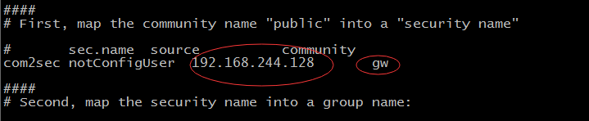

62行将systemview改为all,供所有snmp访问权限

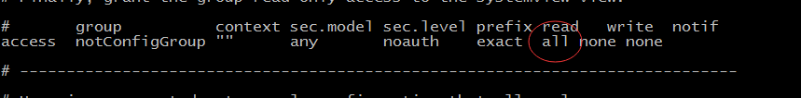

85行将#注释符号去掉

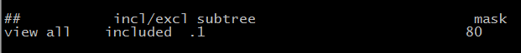

修改snmp级别以减少日志输出

[root@HE1 home]# vi /etc/init.d/snmpd

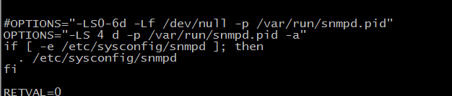

OPTIONS="-LS 4 d -p /var/run/snmpd.pid -a"

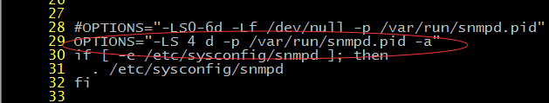

[root@HE1bin]# /etc/init.d/snmpd restart

Stoppingsnmpd: [ OK ]

Startingsnmpd: [ OK ]

验证snmp服务

[root@HE1 bin]# ps-ef | grep 'snmpd'



监控机修改lepus配置文件添加44,45,46行内容

[root@HE3lepus]# vi /usr/local/lepus/check_os.sh

在43行后添加44,45,46行内容

if [ -z $mem_shared ]; then

mem_shared=0

fi

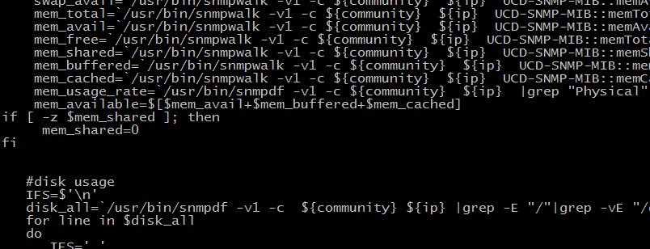

[root@HE3 lepus]#python check_os.py

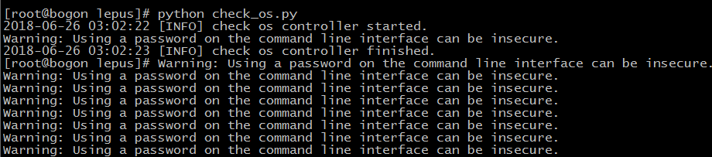

# 客户端的操作

yum install net-snmp*

vi /etc/snmp/snmpd.conf

修改行：

41 com2sec notConfigUser 10.10.7.111 lepussnmp

62 access notConfigGroup "" any noauth exact all none none

85 view all included .1 80

vi /etc/init.d/snmpd

28行替换：

OPTIONS="-LS 4 d -p /var/run/snmpd.pid -a"

/etc/init.d/snmpd start

ps -ef | grep 'snmpd'

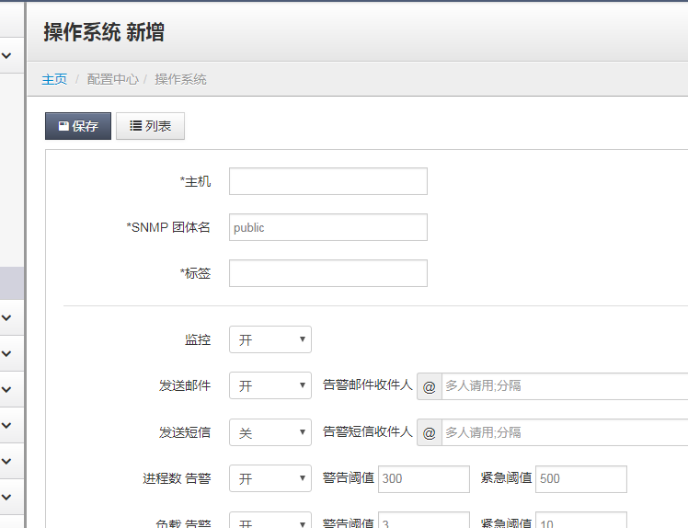

snmpwalk -v 2c -c lepussnmp 10.10.7.141

rpm -ivh lm_sensors-libs-3.1.1-17.el6.x86_64.rpm

rpm -ivh lm_sensors-devel-3.1.1-17.el6.x86_64.rpm

rpm -ivh popt-devel-1.13-7.el6.x86_64.rpm

rpm -ivh net-snmp-libs-5.5-60.el6.x86_64.rpm

rpm -ivh net-snmp-perl-5.5-60.el6.x86_64.rpm

rpm -ivh net-snmp-python-5.5-60.el6.x86_64.rpm

rpm -ivh net-snmp-utils-5.5-60.el6.x86_64.rpm

rpm -ivh net-snmp-5.5-60.el6.x86_64.rpm

rpm -ivh elfutils-libelf-0.164-2.el6.x86_64.rpm --replacefiles

rpm -ivh elfutils-libelf-devel-0.164-2.el6.x86_64.rpm --replacefiles

rpm -ivh elfutils-libs-0.164-2.el6.x86_64.rpm --replacefiles

rpm -ivh elfutils-devel-0.164-2.el6.x86_64.rpm --replacefiles

rpm -ivh file-libs-5.04-30.el6.x86_64.rpm --replacefiles

rpm -ivh file-5.04-30.el6.x86_64.rpm --replacefiles

rpm -ivh file-devel-5.04-30.el6.x86_64.rpm --replacefiles

rpm -ivh tcp_wrappers-libs-7.6-58.el6.x86_64.rpm --replacefiles

rpm -ivh tcp_wrappers-devel-7.6-58.el6.x86_64.rpm --replacefiles

rpm -ivh rpm-4.8.0-59.el6.x86_64.rpm --replacefiles

rpm -ivh rpm-devel-4.8.0-59.el6.x86_64.rpm --replacefiles

rpm -ivh rpm-libs-4.8.0-59.el6.x86_64.rpm --replacefiles

rpm -ivh rpm-python-4.8.0-59.el6.x86_64.rpm --replacefiles

rpm -ivh net-snmp-devel-5.5-60.el6.x86_64.rpm

# cat update_file.sh

#!/bin/bash

FILE1=/etc/snmp/snmpd.conf

FILE2=/etc/init.d/snmpd

CON1='com2sec notConfigUser 10.10.7.111 lepussnmp'

CON2='access notConfigGroup "" any noauth exact all none none'

CON3='view all included .1 80'

CON4='OPTIONS="-LS 4 d -p /var/run/snmpd.pid -a"'

sed -n -e "41p" $FILE1

sed -n -e "62p" $FILE1

sed -n -e "85p" $FILE1

sed -n -e "28p" $FILE2

sed -i "41c${CON1}" $FILE1

sed -i "62c${CON2}" $FILE1

sed -i "85c${CON3}" $FILE1

sed -i "28c${CON4}" $FILE2

echo '###########################################update end############################'

sed -n -e "41p" $FILE1

sed -n -e "62p" $FILE1

sed -n -e "85p" $FILE1

sed -n -e "28p" $FILE2

echo '#################################################################################'

/etc/init.d/snmpd start

ps -ef | grep 'snmpd'

echo '/etc/init.d/snmpd start' >> /etc/rc.local

cat /etc/rc.local

scp 10.10.4.49:/home/software/snmp.tar.gz ./