环境介绍
系统 | 服务 | IP
Centos6.5 | byxf-jira-02 | 172.16.1.93

环境准备
[root@byxf-jira-02 ~]# chkconfig --level 2345 iptables off
[root@byxf-jira-02 ~]# service iptables stop
[root@byxf-jira-02 ~]# vi /etc/selinux/config #关闭selinux
#SELINUX=enforcing
SELINUX=disabled
[root@byxf-jira-02 ~]# setenforce 0
[root@byxf-jira-02 ~]# cd /usr/local/
[root@byxf-jira-02 ~]# tar -xvf jdk1.7.0_45.tar
[root@byxf-jira-02 ~]# ln -s jdk1.7.0_45 java
[root@byxf-jira-02 ~]# vi /etc/profile #添加java环境变量
export JAVA_HOME=/usr/local/java
export CLASS_PATH=$JAVA_HOME/lib/dt.jar:$JAVA_HOME/lib/tools.jar
export PATH=$JAVA_HOME/bin:$PATH
[root@byxf-jira-02 ~]# source /etc/profile
[root@byxf-jira-02 software]# yum install gcc gcc-c++ cmake bison ncurses ncurses-devel -y

安装Mysql
[root@byxf-jira-02 ~]# cd /home/software/
[root@byxf-jira-02 software]# tar -zxvf cmake-2.8.8.tar.gz
[root@byxf-jira-02 software]# ./configure
[root@byxf-jira-02 software]# make
[root@byxf-jira-02 software]# make install
[root@byxf-jira-02 software]# mkdir -p /usr/local/mysql
[root@byxf-jira-02 software]# cd /
[root@byxf-jira-02 software]# mkdir mysql-data
[root@byxf-jira-02 ~]# cd /home/software/
[root@byxf-jira-02 software]# tar -zxvf mysql-5.6.25.tar.gz
[root@byxf-jira-02 software]# cmake . -DCMAKE_INSTALL_PREFIX=/usr/local/mysql -DMYSQL_DATADIR=/mysql-data/ -DDEFAULT_CHARSET=utf8 -DDEFAULT_COLLATION=utf8_general_ci -DEXTRA_CHARSETS=all -DENABLED_LOCAL_INFILE=1
[root@byxf-jira-02 software]# make
[root@byxf-jira-02 software]# make install
[root@byxf-jira-02 software]# cd /usr/local/mysql/
[root@byxf-jira-02 software]# chown -R mysql:mysql .
[root@byxf-jira-02 software]# /usr/local/mysql/scripts/mysql_install_db --user=mysql --basedir=/usr/local/mysql --datadir=/mysql-data
[root@byxf-jira-02 software]# cp support-files/my-default.cnf /etc/my.cnf
[root@byxf-jira-02 software]# chown -R mysql:mysql /mysql-data
[root@byxf-jira-02 ~]# vi /etc/profile #增加mysql的环境变量
export PATH=/usr/local/mysql/bin:/usr/local/mysql/lib:$JAVA_HOME/bin:$PATH
[root@byxf-jira-02 software]# /usr/local/mysql/bin/mysqld_safe --user=mysql &
[root@byxf-jira-02 software]# /usr/local/mysql/bin/mysqladmin -u root password byxf#2016
[root@byxf-jira-02 software]# mysql -uroot –p
#建立jira库
CREATE DATABASE jira;
use jira;
GRANT ALL ON jira.* TO jira@'172.16.1.93' IDENTIFIED BY 'jira';
#建立wiki库
CREATE DATABASE confluence;
use wiki;
GRANT ALL ON confluence.* TO wiki@'172.16.1.93' IDENTIFIED BY 'wiki';

安装JIRA
[root@byxf-jira-02 ~]# cd /home/software/
[root@byxf-jira-02 software]# tar -xvf atlassian-jira-6.3.6.tar.gz
[root@byxf-jira-02 software]# cp -r atlassian-jira-6.3.6-standalone /home/jira
[root@byxf-jira-02 software]# vi /home/jira/atlassian-jira/WEB-INF/classes/jira-application.properties
#配置jira_home
jira.home = /home/jira/jira_home
[root@byxf-jira-02 software]# cd /home/jira/bin
[root@byxf-jira-02 bin]# ./start-jira.sh #启动JIRA

配置JIRA
5.1登陆：172.16.1.93:8080,选择my own database,点击next
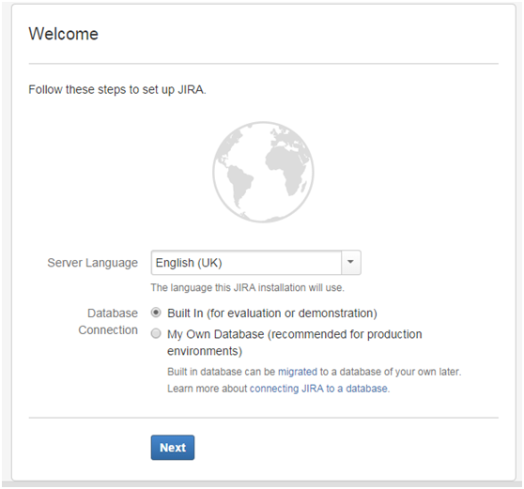
5.2配置自己的mysql数据库信息，测试连接后，点击next
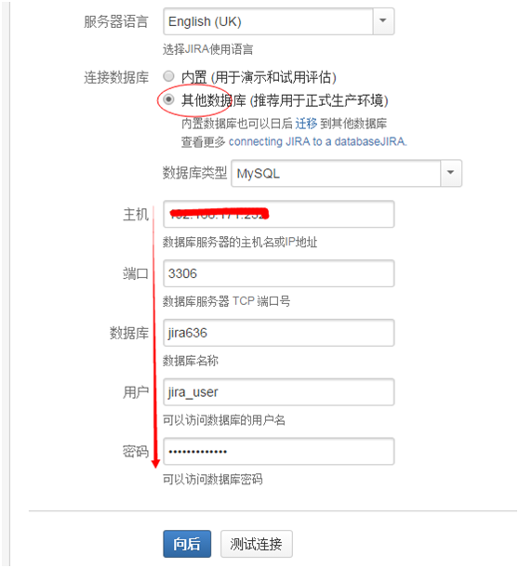
5.3点击第一个
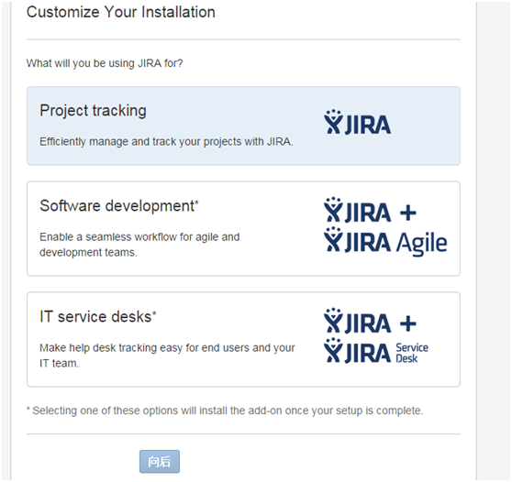
5.4输入临时授权码
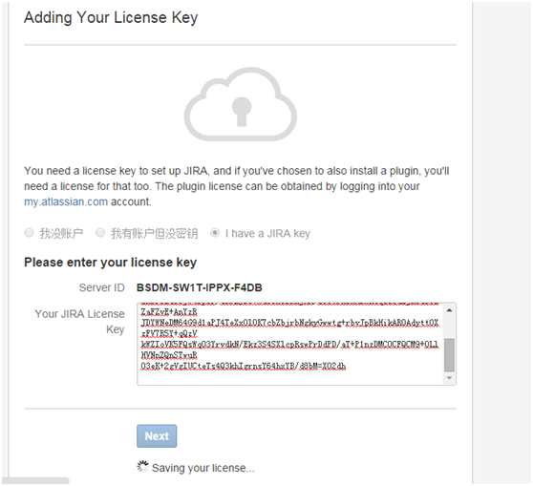
临时授权码：
AAABBw0ODAoPeNptkFtLxDAQhd/zKwI+R9Kwy66FPKxthGhvtF0p4kuso0a6sUwvuP/edissyj4MD
HPOfHOYqzu0tICWeoJy4a+FzzkNwpIK7q1ICF2Ntu3tl5P3Ot89+1SNphnMPCEBwqkJTQ9y9jN+w
zxBPi2a68jW4DpQr/a0rZJS5VmuC0XOBNnjAH/s5bGFxBxABmkcqzzQu2jRTd3bEZaFZvE+AnYzR
JDYWNeDM64G9d1aPJ4TeXxOlOK7cbZbjrbNgkyGwwtg+rbvJpBkHikAR0Adytt0XzFV7R5Y+qQzV
kWZIoVK5FQsWq03YrvdkN/Ekz3S4SXlcpRswPrDdPD/aT+P1nzDMC0CFQCM9+0LlHVNnZQnSTwuR
O3eK+2gVgIUCteTs4Q3khIgrnsY64hxYB/d8bM=X02dh
5.5注册完后填写管理员账号和密码
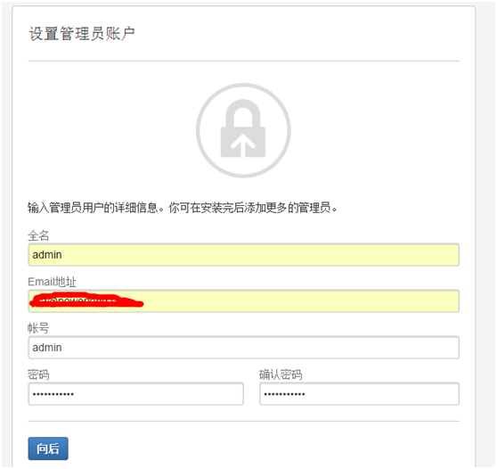
5.6配置邮件服务器，也可以跳过以后配置
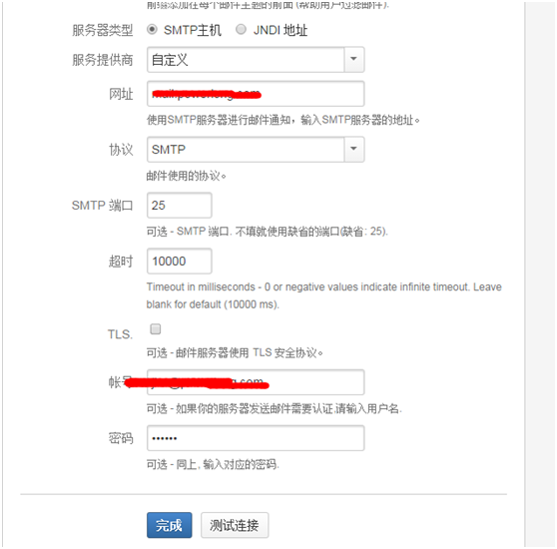

JIRA汉化
6.1下载6.3.6官方中文翻译包。地址如下：
https://translations.atlassian.com/dashboard/download?lang=zh_CN#/JIRA/6.3.6

6.2登陆jira，点击插件->管理插件->上传，选择中文包
6.3上传后，选择系统-.>通用设置，设置语言
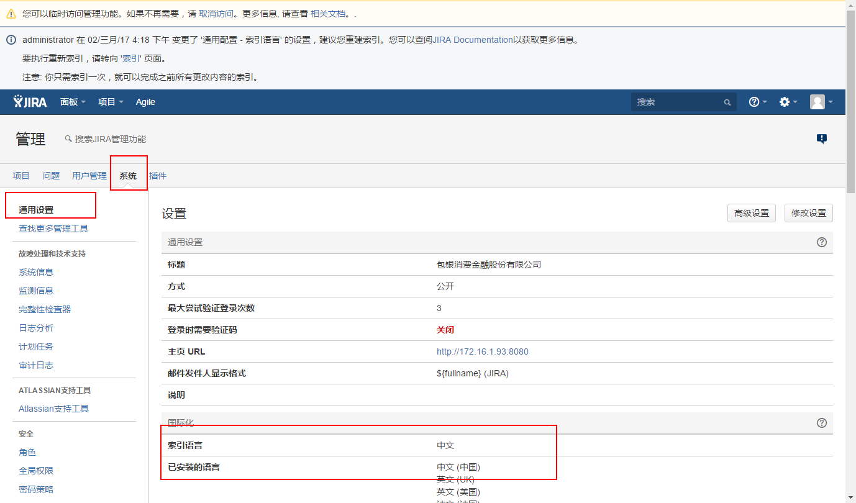

JIRA破解
7.1登陆JIRA，点击右上角齿轮形状的管理图标，选择“系统”，再选择“授权”，看到使用日期不到1个月，如下所示：
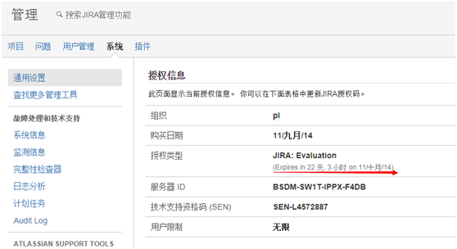

7.2将附件中的atlassian-extras-2.2.2.jar替换你的JIRA的安装目录的\atlassian-jira\WEB-INF\lib同名jar包，破解包下载地址为：http://download.csdn.net/detail/mchdba/7950429。

7.3 进入JIRA授权页面
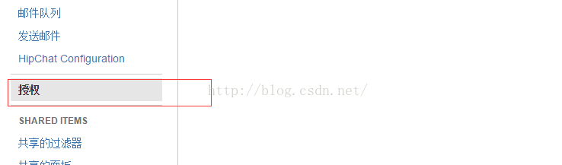

授权码： 注意修改ServerID
#Description=JIRA: Commercial,
CreationDate=2016-08-10,
jira.LicenseEdition=ENTERPRISE,
Evaluation=false,
jira.LicenseTypeName=COMMERCIAL,
jira.active=true,
licenseVersion=2,
MaintenanceExpiryDate=2099-12-31,
Organisation=pl,
SEN=SEN-L4572887,
ServerID=BM13-ZSIP-VSZX-4F8O,
jira.NumberOfUsers=-1,
LicenseID=AAABBw0ODAoPeNptkFtLxDAQhd/zKwI+R9Kwy66FPKxthGhvtF0p4kuso0a6sUwvuP/edissyj4MD
HPOfHOYqzu0tICWeoJy4a+FzzkNwpIK7q1ICF2Ntu3tl5P3Ot89+1SNphnMPCEBwqkJTQ9y9jN+w
zxBPi2a68jW4DpQr/a0rZJS5VmuC0XOBNnjAH/s5bGFxBxABmkcqzzQu2jRTd3bEZaFZvE+AnYzR
JDYWNeDM64G9d1aPJ4TeXxOlOK7cbZbjrbNgkyGwwtg+rbvJpBkHikAR0Adytt0XzFV7R5Y+qQzV
kWZIoVK5FQsWq03YrvdkN/Ekz3S4SXlcpRswPrDdPD/aT+P1nzDMC0CFQCM9+0LlHVNnZQnSTwuR
O3eK+2gVgIUCteTs4Q3khIgrnsY64hxYB/d8bM=X02dh,
LicenseExpiryDate=2099-12-31,
PurchaseDate=2016-08-10

7.4破解成功如下：
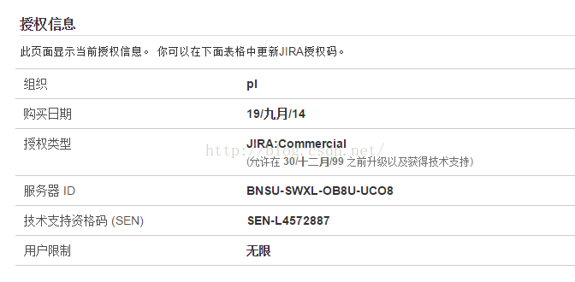
7.5拷贝破解的插件管理包覆盖老的管理包
[root@byxf-jira-02 atlassian-bundled-plugins]# mv atlassian-universal-plugin-manager-plugin-2.17.13.jar atlassian-universal-plugin-manager-plugin-2.17.13.jar.old
[root@byxf-jira-02 atlassian-bundled-plugins]# cp /home/software/atlassian-universal-plugin-manager-plugin-2.17.13.jar /home/jira/atlassian-jira/WEB-INF/atlassian-bundled-plugins/
7.6输入授权码
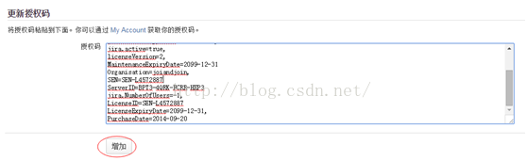
Description=JIRA Agile (formerly GreenHopper) for JIRA\: Commercial,
NumberOfUsers=-1,
CreationDate=2014-08-01,
Evaluation=false,
greenhopper.LicenseEdition=ENTERPRISE,
licenseVersion=2,
MaintenanceExpiryDate=2099-01-01,
Organisation=saper,
greenhopper.active=true,
SEN=SEN-L4390388, #
ServerID=BQJE-RNSR-9NMG-JDWN,
LicenseExpiryDate=2099-01-01,
LicenseTypeName=COMMERCIAL,
PurchaseDate=2014-08-01

7.7重启jira
[root@byxf-jira-02 atlassian-bundled-plugins]# cd /home/jira/bin
[root@byxf-jira-02 atlassian-bundled-plugins]#./shutdown.sh
[root@byxf-jira-02 atlassian-bundled-plugins]#./start-jira.sh

安装WIKI
[root@byxf-jira-02 ~]# cd /home/software/
[root@byxf-jira-02 ~]# tar -zxvf atlassian-confluence-5.4.4.tar.gz
[root@byxf-jira-02 software]# mv atlassian-confluence-5.4.4 /home/wiki
[root@byxf-jira-02 software]# cd /home/wiki/confconfluence
[root@byxf-jira-02 conf]# vi WEB-INF/classes/confluence-init.properties
#添加WIKI数据目录
confluence.home=/home/wiki/confluence-data
[root@byxf-jira-02 software]# cd /home/wiki/bin
[root@byxf-jira-02 confluence]# ./start-confluence.sh

WIKI破解
9.1替换注册包
[root@byxf-jira-02 confluence]# cd /home/wiki/confluence/WEB-INF/lib/ [root@byxf-jira-02 confluence]# mv atlassian-extras-2.4.jar atlassian-extras-2.4.jar.old
[root@byxf-jira-02 confluence]# cp /home/software/wiki_software/atlassian-extras-2.4.jar /home/wiki/confluence/WEB-INF/lib/ #替换注册jar包
[root@byxf-jira-02 software]# cd /home/wiki/bin
[root@byxf-jira-02 confluence]# ./start-confluence.sh

9.2在本地windows上安装jdk，并运行破解工具，打开wiki，查看serverID，输入到破解工具中，然后将生成的linence key输入
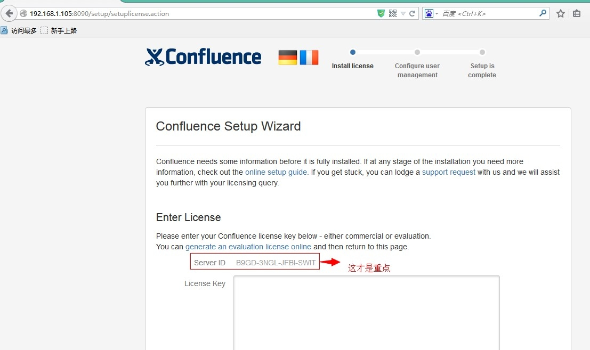
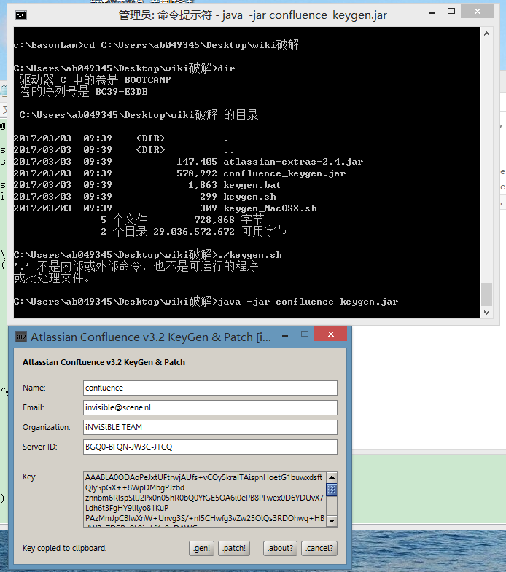
9.3输入key
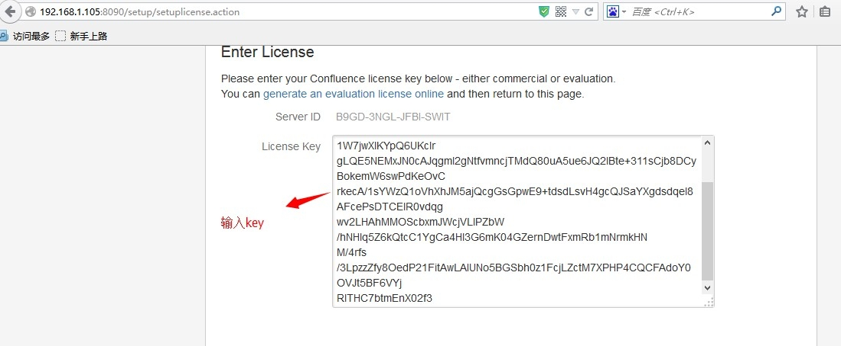

配置WIKI
10.1选择安装方式，选择Production installiation
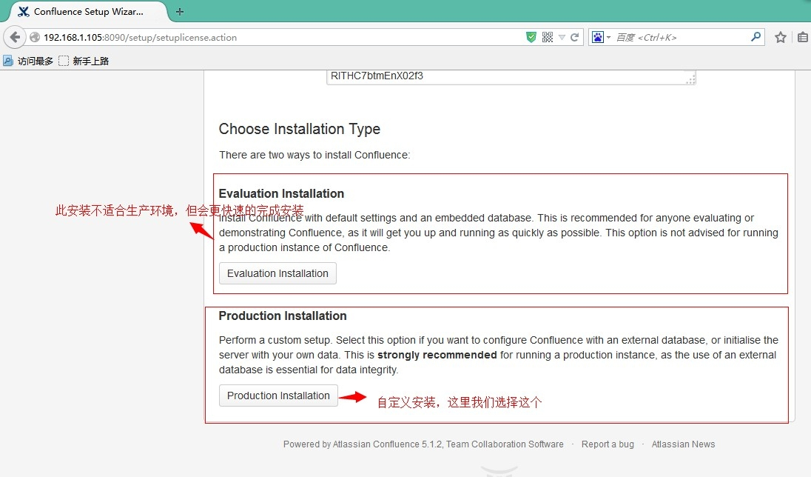

10.2选择连接数据库，选择Extenam Database
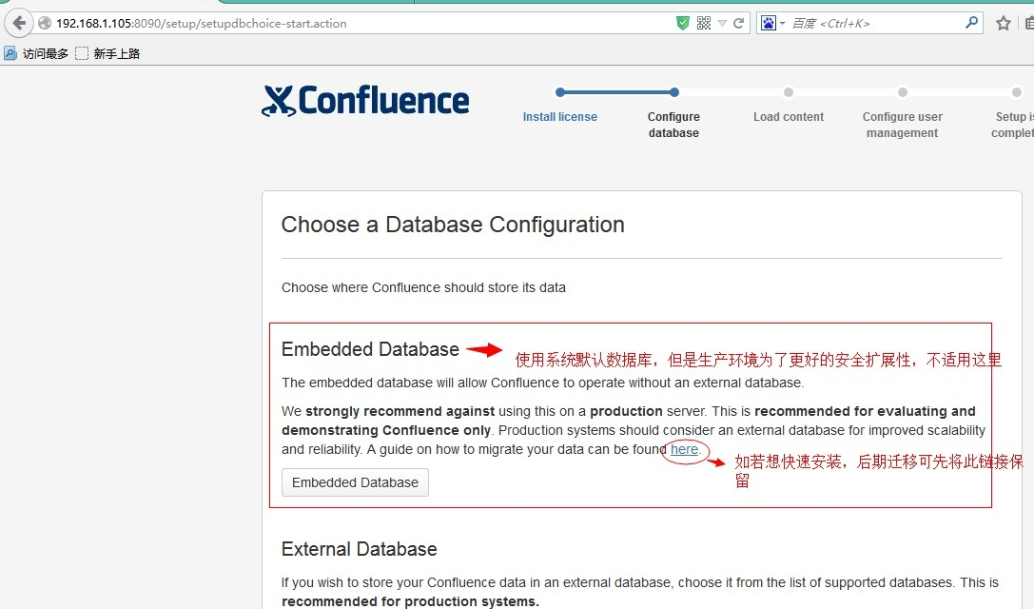
10.3 WIKI安装mysql数据库所需连接包后重启

[root@byxf-jira-02 confluence]# cp /home/software/mysql-connector-java-5.1.25-bin.jar /home/jira/atlassian-confluence-5.4.4/confluence/WEB-INF/lib/

10.4 WIKI配置连接数据库方式，选择JDBC
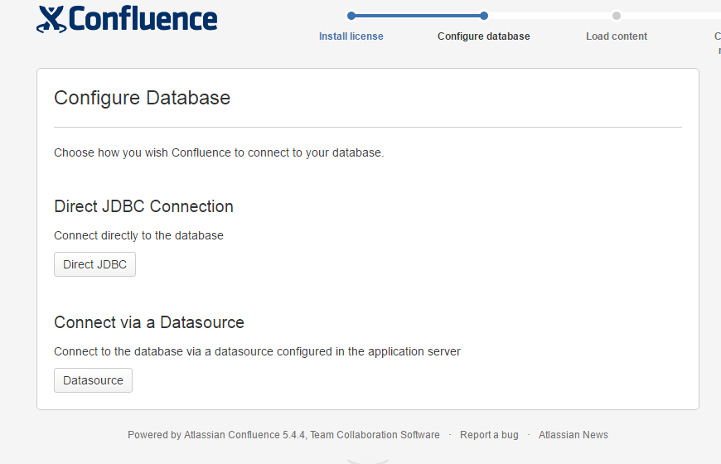
10.4 WIKI数据库配置
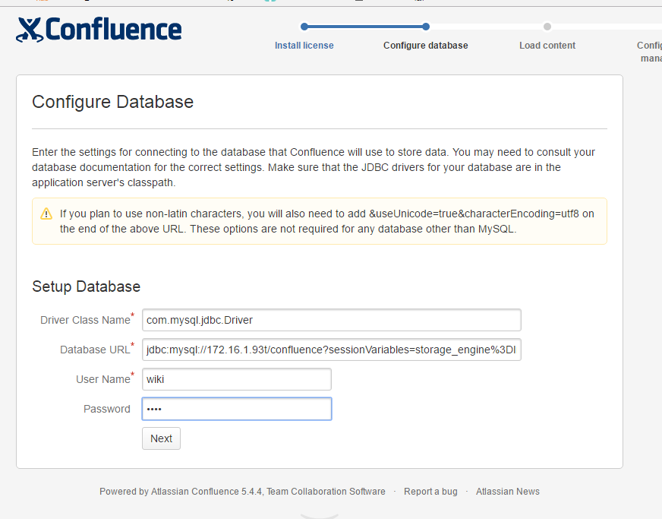

WIKI汉化
拷贝汉化包到指定目录然后重启
[root@byxf-jira-02 ~]# cp /home/software/Confluence-5.4.4-language-pack-zh_CN.jar /home/wiki/confluence/WEB-INF/lib/
[root@byxf-jira-02 software]# cd /home/wiki/bin
[root@byxf-jira-02 confluence]# ./start-confluence.sh

JIRA备份恢复

WIKI备份恢复

