环境介绍
系统 | 服务 | IP
Centos6.5 | prd-dmz-syslog+vpn-01 | 10.10.2.100

环境准备
1、安装依赖包
[root@uat2-app-01 software]# yum -y install httpd mysql mysql-devel mysql-server PHP php-mysql php-gd php-imap php-odbc php-pear php-xml php-xmlrpc cairo-devel libxml2-devel pango-devel rrdtool net-snmp net-snmp-utils
[root@prd-dmz-vpn-03 ~]# chkconfig httpd on
[root@prd-dmz-vpn-03 ~]# chkconfig mysql on
[root@prd-dmz-vpn-03 ~]# chkconfig --level 234 mysqld on
[root@prd-dmz-vpn-03 ~]# /etc/init.d/mysqld start
[root@prd-dmz-vpn-03 ~]# /etc/init.d/httpd start
[root@prd-dmz-vpn-03 ~]# mysqladmin -u root password byxf#2016
[root@prd-dmz-vpn-03 ~]# setenforce 0
[root@prd-dmz-vpn-03 ~]# chkconfig snmpd on
[root@prd-dmz-vpn-03 ~]# vi /etc/snmp/snmpd.conf
修改以下内容：
com2sec notConfigUser 10.10.2.100 public
access notConfigGroup "" any noauth exact all none none
去掉注释
view all included .1 80

安装Cacti
上传安装包到服务器后进行安装
[root@prd-dmz-vpn-03 ~]# tar -xvf cacti-0.8.8h.tar.gz -C /var/www/html
[root@prd-dmz-vpn-03 ~]# mv cacti-0.8.8h/ cacti
[root@prd-dmz-vpn-03 ~]# mysql -u root –p
创建cacti数据库：
creat database cacti；
grant all privileges on cacti.* to 'cactiuser'@'10.10.2.100' identified by 'cactiuser'
flush privileges;
use cacti;
source /var/www/html/cacti/cacti.sql;
exit
[root@prd-dmz-vpn-03 ~]# vi /var/www/html/cacti/include/config.php
修改内容：
$database_type = "mysql";
$database_default = "cacti";
$database_hostname = "10.10.2.100";
$database_username = "cactiuser";
$database_password = "cactiuser";
$database_port = "3306";
$database_ssl = false;
[root@prd-dmz-vpn-03 ~]# useradd cacti
[root@prd-dmz-vpn-03 ~]# chown -R cacti:cacti /var/www/html/cacti/log/
[root@prd-dmz-vpn-03 ~]# chown -R cacti:cacti /var/www/html/cacti/rra/
[root@prd-dmz-vpn-03 ~]# vi /etc/crontab
#添加以下内容
*/1 * * * * root /usr/bin/php /var/www/html/cacti/poller.php > /dev/null 2>&1
[root@prd-dmz-vpn-03 ~]# service httpd restart

配置cacti界面：
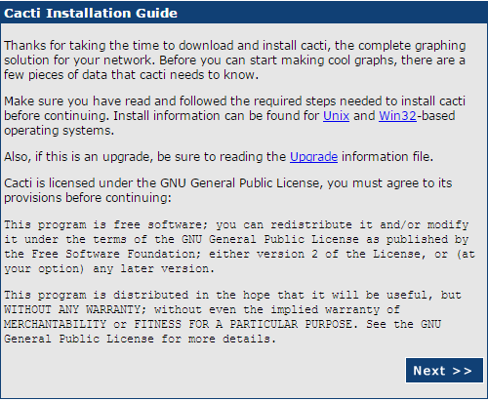
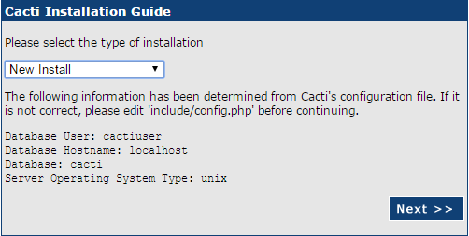
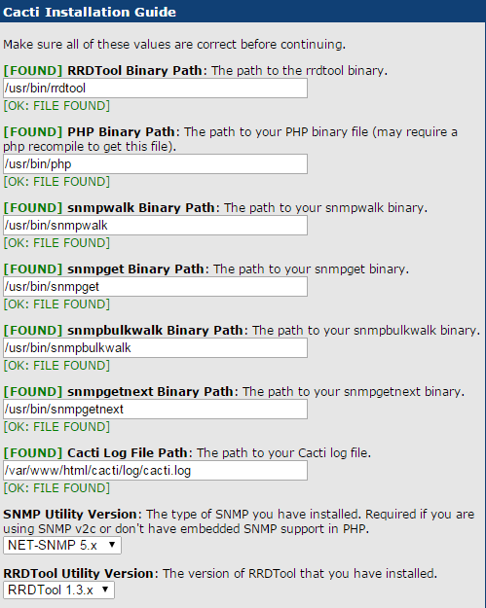
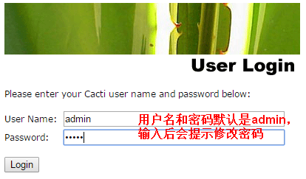


安装cacti插件
[root@prd-dmz-vpn-03 ~]# wget http://docs.cacti.net/_media/plugin:settings-v0.71-1.tgz
[root@prd-dmz-vpn-03 ~]# mv plugin:settings-v0.71-1.tgz settings-v0.71-1.tgz
[root@prd-dmz-vpn-03 ~]# tar -zxvf settings-v0.71-1.tgz -C /var/www/html/cacti/plugins
[root@prd-dmz-vpn-03 ~]# wget http://docs.cacti.net/_media/plugin:syslog-v1.22-2.tgz -O syslog.tgz
[root@prd-dmz-vpn-03 ~]# tar zxvf syslog.tgz -C /var/www/html/cacti/plugins
[root@prd-dmz-vpn-03 ~]# chown -R apache:apache /var/www/html/plugins/syslog
[root@prd-dmz-vpn-03 ~]# mysql -uroot –p
#创建syslog数据库
create database syslog;
grant all privileges on syslog.* on cactiuser@localhost identified by ' cactiuser' with grant option;
flush privileges;
exit
[root@prd-dmz-vpn-03 ~]# mysql -ucactiuser -pcactiuser syslog < /var/www/html/cacti/plugins/syslog/syslog.sql
[root@prd-dmz-vpn-03 ~]# vi /var/www/html/cacti/plugins/syslog/config.php
#修改以下内容
/* revert if you dont use the Cacti database */
$use_cacti_db = false;

if (!$use_cacti_db) {
$syslogdb_type = 'mysql';
$syslogdb_default = 'syslog';
$syslogdb_hostname = 'localhost';
$syslogdb_username = 'cactiuser';
$syslogdb_password = 'cactiuser';
$syslogdb_port = 3306;
}else{
$syslogdb_type = $database_type;
$syslogdb_default = $database_default;
$syslogdb_hostname = $database_hostname;
$syslogdb_username = $database_username;
$syslogdb_password = $database_password;
$syslogdb_port = $database_port;
}

安装后点击下载插件，成功后如图：
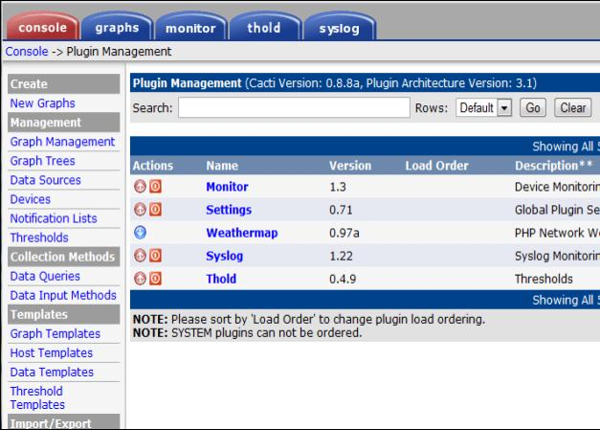
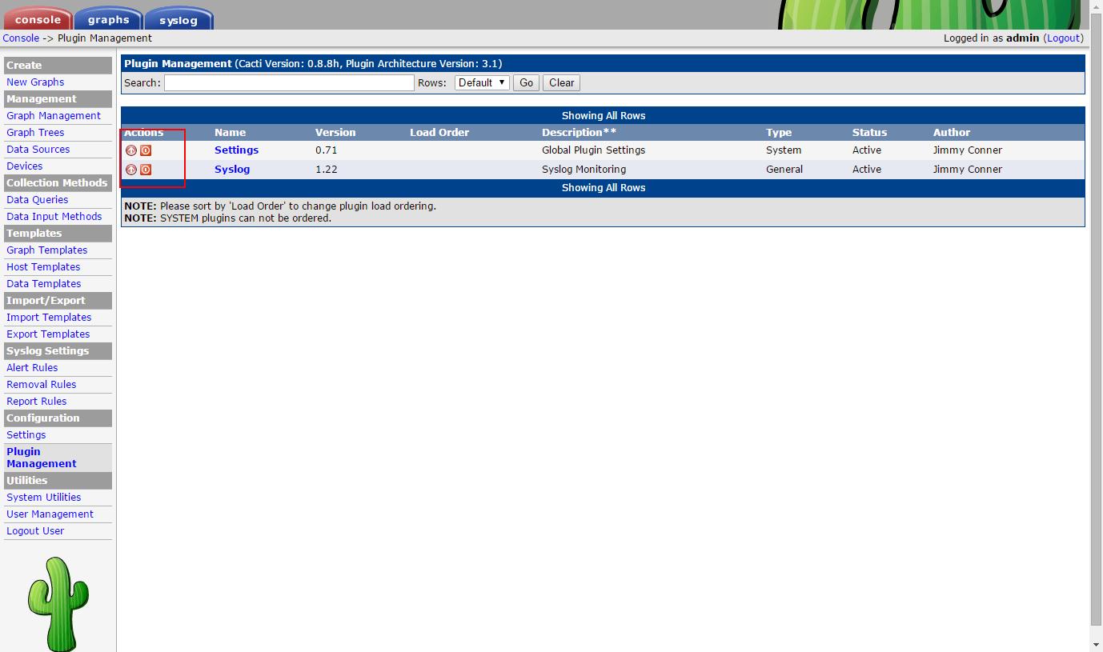

安装syslog
[root@prd-dmz-sftp-01 ~]# yum install -y rsyslog rsyslog-mysql
[root@prd-dmz-vpn-03 ~]# vi /etc/rsyslog.conf
$ModLoad imuxsock # provides support for local system logging (e.g. via logger command)
$ModLoad imklog # provides kernel logging support (previously done by rklogd)
$UDPServerRun 514
$ActionFileDefaultTemplate RSYSLOG_TraditionalFileFormat
$IncludeConfig /etc/rsyslog.d/*.conf
*.info;mail.none;authpriv.none;cron.none;local4.none /var/log/messages
authpriv.* /var/log/secure
mail.* -/var/log/maillog
cron.* /var/log/cron
*.emerg *
uucp,news.crit /var/log/spooler
local7.* /var/log/boot.log
$ModLoad immark.so
$ModLoad imudp.so
$ModLoad imudp
$UDPServerRun 514
$ModLoad imklog
$ModLoad imuxsock
$ModLoad immark
$ModLoad imudp
$ModLoad imtcp
$ModLoad ommysql
$template cacti_syslog,"INSERT INTO syslog_incoming(facility, priority, date, time, host, message) values (%syslogfacility%, %syslogpriority%, '%timereported:::date-mysql%', '%timereported:::date-mysql%', '%HOSTNAME%', '%msg%')", SQL
*.* :ommysql:localhost,syslog,cactiuser,cactiuser;cacti_syslog
[root@prd-dmz-vpn-03 ~]# vi /etc/sysconfig/rsyslog
SYSLOGD_OPTIONS="-c -r -m 0"
KLOGD_OPTIONS="-x"

客户端配置
[root@prd-dmz-vpn-03 ~]# echo "export PROMPT_COMMAND='{ msg=\$(history 1 | { read x y; echo \$y; });logger \"[euid=\$(whoami)]\":\$(who am i):[\`pwd\`]\"\$msg\"; }'" >> /etc/bashrc
[root@prd-dmz-app-01 ~]#echo "*.info @@10.10.2.100:514" >> /etc/rsyslog.conf
[root@prd-dmz-app-01 ~]# echo "*.info @10.10.2.100" >> /etc/rsyslog.conf
[root@prd-dmz-app-01 ~]# service rsyslog restart

