??

How to underline a letter

Space between each letter

Pseudocode

* Keep guess count stable (DON’T CHANGE) when same letter guessed
* Bank of words to guess ”wordAnswers”
* Restart game (w/ new word) automatically after win or loss
* DISPLAY:
  + “Press any key to get started! Onkeyup
  + Wins (I’d like Losses, too)
  + Spaces of word to guess: _ _ _ _ _ _ _ (maybe with 2em?)
  + Reveal correct letters: r _ a _ _ p _
  + Number of guesses left
  + Letters already guessed: I Z Y H (displayed in caps) “guessedLetters”

Correct guess prompts the pic of the word (i.e. Blondie’s pic and song)

— Words to guess “wordAnswers”

(object to correspond with situation???)

"**Mister Peanut**" : “A car could strike her! So I took home the tick-covered pregnant stray wondering near Middleground Road. She was loved; had 8 pups. The beloved runt, now 14 has great, big ears. Guess his name.”

"**Campfire breakfast**" : "Peter..."

"**Mercy Boulevard**" : "St. Jo's blah, blah, blah, blah"

"**Kesuke Miyagi**" : "Charater in 'Karate Kid' movie who had mercy on the bad guy..."

—Corresponding “theSituation” goes with each word in wordAnswers

“A car could strike her! So I took home the tick-covered pregnant stray I found wondering near Middleground Rd. I de-ticked, loved her. Here is one of her puppies, a wonderful 14-year-old with an under bite and great, big ears :).”

It’s sweet, but not surapy. It’s wholesome lke eating kale that tasted like steak for your soul. It’s kindness you didn’t deserve or expect. It’s just good.

—per word, an array of correctLetters (that are in the word)

Mr. Peanut == _ _ _ _ _ _ _ _ _ _ _

Mr. Miagui?? Or Honk! Honk!

campfire

Mercy Boulevard wonderfully

War BC

—formatted screen

guessedLetters bank appears

Guess count

—First prompt: “Press any key to get started!”

—Player presses any key to get started (Onkeyup?)

(calls up a hint when game starts)

—prompts blank underscores _ _ _ _ _ _ _ _( that == a wordAnswers)

#create array of all the wordAnswers ? (MISTER PEANUT…?)

CAMPFIRE BREAKFAST

KESUKE MIYAGI

MERCY BOULEVARD

A lot of array functions you can run on a string —Dustin

GUESSFUNCTION:

Use key events to listen for the letters that your players will type.

1. user hits any key
2. prompt: “Press any key to get started!”
3. Prompts **blank spaces** — — — — — — — — — —from corresponding word in wordAnswers
4. “press any key” disappears
5. Prompts corresponding **hint**
6. user types letter
7. (make Uppercase)
8. Compare letter to correctLetters (in array from wordAnswers?)
9. if in correctLetters —> fill corresponding blank space
10. if in correctLetters —> guessCount NOT changed
11. else, if NOT in correctLetters—> letter appears in guessedLetters
12. else, if NOT in correctLetters—> guessCount++
13. repeat GUESSFUNCTION
14. until guessCount=== 15
15. prompt “Game over”
16. prompt corresponding picture
17. |OR| each letter in correctLetters array is picked (maybe arr1 = [“a”, “c”, “t”] == arr2 = [“a”, “c”, “t”] ???)
18. prompt “You win!”
19. prompt corresponding picture
20. prompt corresponding text
21. After the user wins/loses the game should automatically choose another word and make the user play it. (“make” is a strong word here. )

—convert all letters to lowercase?

—pictures:

Peanut

Mercydef

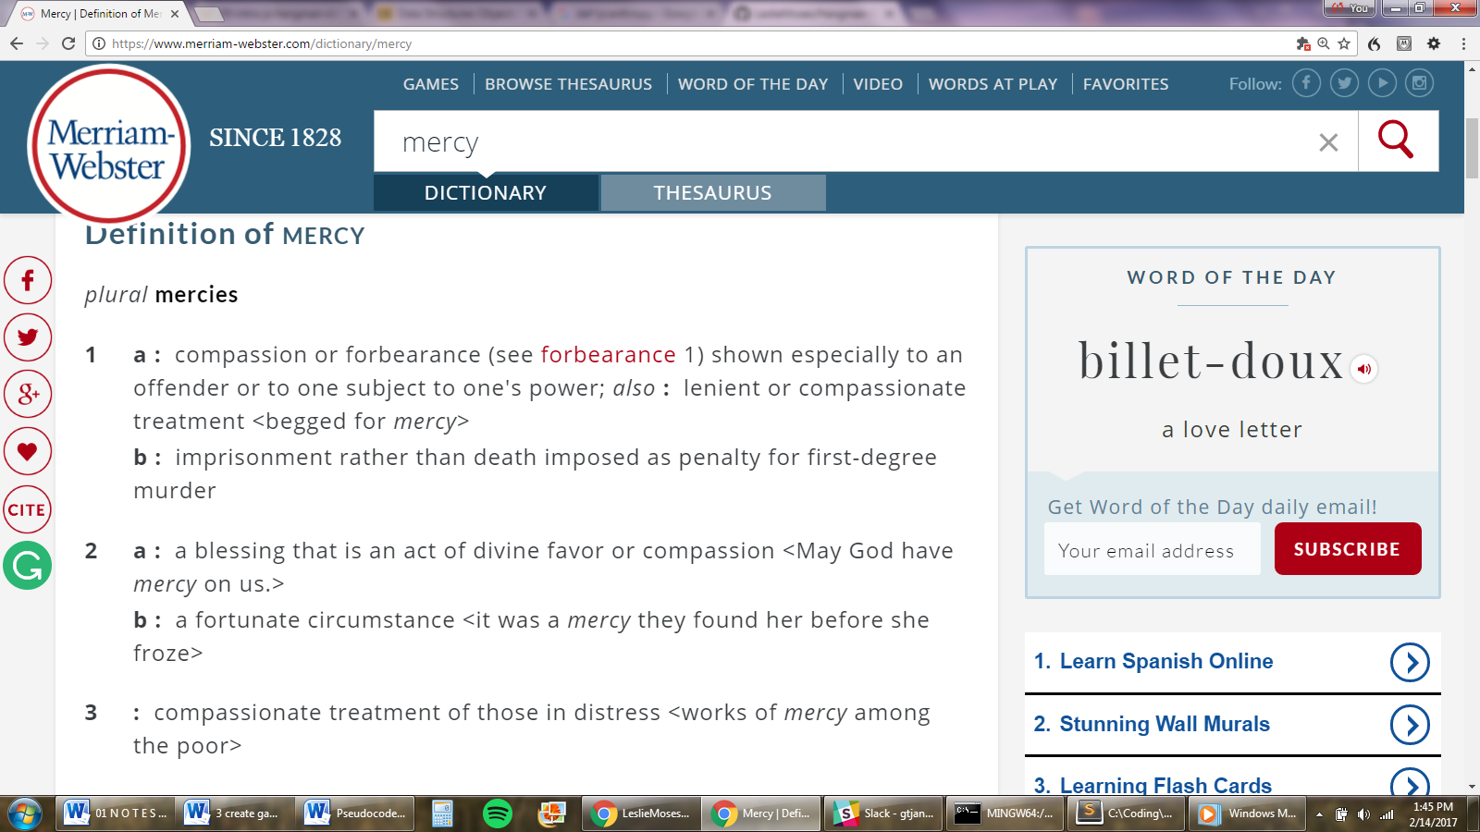

10:17

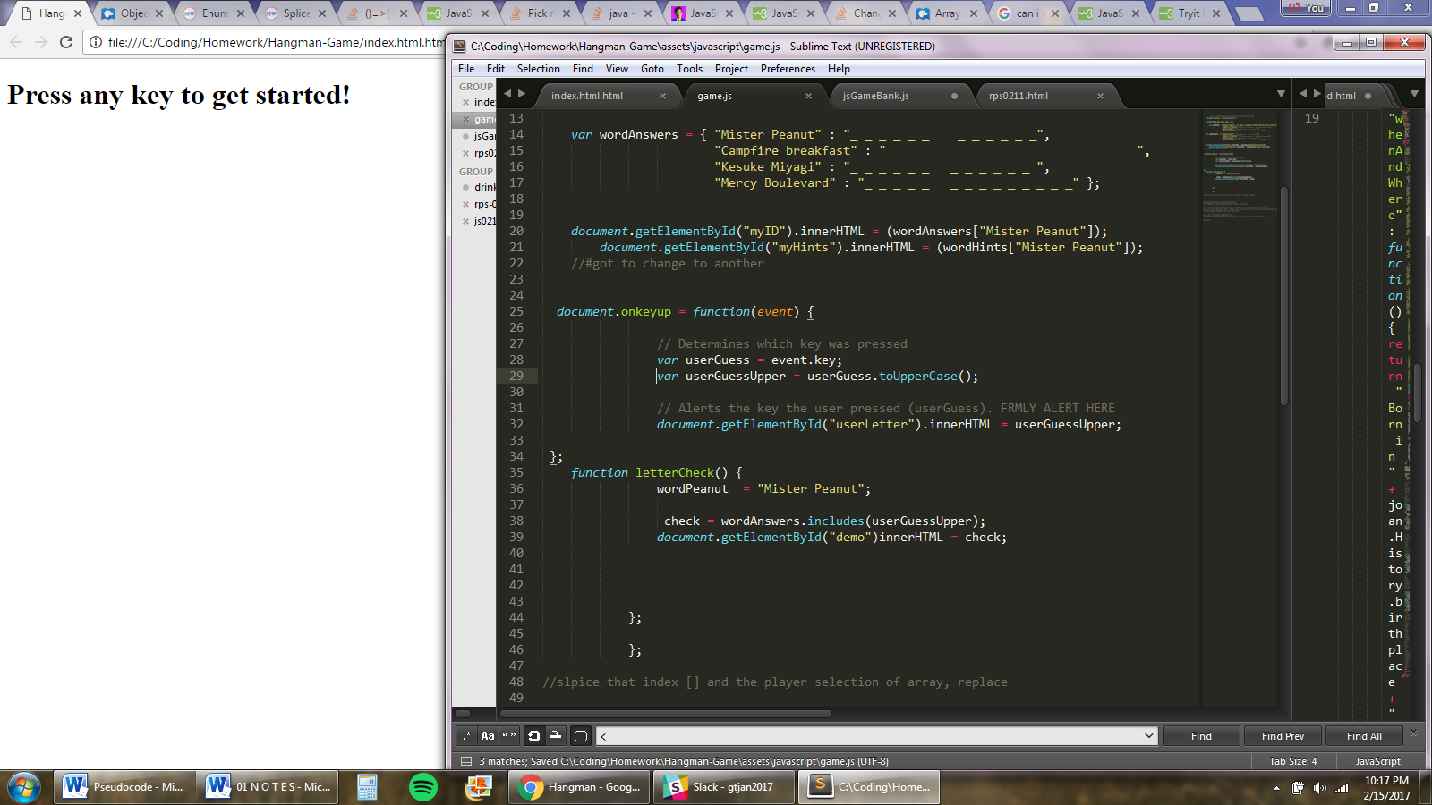

0217 4:18

