The Laws of Distribution

The Common Root of the Leonardo Rule, the Pareto Principle, and the Dunbar Number

Content

The Laws of Distribution 3

The Formula of Distribution 3

A Leonardo szabálya 4

A kettő kombinációja 5

A Pareto-elv, mint következmény 6

A Dunbar-szám, mint következmény 7

Következmények 8

Összegzés 9

# The Laws of Distribution

One of the oldest questions in living and human systems is how to distribute finite resources in a way that ensures the system’s survival and keeps every endpoint functional. At first glance, trees, economies, and human social networks seem to have nothing in common. However, upon closer inspection, a shared logic emerges—one that enforces the same law: distribution is finite, fractal, and always organizes itself into structure.

# The Formula of Distribution

Let us imagine that we have a given amount of resources $X$. At each branching point, a portion $α$ must be retained for self-maintenance, and the remainder can be passed on. The energy or attention distributed in this way becomes smaller at each subsequent level: by the time it reaches the endpoints, only what has filtered through the entire network remains. This process can be described with a simple formula: the distributable portion at level nn is ${\left(1-α\right)}^{n}$, which defines a finite domain for the system.

A képen szöveg, sor, Diagram, képernyőkép látható

Előfordulhat, hogy az AI által létrehozott tartalom helytelen.

1. Ábra: Exponenciális eloszlás-görbe különböző $α$ értékekre

## The Leonardo Rule

Nature follows the same geometric law in trees, blood vessels, and neurons: the cross-sectional area of the parent branch equals the sum of the cross-sectional areas of its child branches. This ensures that the system neither thins out excessively nor becomes unstable. The branching number $k$ is typically 2–3, which profoundly determines the structure of the entire network.

A képen szöveg, képernyőkép, rozsdabarna, kör látható

Előfordulhat, hogy az AI által létrehozott tartalom helytelen.

2. Ábra: Leonardo-szabály: a szülőág keresztmetszete = utódágak összege

## The Combination of the Two

When we compare the distribution formula with the Leonardo Rule, it becomes clear: the portion reaching the endpoints always follows the form

$$\frac{X⋅{\left(1-α\right)}^{L}}{k^{L}}$$

where LL is the number of levels. From this, it directly follows that every system has a maximum number of endpoints. Not because it “doesn’t want” more, but because physics and geometry do not allow it.

**Formula:**

A képen képernyőkép, tervezés látható

Előfordulhat, hogy az AI által létrehozott tartalom helytelen.

3. Ábra: Háromszintes fraktálfa az elosztással

## The Pareto Principle as a Consequence

The Pareto Principle is not an empirical rule, but the natural outcome of combining the distribution formula with the Leonardo Rule. The system becomes top-heavy: at the upper levels, a few nodes receive a large share of resources, while at the lower levels, many endpoints share very little. This gives rise to the familiar 80/20 ratio of the Pareto Principle: a small number of units carry most of the system’s total value. It is not an exception—it is a necessary consequence. (Note: the ratio observed by Pareto does not align perfectly with the curve; I will elaborate on the reasons for this later.)

A képen szöveg, sor, diagram, képernyőkép látható

Előfordulhat, hogy az AI által létrehozott tartalom helytelen.

4. Ábra: Az elosztás normalizált százalékos reprezentációja

## The Dunbar Number as a Consequence

Human relationships are no exception. Attention, time, and energy are also divisible quantities. If every relationship requires a minimum amount of attention $ε$, and each person retains a portion $α$ for themselves, then a limit eventually emerges: the maximum number of relationships that can be stably maintained. This is the Dunbar threshold (~150), which has been empirically confirmed by numerous studies.

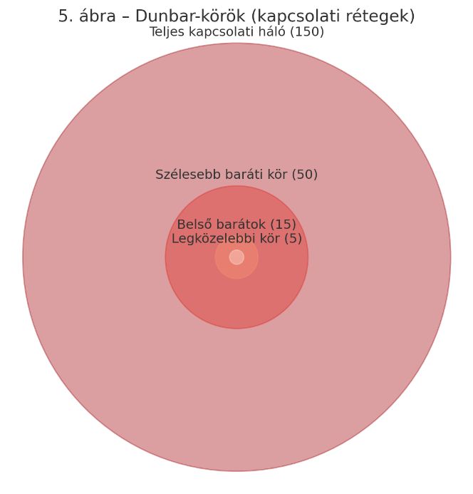

5. Ábra: Dunbar-körök (kapcsolati rétegek)

# Consequences

It is worth recognizing that every system also chooses a strategy:

* **Tall trees** with few branches (small $k$) build long trunks and only unfold their canopy at the top. That’s why they can reach heights of up to a hundred meters.
* **Wide trees** with more branches (larger $k$) spread broadly but reach lower heights.
* Human networks follow a similar pattern: the inner circle is narrow with strong connections, while the outer circle is wide but consists of looser ties.

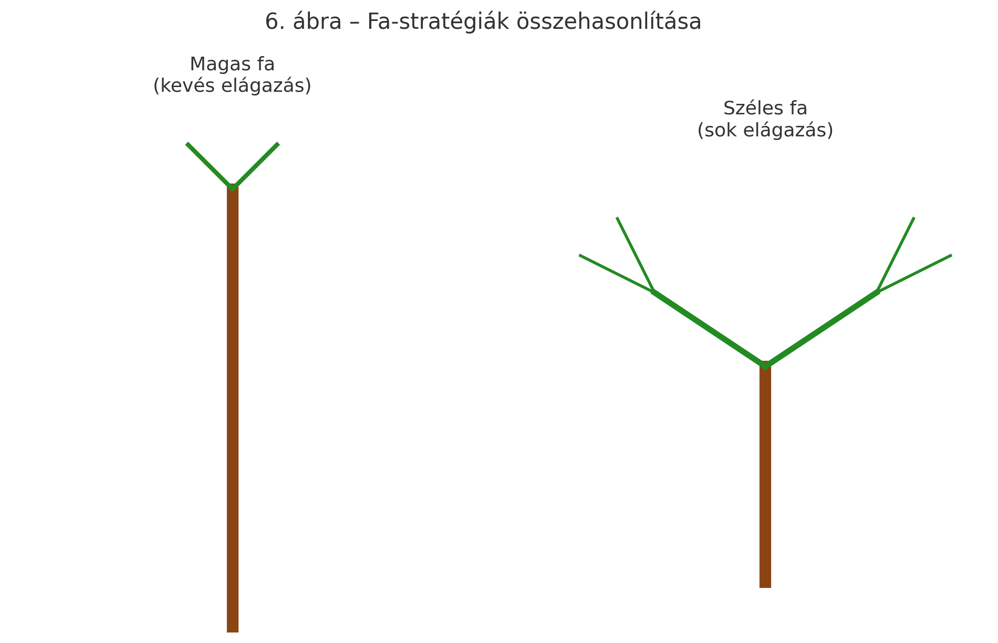

6. Ábra: Fa-stratégiák összehasonlítása

# Summary

The distribution formula, Leonardo’s rule, the Pareto principle, and the Dunbar number are not four separate worlds, but different expressions of the same deeper law. A single logic describes how a system can survive, how far resources can be distributed, and why the same patterns repeat in nature and society. This shared interpretive framework is not just an explanation—it is a bridge: the branching of a tree, economic distribution, and human relationships all answer the same question: **how can the whole be sustained when resources are finite?**

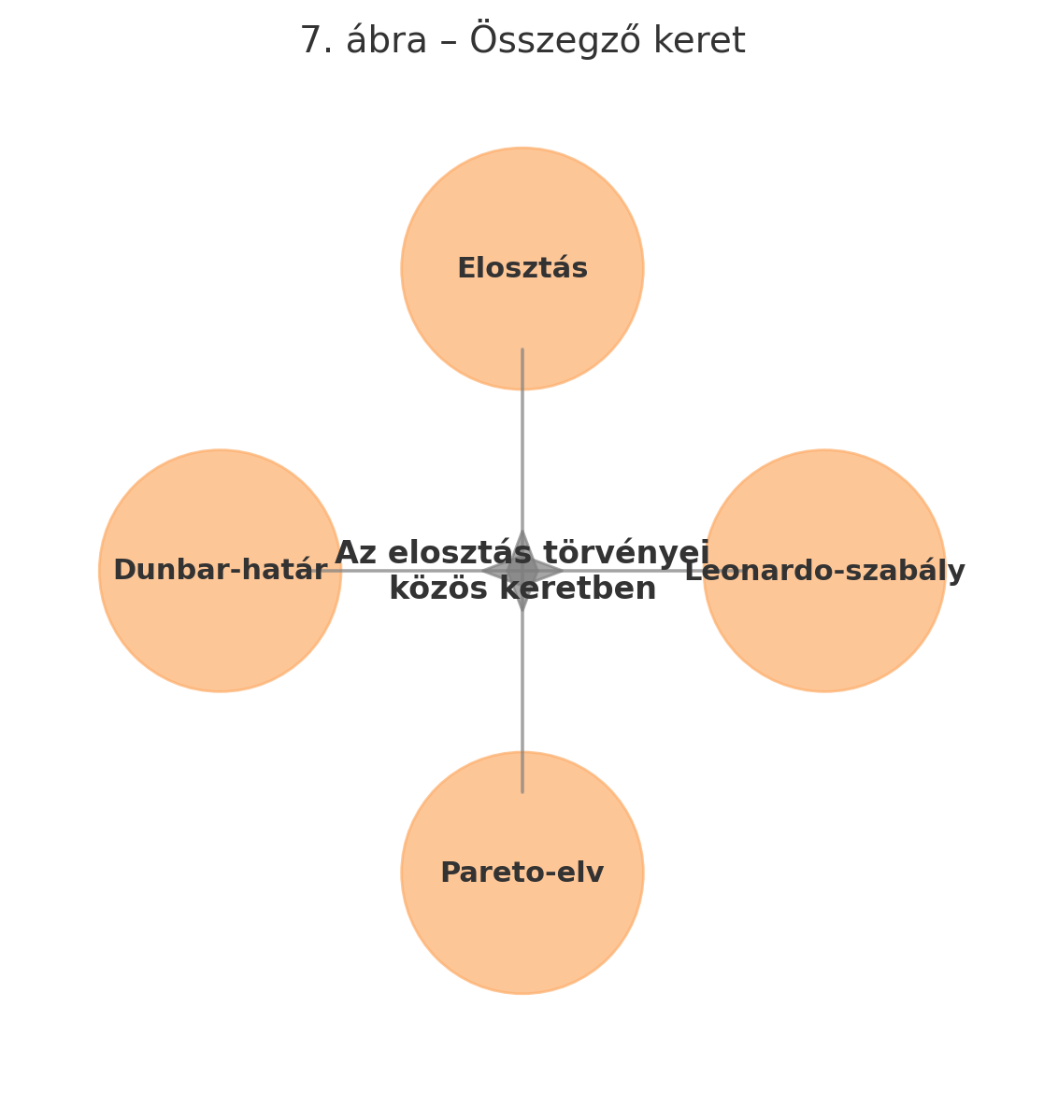

7. Ábra: Összegző keret: Az elosztás tőrvényei közös keretben