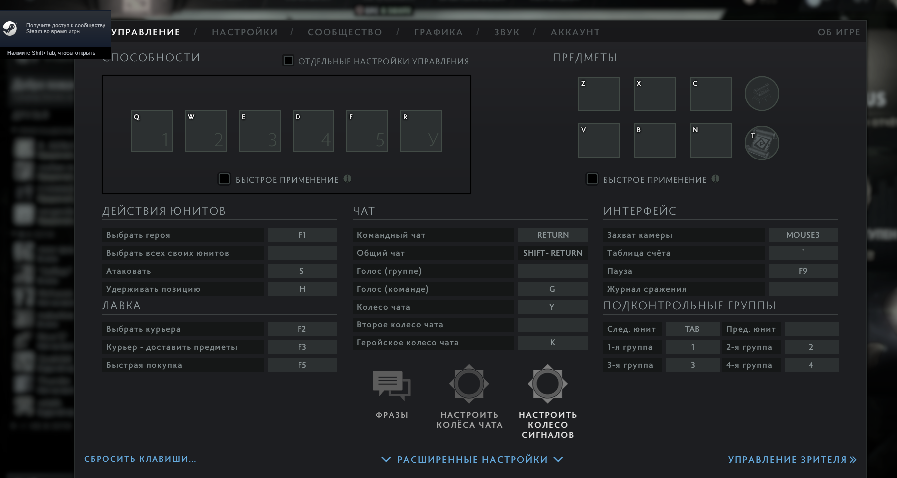

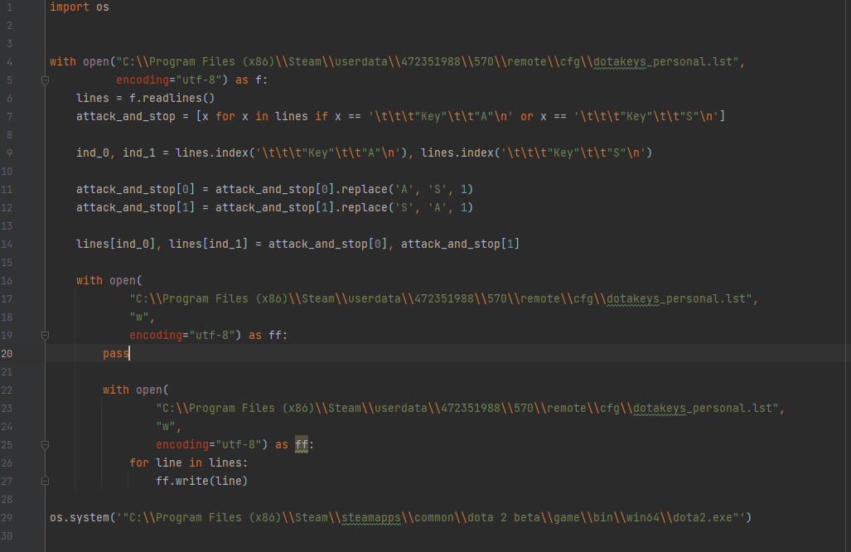

Путь к конфигу следующий: C:\\Program Files (x86)\\Steam\\userdata\\472351988\\570\\remote\\cfg\\dotakeys_personal.lst

Я выложил код скрином и текстом, тк в тексте сбилась табуляция

import os  
  
  
with open("C:\\Program Files (x86)\\Steam\\userdata\\472351988\\570\\remote\\cfg\\dotakeys_personal.lst",  
 encoding="utf-8") as f:  
 lines = f.readlines()  
 attack_and_stop = [x for x in lines if x == '\t\t\t"Key"\t\t"A"\n' or x == '\t\t\t"Key"\t\t"S"\n']  
  
 ind_0, ind_1 = lines.index('\t\t\t"Key"\t\t"A"\n'), lines.index('\t\t\t"Key"\t\t"S"\n')  
  
 attack_and_stop[0] = attack_and_stop[0].replace('A', 'S', 1)  
 attack_and_stop[1] = attack_and_stop[1].replace('S', 'A', 1)  
  
 lines[ind_0], lines[ind_1] = attack_and_stop[0], attack_and_stop[1]  
  
 with open(  
 "C:\\Program Files (x86)\\Steam\\userdata\\472351988\\570\\remote\\cfg\\dotakeys_personal.lst",  
 "w",  
 encoding="utf-8") as ff:  
 pass  
  
 with open(  
 "C:\\Program Files (x86)\\Steam\\userdata\\472351988\\570\\remote\\cfg\\dotakeys_personal.lst",  
 "w",  
 encoding="utf-8") as ff:  
 for line in lines:  
 ff.write(line)  
  
os.system('"C:\\Program Files (x86)\\Steam\\steamapps\\common\\dota 2 beta\\game\\bin\\win64\\dota2.exe"')