+FEDERAL STATE AUTONOMOUS EDUCATIONAL INSTITUTION

OF HIGHER EDUCATION

ITMO UNIVERSITY

**Report**

**on the practical task No. 4**

**“Algorithms for unconstrained nonlinear optimization. Stochastic and metaheuristic algorithms”**

Performed by

Chernobrovkin Timofey (412642)

Academic group J4133c

Accepted by

Dr Petr Chunaev

St. Petersburg

2023

# Goal

The use of stochastic and metaheuristic algorithms (Simulated Annealing, Differential Evolution, Particle Swarm Optimization) in the tasks of unconstrained nonlinear optimization and the experimental comparison of them with Nelder-Mead and Levenberg-Marquardt algorithms.

# Problem

1. Generate the noisy data (𝑥𝑘, 𝑦𝑘), where 𝑘 = 0, … ,1000, according to the rule:

where 𝛿𝑘~𝑁(0,1) are values of a random variable with standard normal distribution. Approximate the data by the rational function

by means of least squares through the numerical minimization of the following function:

To solve the minimization problem, use Nelder-Mead algorithm, Levenberg-Marquardt algorithm and **at least two** of the methods among Simulated Annealing, Differential Evolution and Particle Swarm Optimization. If necessary, set the initial approximations and other parameters of the methods. Use 𝜀 = 0.001 as the precision; at most 1000 iterations are allowed. Visualize the data and the approximants obtained **in a single plot**. Analyze and compare the results obtained (in terms of number of iterations, precision, number of function evaluations, etc.).

1. Choose at least 15 cities in the world having land transport connections between them. Calculate the distance matrix for them and then apply the Simulated Annealing method to solve the corresponding Travelling Salesman Problem. Visualize the results at the first and the last iteration. If necessary, use the city dataset from <https://people.sc.fsu.edu/~jburkardt/datasets/cities/cities.htm>

# Theory

Stochastic (Monte Carlo) algorithms are a broad class of algorithms that rely on repeated random sampling to solve an optimization problem. These methods are most useful when it is impossible or difficult to apply other methods (for example, there is no information about the differentiability of the function being optimized or the problem is discrete).

Metaheuristic algorithms are algorithms inspired by natural phenomena that solve an optimization problem by trial and error. and error. Metaheuristic methods, generally speaking, do not guarantee that a solution to the optimization problem will be found.

This lab work covers methods for Simulating Annealing, Differential Evolution, and Particle Swarm Optimization. Recall that simulated annealing is a metaheuristic algorithm that solves an optimization problem similar to the annealing process in metallurgy (heating and controlled cooling of a material to increase its crystal size and reduce defects). Differential evolution is a metaheuristic algorithm that solves the optimization problem through the evolution of a population of agents, i.e., possible solutions, creating new generations of agents by combining existing ones and further selecting the best ones. The particle swarm method is a metaheuristic algorithm that solves the optimization problem by iteratively changing the position of possible solutions (particles) at a certain rate. The change in the position of each particle is influenced by its best known position and the best known positions of other particles.

Simulated annealing – A general algorithmic method for solving a global optimization problem, especially discrete and combinatorial optimization. One example of Monte Carlo methods. The algorithm is based on the simulation of the physical process that occurs during the crystallization of a substance, including the annealing of metals. It is assumed that the atoms of the substance are almost lined up in the crystal lattice, but transitions of individual atoms from one cell to another are still allowed. The activity of atoms is the greater the higher the temperature, which is gradually lowered, leading to the fact that the probability of transitions to states with higher energy decreases. A stable crystal lattice corresponds to the minimum energy of the atoms, so the atom either transitions to a lower energy state or stays in place.

Differential Evolution – a method of multivariate mathematical optimization that belongs to the class of stochastic optimization algorithms (i.e., works using random numbers) and uses some ideas of genetic algorithms, but, unlike them, does not require working with variables in binary code. It is a direct optimization method, that is, it requires only the ability to compute the values of the target function, but not its derivatives. The method of differential evolution is designed to find the global minimum (or maximum) of non-differentiable, nonlinear, multimodal (having, possibly, a large number of local extrema) functions from many variables. The method is easy to implement and use (it contains few control parameters requiring selection), and is easily parallelized.

Particle Swarm Optimization – is a numerical optimization method that does not require knowing the exact gradient of the function being optimized. The algorithm is quite simple. It models a multi-agent system where agents-particles move towards optimal solutions while exchanging information with their neighbors. The current state of a particle is characterized by its coordinates in the solution space (i.e., the actual solution associated with it), as well as the velocity vector of the movement. Both of these parameters are chosen randomly at the initialization stage. In addition, each particle stores the coordinates of the best solution found by it, as well as the best solution traversed by all particles - this simulates the instantaneous exchange of information between birds. At each iteration of the algorithm, the direction and length of the velocity vector of each particle are changed in accordance with the information about the found optima.

# Materials and methods

In this task, all calculations were performed on the student's personal laptop. The work was performed in the Python programming language.

# Results

I. Сгенерировав зашумлённые данные и аппроксимировав рациональной функцией решили задачу минимизации использовав алгоритм Нелдера-Мида, алгоритм Левенберга-Марквардта и Differential Evolution и Particle Swarm Optimization как два выбранных метода рассматриваемых в данной работе. Полученные результаты для всех перечисленных методов представлены на рисунке 1.

Для сравнения работы алгоритмов их выходные данные и параметры работы занесены в таблицу 1.

|  |  |  |  |  |  |  |
| --- | --- | --- | --- | --- | --- | --- |
| algorithm | a | b | c | d | f-calculation | iterations |
| Nelder-Mead | -1.0031 | 1.0036 | -2.0009 | 1.0009 | 570 | 334 |
| Levenberg-Marquardt | -1.3351 | 1.2234 | 0.8782 | 0.3702 | 16 | 2 |
| Particle Swarm | -0.3639 | -0.1421 | -0.0009 | -1.0000 | 195 | 106 |
| Differential Evolution | -0.9987 | 0.9990 | -2.0000 | 1.0000 | 7645 | 124 |

Figure 1 – Results of solving the minimization problem

II. Для выполнения второго задания мною были выбраны 15 городов на евразийском континенте и записаны их координаты. Были выбраны города St. Petersburg, Moskow, Yekaterinburg, Artemovsky, Ulaanbaatar, Wuhan, Tampere, Hanoi, Hong Kong, Dresden, Orleans, Lisbon, Norilsk, Kathmandu, Tbilisi. Применив метод имитационного отжига получили следующий результат для первой итерации (рисунок 2) и для последней итерации (рисунок 3).

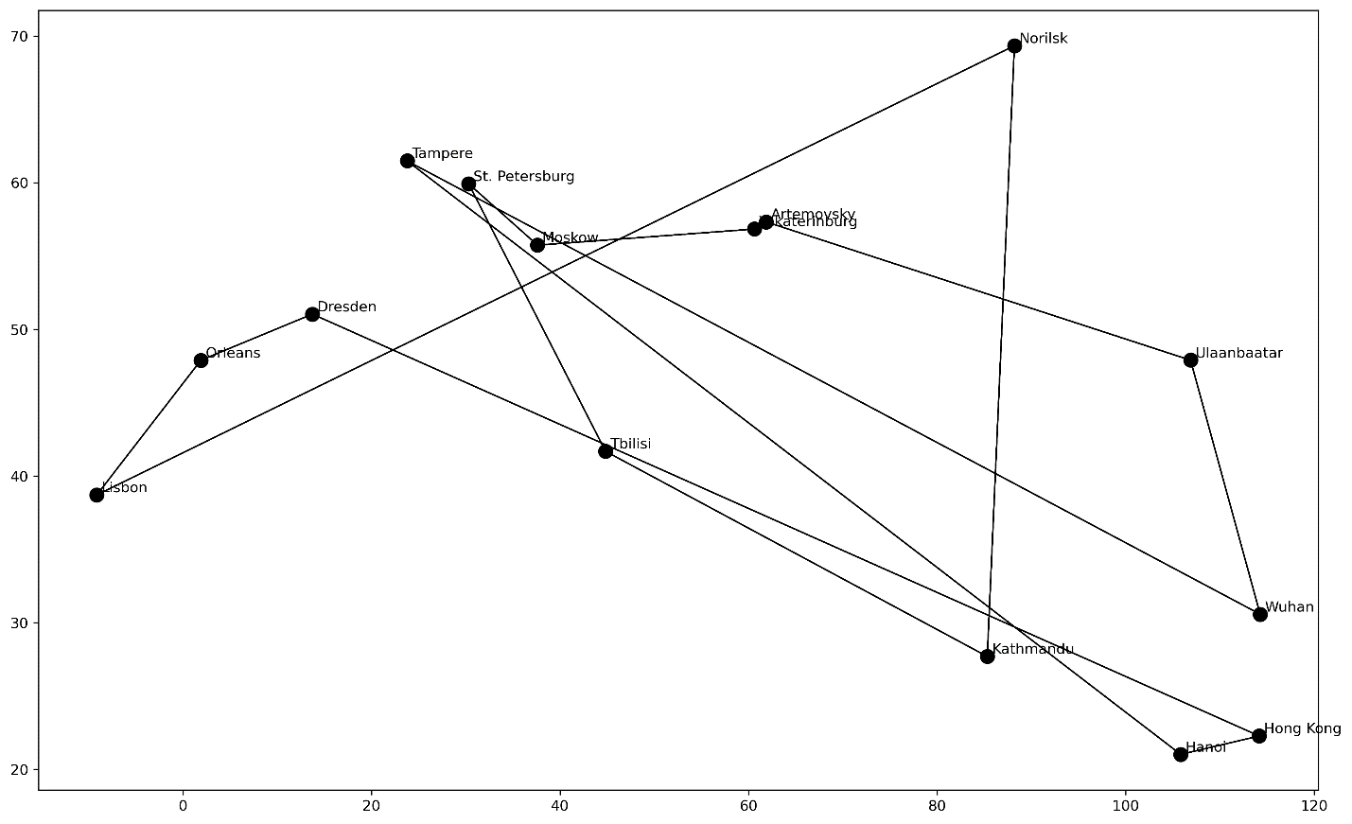

Рисунок 2 – Результат для первой итерации

Рисунок 3 – Результат для последней итерации

# Conclusion

При выполнении данного задания было изучено использование стохастических и метаэвристических алгоритмов (Simulated Annealing, Дифференциальная эволюция, оптимизация роем частиц) в задачах неограниченной нелинейной оптимизации и экспериментальное сравнение их с алгоритмами Нелдера-Мида и алгоритмами Левенберга-Марквардта.

Among the methods used, only the Levenberg-Marquardt algorithm did not reveal one of the "discontinuities" of the approximated function. It approximated the data almost straight. Consequently, this method does not always lead to close results and may not find the desired solution to the optimization problem.

Также при помощи метода имитационного отжига была решена Travelling Salesman Problem. К сожалению, данный алгоритм не учитывает географические особенности местности, например горы, мосты и траекторию дорог, поэтому оптимизировать передвижение путешественника он может лишь условно.

# Appendix

GitHub link: