Title Printing guide for the Voron Trident 1.9
Date 2021-12-09
Copy-rite None. Free domain. Be free.
Warranty None. Use at own risk. For entertainment purposes only
Author
Initial Stephen George (Original idea and creation)

Introduction
You order the parts and vitamins in the sourcing guide and while you are waiting you print the plastic parts, all 185 of them. The vitamins arrive and now you have to work out what goes where. Or you use this guide to print the parts as you need them, possibly the night before.

Print parameters (More details on page 4 of Trident manual)
Material ABS, Infill gyroid, Infill 40% Layer_height 0.2mm, Wall_count 4, Nossil 4mm, Top/bottom layers 5

The Rules
The first time a picture of the part is shown in the instructions it should be added to the list. After that it’s ignored as you should have already printed it.

The Machine the parts are for
Building Formbot kit, 250 x 250, Direct feed, Dragon High Flow, 3 hole cable chain.

Keeping track
The Printed ▢ tick box in the page number box is for your use.

It allows you to print out this pdf (without this header page) and tick off the parts as they come off the printer. Hopefully you won’t double print when you don’t want to.

Future Improvements to this doc
3) Time of print using a Prusa mini as a guide
Any other ideas please visit old.reddit.com/r/VORONDesign

Source files
https://github.com/LesserSpottedAustralianSquirel/voron_trident_pic
This include this .pdf and the source files

Notes
This is fan base documentation. The official document take precedence in any conflict of information or technical detail.

Silly quote
May your Voron print head always fly “straight and true”, never tire and crash the bed for a sleep.

Picture | Details | Page | Comment
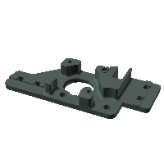 | Directory  STLs/Gantry/AB_Drive_Units  Filename  a_drive_frame_upper.stl  Manual name  A drive | 26  Done?  ▢ Yes | And  so it begins
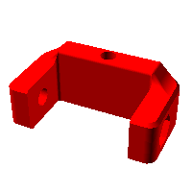 | Directory  STLs/Gantry/Front_Idlers  Filename  [a]_tensioner_left.stl  Manual name  none found | 27  Done?  ▢ Yes | NB Page 27  “Look for asterix next to the part.  It indicates that this is an accent part.”  Except * is not a good character in a file name, so they changed it to  Files starting with [a]
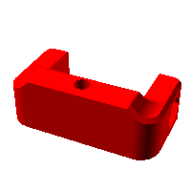 | Directory  STLs/Gantry/Front_Idlers  Filename  [a]_tensioner_right.stl  Manual name  none found | 27  Done?  ▢ Yes | Joke alert  Don’t print part  rm *  If you have no idea what I am talking about please ignore this note
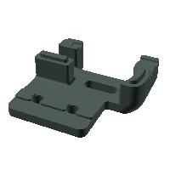 | Directory  STLs/Gantry/Front_Idlers  Filename  front_idler_a_x2.stl  Manual name  A idler | 28  Done?  ▢ Yes | x2
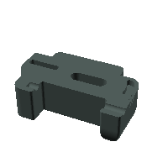 | Directory  STLs/Gantry/Front_Idlers  Filename  front_idler_b_x2.stl  Manual name  none found | 28  Done?  ▢ Yes | x2
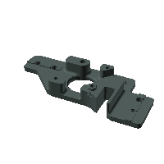 | Directory  STLs/Gantry/AB_Drive_Units  Filename  a_drive_frame_lower.stl  Manual name  A drive | 34  Done?  ▢ Yes
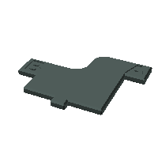 | Directory  STLs/Tools  Filename  AB_pulley_jig.stl  Manual name  none found | 35  Done?  ▢ Yes | tool
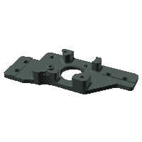 | Directory  STLs/Gantry/AB_Drive_Units  Filename  b_drive_frame_lower.stl  Manual name  B drive | 37  Done?  ▢ Yes
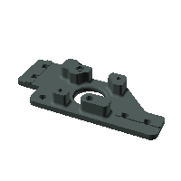 | Directory  STLs/Gantry/AB_Drive_Units  Filename  b_drive_frame_upper.stl  Manual name  B drive | 37  Done?  ▢ Yes
No Pic | T-Nuts M5  AKA  “Roll in” T nuts | 44  Done?  ▢ Yes | They don’t have to go into the end.  They can be “rolled in”.  No need to disassemble frame.
No Pic | Warning  Lone M3 on page  Pretending to be M5 | 44  Done?  ▢ Yes | Beware Of  Of the lone  lone M3 T-nut. Which I read as an M5 and had to get it back out
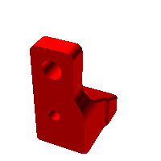 | Directory  STLs/Gantry/AB_Drive_Units  Filename  [a]_y_endstop_bumper.stl  Manual name  End stop | 50  Done?  ▢ Yes
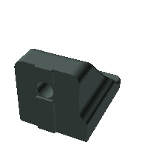 | Directory  STLs/Z_Assembly  Filename  z_rear_extrusionbracket_left.stl  Manual name  Rear brace | 53  Done?  ▢ Yes
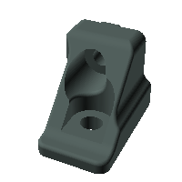 | Directory  STLs/Z_Assembly  Filename  z_rear_extrusionbracket_right.stl  Manual name  Rear brace | 53  Done?  ▢ Yes
 | Directory  STLs/Tools  Filename  MGN9_rail_guide_x2.stl  Manual name  Guide | 58  Done?  ▢ Yes | x2
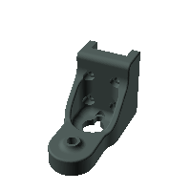 | Directory  STLs/Z_Assembly  Filename  z_carriage_rear_3hole.stl  Manual name  Generic Cable Chain | 64  Done?  ▢ Yes | Check directory for 2 hole version if required  on cable chain
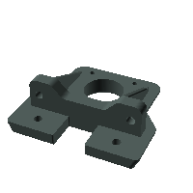 | Directory  STLs/Z_Assembly  Filename  z_stepper_rear.stl  Manual name  none found | 65  Done?  ▢ Yes
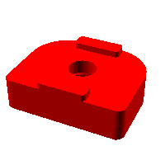 | Directory  STLs/Z_Assembly  Filename  [a]_z_rail_stop_x3.stl  Manual name  none found | 68  Done?  ▢ Yes | x3
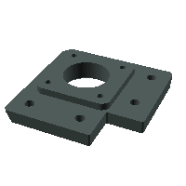 | Directory  STLs/Z_Assembly  Filename  z_stepper_left.stl  Manual name  none found | 69  Done?  ▢ Yes
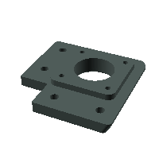 | Directory  STLs/Z_Assembly  Filename  z_stepper_right.stl  Manual name  none found | 73  Done?  ▢ Yes
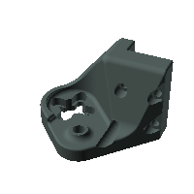 | Directory  STLs/Z_Assembly  Filename  z_carriage_left.stl  Manual name  Left Z joint | 77  Done?  ▢ Yes
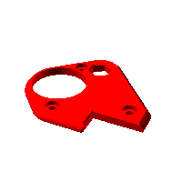 | Directory  STLs/Z_Assembly  Filename  [a]_z_carriage_left.stl  Manual name  none found | 77  Done?  ▢ Yes
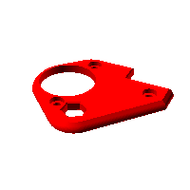 | Directory  STLs/Z_Assembly  Filename  [a]_z_carriage_right.stl  Manual name  none found | 79  Done?  ▢ Yes
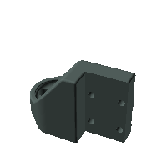 | Directory  STLs/Z_Assembly  Filename  z_carriage_right.stl  Manual name  none found | 79  Done?  ▢ Yes
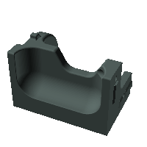 | Directory  STLs/Skirt  Filename  corner_a_x2.stl  Manual name  Feet | 90  Done?  ▢ Yes | x2
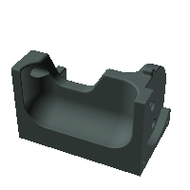 | Directory  STLs/Skirt  Filename  corner_b_x2.stl  Manual name  Feet | 90  Done?  ▢ Yes | x2
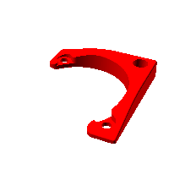 | Directory  STLs/Skirt  Filename  [a]_corner_baseplate_a_x2.stl  Manual name  none found | 90  Done?  ▢ Yes | x2
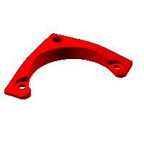 | Directory  STLs/Skirt  Filename  [a]_corner_baseplate_b_x2.stl  Manual name  none found | 90  Done?  ▢ Yes | x2
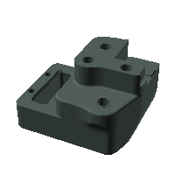 | Directory  STLs/Gantry/X_Axis/XY_Joints  Filename  xy_joint_left_lower_MGN12.stl  Manual name  Left XY Joint | 99  Done?  ▢ Yes
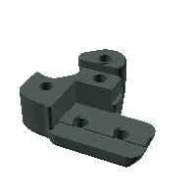 | Directory  STLs/Gantry/X_Axis/XY_Joints  Filename  xy_joint_left_upper_MGN12.stl  Manual name  none found | 99  Done?  ▢ Yes
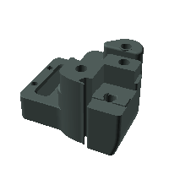 | Directory  STLs/Gantry/X_Axis/XY_Joints  Filename  xy_joint_right_lower_MGN12.stl  Manual name  Right XY Joint | 99  Done?  ▢ Yes
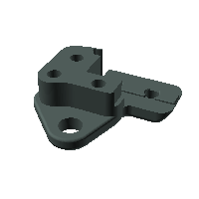 | Directory  STLs/Gantry/X_Axis/XY_Joints  Filename  xy_joint_right_upper_MGN12.stl  Manual name  none found | 99  Done?  ▢ Yes
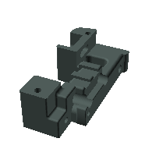 | Directory  STLs/Gantry/X_Axis/X_Carriage  Filename  x_carriage_frame_left.stl  Manual name  X Carriage | 99  Done?  ▢ Yes
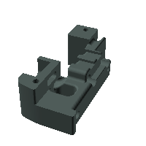 | Directory  STLs/Gantry/X_Axis/X_Carriage  Filename  x_carriage_frame_right.stl  Manual name  X Carriage | 99  Done?  ▢ Yes
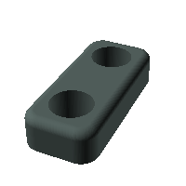 | Directory  STLs/Gantry/X_Axis/X_Carriage  Filename  probe_retainer_bracket.stl  Manual name  none found | 100  Done?  ▢ Yes | There are two similar shapes this one and the 9mm one  probe_retainer_bracket_9mm.st
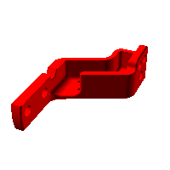 | Directory  STLs/Gantry/X_Axis/XY_Joints  Filename  [a]_xy_joint_cable_bridge_3hole.stl  Manual name  none found | 100  Done?  ▢ Yes | Check directory for 2 hole version if required for cable chain
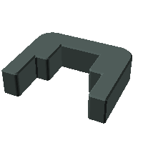 | Directory  STLs/Tools  Filename  MGN12_rail_guide_x2.stl  Manual name  none found | 113  Done?  ▢ Yes | x2
? |  | 129  Done?  ▢ Yes | I am guessing the blue part is a thermal fuse. Not an STL
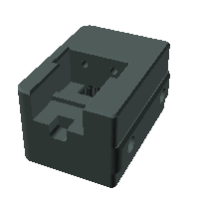 | Directory  STLs/Z_Assembly  Filename  nozzle_probe.stl  Manual name  none found | 130  Done?  ▢ Yes
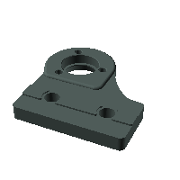 | Directory  STLs/Z_Assembly  Filename  z_bed_left.stl  Manual name  none found | 134  Done?  ▢ Yes
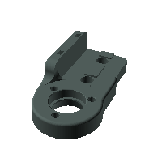 | Directory  STLs/Z_Assembly  Filename  z_bed_rear.stl  Manual name  none found | 136  Done?  ▢ Yes
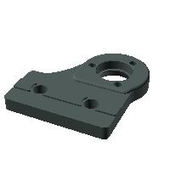 | Directory  STLs/Z_Assembly  Filename  z_bed_right.stl  Manual name | 138  Done?  ▢ Yes
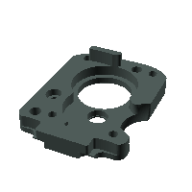 | Directory  STLs/Gantry/X_Axis/X_Carriage/Direct Feed  Filename  extruder_motor_plate.stl  Manual name  none found | 146  Done?  ▢ Yes
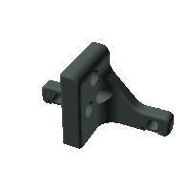 | Directory  STLs/Gantry/X_Axis/X_Carriage/  Direct Feed  Filename  chain_anchor_3hole.stl  Manual name  none found | 146  Done?  ▢ Yes | Check directory for 2 hole version if required
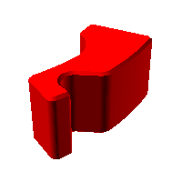 | Directory  STLs/Gantry/X_Axis/X_Carriage/  Direct Feed  Filename  [a]_latch_shuttle.stl  Manual name  none found | 146  Done?  ▢ Yes
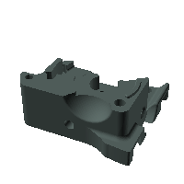 | Directory  STLs/Gantry/X_Axis/X_Carriage/  Direct Feed  Filename  extruder_body.stl  Manual name  none found | 147  Done?  ▢ Yes
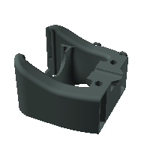 | Directory  STLs/Gantry/X_Axis/X_Carriage/Toolheads/Dragon  Filename  printhead_front_dragon.stl  Manual name  none found | 148  Done?  ▢ Yes | DRAGON mount  DO YOU HAVE A DRAGON hot end?
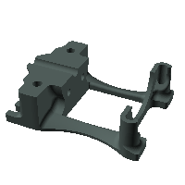 | Directory  STLs/Gantry/X_Axis/X_Carriage/Toolheads/Dragon  Filename  printhead_rear_dragon.stl  Manual name  none found | 149  Done?  ▢ Yes | DRAGON mount  DO YOU HAVE A DRAGON hot end?
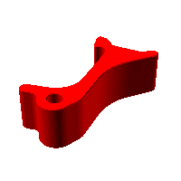 | Directory  STLs/Gantry/X_Axis/X_Carriage/Direct Feed  Filename  [a]_latch.stl  Manual name  none found | 161  Done?  ▢ Yes
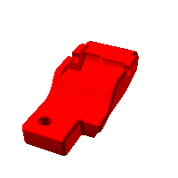 | Directory  STLs/Gantry/X_Axis/X_Carriage/Direct Feed  Filename  [a]_guidler.stl  Manual name  none found | 161  Done?  ▢ Yes
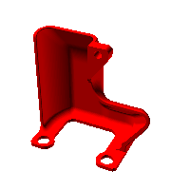 | Directory  STLs/Gantry/X_Axis/X_Carriage/Direct Feed  Filename  [a]_connector_cover.stl  Manual name  none found | 163  Done?  ▢ Yes
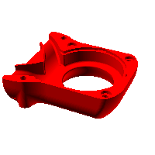 | Directory  STLs/Gantry/X_Axis/X_Carriage  Filename  [a]_blower_housing_front.stl  Manual name  none found | 167  Done?  ▢ Yes
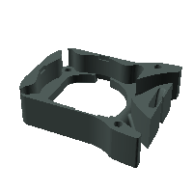 | Directory  STLs/Gantry/X_Axis/X_Carriage  Filename  blower_housing_rear.stl  Manual name  none found | 167  Done?  ▢ Yes
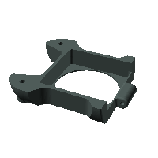 | Directory  STLs/Gantry/X_Axis/X_Carriage  Filename  hotend_fan_mount.stl  Manual name  none found | 168  Done?  ▢ Yes
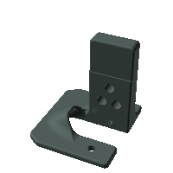 | Directory  STLs/Z_Assembly  Filename  z_cable_chain_mount_3hole.stl  Manual name  Z chain Anchor | 173  Done?  ▢ Yes | Check directory for 2 hole version if required
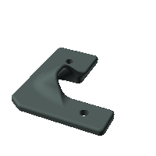 | Directory  STLs/Panels  Filename  wire_corner_left.stl  Manual name  cable cover | 175  Done?  ▢ Yes
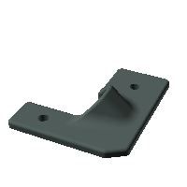 | Directory  STLs/Panels  Filename  wire_corner_right.stl  Manual name  none found | 176  Done?  ▢ Yes
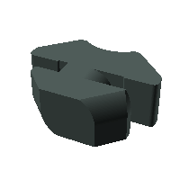 | Directory  STLs/ElectronicsBay  Filename  cable_frame_anchor_x6.stl  Manual name  none found | 178  Done?  ▢ Yes | x6
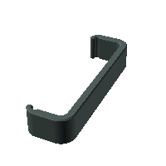 | Directory  STLs/ElectronicsBay  Filename  DIN_center_support_x2.stl  Manual name  none found | 181  Done?  ▢ Yes | x2
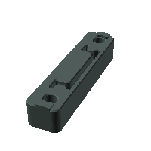 | Directory  STLs/ElectronicsBay  Filename  DIN_frame_mount_x4.stl  Manual name  none found | 181  Done?  ▢ Yes | x4
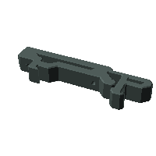 | Directory  STLs/ElectronicsBay  Filename  pcb_din_clip_v2_x5.stl  Manual name  none foundy | 189  Done?  ▢ Yes | x5
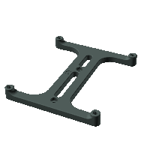 | Directory  STLs/ElectronicsBay  Filename  raspberrypi_bracket.stl  Manual name  none found | 198  Done?  ▢ Yes
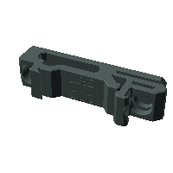 | Directory  STLs/ElectronicsBay  Filename  lrs_psu_bracket_x2.stl  Manual name  none found | 191  Done?  ▢ Yes | x2
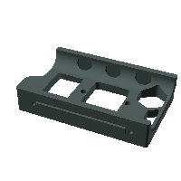 | Directory  STLs/Skirt  Filename  power_inlet_filtered.stl  Manual name  none found | 195  Done?  ▢ Yes
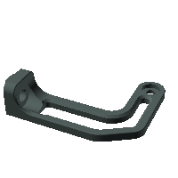 | Directory  STLs/ElectronicsBay  Filename  PSU_stabilizer_50mm.stl  Manual name  none found | 198  Done?  ▢ Yes
? | Springloaded  Can’t find | 199  Done?  ▢ Yes | Possibly not printed part
? | Springloaded  Can’t find | 199  Done?  ▢ Yes | Possibly not printed part
 | Directory  STLs/ElectronicsBay  Filename  raspberrypi_bracket.stl  Manual name  none found | 201  Done?  ▢ Yes | WARNING LOOKS NOTHING LIKE PICTURE IN MANUAL  I HAVE DONE SOMETHING WRONG
? | Can’t find | 202  Done?  ▢ Yes
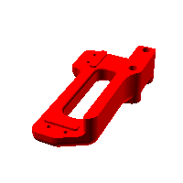 | Directory  STLs/Gantry/X_Axis/XY_Joints  Filename  [a]_endstop_pod_microswitch.stl  Manual name  none found | 203  Done?  ▢ Yes
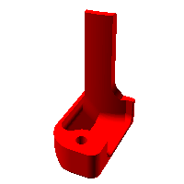 | Directory  STLs/Gantry/AB_Drive_Units  Filename  [a]_wire_cover.stl  Manual name  none found | 225  Done?  ▢ Yes
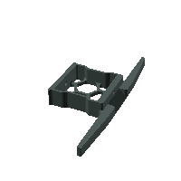 | Directory  STLs/Skirt  Filename  side_fan_support_x2.stl  Manual name  none found | 233  Done?  ▢ Yes | x2
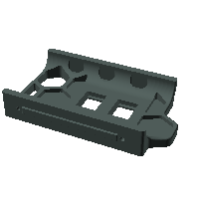 | Directory  STLs/Skirt  Filename  keystone_panel.stl  Manual name  none found | 233  Done?  ▢ Yes
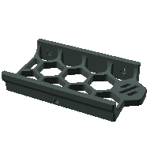 | Directory  STLs/Skirt/250  Filename  front_skirt_a_250.stl  Manual name  none found | 233  Done?  ▢ Yes | WARNING  250mm x 250mm  do you have this bed size?
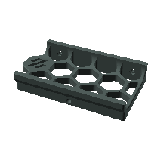 | Directory  STLs/Skirt/250  Filename  front_skirt_b_250.stl  Manual name  none found | 233  Done?  ▢ Yes | WARNING  250mm x 250mm  do you have this bed size?
? | LED Screen  Can’t find | 234  Done?  ▢ Yes
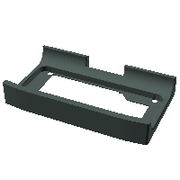 | Directory  STLs/Skirt  Filename  mini12864_case_front.stl  Manual name  none found | 234  Done?  ▢ Yes
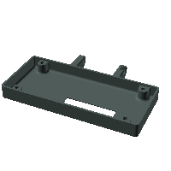 | Directory  STLs/Skirt  Filename  mini12864_case_rear.stl  Manual name  none found | 235  Done?  ▢ Yes
 | Can’t find round thing  You make my heart sing,  Wild thing. | 235  Done?  ▢ Yes
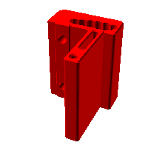 | Directory  STLs/Skirt  Filename  [a]_mini12864_case_hinge.stl  Manual name  none found | 236  Done?  ▢ Yes
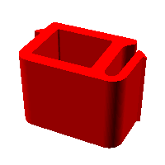 | Directory  STLs/Skirt  Filename  [a]_keystone_blank_insert_x2.stl  Manual name  none found | 237  Done?  ▢ Yes | x2
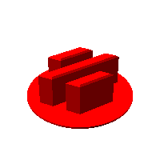 | Directory  STLs/Skirt  Filename  [a]_skirt_logo_x2.stl  Manual name  none found | 237  Done?  ▢ Yes | X2
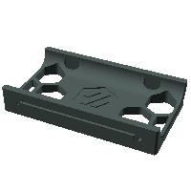 | Directory  STLs/Skirt  Filename  rear_center_skirt_250.stl  Manual name  none found | 241  Done?  ▢ Yes | WARNING  250mm x 250mm  do you have this bed size?
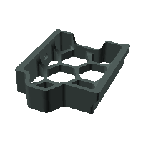 | Directory  STLs/Skirt  Filename  side_skirt_a_250_x2.stl  Manual name  none found | 242  Done?  ▢ Yes | WARNING  250mm x 250mm  do you have this bed size?  x2
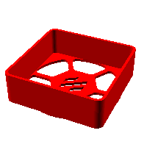 | Directory  STLs/Skirt  Filename  [a]_60mm_fan_blank_insert_x2.stl  Manual name  none found | 244  Done?  ▢ Yes | x2
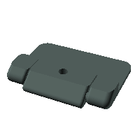 | Directory  STLs/Panels  Filename  bottom_panel_hinge_x2.stl  Manual name  none found | 250  Done?  ▢ Yes | x2
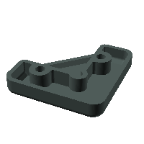 | Directory  STLs/Panels  Filename  corner_panel_clip_4mm_x8.stl  Manual name  none found | 254  Done?  ▢ Yes | Warning 4mm or 6mm part?  x8
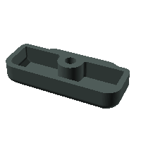 | Directory  STLs/Panels  Filename  midspan_panel_clip_4mm_x7.stl  Manual name  none found | 254  Done?  ▢ Yes | Warning 4mm or 6mm part?  x7
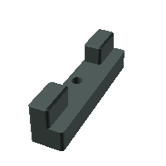 | Directory  STLs/Panels/Front_Doors  Filename  latch_x2.stl  Manual name  none found | 263  Done?  ▢ Yes | x2
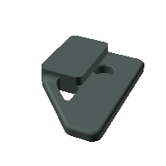 | Directory  STLs/Panels/Front_Doors  Filename  handle_a_x2.stl  Manual name  none found | 263  Done?  ▢ Yes | x2
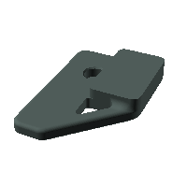 | Directory  STLs/Panels/Front_Doors  Filename  handle_b_x2.stl  Manual name  none found | 263  Done?  ▢ Yes | x2
 | Directory  STLs/Panels/Front_Doors  Filename  latch_x2.stl  Manual name  none found | 263  Done?  ▢ Yes | x2
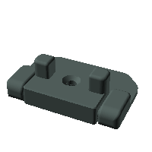 | Directory  STLs/Panels/Front_Doors  Filename  door_hinge_x6.stl  Manual name  none found | 265  Done?  ▢ Yes | x6
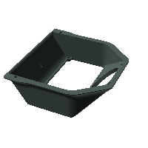 | Directory  STLs/Exhaust_Filter  Filename  exhaust_filter_housing.stl  Manual name  none found | 268  Done?  ▢ Yes
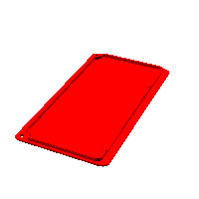 | Directory  STLs/Exhaust_Filter  Filename  [a]_filter_access_cover.stl  Manual name  none found | 270  Done?  ▢ Yes
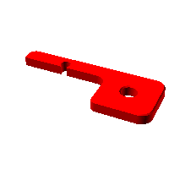 | Directory  STLs/Exhaust_Filter  Filename  [a]_exhaust_filter_mount_x2.stl  Manual name  none found | 272  Done?  ▢ Yes | x2
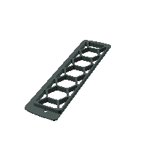 | Directory  STLs/Exhaust_Filter  Filename  exhaust_filter_grill.stl  Manual name  none found | 272  Done?  ▢ Yes
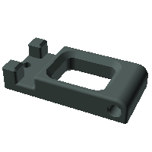 | Directory  STLs/Exhaust_Filter  Filename  bowen_retainer.stl  Manual name  none found | 275  Done?  ▢ Yes
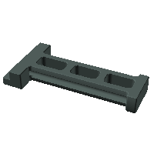 | Directory  STLs/Exhaust_Filter  Filename  spool_holder.stl  Manual name  none found | 276  Done?  ▢ Yes
 | Steve | 280  Done?  ▢ Yes | Man in the red shirt. Well reddish.  It’s in that spectrum
 | Eddie | 280  Done?  ▢ Yes | This is not a red shirt
 | Dunar | 280  Done?  ▢ Yes | Support structure may be required for the beard.
 | [a]_Russiancatfood  Manual name  Maks Zolin | 280  Done?  ▢ Yes | May require multiple materials  Fearless leader

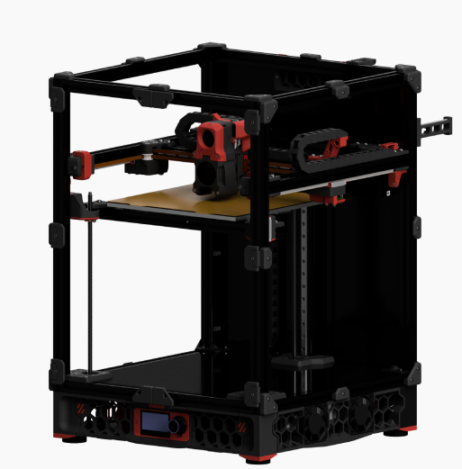

Done!

I have one question for you.

Did you print the tool on page 58 in the accent colour?

▢ Yes, because it’s cool

▢ No, Mr George, Because I am on to you

Place ✓ above

