High-Frequency Limit Order Book Dynamics: An Evolutionary Machine Learning Approach

Abstract
Traditional predictive models in prediction markets often fail due to extreme high-frequency noise and a focus on absolute price outcomes. This paper proposes a micro-structural trading framework targeting short-term mid-price returns (r_{t, t+5}). By engineering regime-agnostic relative features (e.g., Micro-Price Imbalance, BSM Mispricing) and employing strict liquidity filters, we eliminate macro-trend overfitting. We utilize an evolutionary ablation study—progressing from XGBoost to Multi-Layer Perceptrons (MLP) and Long Short-Term Memory (LSTM) networks—to isolate the predictive contributions of non-linear feature crossing versus 60-second temporal memory. Furthermore, we address the misalignment between global Mean Squared Error (MSE) loss and our quantile-based execution strategy, providing insights into the robustness of tree-based models in noisy tabular environments.

1. Introduction: The Mission
In high-frequency prediction markets (e.g., Polymarket), order book dynamics evolve in milliseconds. Instead of predicting the final resolution of a contract—which is susceptible to long-term macro shifts—our objective is to capture fleeting, localized pricing inefficiencies. Our mission is strictly defined as predicting the 5-second forward mid-price return, denoted as $r_{t, t+5}$.
This precise, short-term objective dictates our entire methodology. We are not investors holding contracts to expiry; we are high-frequency liquidity takers (or makers) seeking to exploit transient order book imbalances before the market reaches equilibrium. Consequently, our data engineering and model selection must explicitly serve this high-frequency, relative-value trading philosophy.

2. Data Philosophy: Regime-Agnostic and Tradable
The previous iteration of this research detailed exhaustive data cleaning steps. Here, we distill our data pipeline into two core philosophies that fundamentally differentiate our approach.

2.1 Regime-Agnostic Feature Engineering (Relative vs. Absolute)
Machine learning models are prone to memorizing absolute price levels (e.g., "Buy when BTC is at $60,000"), which leads to catastrophic failures during regime shifts. To prevent this, we ruthlessly purged all absolute price features from our dataset, including the underlying oracle price and contract strike prices.
Instead, we engineered a purely Relative Feature Space, focusing on three dimensions:
- Microstructure Imbalance: E.g., Micro_Price_Imbalance (Micro-price minus Mid-price), capturing immediate buying/selling pressure.
- Theoretical Mispricing: E.g., BSM_Mispricing, the deviation between the Black-Scholes-Merton theoretical option value and the actual market bid/ask.
- Momentum & Volatility: 15-second momentum and 1-second Exponentially Weighted Moving Average (EWMA) realized volatility.

2.2 Tradability Filtering (The Sniper Approach)
A statistically accurate prediction is worthless if the market is illiquid. We designed a strict filter to ensure our models only train on, and predict for, highly active market states:
- Warm-up Exclusions: We removed the first hour of global data and the first 60 seconds of every individual contract to allow rolling metrics (like EWMA) to stabilize.
- Illiquidity & Extreme Probability Exclusions: We excluded periods with excessively wide bid-ask spreads (> 0.03$) and contracts deep in-the-money or out-of-the-money (prices $> 0.98 or $< 0.02). This prevents the model from learning "garbage time" noise where friction costs would negate any theoretical edge.

3. Model Architecture: An Evolutionary Ablation Study
Rather than arbitrarily applying complex deep learning architectures, we designed an evolutionary ablation study to explicitly quantify where the alpha originates.

3.1 The Cross-Sectional Baseline: XGBoost
We established XGBoost as our primary baseline to evaluate cross-sectional feature interactions at time t. Interestingly, our empirical backtests revealed a distinct behavioral signature for the tree-based ensemble. Rather than exhibiting consistent "robustness" (i.e., a high win rate across all trades), XGBoost demonstrated a strong capacity for fat-tail capture (asymmetric payoff). When executing the Top 10% signals, the post-fee win rate was relatively low, indicating a high false-positive rate amid market microstructure noise. However, the overall Profit and Loss (PnL) remained significantly positive. This suggests that XGBoost’s discrete tree-splitting mechanism is highly adept at isolating specific, high-magnitude price jumps, compensating for frequent small friction losses with occasional massive gains.

XGBoost:
RMSE: 0.327701 MAE: 0.070471 R^2: 0.000590
Rank IC: 0.1223 Directional accuracy: 50.77%

3.2 The Neural Bridge: Multi-Layer Perceptron (MLP)
To transition from trees to deep sequence models, we introduced an MLP. The MLP operates on the same cross-sectional single-time-step data as XGBoost. By comparing the MLP to XGBoost, we isolated the efficacy of deep, non-linear feature crossing within neural architectures, independent of time. This step verified that our engineered features were compatible with gradient descent optimization before adding the complexity of sequence windows.

MLP:
RMSE: 0.327518. MAE: 0.069295. R^2: 0.001710
Rank IC: 0.2025. Directional accuracy: 59.48%

3.3 Temporal Dynamics: LSTM with a 60s Window
Having validated the cross-sectional signals, we introduced the temporal dimension using an LSTM. By feeding the model a rolling 60-second sequence [t-60, t], the LSTM is tasked with capturing dynamic liquidity vacuums and order flow momentum. Unlike standard Recurrent Neural Networks (RNNs) which suffer from information dilution over 60 steps, the LSTM's gating mechanisms effectively filter out transient micro-vibrations, retaining only the structural order book shifts that precede a 5-second price jump.

RNN:
RMSE: 0.341496 MAE: 0.072100 R^2: -0.000028
Rank IC: 0.1954 Directional accuracy: 59.26%
LSTM:
RMSE: 0.341964 MAE: 0.072208 R²:-0.0028
Rank IC: 0.2209 Directional Accuracy: 60.19%

3.4 Alignment of Objective Functions and Execution Strategy
A critical reflection in our research pertains to the Loss Function. Our downstream trading execution relies on a Quantile Strategy: we only take positions when the model's prediction falls within the Top 10% (Long) or Bottom 10% (Short) of confidence intervals.
Standard models are trained to minimize global Mean Squared Error (MSE), meaning they spend computational effort fitting the middle 80% of mundane, flat-line market movements—which we never intend to trade. Future iterations of this pipeline should explore tail-focused loss functions (e.g., weighted MSE or Pairwise Ranking Loss) to force the network to explicitly optimize for the extreme 10% tail events that dictate actual profitability.

4. Backtesting and Realistic Frictions
To translate predictive signals into actionable insights, we simulated a high-fidelity out-of-sample backtest. We applied the aforementioned Quantile Strategy (Top/Bottom 10%) against realistic market frictions. We modeled a dynamic fee structure utilizing the formulation Fee = P * (1 - P) * C * 0.072, accounting for the distinct difference between Maker rebates and Taker fees in crypto prediction markets.
XGBOOST:
Win rate: 42.72%
Gross P&L sum: 534.709012 Trade_cost_sum: 158.721998 Net_pnl_sum: 375.987015
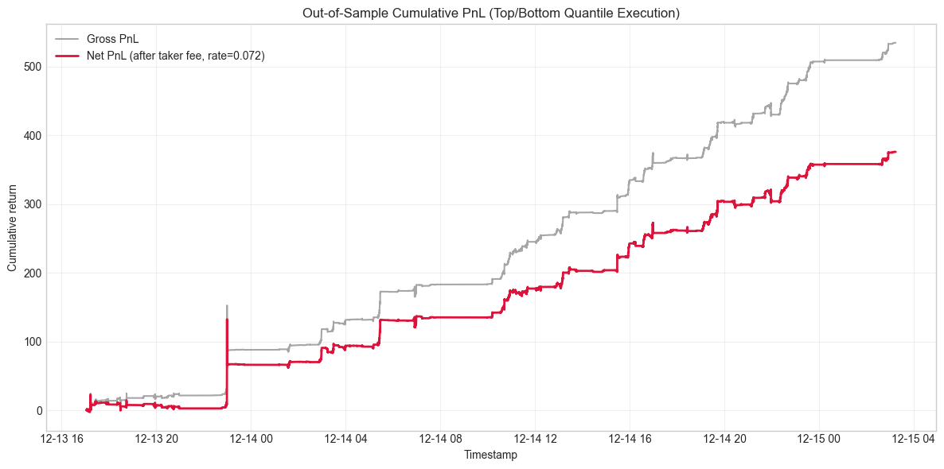
MLP:
Win rate: 50.94%
Gross P&L sum: 341.210328 Trade_cost_sum: 155.312451 Net_pnl_sum: 185.897877
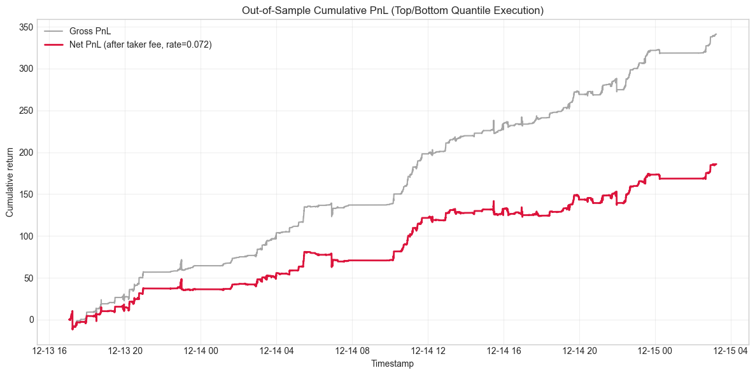
RNN:
Win rate: 49.02%
Gross P&L sum: 132.348678 Trade_cost_sum: 146.113898 Net_pnl_sum: -13.765220

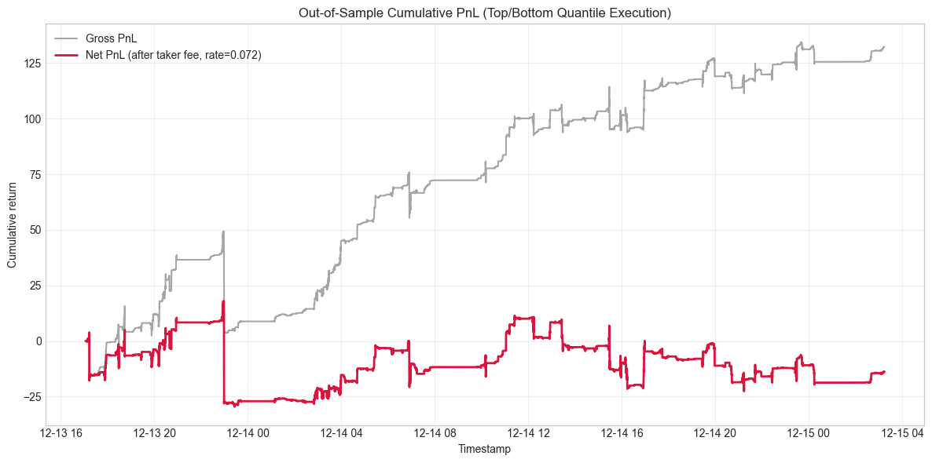
LSTM:
Win rate: 52.16%
Gross P&L sum: 418.0846 Trade_cost_sum: 134.8655 Net_pnl_sum: 283.2191

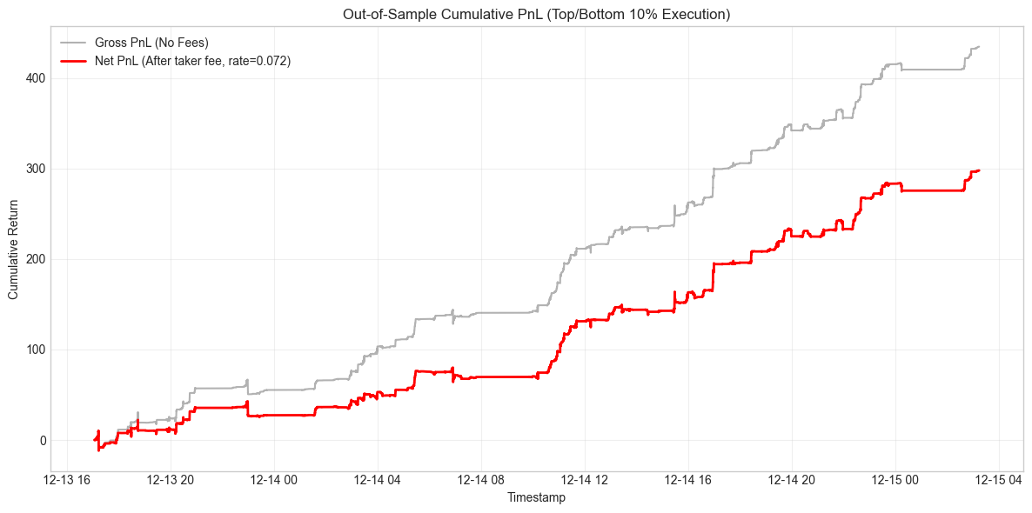

5. Conclusion
By redefining the prediction task to target relative 5-second mid-price returns, we successfully extracted tradable microstructure alpha. Our evolutionary ablation study yielded critical insights into model behavior under severe market friction. We discovered an explicit trade-off between architectural types: while deep sequence models (LSTM) excel at filtering continuous order flow dynamics via their 60-second temporal memory, tree-based models (XGBoost) behave as highly effective "extreme event triggers." Although XGBoost suffers from a lower post-fee win rate, its architectural tendency to isolate fat-tail pricing anomalies generates highly asymmetric payouts. Future research will focus on ensembling these distinct characteristics—utilizing LSTM for directional stability and XGBoost for extreme magnitude triggering—while developing custom loss functions tailored specifically for quantile-based execution.

