**MATLAB ASCII Art Tool**

This MATLAB GUI script helps to produce ASCII Art text files based the images users provided. Run AsciiArt.m to start.

To make an ASCII Art file, open an image first.

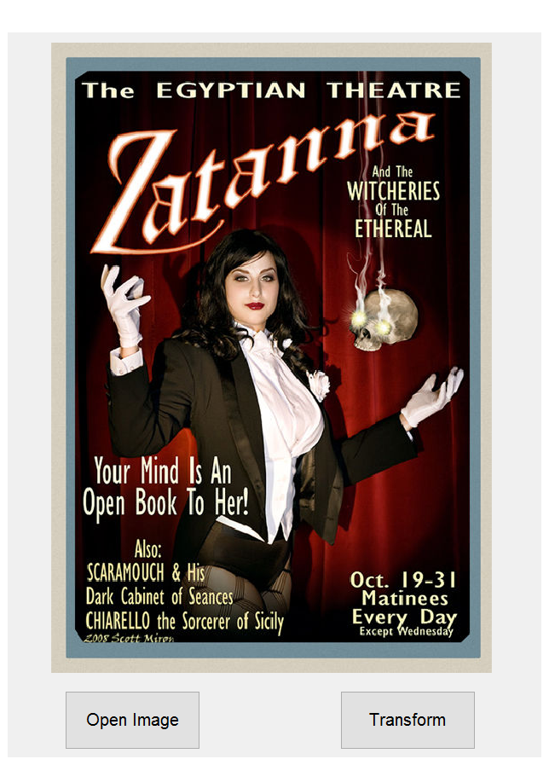

Then click ‘Transform’ button; once the transformation is completed, a message box will be shown:

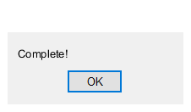

Then you may choose whether to see the preview or not:



Once you click on ‘Yes’ button, a preview will be shown in the Command Window.

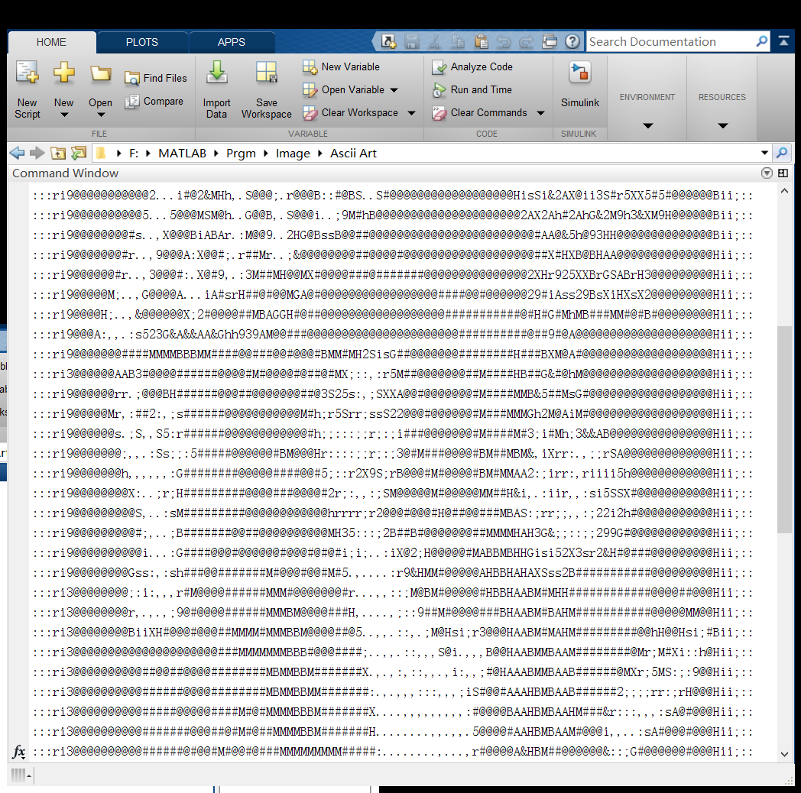

After that (no matter if you chose ‘Yes’ or ‘No’), a ‘Save’ button will be shown and you may save your ASCII Art file. 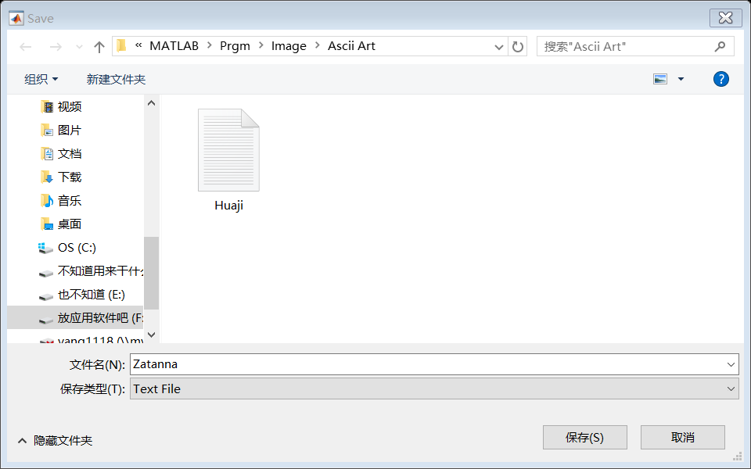

Another message box will be shown since the *.txt file is saved.



After editing the current image, you can continue to open another image and produce ASCII Art based on it.

Followed is the ASCII Art produced by the example image:

