**DSA302 Project Report**

Group Members:

|  |  |
| --- | --- |
| **Name** | **Student ID** |
| Chen Yupeng | 01336721 |
| Lester Ye Ge | 01337915 |
| Deanna Seng See Yin | 01450555 |

**1. Portfolio Asset Selection**

1.1 Initial Portfolio Selection

Our group initially selected a portfolio consisting of ten ETFs representing ten asset sub-classes. Amongst these ten asset sub-classes, there were three equities ETFs; two bond ETFs; two real-estate ETFs; and three currency ETFs. The three equities ETFs, QQQ, FEZ and AIA tracks the NASDAQ-100 index, EURO STOXX-50 index and S&P Asia 50 index respectively. The two bond ETFs, FXNAX and SEGA.MI, tracks Bloomberg Barclays U.S. Aggregate Bond Index and Bloomberg Barclays Euro Treasury Bond Index respectively. The two real-estate ETFs, VNQ and IQQP.DE tracks the MSCI US Investable Market Real Estate 25/50 Index and FTSE EPRA Nareit Developed Europe ex UK Index. Lastly, the three currency ETFs, UUP, FXE, and FXY are the Invesco currency trust ETFs for US dollar, Euro, and Japanese Yen respectively. These asset sub-classes have been summarised in the following table.

|  |  |  |  |  |
| --- | --- | --- | --- | --- |
| **Name of ETF** | **Underlying Index** | **Ticker Symbol** | **Fund Type/Index Description** | **Sub-asset Class** |
| Invesco QQQ Trust Series 1 | NASDAQ-100 | QQQ | ETF. Nasdaq-100 is an index comprising 100 of the largest non-financial companies list on Nasdaq Stock Market. | Equities – US |
| SPDR Euro Stoxx 50 ETF | EURO STOXX-50 | FEZ | ETF. EURO-STOXX 50 is a stock index of 50 largest and most liquid Eurozone stocks. | Equities – EU |
| iShares Asia 50 ETF | S&P Asia 50 | AIA | ETF. S&P50 Asia is a stock index of 50 leading blue-chip companies in mostly Hong Kong, Korea, Singapore and Taiwan. | Equities – Asia |
| Fidelity® U.S. Bond Index Fund | Bloomberg Barclays U.S. Aggregate Bond Index | FXNAX | ETF. The Bloomberg U.S. Aggregate Bond Index is an market value-weighted index for U.S. dollar denominated investment-grade fixed-rate debt issues. Returns are mostly in form of interests dividend | Bonds – US |
| iShares Core Euro Govt Bond UCITS ETF | Bloomberg Barclays Euro Treasury Bond Index | SEGA.MI | ETF. Underlying index composes of Eurozone investment grade government bonds | Bonds – EU |
| Vanguard Real Estate Index Fund ETF | MSCI US Investable Market Real Estate 25/50 Index | VNQ | ETF. Underlying index is designed to capture the large, mid and small cap segments of U.S. equities | Real Estate – US |
| iShares European Property Yield UCITS ETF EUR Dist | FTSE EPRA Nareit Developed Europe ex UK Index | IQQP.DE | ETF. Underlying index composes of listed real estate companies and REITs of developed European countries, excluding the UK. | Real Estate – UK |
| Invesco DB US Dollar Index Bullish Fund | U.S. Dollar Index (DXY) | UUP | ETF. Comprises long USD futures contracts against the currency basket. | Currency - USD |
| Invesco CurrencyShares Euro Trust ETF | - | FXE | ETF. Comprises Euro currency as the asset held by the fund. | Currency – Euro |
| Invesco CurrencyShares Japanese Yen Trust | - | FXY | ETF. Comprises Yen currency as the asset held by the fund. | Currency – Yen |

Table 1: Overview of initial portfolio composition

1.1.1 Ideology behind initial portfolio

The initial portfolio was designed to achieve a wide spectrum of expected returns whilst minimising the portfolio standard deviation by addition of various other asset sub-classes. The equities ETFs chosen tracks underlying indices which comprises only a few, largest stocks (less than 100) with the purpose of contributing higher returns to the portfolio despite its high standard deviation (as Nasdaq-100 is highly tech-sector biased). This was the desired purpose for adding the other two equities ETFs as well. The currency ETFs were added due to their low standard deviations and low correlations with other stocks in the portfolio. The bond ETFs generally have very good Sharpe Ratio (low standard deviation and better returns than currency ETFs).

1.1.1 Optimisation result

The result of the first optimisation, however, was not very ideal – the global minimum portfolio has a portfolio expected return of approximate 0.00% and standard deviation of 0.062

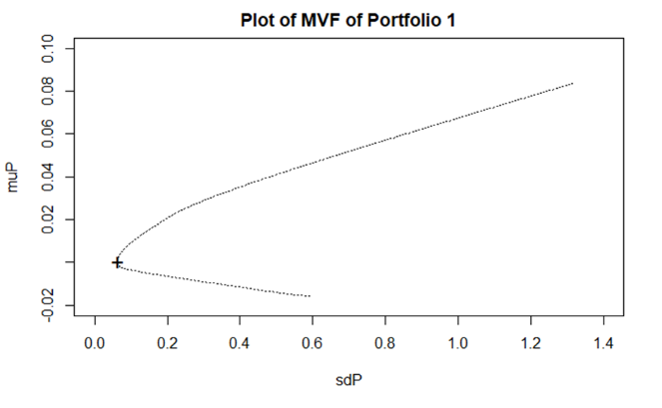

Fig 1: Comparison of portfolio of 10 assets against portfolio of components

In the above figure, the top left plot shows the Minimum Variance Frontier (MVF) of the portfolio of 10 assets (portfolio 1) while the top right shows a comparison of the plot of MVFs of portfolio 1 against its component portfolio consisting of only the equities and bonds ETFs (total of 5 asset sub-classes). From the result, we can see that **addition of the currency ETFs did help to diversify our portfolio with a Southwest shift of the MVF** after the addition of the three ETFs (even though the ideal shift would be a Northwest shift indicating a better global minimum portfolio in terms of higher portfolio return and lower variance).

The bottom plot was the top right plot with the inclusion of the MVF of portfolio consisting of equities, bonds, and currencies ETFs. Visually, it seems as though there were only two MVFs plotted. This, however, is due to the fact that the MVF for the equities, bonds and currencies portfolio largely overlaps with portfolio 1 (consisting of 10 assets). The global minimum portfolios for these two MVFs have a difference of 0.001% in portfolio return and 0.0002 in portfolio standard deviation. This not only confirmed our point above that inclusion of currency ETFs helped to diversify the portfolio, but at the same time, also showed that the **inclusion of the real-estate ETFs did not help to improve the portfolio**.

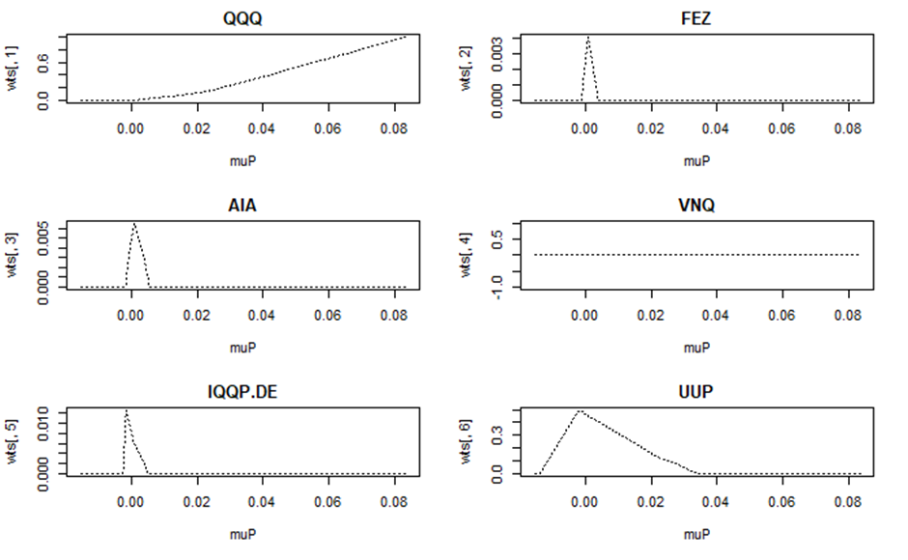

Fig 2: Change of asset weights in optimisation with change in portfolio return of portfolio 1

The figure above is a collection of plots of the changes in the weights of different asset sub-classes in portfolio one during the optimisation (with gradually increasing portfolio returns). As can be observed, the assignment of weights in this portfolio is not very robust, with ETFs such as UUP and FXE taking extremely heavy weights at low portfolio returns, and QQQ contributing to almost all the weights of the portfolio at higher returns. The US bonds ETF took up majority of the weights in the mid segment of this range of portfolio returns. Real-estate ETF VNQ was assigned 0 weight (and IQQP.DE almost 0 weight as well) throughout the entire interval. This explains the MVF plot which showed that the same MVF for portfolio with and without inclusion of real-estate ETFs.

1.1.2 Observations

Table 2: Sharpe Ratio, Standard Deviation, Expected Return of asset subclasses in Portfolio 1

Fig 3: Correlation Plot of 10 ETFs

We have developed a few explanations for our observations above. Looking at the above table, we observe that the reason why currency ETFs are assigned huge weights at low portfolio returns (and at negative returns of the interval), is because they are only ETFs with negative expected returns (and the leftmost of portfolio return interval for optimisation is negative). If we do not include negative returns in our optimisation, then these FXE and FXNAX will not be assigned any weights at all. UUP is assigned heavy weights at low, positive portfolio returns because it has extremely low standard deviation. As the portfolio return increases, these assets do not contribute sufficient returns to achieve the target, pre-set portfolio return (portfolio return is fixed as our constraint in optimisation) and therefore they are not assigned any weights as return target increases along the MVF.

However, these **currency ETFs provide diversification of risk to our portfolio** as they have negative correlation (except FXE) with majority of the other assets in the portfolio. However, due to their negative returns, our team has decided to only include UUP in our next portfolio. We can see that QQQ has extremely high returns compared to our other assets (and also the best Sharpe ratio), and therefore it is as expected that QQQ will gradually be assigned heavier weights as portfolio returns increases along the MVF. FXNAX and SEGA.MI both have good Sharpe ratios, and therefore these two assets carry heavy weights in the mid-range of portfolio returns. As SEGA.MI has worse Sharpe ratio and positive correlation with QQQ, SEGA.MI is almost assigned no weights as FXNAX serves the purpose of SEGA.MI (moderate returns; good sharpe ratio; negative correlation with quality asset QQQ).

We can summarise our observations into 3 points:

1. **Assets with the best Sharpe ratios are quality assets** which will be assigned weights. Assets with low Sharpe ratios and positive correlation with assets of high Sharpe ratio will be assigned almost no weight in most of the points on the MVF. Drastic differences in Sharpe ratio and expected returns will cause the weight assignments to be imbalanced (some assets will take almost all the weights while others take none).
2. **Adding assets which has negative correlations** with other portfolio assets (e.g. currency assets) improves MVF by **decreasing portfolio variance**.
3. Adding one more of the same asset sub-class is redundant if they have similar returns, standard deviations, and correlations with other assets. This is because only the better asset will be used. This is seen later when we created a new portfolio with fewer assets but achieved the same MVF as the current 10-ETF portfolio.

The reason why we would want to have a more balanced assignment of weights is because we can only limit portfolio weights of certain assets (as tasked in the project guideline; implementing holdings constraints) if the distribution of weights is not too concentrated in one or two assets. Else, there will be no solution to the quadratic problem for that particular range of expected portfolio returns.

**2. Portfolio Performance Analysis**

2.1 Tidying of Portfolio

We removed the Real-Estate, Euro-equities, and Asian-equities ETFs from portfolio 1 to create a new portfolio consisting of 6 assets. The reason for the removal of Europe and Asian equities is due to their high, positive correlation with QQQ.

Even though we were not able to shift the MVF of the portfolio further Southwest (As we were unable to find identify ETFs with better Sharpe Ratio as we are constrained by the scope of the project in the types of asset sub-classes to choose from), however, we managed to create the same MVF using fewer assets (As seen below, the two MVFs from the old and new portfolio are almost the same, with the new portfolio consisting of only 6 assets).

Fig 4: Comparison of MVP of new and old portfolio

Fig 5: Plot of new portfolio asset weights along MVF

With the new portfolio, we are now able to locate a region of expected portfolio return between 0% to 0.04% (daily return) between which most of the ETFs in our portfolio have a relatively balanced weight assignment. We then used this range of expected portfolio returns to implement holding constraints and observe the changes to the MVF of the portfolio.

2.2 Implementing Holding Constraints

Fig 6: MVF Comparison of 10% equity holding constraint vs no constraint

Fig 7: Asset weight with 10% equity holding constraint vs no constraint

The above plot shows the visual comparison of the two MVFs. We can see that there is almost no difference in the MVF of the portfolio after adding the **inequality holding constraint of less than 0.1 weight on QQQ**. As can be seen from the red line which indicates the constrained portfolio, QQQ’s weight is capped at 0.1 and returns are compensated with an increase in SEGA.MI (European bonds) and FXNAX. At the same time, we noticed that weights of FXE and UUP start to decrease at a faster rate with the constraint becoming binding. This is because these two ETFs contributes to reducing portfolio variance with their negative correlation with QQQ, and the reduction of QQQ weights decreased the ability of these two ETFs to decrease portfolio variance.

2.3 Risk-Free Asset

Fig 8: Plot of tangency portfolio with risk-free asset

From the risk-free rate of 0.05% (3-month treasury yield as of November 5, 2021), we plot the Security Market Line (SML) along the tangent of the MVF to create the tangency portfolio (TP). The SML traces the portfolio expected-return and portfolio standard deviation locus of a portfolio consisting of the risk-free asset and the tangency portfolio. With the TP, we obtain the optimised portfolio weights below:

|  |  |  |  |  |  |
| --- | --- | --- | --- | --- | --- |
| QQQ | UUP | FXE | FXY | FXNAX | SEGA.MI |
| 0.1266 | 0.1288 | 0.0000 | 0.0000 | 0.6708 | 0.0739 |

Table 3: Weights of tangency portfolio

The mean and standard deviation of the optimised portfolio is calculated as 0.0216 and 0.209 respectively.

2.3.1 Inflation Rate

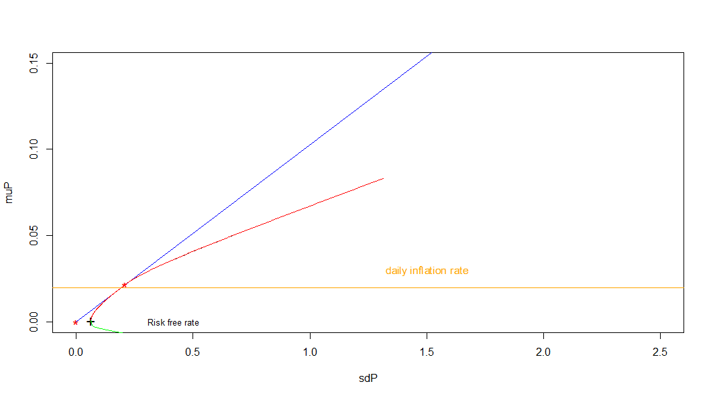Taking inflation rate of 5% as of May 2021, we derive the daily inflation rate to be 0.019841. Plotting the daily inflation rate on the MVF, we obtain the following figure:

Fig 9: Plot of tangency portfolio with risk-free asset and inflation rate

From figure 9, we observe that the daily inflation of 0.019841 is slightly below the tangency portfolio’s mean, 0.0216. When adjusting the daily returns for inflation, the tangency portfolio mean shifts to 0.001759. Therefore, we note that while our nominal daily returns for our optimised portfolio have been decent, our real daily returns were much lower after accounting for inflation.

2.4 Performance Ratios

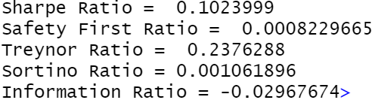

Fig 10: Portfolio Performance Ratios

Fig 11: Performance Ratios of S&P500 ETF over the same period

We obtained the standard deviation and mean at the point at which the SML tangents the MVF. Using the optimal weights, we calculated the optimal weighted return of our portfolio. With these values, we evaluated the performance of our portfolio by using the following risk-adjusted performance measures: Sharpe Ratio, Roy’s Safety First Ratio, Treynor ratio, Sortino ratio and Information ratio. For our benchmark, we selected SP500’s returns in the same period as the benchmark returns.

**Sharpe Ratio**

Compared to the benchmark sharpe ratio, our portfolio’s sharpe ratio is much higher, suggesting that it’s risk-adjusted performance is better.

**Safety First Ratio**

Our portfolio’s safety first ratio is slightly lower than the benchmark’s safety first ratio. This means our portfolio is slightly less likely to hit the required minimum return.

**Treynor ratio**

Given that the Treynor ratio is positive, our portfolio is less sensitive to market risk.

**Sortino ratio**

Our portfolio’s ratio is higher than that of the benchmark’s. Hence, given the downside deviations of both assets, our portfolio is returning more efficiently.

**Information ratio**

Since our information ratio is negative, this means that it was unable to produce excess returns.

Overall, the performance of our portfolio based on these risk-adjusted yardsticks is better than the benchmark return’s performance, making it a suitable investment.

2.5 Portfolio Limitations

The tangency portfolio only works well when our estimations of the means and variances of the asset components of the portfolio is accurate. However, in the short-term, the means and variances of the assets used in the portfolio may likely have significantly different means and variances as that which we have estimated using the historical data of ten years.

Additionally, the correlations between assets of the portfolio may also change significantly during special economic events. Once example of such would be during the start of the Covid-19 pandemic which spurred a huge sell-off in many different asset markets (equities, bonds) in March 2019. During such periods, the assets are likely to become highly correlated during such frenzy sell-offs. The tangency portfolio is not designed to outperform benchmarks and other portfolios during such events.

**3. Declaration**

Each member of this group contributes honestly and fairly to the completion of this report.

**References**

Resolve Asset Management. (n.d.). PORTFOLIO OPTIMIZATION: SIMPLE VERSUS OPTIMAL METHODS. Retrieved from Resolve Asset Management: <https://investresolve.com/portfolio-optimization-simple-optimal-methods/>

Fama, Eugene, and Kenneth French. 1988. “Permanent and Temporary Components of Stock Prices.” Journal of Political Economy 96. <https://teach.business.uq.edu.au/courses/FINM6905/files/module-2/readings/Fama>: 246–73.

Haugen, R., and N. Baker. 1991. “The Efficient Market Inefficiency of Capitalization-Weighted Stock Portfolios.” Journal of Portfolio Management 17. <http://dx.doi.org/10.3905/jpm.1991.409335>: 35–40.